Mineral Titles Act 2010
NOTICE OF LAND CEASING TO BE A MINERAL TITLE AREA
Title Type and Number: | Exploration Licence 28508
Area Ceased on: | 19 July 2023
Area: | 12 Blocks, 39.53 km²
Locality: | BATTEN
Name of Applicant(s)/Holder(s): | 100% SANDFIRE RESOURCES LIMITED* [ACN. 105 154 185]
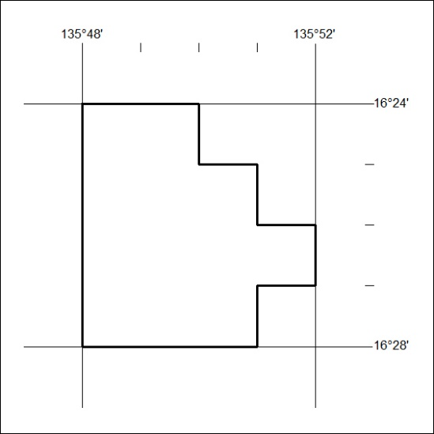

291/23

Corrigendum
Notice Number 277/23 appearing in MN079/23 on 12 July 2023 is hereby cancelled and replaced by the following:

Mineral Titles Act 2010
NOTICE OF LAND CEASING TO BE A MINERAL TITLE APPLICATION AREA
Title Type and Number: | Exploration Licence 32969
Area Ceased on: | 10 July 2023
Area: | 245 Blocks, 759.20 km²
Locality: | ANGAS
Name of Applicant(s)/Holder(s): | 100% CORE URANIUM LIMITED [ACN. 652 691 579]
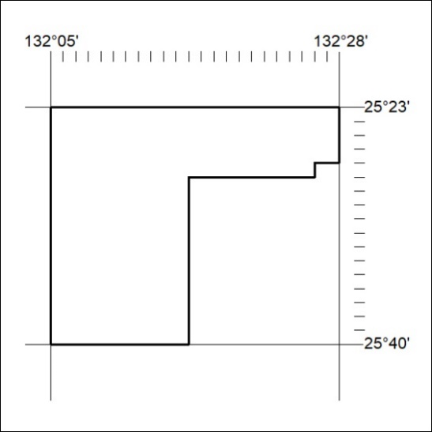

292/23

Corrigendum
Notice Number 278/23 appearing in MN079/23 on 12 July 2023 is hereby cancelled and replaced by the following:

Mineral Titles Act 2010
NOTICE OF LAND CEASING TO BE A MINERAL TITLE APPLICATION AREA
Title Type and Number: | Exploration Licence 32970
Area Ceased on: | 10 July 2023
Area: | 153 Blocks, 474.19 km²
Locality: | SENTINEL BORE
Name of Applicant(s)/Holder(s): | 100% CORE URANIUM LIMITED [ACN. 652 691 579]
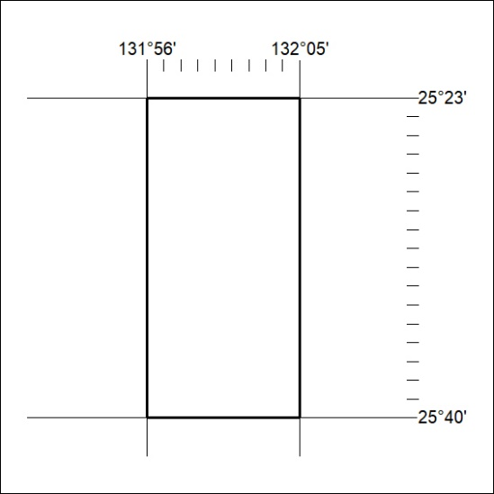

293/23

Corrigendum
Notice Number 282/23 appearing in MN079/23 on 12 July 2023 is hereby cancelled and replaced by the following:

Mineral Titles Act 2010
NOTICE OF LAND CEASING TO BE A MINERAL TITLE APPLICATION AREA
Title Type and Number: | Exploration Licence 32979
Area Ceased on: | 10 July 2023
Area: | 247 Blocks, 764.68 km²
Locality: | UMBEARA
Name of Applicant(s)/Holder(s): | 100% CORE URANIUM LIMITED [ACN. 652 691 579]
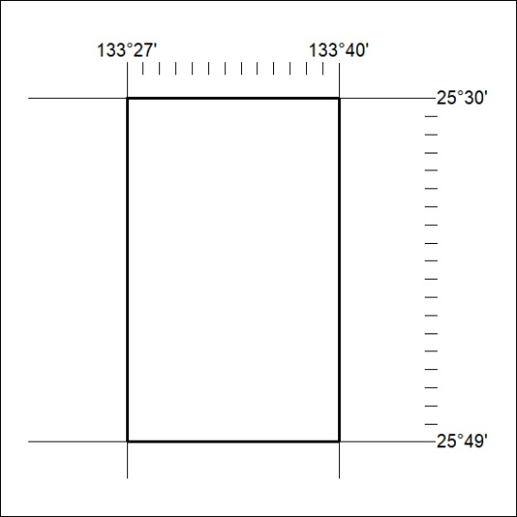

294/23

Corrigendum
Notice Number 265/23 appearing in MN079/23 on 12 July 2023 is hereby cancelled and replaced by the following:

Mineral Titles Act 2010
NOTICE OF LAND CEASING TO BE A MINERAL TITLE AREA
Title Type and Number: | Mineral Authority 31361
Area Ceased on: | 12 July 2023
Area: | 250 Blocks, 774.23 km²
Locality: | FINKE
Name of Applicant(s)/Holder(s): | 100% TRI-STAR ENERGY COMPANY [ACN. 089 539 695]
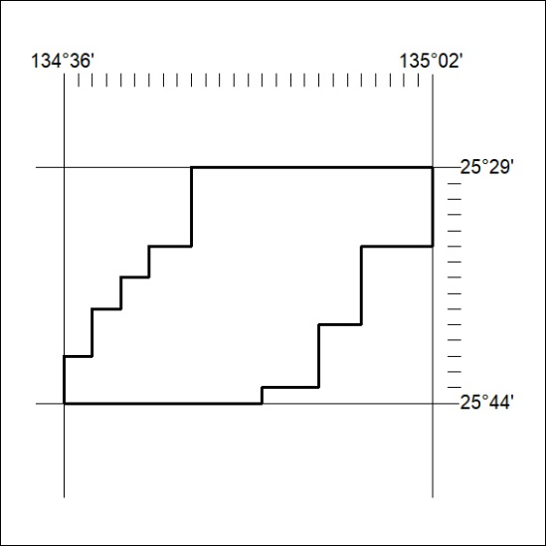

295/23

Corrigendum
Notice Number 266/23 appearing in MN079/23 on 12 July 2023 is hereby cancelled and replaced by the following:

Mineral Titles Act 2010
NOTICE OF LAND CEASING TO BE A MINERAL TITLE AREA
Title Type and Number: | Mineral Authority 31362
Area Ceased on: | 12 July 2023
Area: | 220 Blocks, 682.98 km²
Locality: | ANDADO
Name of Applicant(s)/Holder(s): | 100% TRI-STAR ENERGY COMPANY [ACN. 089 539 695]
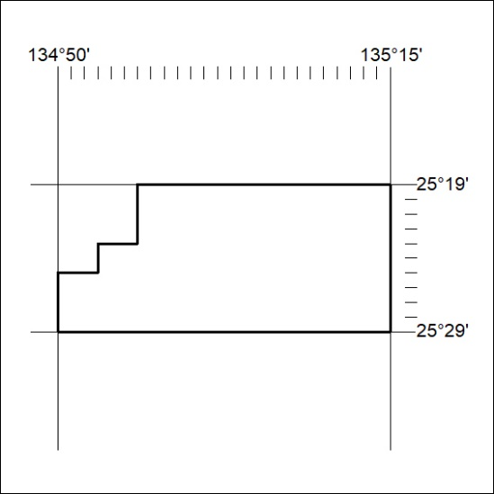

296/23

Corrigendum
Notice Number 267/23 appearing in MN079/23 on 12 July 2023 is hereby cancelled and replaced by the following:

Mineral Titles Act 2010
NOTICE OF LAND CEASING TO BE A MINERAL TITLE AREA
Title Type and Number: | Mineral Authority 31363
Area Ceased on: | 12 July 2023
Area: | 96 Blocks, 298.24 km²
Locality: | ANDADO
Name of Applicant(s)/Holder(s): | 100% TRI-STAR ENERGY COMPANY [ACN. 089 539 695]
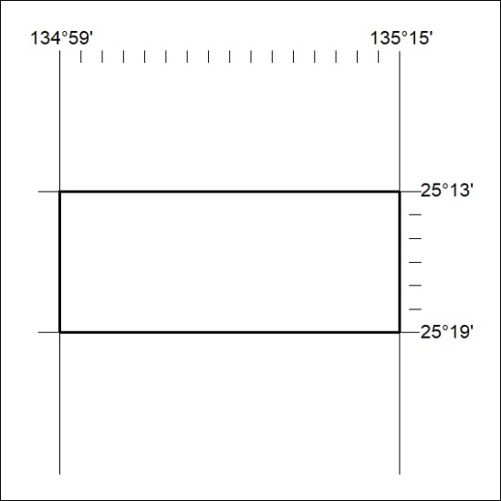

297/23

Corrigendum
Notice Number 268/23 appearing in MN079/23 on 12 July 2023 is hereby cancelled and replaced by the following:

Mineral Titles Act 2010
NOTICE OF LAND CEASING TO BE A MINERAL TITLE AREA
Title Type and Number: | Mineral Authority 31364
Area Ceased on: | 12 July 2023
Area: | 250 Blocks, 768.75 km²
Locality: | FINKE
Name of Applicant(s)/Holder(s): | 100% TRI-STAR ENERGY COMPANY [ACN. 089 539 695]
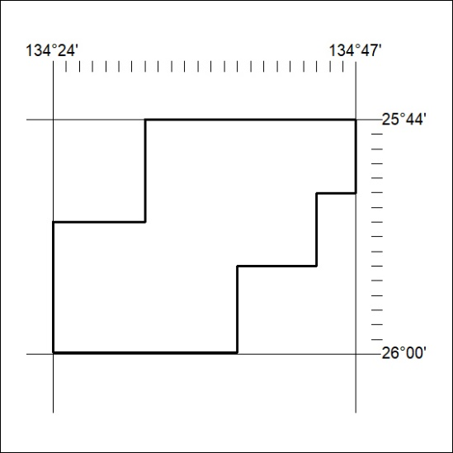

298/23

Corrigendum
Notice Number 269/23 appearing in MN079/23 on 12 July 2023 is hereby cancelled and replaced by the following:

Mineral Titles Act 2010
NOTICE OF LAND CEASING TO BE A MINERAL TITLE AREA
Title Type and Number: | Mineral Authority 31372
Area Ceased on: | 12 July 2023
Area: | 208 Blocks, 644.31 km²
Locality: | McDILLS
Name of Applicant(s)/Holder(s): | 100% TRI-STAR ENERGY COMPANY [ACN. 089 539 695]
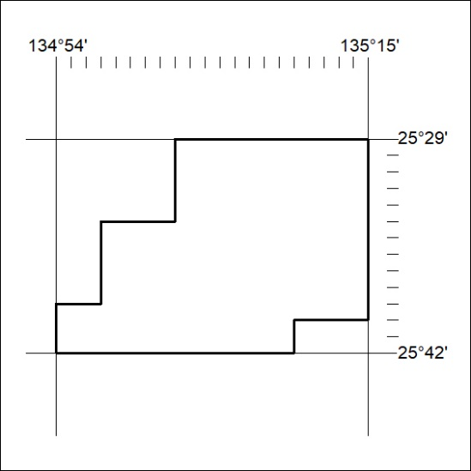

299/23

Corrigendum
Notice Number 270/23 appearing in MN079/23 on 12 July 2023 is hereby cancelled and replaced by the following:

Mineral Titles Act 2010
NOTICE OF LAND CEASING TO BE A MINERAL TITLE AREA
Title Type and Number: | Mineral Authority 31373
Area Ceased on: | 12 July 2023
Area: | 232 Blocks, 712.03 km²
Locality: | FINKE
Name of Applicant(s)/Holder(s): | 100% TRI-STAR ENERGY COMPANY [ACN. 089 539 695]
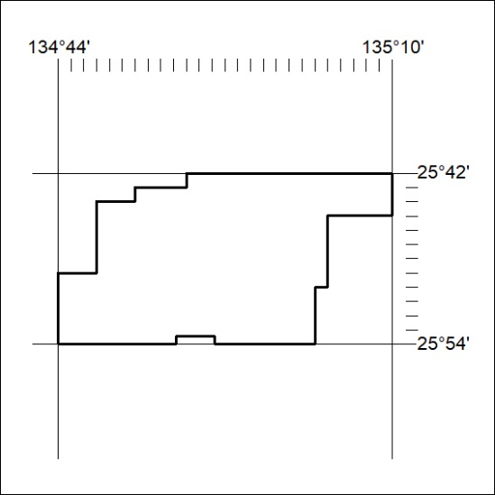

300/23

Corrigendum
Notice Number 271/23 appearing in MN079/23 on 12 July 2023 is hereby cancelled and replaced by the following:

Mineral Titles Act 2010
NOTICE OF LAND CEASING TO BE A MINERAL TITLE AREA
Title Type and Number: | Mineral Authority 31374
Area Ceased on: | 12 July 2023
Area: | 152 Blocks, 454.18 km²
Locality: | FINKE
Name of Applicant(s)/Holder(s): | 100% TRI-STAR ENERGY COMPANY [ACN. 089 539 695]
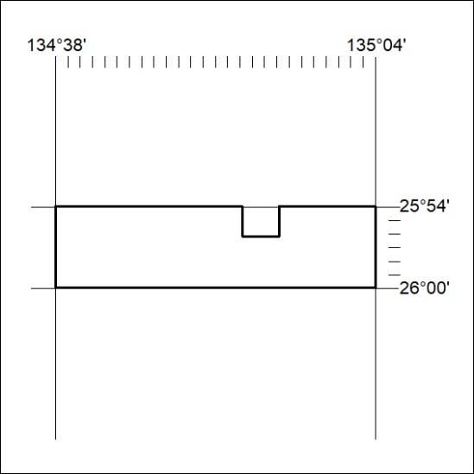

301/23

Corrigendum
Notice Number 272/23 appearing in MN079/23 on 12 July 2023 is hereby cancelled and replaced by the following:

Mineral Titles Act 2010
NOTICE OF LAND CEASING TO BE A MINERAL TITLE AREA
Title Type and Number: | Mineral Authority 31377
Area Ceased on: | 12 July 2023
Area: | 181 Blocks, 556.82 km²
Locality: | BEDDOME
Name of Applicant(s)/Holder(s): | 100% TRI-STAR ENERGY COMPANY [ACN. 089 539 695]
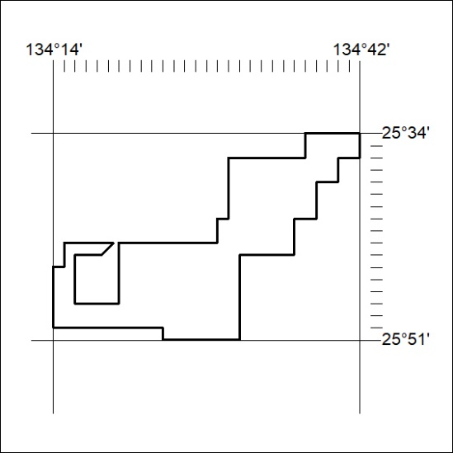

302/23

