Mineral Titles Act 2010
NOTICE OF LAND CEASING TO BE A MINERAL TITLE AREA
Title Type and Number: | Mineral Authority 31361
Area Ceased on: | 12 July 2023
Area: | Blocks, 774.23 km²
Locality: | FINKE
Name of Applicant(s)/Holder(s): | 100% TRI-STAR ENERGY COMPANY [ACN. 089 539 695]
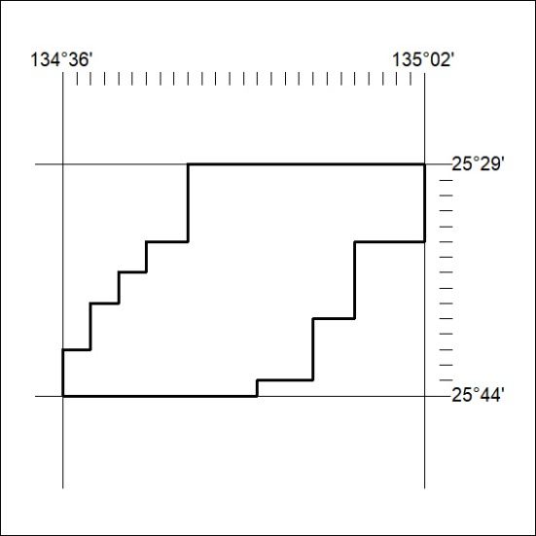

265/23

Mineral Titles Act 2010
NOTICE OF LAND CEASING TO BE A MINERAL TITLE AREA
Title Type and Number: | Mineral Authority 31362
Area Ceased on: | 12 July 2023
Area: | Blocks, 682.98 km²
Locality: | ANDADO
Name of Applicant(s)/Holder(s): | 100% TRI-STAR ENERGY COMPANY [ACN. 089 539 695]
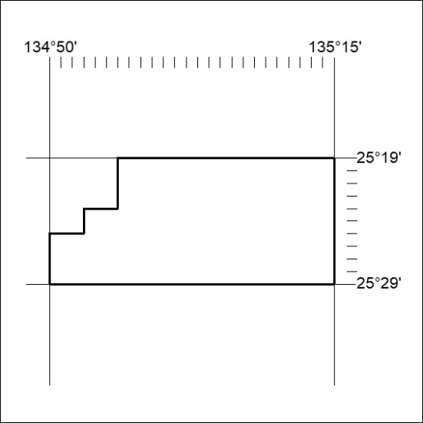

266/23

Mineral Titles Act 2010
NOTICE OF LAND CEASING TO BE A MINERAL TITLE AREA
Title Type and Number: | Mineral Authority 31363
Area Ceased on: | 12 July 2023
Area: | Blocks, 298.24 km²
Locality: | ANDADO
Name of Applicant(s)/Holder(s): | 100% TRI-STAR ENERGY COMPANY [ACN. 089 539 695]
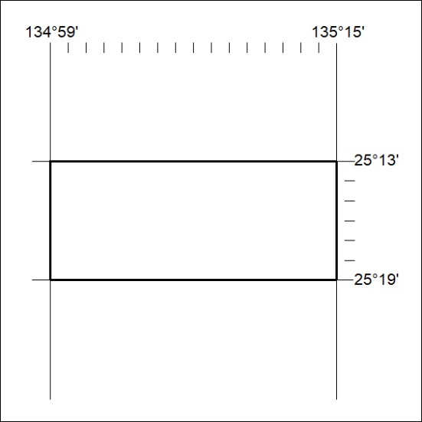

267/23

Mineral Titles Act 2010
NOTICE OF LAND CEASING TO BE A MINERAL TITLE AREA
Title Type and Number: | Mineral Authority 31364
Area Ceased on: | 12 July 2023
Area: | Blocks, 768.75 km²
Locality: | FINKE
Name of Applicant(s)/Holder(s): | 100% TRI-STAR ENERGY COMPANY [ACN. 089 539 695]
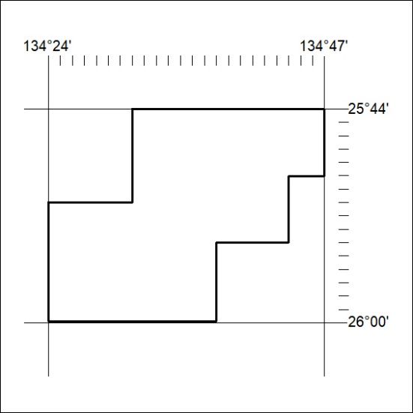

268/23

Mineral Titles Act 2010
NOTICE OF LAND CEASING TO BE A MINERAL TITLE AREA
Title Type and Number: | Mineral Authority 31372
Area Ceased on: | 12 July 2023
Area: | Blocks, 644.31 km²
Locality: | McDILLS
Name of Applicant(s)/Holder(s): | 100% TRI-STAR ENERGY COMPANY [ACN. 089 539 695]
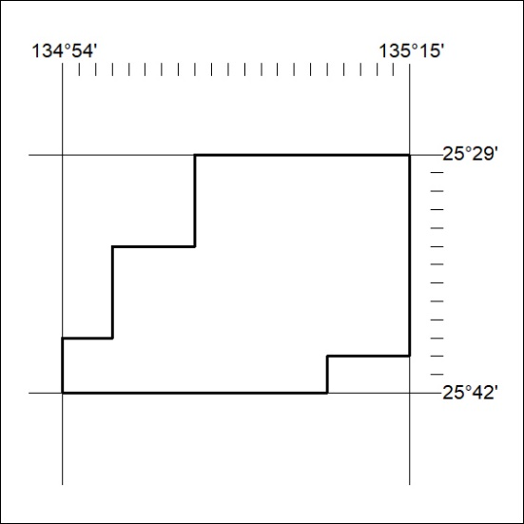

269/23

Mineral Titles Act 2010
NOTICE OF LAND CEASING TO BE A MINERAL TITLE AREA
Title Type and Number: | Mineral Authority 31373
Area Ceased on: | 12 July 2023
Area: | Blocks, 712.03 km²
Locality: | FINKE
Name of Applicant(s)/Holder(s): | 100% TRI-STAR ENERGY COMPANY [ACN. 089 539 695]
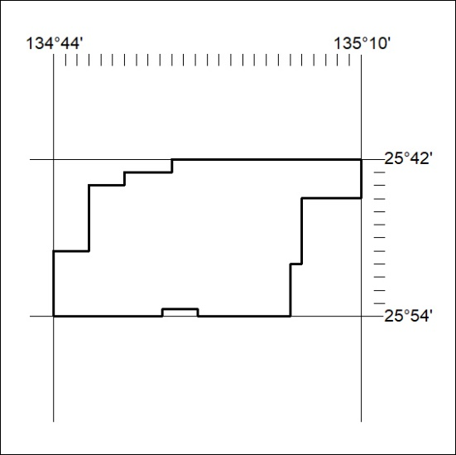

270/23

Mineral Titles Act 2010
NOTICE OF LAND CEASING TO BE A MINERAL TITLE AREA
Title Type and Number: | Mineral Authority 31374
Area Ceased on: | 12 July 2023
Area: | Blocks, 454.18 km²
Locality: | FINKE
Name of Applicant(s)/Holder(s): | 100% TRI-STAR ENERGY COMPANY [ACN. 089 539 695]
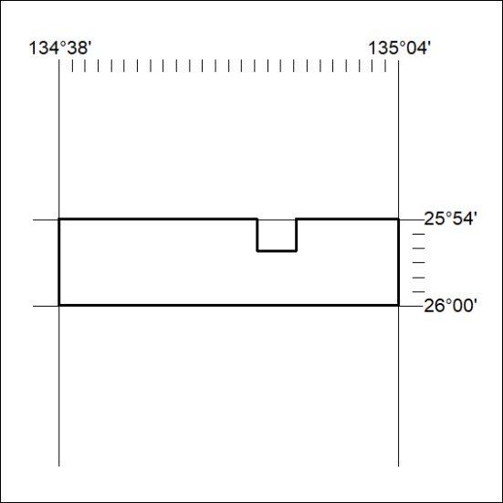

271/23

Mineral Titles Act 2010
NOTICE OF LAND CEASING TO BE A MINERAL TITLE AREA
Title Type and Number: | Mineral Authority 31377
Area Ceased on: | 12 July 2023
Area: | Blocks, 556.82 km²
Locality: | BEDDOME
Name of Applicant(s)/Holder(s): | 100% TRI-STAR ENERGY COMPANY [ACN. 089 539 695]
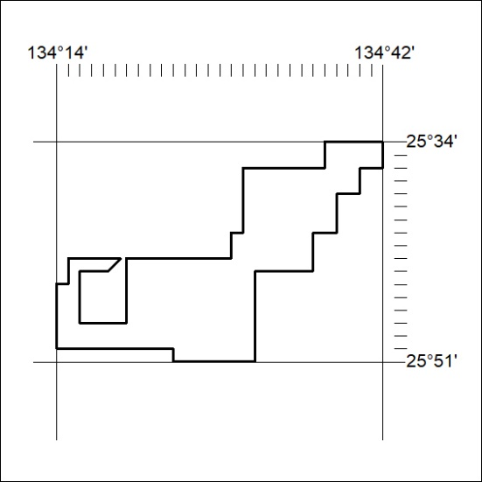

272/23

Mineral Titles Act 2010
NOTICE OF LAND CEASING TO BE A MINERAL TITLE APPLICATION AREA
Title Type and Number: | Exploration Licence 31482
Area Ceased on: | 11 July 2023
Area: | 25 Blocks, 77.55 km²
Locality: | SOUTHS RANGE
Name of Applicant(s)/Holder(s): | 100% MACDONALD Stuart
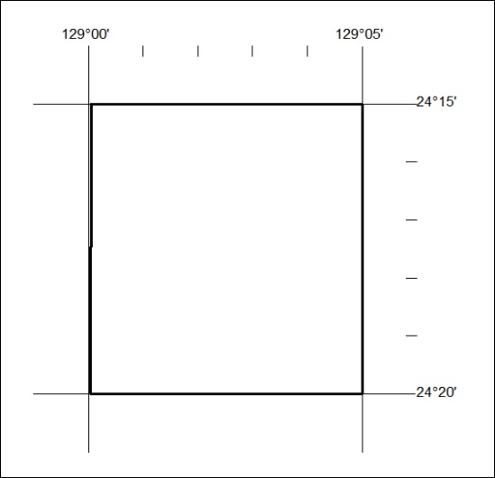

273/23

Mineral Titles Act 2010
NOTICE OF LAND CEASING TO BE A MINERAL TITLE APPLICATION AREA
Title Type and Number: | Exploration Licence 32966
Area Ceased on: | 10 July 2023
Area: | 198 Blocks, 612.03 km²
Locality: | SENTINEL BORE
Name of Applicant(s)/Holder(s): | 100% CORE URANIUM LIMITED [ACN. 652 691 579]
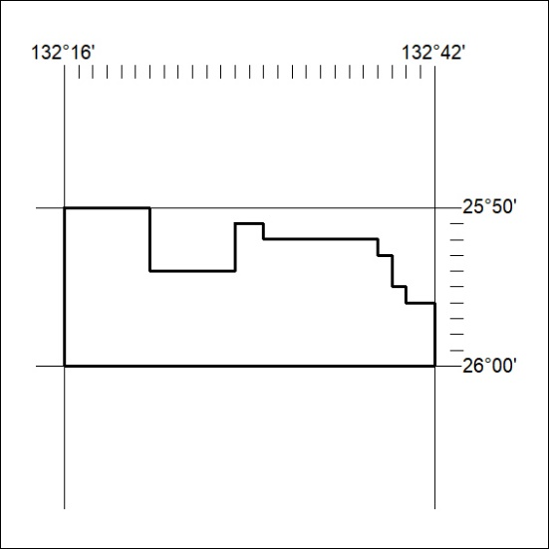

274/23

Mineral Titles Act 2010
NOTICE OF LAND CEASING TO BE A MINERAL TITLE APPLICATION AREA
Title Type and Number: | Exploration Licence 32967
Area Ceased on: | 10 July 2023
Area: | 232 Blocks, 717.88 km²
Locality: | VICTORY
Name of Applicant(s)/Holder(s): | 100% CORE URANIUM LIMITED [ACN. 652 691 579]
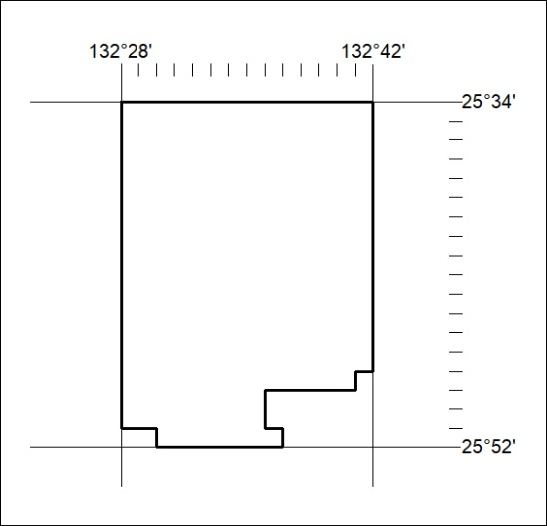

275/23

Mineral Titles Act 2010
NOTICE OF LAND CEASING TO BE A MINERAL TITLE APPLICATION AREA
Title Type and Number: | Exploration Licence 32968
Area Ceased on: | 10 July 2023
Area: | 182 Blocks, 563.71 km²
Locality: | SENTINEL BORE
Name of Applicant(s)/Holder(s): | 100% CORE URANIUM LIMITED [ACN. 652 691 579]
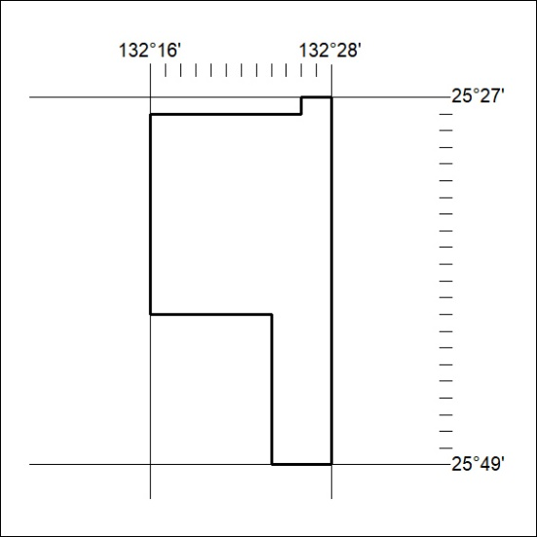

276/23

Mineral Titles Act 2010
NOTICE OF LAND CEASING TO BE A MINERAL TITLE APPLICATION AREA
Title Type and Number: | Exploration Licence 32969
Area Ceased on: | 10 August 2023
Area: | 245 Blocks, 759.20 km²
Locality: | ANGAS
Name of Applicant(s)/Holder(s): | 100% CORE URANIUM LIMITED [ACN. 652 691 579]
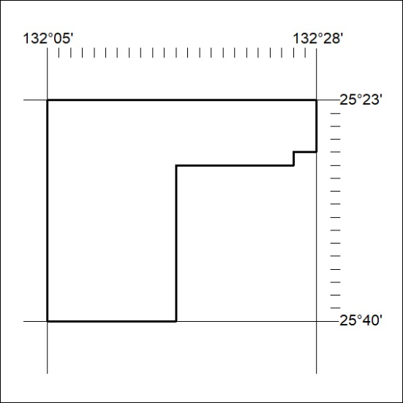

277/23

Mineral Titles Act 2010
NOTICE OF LAND CEASING TO BE A MINERAL TITLE APPLICATION AREA
Title Type and Number: | Exploration Licence 32970
Area Ceased on: | 10 August 2023
Area: | 153 Blocks, 474.19 km²
Locality: | SENTINEL BORE
Name of Applicant(s)/Holder(s): | 100% CORE URANIUM LIMITED [ACN. 652 691 579]
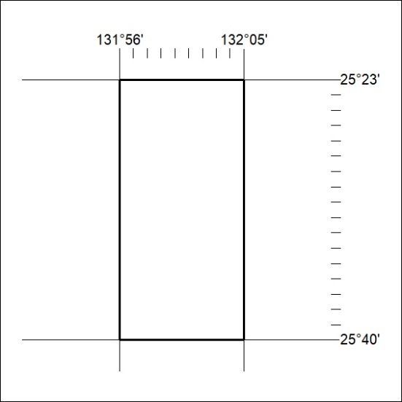

278/23

Mineral Titles Act 2010
NOTICE OF LAND CEASING TO BE A MINERAL TITLE APPLICATION AREA
Title Type and Number: | Exploration Licence 32971
Area Ceased on: | 10 July 2023
Area: | 249 Blocks, 771.91 km²
Locality: | EBENEZER
Name of Applicant(s)/Holder(s): | 100% CORE URANIUM LIMITED [ACN. 652 691 579]
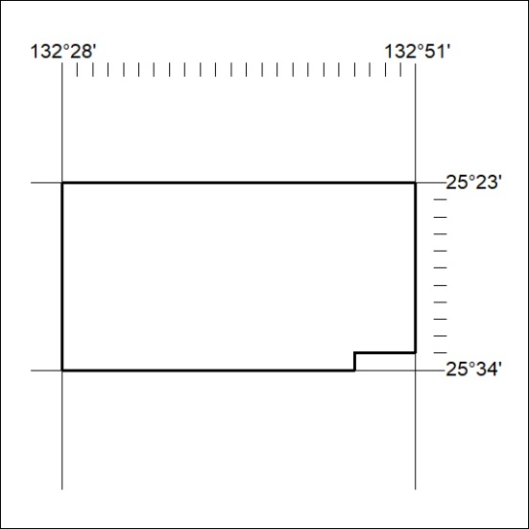

279/23

Mineral Titles Act 2010
NOTICE OF LAND CEASING TO BE A MINERAL TITLE APPLICATION AREA
Title Type and Number: | Exploration Licence 32972
Area Ceased on: | 10 July 2023
Area: | 207 Blocks, 640.71 km²
Locality: | VICTORY
Name of Applicant(s)/Holder(s): | 100% CORE URANIUM LIMITED [ACN. 652 691 579]
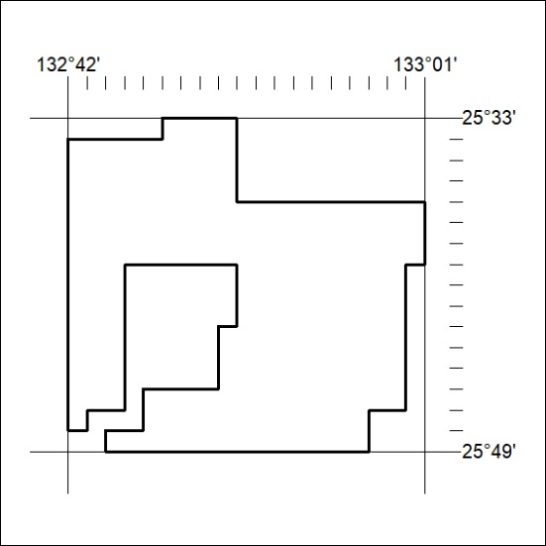

280/23

Mineral Titles Act 2010
NOTICE OF LAND CEASING TO BE A MINERAL TITLE APPLICATION AREA
Title Type and Number: | Exploration Licence 32973
Area Ceased on: | 10 July 2023
Area: | 247 Blocks, 764.93 km²
Locality: | KULGERA
Name of Applicant(s)/Holder(s): | 100% CORE URANIUM LIMITED [ACN. 652 691 579]
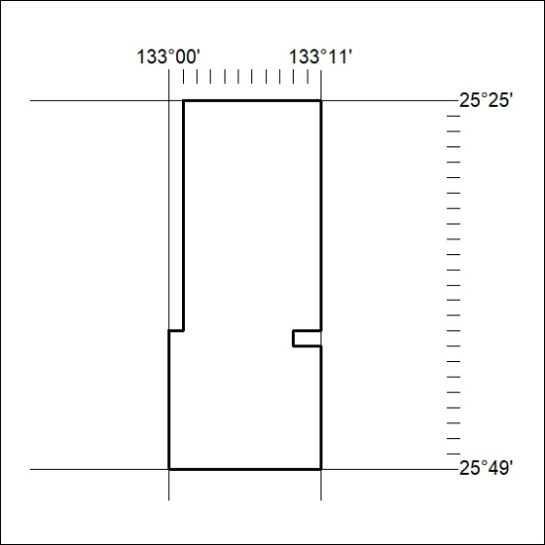

281/23

Mineral Titles Act 2010
NOTICE OF LAND CEASING TO BE A MINERAL TITLE APPLICATION AREA
Title Type and Number: | Exploration Licence 32979
Area Ceased on: | 10 July 2023
Area: | Blocks, 764.68 km²
Locality: | UMBEARA
Name of Applicant(s)/Holder(s): | 100% CORE URANIUM LIMITED [ACN. 652 691 579]
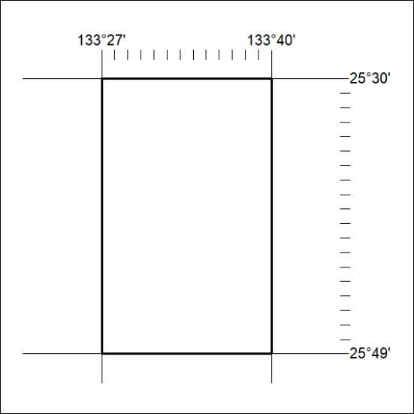

282/23

Mineral Titles Act 2010
NOTICE OF LAND CEASING TO BE A MINERAL TITLE APPLICATION AREA
Title Type and Number: | Exploration Licence 32980
Area Ceased on: | 10 July 2023
Area: | 248 Blocks, 767.83 km²
Locality: | UMBEARA
Name of Applicant(s)/Holder(s): | 100% CORE URANIUM LIMITED [ACN. 652 691 579]
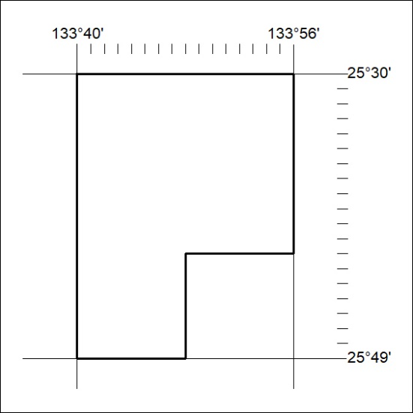

283/23

