Mineral Titles Act
NOTICE OF GRANT OF A MINERAL TITLE
Title Type and Number: | Exploration Licence 33141
Granted: | 15 June 2023, for a period of 6 Years
Area: | 14 Blocks, 44.25 km²
Locality: | QUARTZ
Name of Holder/s: | 100% PEREGIAN MINERALS PTY LTD [ACN. 656 661 586]
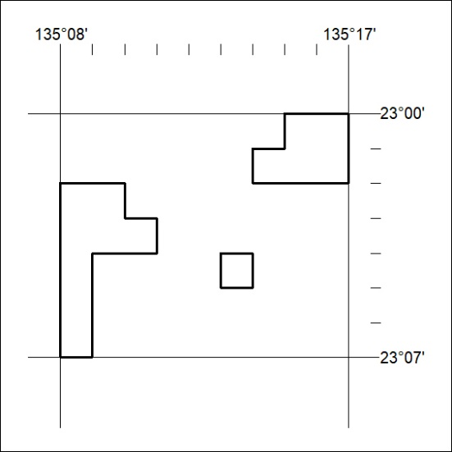
Area granted is indicated above. The titleholder is not permitted to exercise occupational rights on any land that is subject to a development title, or an application for a development title. Any land the subject of a Reserved Land gazettal under the Mineral Titles Act and all land vested in the Commonwealth of Australia is also excluded by description but not excised from the grant area.
217/23

Mineral Titles Act
NOTICE OF GRANT OF A MINERAL TITLE
Title Type and Number: | Extractive Mineral Exploration Licence 33457
Granted: | 16 June 2023, for a period of 2 Years
Area: | 2 Blocks, 0.66 km²
Locality: | NOONAMAH
Name of Holder/s: | 100% YEBNA QUARRIES HOLDINGS PTY LTD [ACN. 600 183 248]
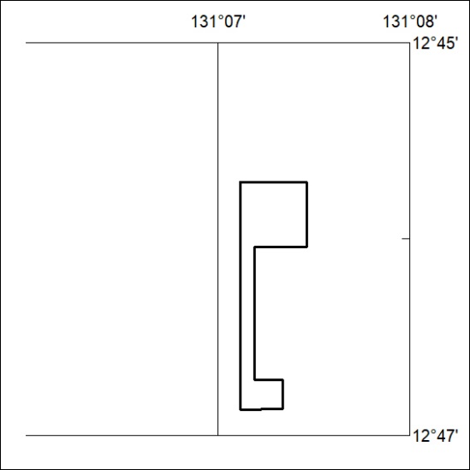
Area granted is indicated above. The titleholder is not permitted to exercise occupational rights on any land that is subject to a development title, or an application for a development title. Any land the subject of a Reserved Land gazettal under the Mineral Titles Act and all land vested in the Commonwealth of Australia is also excluded by description but not excised from the grant area.
218/23

