Mineral Titles Act 2010
NOTICE OF LAND CEASING TO BE A MINERAL TITLE AREA
Title Type and Number: | Exploration Licence 28029
Area Ceased on: | 17 April 2023
Area: | 1 Block, 0.01 km²
Locality: | RIDDOCH
Name of Applicant(s)/Holder(s): | 100% DBL BLUES PTY LTD [ACN. 140 024 442]
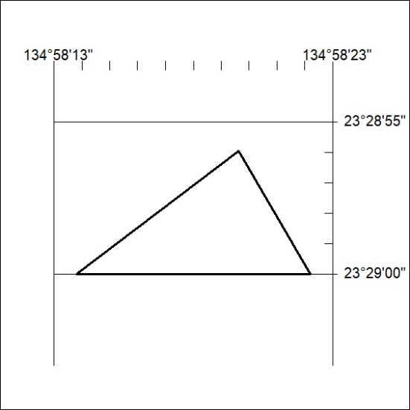

101/23

Mineral Titles Act 2010
NOTICE OF LAND CEASING TO BE A MINERAL TITLE AREA
Title Type and Number: | Exploration Licence 30085
Area Ceased on: | 17 April 2023
Area: | 16 Blocks, 52.51 km²
Locality: | KILGOUR
Name of Applicant(s)/Holder(s): | 100% TODD RIVER METALS PTY LTD [ACN. 600 314 038]
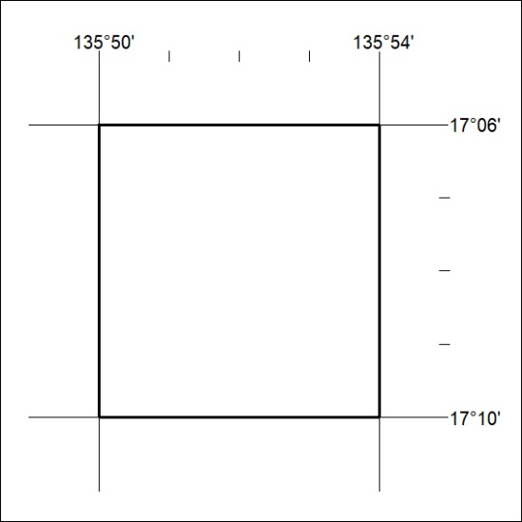

102/23
Mineral Titles Act 2010
NOTICE OF LAND CEASING TO BE A MINERAL TITLE AREA
Title Type and Number: | Exploration Licence 32408
Area Ceased on: | 17 April 2023
Area: | 192 Blocks, 626.28 km²
Locality: | NONGRA
Name of Applicant(s)/Holder(s): | 100% OAKAJEE EXPLORATION PTY LTD [ACN. 629 544 912]
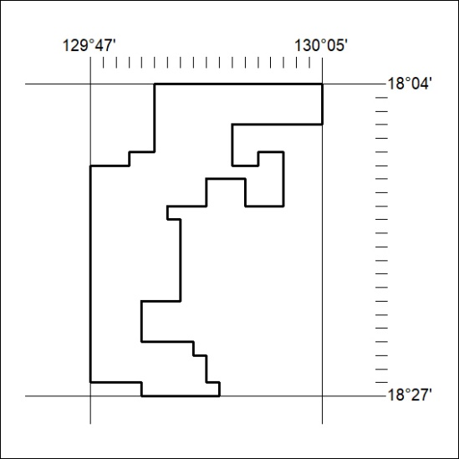

103/23

