Mineral Titles Act 2010
NOTICE OF LAND CEASING TO BE A MINERAL TITLE AREA
Title Type and Number: | Exploration Licence 31939
Area Ceased on: | 14 April 2023
Area: | 2 Blocks, 6.68 km²
Locality: | BATCHELOR
Name of Applicant(s)/Holder(s): | 100% NT MINING OPERATIONS PTY LTD* [ACN. 136 525 990]
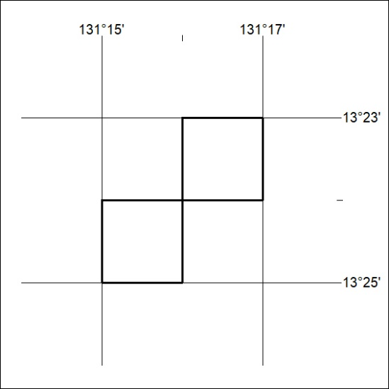

100/23

