Mineral Titles Act 2010
NOTICE OF LAND CEASING TO BE A MINERAL TITLE AREA
Title Type and Number: | Mineral Lease 29822
Area ceased on: | 16 January 2023
Area: | 2359.00 Hectares
Locality: | McFARLANE
Name of Applicants(s)Holder(s): | 100% PRODIGY GOLD NL* [ACN. 009 127 020]
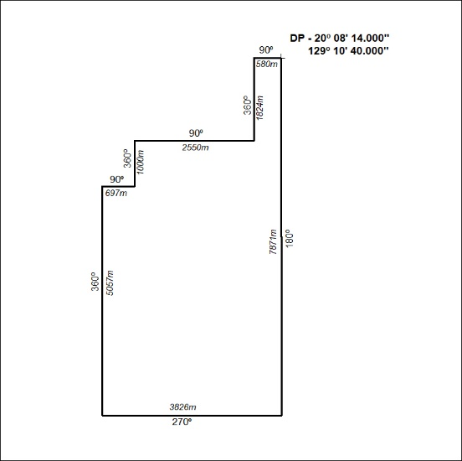

020/23

Mineral Titles Act
NOTICE OF GRANT OF A MINERAL TITLE
Title Type and Number: | Exploration Licence 33188
Granted: | 16 January 2023, for a period of 6 Years
Area: | 25 Blocks, 75.69 km²
Locality: | BATCHELOR
Name of Holder/s: | 100% MANGUSTA MINERALS PTY LTD [ACN. 653 950 522]
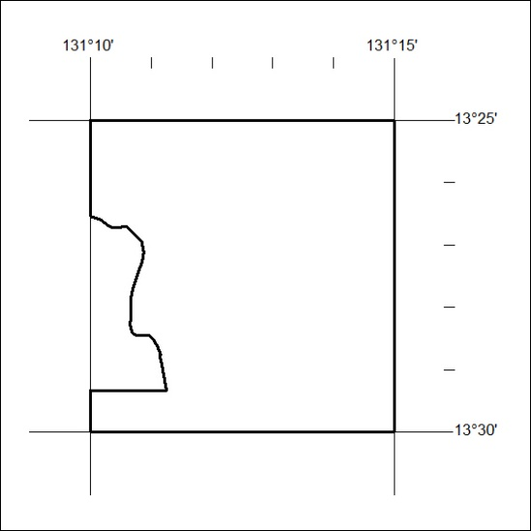
Area granted is indicated above. The titleholder is not permitted to exercise occupational rights on any land that is subject to a development title, or an application for a development title. Any land the subject of a Reserved Land gazettal under the Mineral Titles Act and all land vested in the Commonwealth of Australia is also excluded by description but not excised from the grant area.

021/23

Mineral Titles Act
NOTICE OF GRANT OF A MINERAL TITLE
Title Type and Number: | Mineral Lease 33459
Granted: | 28 March 2014, for a period of 25 Years
Area: | 2359.00 Hectares
Locality: | McFARLANE
Name of Holder/s: | 100% PRODIGY GOLD NL* [ACN. 009 127 020]

022/23

