Mineral Titles Act
NOTICE OF GRANT OF A MINERAL TITLE
Title Type and Number: | Exploration Licence 32750
Granted: | 12 January 2023, for a period of 6 Years
Area: | 250 Blocks, 824.10 km²
Locality: | SCARLET HILL
Name of Holder/s: | 100% FIDDLER'S CREEK MINING COMPANY PTY LTD * [ACN. 099 215 648]
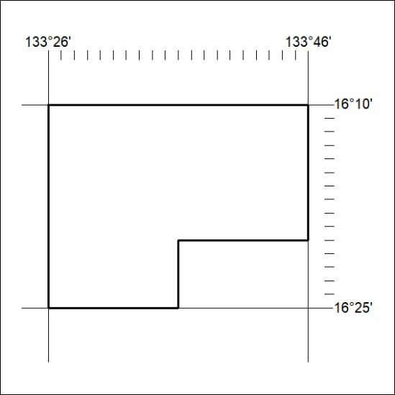
Area granted is indicated above. The titleholder is not permitted to exercise occupational rights on any land that is subject to a development title, or an application for a development title. Any land the subject of a Reserved Land gazettal under the Mineral Titles Act and all land vested in the Commonwealth of Australia is also excluded by description but not excised from the grant area.
018/23

Mineral Titles Act
NOTICE OF GRANT OF A MINERAL TITLE
Title Type and Number: | Exploration Licence 32752
Granted: | 12 January 2023, for a period of 6 Years
Area: | 220 Blocks, 726.93 km²
Locality: | LARRIMAH
Name of Holder/s: | 100% FIDDLER'S CREEK MINING COMPANY PTY LTD * [ACN. 099 215 648]
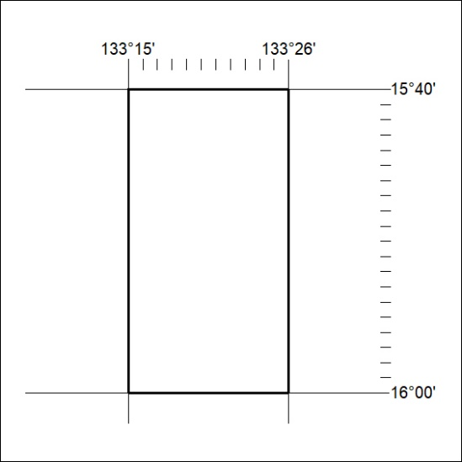
Area granted is indicated above. The titleholder is not permitted to exercise occupational rights on any land that is subject to a development title, or an application for a development title. Any land the subject of a Reserved Land gazettal under the Mineral Titles Act and all land vested in the Commonwealth of Australia is also excluded by description but not excised from the grant area.
019/23

Mineral Titles Act
NOTICE OF GRANT OF A MINERAL TITLE
Title Type and Number: | Exploration Licence 32805
Granted: | 12 January 2023, for a period of 6 Years
Area: | 222 Blocks, 712.73 km²
Locality: | LARRIMAH
Name of Holder/s: | 100% FIDDLER'S CREEK MINING COMPANY PTY LTD * [ACN. 099 215 648]
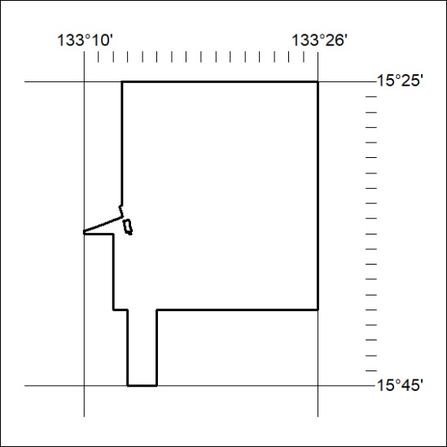
Area granted is indicated above. The titleholder is not permitted to exercise occupational rights on any land that is subject to a development title, or an application for a development title. Any land the subject of a Reserved Land gazettal under the Mineral Titles Act and all land vested in the Commonwealth of Australia is also excluded by description but not excised from the grant area.
019/23

