Mineral Titles Act 2010
NOTICE OF LAND CEASING TO BE A MINERAL TITLE AREA
Title Type and Number: | Extractive Mineral Exploration Licence 32502
Area Ceased on: | 28 December 2022
Area: | 4 Blocks, 13.36 km²
Locality: | McKINLAY RIVER
Name of Applicant(s)/Holder(s): | 100% ACACIA ENTERPRISES (NT) PTY LTD [ACN. 158 649 864]
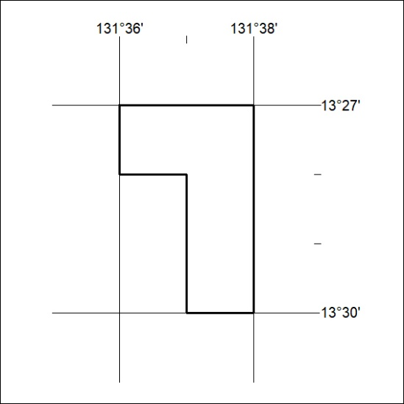

001/23

Mineral Titles Act 2010
NOTICE OF LAND CEASING TO BE A MINERAL TITLE AREA
Title Type and Number: | Extractive Mineral Exploration Licence 32503
Area Ceased on: | 28 December 2022
Area: | 4 Blocks, 13.36 km²
Locality: | McKINLAY RIVER
Name of Applicant(s)/Holder(s): | 100% ACACIA ENTERPRISES (NT) PTY LTD [ACN. 158 649 864]
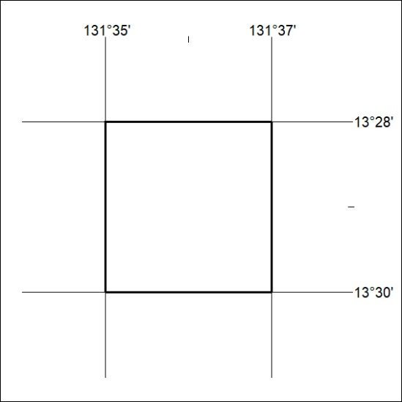

002/23

Mineral Titles Act 2010
NOTICE OF LAND CEASING TO BE A MINERAL TITLE AREA
Title Type and Number: | Extractive Mineral Permit 23038
Area ceased on: | 31 December 2022
Area: | 6.00 Hectare
Locality: | NOONAMAH
Name of Applicants(s)Holder(s): | 100% BERNO BROS. PTY. LIMITED [ACN. 009 592 741]
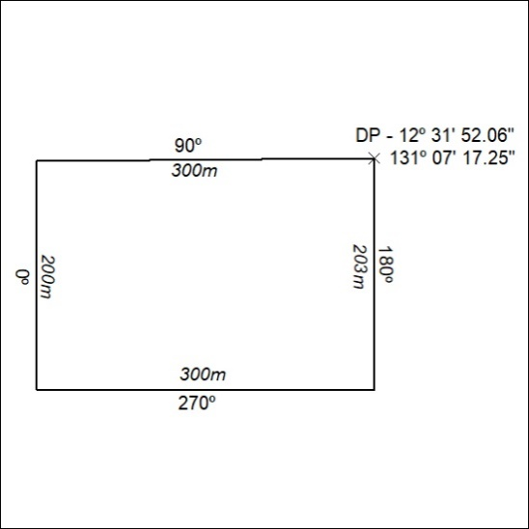

003/23

