Mineral Titles Act
NOTICE OF GRANT OF A MINERAL TITLE
Title Type and Number: | Exploration Licence 32849
Granted: | 04 April 2022, for a period of 6 Years
Area: | 71 Blocks, 231.46 km²
Locality: | PARADISE BORE
Name of Holder/s: | 100% XAVIER RESOURCES PTY LTD [ACN. 623 262 304]
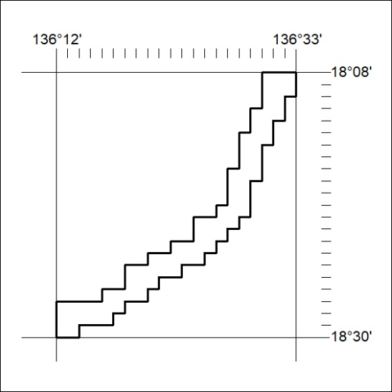
Area granted is indicated above. The titleholder is not permitted to exercise occupational rights on any land that is subject to a development title, or an application for a development title. Any land the subject of a Reserved Land gazettal under the Mineral Titles Act and all land vested in the Commonwealth of Australia is also excluded by description but not excised from the grant area.
86/22

Mineral Titles Act
NOTICE OF GRANT OF A MINERAL TITLE
Title Type and Number: | Exploration Licence 32850
Granted: | 04 April 2022, for a period of 6 Years
Area: | 249 Blocks, 812.06 km²
Locality: | BOXER
Name of Holder/s: | 100% XAVIER RESOURCES PTY LTD [ACN. 623 262 304]
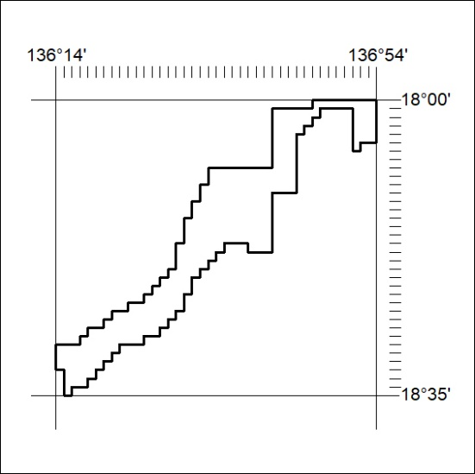
Area granted is indicated above. The titleholder is not permitted to exercise occupational rights on any land that is subject to a development title, or an application for a development title. Any land the subject of a Reserved Land gazettal under the Mineral Titles Act and all land vested in the Commonwealth of Australia is also excluded by description but not excised from the grant area.
87/22

Mineral Titles Act
NOTICE OF GRANT OF A MINERAL TITLE
Title Type and Number: | Exploration Licence 32865
Granted: | 04 April 2022, for a period of 6 Years
Area: | 217 Blocks, 709.25 km²
Locality: | COANJULA
Name of Holder/s: | 100% BENMARA RESOURCES PTY LTD [ACN. 652 390 139]
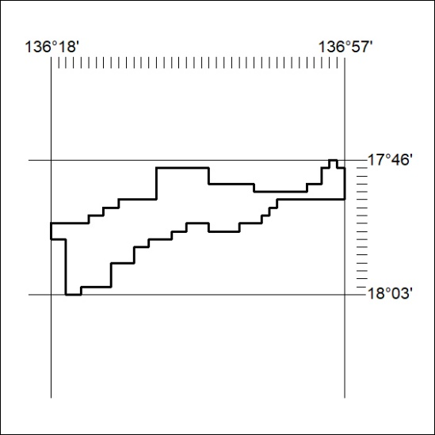
Area granted is indicated above. The titleholder is not permitted to exercise occupational rights on any land that is subject to a development title, or an application for a development title. Any land the subject of a Reserved Land gazettal under the Mineral Titles Act and all land vested in the Commonwealth of Australia is also excluded by description but not excised from the grant area.
88/22

