Mineral Titles Act 2010
NOTICE OF LAND CEASING TO BE A MINERAL TITLE AREA
Title Type and Number: | Exploration Licence 28694
Area Ceased on: | 25 February 2022
Area: | 8 Blocks, 25.45 km²
Locality: | DOREEN
Name of Applicant(s)/Holder(s): | 100% TODD RIVER METALS PTY LTD [ACN. 600 314 038]
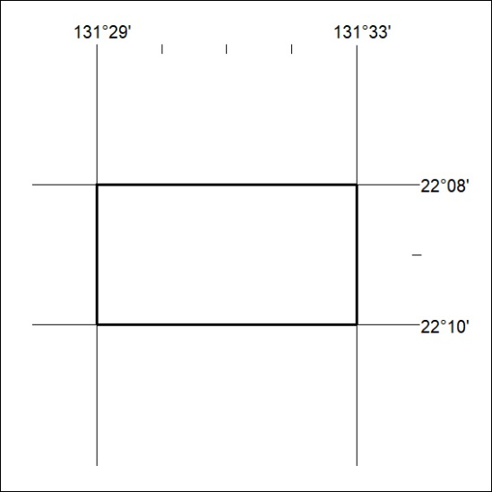

47/22

