Corrigendum
Notice Number 26/22 appearing in MN09/22 on 10 February 2022 is hereby cancelled and replaced by the following:

Mineral Titles Act 2010
NOTICE OF LAND CEASING TO BE A MINERAL TITLE AREA
Title Type and Number: | Extractive Mineral Permit 24595
Area ceased on: | 15 February 2022
Area: | 93.00 Hectare
Locality: | NOONAMAH
Name of Applicants(s)Holder(s): | 100% BOB KERR TRANSPORT PTY LTD [ACN. 109 115 059]
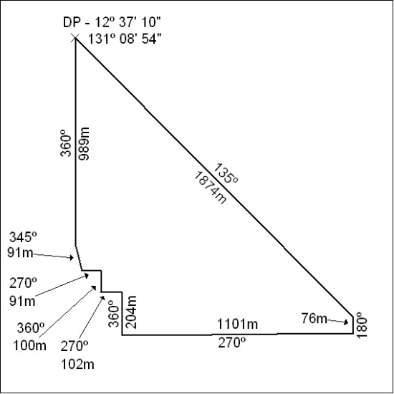

28/22

