  - Biosecurity
An emergency animal disease (EAD) outbreak could seriously damage the Australian economy, environment, livestock industries or impact human health.
State and territory governments are responsible for managing EAD outbreaks in their jurisdictions. Responding to EADs requires coordination and significant resources from all tiers of government and industry.
EAD responses are managed according to the nationally agreed Australian Veterinary Emergency Plan (AUSVETPLAN) arrangements.
Primarily, Australian policy is to eradicate incursions of exotic emergency animal disease as quickly as possible by establishing declared areas and implementing a number of control measures.

Declared areas
Declared areas are established during a response to prevent the spread of disease.

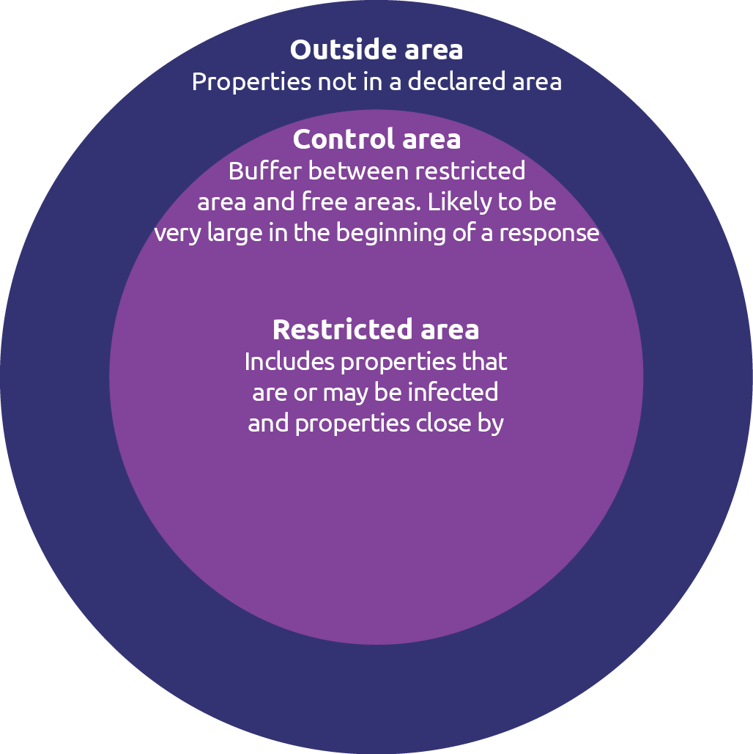

Control measures
 | Quarantine and movement controls | Restrictions on movements (onto and off premises)  of animals, vehicles, equipment, animal products, animal waste and other items that could be contaminated.
 | Biosecurity requirements for people | Required decontamination or changes of clothing of  and footwear when people move on and off premises.
 | Tracing | Reviewing movements of animals, people and objects on and off infected premises to help identify where infection may have come from and spread to.
 | Surveillance | Checking for signs of disease or contamination, investigating anything suspicious and taking samples for laboratory testing if needed.
 | Treatment of infected animals | Treatment of infected animals where an effective treatment is available.
 | Vaccination | For some diseases, vaccines may be available and used to create a barrier of immune animals between infected and uninfected areas.
 | Destruction | Culling of animals that are infected or are a high disease risk. High-risk objects that can’t be decontaminated may also be destroyed.
 | Valuation and compensation | Compensation may be available for animals that  have died from the disease, or animals or property destroyed as part of the official disease response. This is governed by state and territory-specific legislation.
 | Disposal | Biosecure disposal of carcasses and animal products or by-products that are, or might be, contaminated.
 | Decontamination | Chemical or other treatment of premises, vehicles, equipment, clothing, footwear and other objects that may be contaminated.

If you notice any severe illness or sudden death in animals, you should immediately contact your veterinarian or the Emergency Animal Disease (EAD) Watch hotline on 1800 675 888.
For more information, go to industry.nt.gov.au
Join the biosecurity Facebook group @biosecNT

