Mineral Titles Act 2010
NOTICE OF LAND CEASING TO BE A MINERAL TITLE AREA
Title Type and Number: | Exploration Licence 25031
Area Ceased on: | 19 December 2021
Area: | 8 Blocks, 25.69 km²
Locality: | WINNALL
Name of Applicant(s)/Holder(s): | 100% PRODIGY GOLD NL* [ACN. 009 127 020]
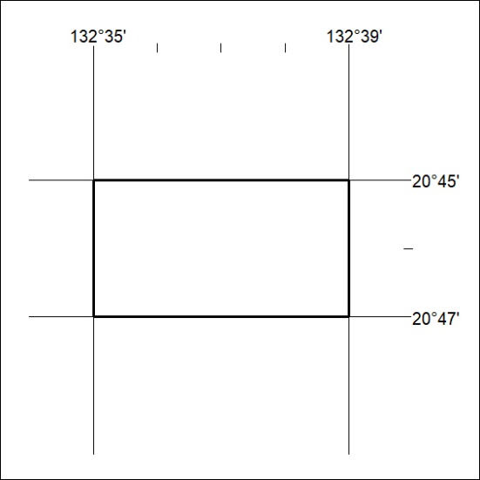

474/21

Mineral Titles Act 2010
NOTICE OF LAND CEASING TO BE A MINERAL TITLE AREA
Title Type and Number: | Exploration Licence 25033
Area Ceased on: | 19 December 2021
Area: | 12 Blocks, 27.94 km²
Locality: | LANDER
Name of Applicant(s)/Holder(s): | 100% PRODIGY GOLD NL* [ACN. 009 127 020]
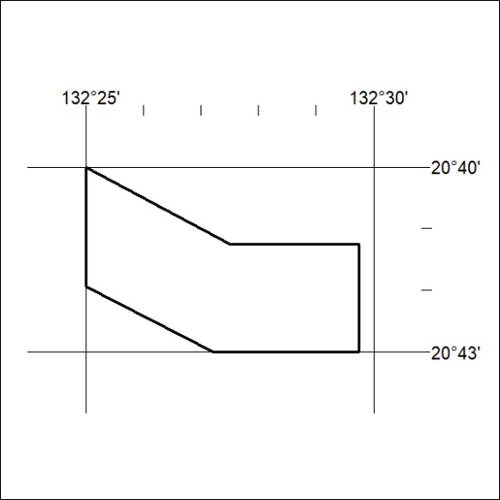

475/21

Mineral Titles Act 2010
NOTICE OF LAND CEASING TO BE A MINERAL TITLE AREA
Title Type and Number: | Exploration Licence 25034
Area Ceased on: | 19 December 2021
Area: | 8 Blocks, 15.06 km²
Locality: | LANDER
Name of Applicant(s)/Holder(s): | 100% PRODIGY GOLD NL* [ACN. 009 127 020]
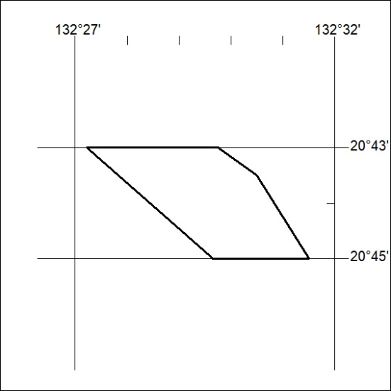

476/21

Mineral Titles Act 2010
NOTICE OF LAND CEASING TO BE A MINERAL TITLE AREA
Title Type and Number: | Exploration Licence 25035
Area Ceased on: | 19 December 2021
Area: | 17 Blocks, 39.35 km²
Locality: | WINNALL
Name of Applicant(s)/Holder(s): | 100% PRODIGY GOLD NL* [ACN. 009 127 020]
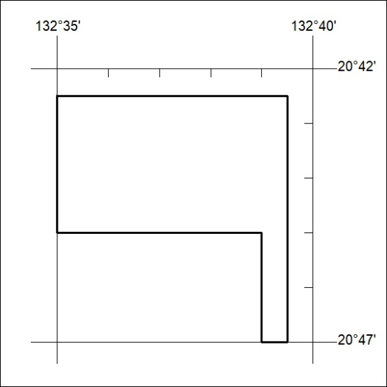

477/21

Mineral Titles Act 2010
NOTICE OF LAND CEASING TO BE A MINERAL TITLE AREA
Title Type and Number: | Exploration Licence 25041
Area Ceased on: | 19 December 2021
Area: | 4 Blocks, 5.09 km²
Locality: | JARRAH JARRAH
Name of Applicant(s)/Holder(s): | 100% PRODIGY GOLD NL* [ACN. 009 127 020]
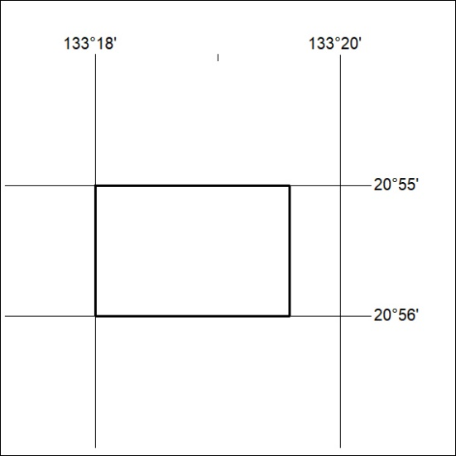

478/21

Mineral Titles Act 2010
NOTICE OF LAND CEASING TO BE A MINERAL TITLE AREA
Title Type and Number: | Exploration Licence 25042
Area Ceased on: | 19 December 2021
Area: | 38 Blocks, 111.50 km²
Locality: | JARRAH JARRAH
Name of Applicant(s)/Holder(s): | 100% PRODIGY GOLD NL* [ACN. 009 127 020]
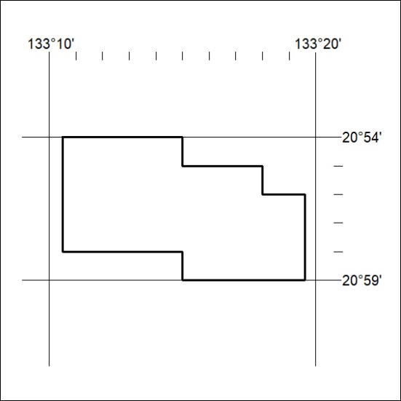

479/21

Mineral Titles Act 2010
NOTICE OF LAND CEASING TO BE A MINERAL TITLE AREA
Title Type and Number: | Exploration Licence 25044
Area Ceased on: | 19 December 2021
Area: | 15 Blocks, 29.01 km²
Locality: | JARRAH JARRAH
Name of Applicant(s)/Holder(s): | 100% PRODIGY GOLD NL* [ACN. 009 127 020]
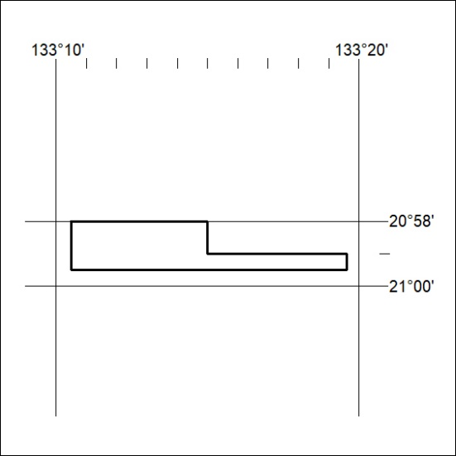

480/21

Mineral Titles Act
NOTICE OF GRANT OF A MINERAL TITLE
Title Type and Number: | Exploration Licence 32758
Granted: | 16 December 2021, for a period of 6 Years
Area: | 97 Blocks, 292.52 km²
Locality: | LAUGHLEN
Name of Holder/s: | 100% GEMPART (NT) PTY LTD* [ACN. 081 859 896]
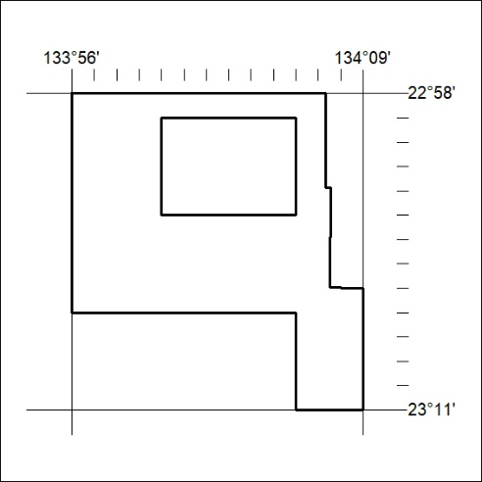
Area granted is indicated above. The titleholder is not permitted to exercise occupational rights on any land that is subject to a development title, or an application for a development title. Any land the subject of a Reserved Land gazettal under the Mineral Titles Act and all land vested in the Commonwealth of Australia is also excluded by description but not excised from the grant area.

481/21

Mineral Titles Act
NOTICE OF GRANT OF A MINERAL TITLE
Title Type and Number: | Exploration Licence 32760
Granted: | 21 December 2021, for a period of 6 Years
Area: | 30 Blocks, 92.95 km²
Locality: | BARKLY
Name of Holder/s: | 100% STRATEGIC ENERGY RESOURCES LIMITED* [ACN. 051 212 429]
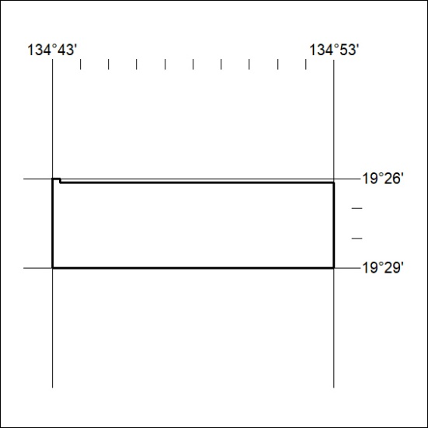
Area granted is indicated above. The titleholder is not permitted to exercise occupational rights on any land that is subject to a development title, or an application for a development title. Any land the subject of a Reserved Land gazettal under the Mineral Titles Act and all land vested in the Commonwealth of Australia is also excluded by description but not excised from the grant area.

482/21

