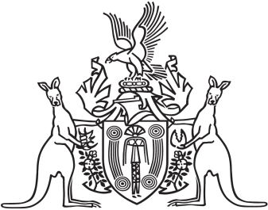
Northern Territory of Australia

Government Gazette
ISSN-0157-833X
No. S98 6 December 2018

Assent to Proposed Law
Her Honour the Administrator declared assent to the following proposed law:
4 December 2018
Water Legislation Amendment Act 2018 (Act No. 29 of 2018)
Michael Tatham
Clerk of the Legislative Assembly
5 December 2018

