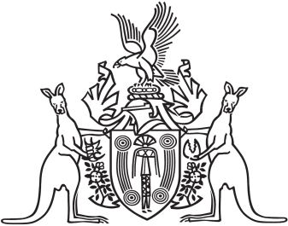
Northern Territory of Australia

Government Gazette
ISSN-0157-833X
No. S82 8 October 2018
Northern Territory of Australia

Pastoral Land Act
Pastoral Land Board
Appointment of Members
I, Eva Dina Lawler, Minister for Environment and Natural Resources, under section 12(1) of the Pastoral Land Act, appoint:
(a) David John James to be a member of the Pastoral Land Board from the date of this instrument to 27 March 2019; and
(b) Leigh Philip Hunt to be a member of the Pastoral Land Board from the date of this instrument to 27 September 2021.
Dated 4 October 2018
E. D. Lawler
Minister for Environment and Natural Resources

