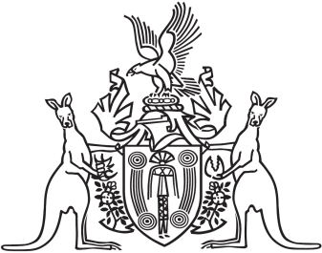
Northern Territory of Australia

Government Gazette
ISSN-0157-833X
No. S78 28 September 2018
Northern Territory of Australia

Guardianship of Adults Act
Appointment of Acting Public Guardian
I, Vicki Susan O'Halloran, Administrator of the Northern Territory of Australia, acting with the advice of the Executive Council, under section 68(1) of the Guardianship of Adults Act and with reference to section 44(2)(b) of the Interpretation Act:
(a) appoint Jennifer Guinane to act as the Public Guardian during all periods when the Public Guardian is unable to perform the duties of the office; and
(b) appoint Lisa Anne Patamisi to act as the Public Guardian during all periods when the Public Guardian is unable to perform the duties of the office if Jennifer Guinane is unable, for any reason, to act as the Public Guardian.
Dated 28 September 2018
V. S. O'Halloran
Administrator
By Her Honour's Command
N. K. Fyles
Minister for Health

