Front cover page.
Heading of Remote Towns Jobs Profile 2017
Jobs profile remote town name Wurrumiyanga
Remote Towns Jobs Profile 2017

Wurrumiyanga (Nguiu)

**© Northern Territory of Australia 2018**

**Preferred Reference:** Department of Trade, Business and Innovation, 2017 Remote Towns Jobs Profiles, Northern Territory Government, June 2018, Darwin.

**Disclaimer**

The data in this publication were predominantly collected by conducting a face-to-face survey of businesses within town boundaries during mid-2017. The collection methodology was created in accordance with Australian Bureau of Statistics data quality framework principles. Data in this publication are only reflective of those businesses reported on as operating in the town at the time of data collection (see table at the end of publication for list of businesses reported on).

To comply with privacy legislation or where appropriate, some data in this publication may have been adjusted and will not reflect the actual data reported by businesses. As a result of this, combined with certain data not being reported by some businesses, some components may not add to totals. Changes over time may also reflect business' change in propensity to report on certain data items rather than actual changes over time. Total figures have generally not been adjusted.

Caution is advised when interpreting the comparisons made to the earlier 2011 and 2014 publications as the businesses identified and reported on and the corresponding jobs may differ between publications.

Notes for each table and chart are alphabetically ordered and listed at the end of the publication.

Any use of this report for commercial purposes is not endorsed by the Department of Trade, Business and Innovation.

Contents

Wurrumiyanga (Nguiu) 4

Introduction 5

Summary 6

Jobs Overview 7

Jobs by Aboriginal Status 8

Jobs by Sector: Private and Public 10

Job Status: Permanent or Temporary 16

Job Vacancies 19

Jobs by Industry 21

Jobs by Occupation 27

Jobs by Industry by Occupation 30

Jobs by Gender 33

Jobs by Age 38

Vocational Education and Training 43

Population 47

Community Development Programme 49

Businesses 50

Notes 51

Abbreviations and Acronyms 52

.

# Wurrumiyanga (Nguiu)

Wurrumiyanga (Nguiu) is located on the southern coast of Bathurst Island, about 80 kilometres north of Darwin, with a population of 1787 residents.

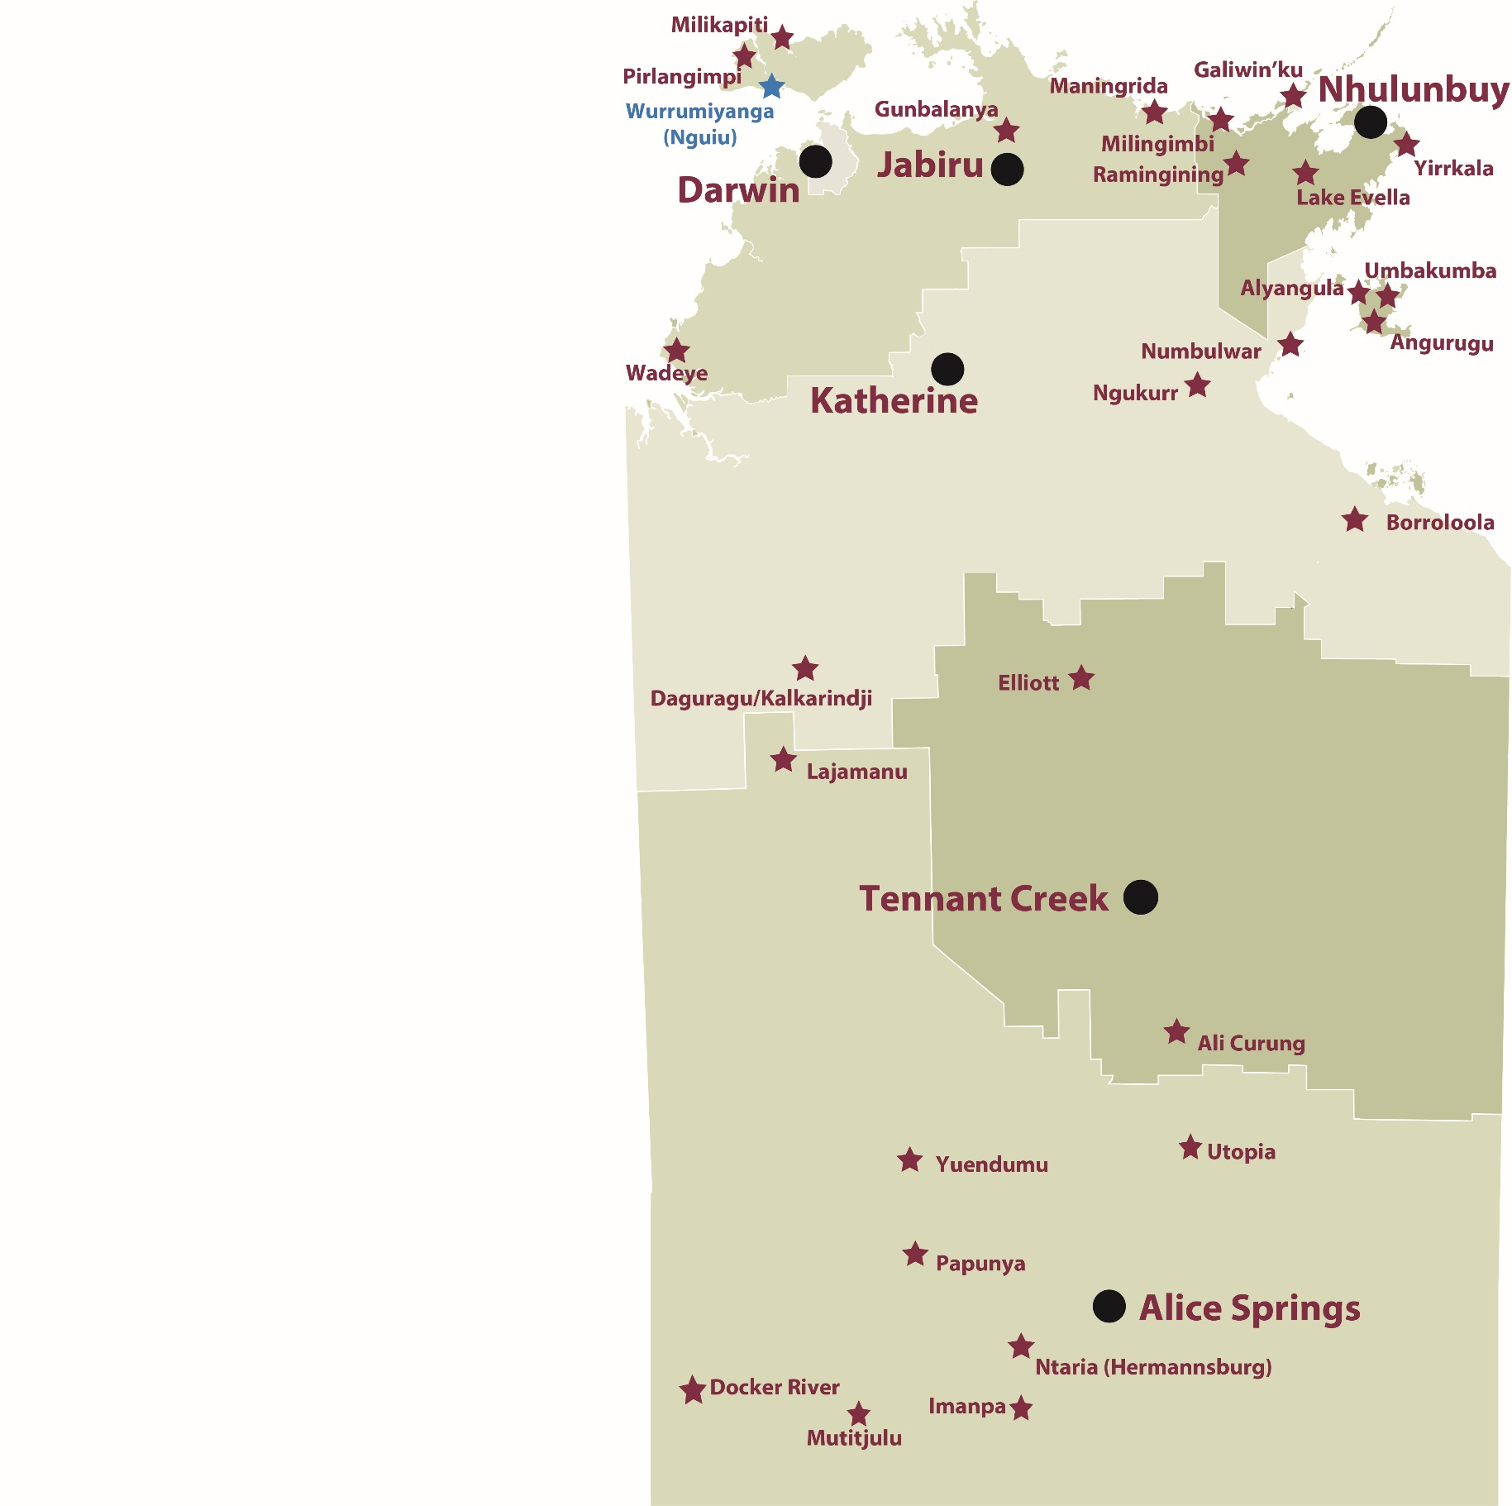

*Source: Department of Trade, Business and Innovation*

# Introduction

This jobs profile provides a snapshot of jobs and the characteristics of job holders in Wurrumiyanga (Nguiu) as at July 2017. It also outlines trends from the 2014 and 2011 surveys.

This job profile is one of 28 profiles developed for remote towns in the Northern Territory. It is anticipated these and subsequent profiles will contribute to a robust evidence base to inform decision making in and relating to these remote Territory towns.

This profile contains information collected by the Northern Territory Department of Trade, Business and Innovation from businesses operating within the town and is supplemented by other administrative data sets and information.

Each profile provides up-to-date information that is intended to inform the planning and design of current and future government programs and as an evidence base to inform decision making relating to workforce development, enterprise and job opportunities.

The data collection methodology and corresponding questionnaire were created in partnership with the Australian Bureau of Statistics (ABS) and in accordance with ABS data quality framework and survey principles.

The surveys were predominantly conducted by the Department’s Small Business Champions and Workforce Training Coordinators, on a face-to-face basis with business representatives.

The information collected and reported on represents a significant goodwill investment by those businesses and organisations that participated. Each business is listed at the end of this publication.

# Summary

The 2017 jobs profile was developed based on responses from 22 businesses operating within the Wurrumiyanga (Nguiu) town boundary, 3 less than in the 2014 survey. Of these, there were:

* 17 businesses from the private sector, accounting for 332 filled jobs or 72% of total filled jobs
* 5 businesses from the public sector, accounting for 129 filled jobs or 28% of total filled jobs
* 18 businesses participated in all three surveys (completed in 2011, 2014 and 2017).

A total of 495 filled and vacant jobs in Wurrumiyanga (Nguiu) were reported, an increase of 88 jobs from 2014.[1]

The 2017 profile highlights:

* there were 461 filled jobs of which:
* 315 jobs (68%) were filled by Aboriginal persons, an increase of 45 jobs from 2014
* 146 jobs (32%) were filled by non-Aboriginal persons, an increase of 26 jobs from 2014
* 73% of employed Aboriginal people are working in the private sector
* Aboriginal persons accounted for 68% of job holders in the town compared to 69% in 2014
* Aboriginal females made up 53% of total Aboriginal filled jobs in the town, unchanged from 2014
* there were 34 vacant jobs, of which:
* job vacancies as a percentage of jobs increased to 7% in 2017 from 4% in 2014
* job vacancies equate to 1 in 14.5 jobs
* 23 of the vacancies were in Community and Personal Service Works, Professional and Labourer areas
* Education and Training was the largest industry employer in 2017
* Arts and Recreation had the highest increase in filled jobs of 34 between 2017 and 2014
* Accommodation and Food Services had the highest decease in filled jobs of 9 between 2017 and 2014, followed by Health Care and Social Assistance with an increase of 29
* training had an increase in student numbers between 2016 and 2013
* Community Services, Health and Education had the highest student numbers in 2016 as well as the highest increase in student numbers between 2016 and 2013
* in 2016 Food Processing was conducted for 14 students, a training area not delivered in 2010 and 2013.

The overall population in Wurrumiyanga (Nguiu) increased by 340 persons (23.5%) between 2006 and 2016 to 1787 persons.

In comparison, the overall Northern Territory population increased by 16.5% between 2006 and 2016.

In 2016, the working age population (15 years and over) in Wurrumiyanga (Nguiu) was an estimated 1,330 persons compared to 1,027 in 2006 an increase of 30%.

There were 0.4 jobs in Wurrumiyanga (Nguiu) per working age person compared to 0.4 jobs per working age person across the Northern Territory.

# Jobs Overview

Table 1: Count of filled jobs and vacancies, 2011, 2014 and 2017 (a)(b)

|  |  |  |  |  |  |
| --- | --- | --- | --- | --- | --- |
|  | **2011** | **2014** | **2017** | **Change 2011-2014** | **Change 2014-2017** |
| **Total All Jobs** | **338** | **407** | **495** | **69** | **88** |
| **Vacancies** | **10** | **17** | **34** | **7** | **17** |
| Vacancies as % of Total All Jobs | 3.0% | 4.2% | 6.9% | 1.2 ppt | 2.7 ppt |
| **Filled Jobs** | **328** | **390** | **461** | **62** | **71** |
| Full-time | 260 | 246 | 249 | -14 | 3 |
| Part-time | 68 | 144 | 212 | 76 | 68 |

Source: Department of Trade, Business and Innovation

Chart 1: Count of vacant jobs and filled jobs by full-time/part-time status, 2011, 2014 and 2017 (a)(b)

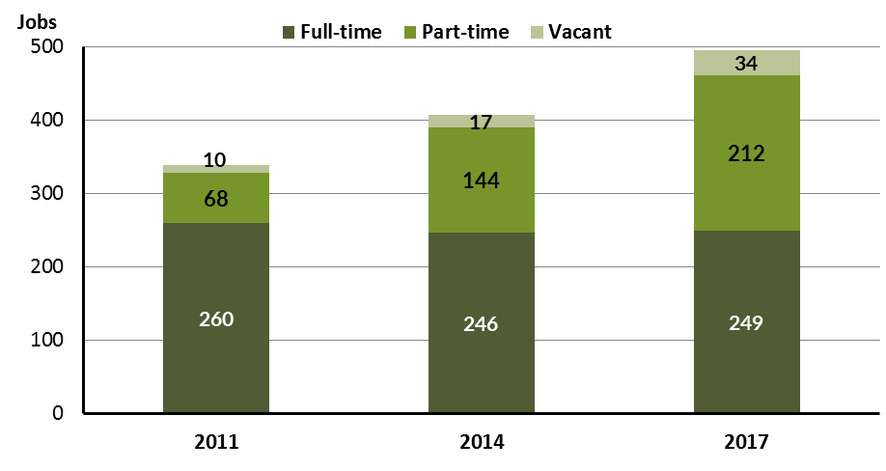

Source: Department of Trade, Business and Innovation

In 2017 in Wurrumiyanga (Nguiu):

* there were a total of 461 **filled jobs**, an increase of 71 jobs from 2014 and an increase of 133 jobs from 2011
* of the 461 **filled jobs** in 2017:
* 249 were full-time jobs, an increase of 3 jobs from 2014 and a decrease of 11 jobs from 2011
* 212 were part-time jobs, an increase of 68 jobs from 2014 and an increase of 144 jobs from 2011
* there were 34 total **job vacancies** in 2017, an increase of 17 vacancies from 2014 and an increase of 24 vacancies from 2011.

# Jobs by Aboriginal Status

Chart 2: Count of filled jobs by Aboriginal status, 2011, 2014 and 2017 (a)(c)

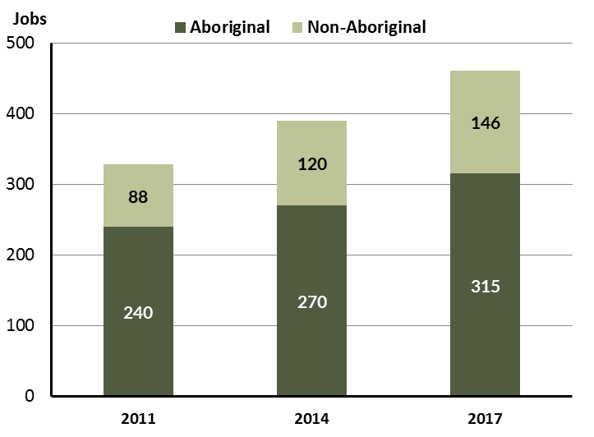

Source: Department of Trade, Business and Innovation

In 2017 in Wurrumiyanga (Nguiu):

* of the 461 **filled jobs**:
* 315 jobs were filled by **Aboriginal** persons, an increase of 45 jobs from 2014 and an increase of 75 jobs from 2011
* 146 jobs were filled by **non-Aboriginal** persons, an increase of 26 jobs from 2014 and an increase of 58 jobs from 2011
* **Aboriginal** persons accounted for 68% of job holders compared to 69% in 2014 and 73% in 2011.

Table 2: Count of filled jobs by full-time/part-time status and Aboriginal status of person in job, 2011, 2014 and 2017 (a)(b)(c)

|  |  |  |  |  |  |  |  |  |  |  |  |  |  |  |  |
| --- | --- | --- | --- | --- | --- | --- | --- | --- | --- | --- | --- | --- | --- | --- | --- |
| **Indicator** | **2011** | | | **2014** | | | **2017** | | | **Change 2011-2014** | | | **Change 2014-2017** | | |
| **Aboriginal** | **Non-Aboriginal** | **Total** | **Aboriginal** | **Non-Aboriginal** | **Total** | **Aboriginal** | **Non-Aboriginal** | **Total** | **Aboriginal** | **Non-Aboriginal** | **Total** | **Aboriginal** | **Non-Aboriginal** | **Total** |
| Full-time | 182 | 78 | **260** | 136 | 110 | **246** | 115 | 134 | **249** | -46 | 32 | **-14** | -21 | 24 | **3** |
| Part-time | 58 | 10 | **68** | 134 | 10 | **144** | 200 | 12 | **212** | 76 | 0 | **76** | 66 | 2 | **68** |
| **Total** | **240** | **88** | **328** | **270** | **120** | **390** | **315** | **146** | **461** | **30** | **32** | **62** | **45** | **26** | **71** |

Source: Department of Trade, Business and Innovation

Chart 3: Count of filled jobs by full-time/part-time status and Aboriginal status of person in job, 2011, 2014 and 2017 (a)(b)(c)

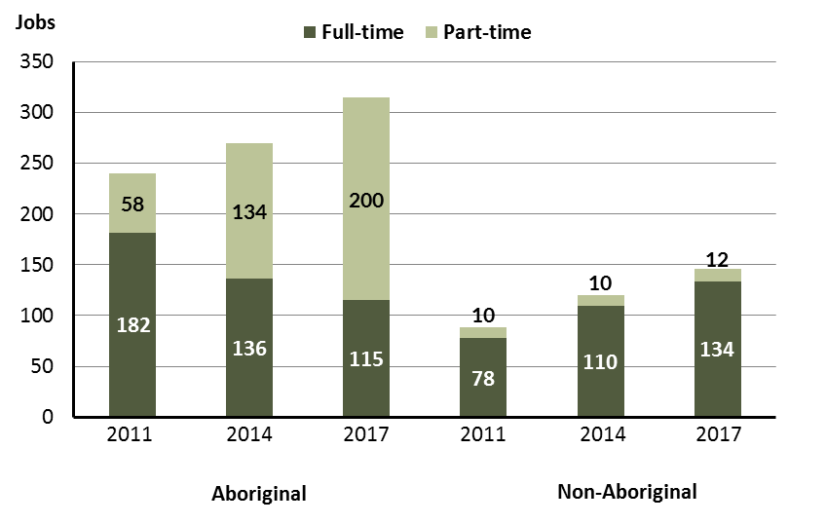

Source: Department of Trade, Business and Innovation

In 2017 in Wurrumiyanga (Nguiu):

* of the 461 filled jobs:
* 115 were **full-time** jobs filled by **Aboriginal** persons, a decrease of 21 jobs from 2014 and a decrease of 67 jobs from 2011
* 200 were **part-time** jobs filled by **Aboriginal** persons, an increase of 66 jobs from 2014 and an increase of 142 jobs from 2011
* 134 were **full-time** jobs filled by **non-Aboriginal** persons, an increase of 24 jobs from 2014 and an increase of 56 jobs from 2011
* 12 were **part-time** jobs filled by **non-Aboriginal** persons, an increase of 2 jobs from 2014 and an increase of 2 jobs from 2011.

# Jobs by Sector: Private and Public

Table 3: Count of filled jobs by sector of business and by Aboriginal status of person employed in job, 2011, 2014 and 2017 (a)(b)(c)

|  |  |  |  |  |  |  |  |  |  |  |  |  |  |  |  |  |
| --- | --- | --- | --- | --- | --- | --- | --- | --- | --- | --- | --- | --- | --- | --- | --- | --- |
| **Indicator** | **2011** | | | **2014** | | | **2017** | | | **Change 2011-2014** | | | **Change 2014-2017** | | | |
| **Aboriginal** | **Non-Aboriginal** | **Total** | **Aboriginal** | **Non-Aboriginal** | **Total** | **Aboriginal** | **Non-Aboriginal** | **Total** | **Aboriginal** | **Non-Aboriginal** | **Total** | **Aboriginal** | **Non-Aboriginal** | **Total** |
| **Public Sector** | 79 | 20 | **99** | 83 | 36 | **119** | 86 | 43 | **129** | 4 | 16 | **20** | 3 | 7 | **10** |
| Australian Government | 5 | 2 | **7** | 5 | 1 | **6** | 5 | 1 | **6** | 0 | -1 | **-1** | 0 | 0 | **0** |
| Territory Government | 9 | 5 | **14** | 18 | 14 | **32** | 21 | 21 | **42** | 9 | 9 | **18** | 3 | 7 | **10** |
| Local Government | 65 | 13 | **78** | 60 | 21 | **81** | 60 | 21 | **81** | -5 | 8 | **3** | 0 | 0 | **0** |
| **Private Sector** | 161 | 68 | **229** | 187 | 84 | **271** | 229 | 103 | **332** | 26 | 16 | **42** | 42 | 19 | **61** |
| **Total** | **240** | **88** | **328** | **270** | **120** | **390** | **315** | **146** | **461** | **30** | **32** | **62** | **45** | **26** | **71** |

Source: Department of Trade, Business and Innovation

**Chart 4: Count of filled jobs by sector of business, 2011, 2014 and 2017 (a)(d)**

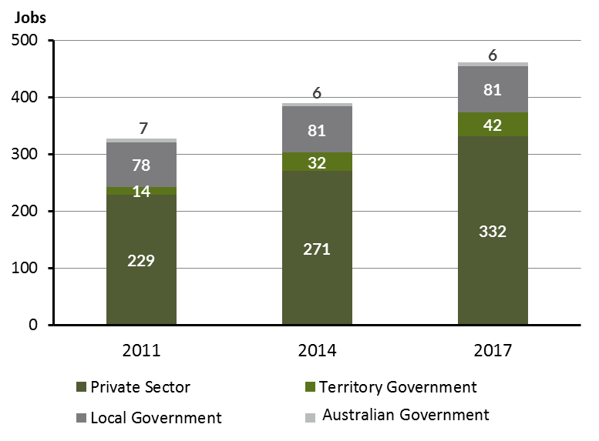

Source: Department of Trade, Business and Innovation

Chart 5: Percentage of filled jobs by sector of business in 2017 (a)(d)

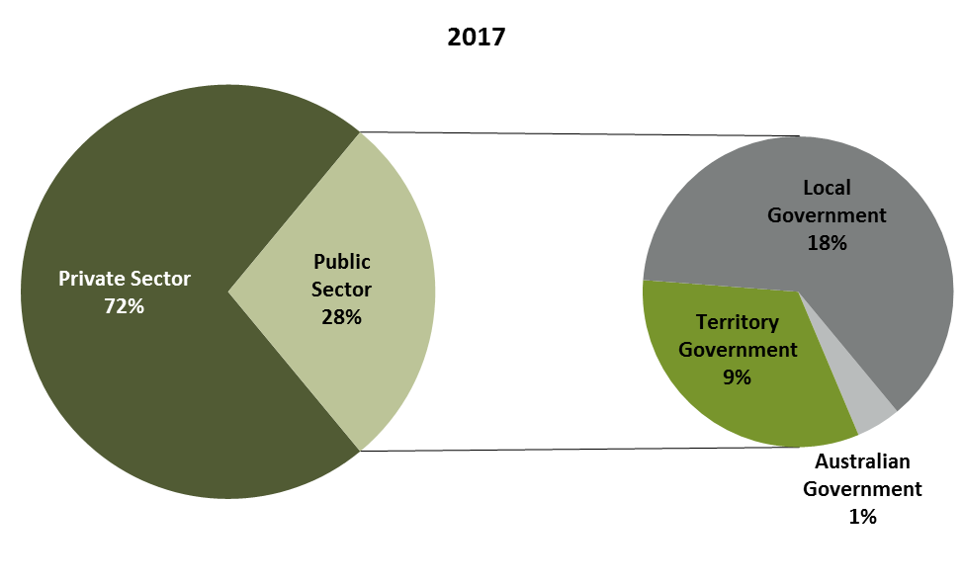

Source: Department of Trade, Business and Innovation

In 2017 in Wurrumiyanga (Nguiu):

* there were 129 jobs in the **public sector**, an increase of 10 jobs from 2014 and an increase of 30 jobs from 2011
* of the 129 jobs in the **public sector**:
* 6 jobs were in the Australian Government, unchanged from 2014 and a decrease of 1 job from 2011
* 42 jobs were in the Territory Government, an increase of 10 jobs from 2014 and a increase of 28 jobs from 2011
* 81 jobs were in the Local Government, unchanged from 2014 and an increase of 3 jobs from 2011
* there were 332 jobs in the **private sector**, an increase of 61 jobs from 2014 and an increase of 103 jobs from 2011.

Chart 6: Count of filled jobs by sector and Aboriginal status of person in job, 2011, 2014 and 2017 (a)(c)(d)

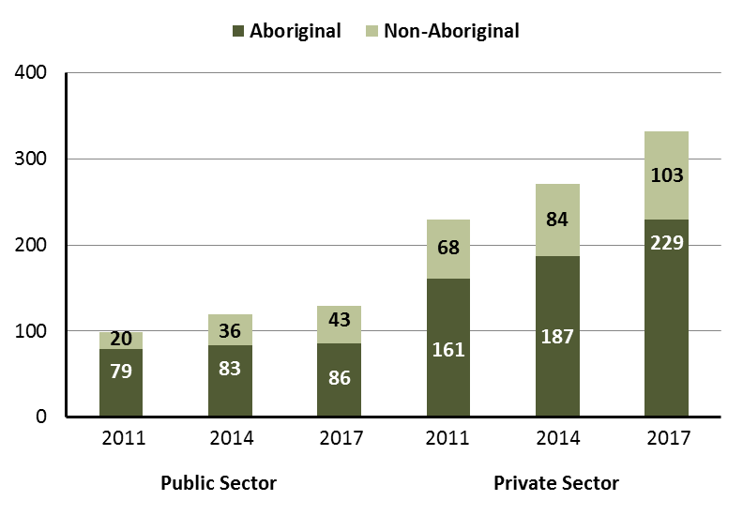

Source: Department of Trade, Business and Innovation

In 2017 in Wurrumiyanga (Nguiu):

* of the 129 jobs in the **public sector**:
* 86 jobs were filled by **Aboriginal** persons, an increase of 3 jobs from 2014 and an increase of 7 jobs from 2011
* 43 jobs were filled by **non-Aboriginal** persons, an increase of 7 jobs from 2014 and an increase of 23 jobs from 2011
* of the 332 jobs in the **private sector**:
* 229 jobs were filled by **Aboriginal** persons, an increase of 42 jobs from 2014 and an increase of 68 jobs from 2011
* 103 jobs were filled by **non-Aboriginal** persons, an increase of 19 jobs from 2014 and an increase of 35 jobs from 2011.

Chart 7: Count of filled jobs by sector and full-time/part-time status of person in job, 2011, 2014 and 2017 (a)(b)(d)

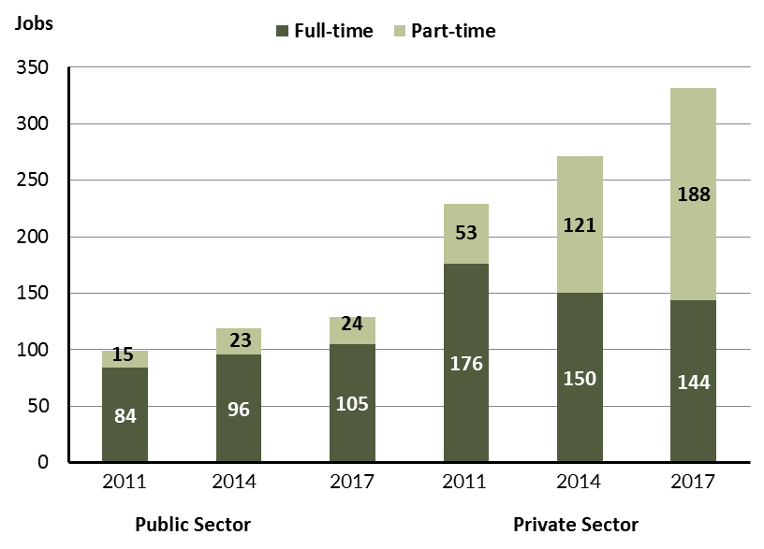

Source: Department of Trade, Business and Innovation

In 2017 in Wurrumiyanga (Nguiu):

* of the 129 jobs in the **public** **sector**:
* 105 were **full-time** jobs, an increase of 9 jobs from 2014 and an increase of 21 jobs from 2011
* 24 were **part-time** jobs, an increase of 1 job from 2014 and an increase of 9 jobs from 2011
* of the 332 jobs in the **private** **sector**:
* 144 were **full-time** jobs, a decrease of 6 jobs from 2014 and a decrease of 32 jobs from 2011
* 188 were **part-time** jobs, an increase of 67 jobs from 2014 and an increase of 135 jobs from 2011.

Table 4: Count of filled jobs by full-time/part-time status and Aboriginal status of person in job by sector, 2011, 2014, and 2017 (a)(b)(c)(d)

|  |  |  |  |  |  |  |  |  |  |
| --- | --- | --- | --- | --- | --- | --- | --- | --- | --- |
| **Indicator** | **2011** | | | | | | | | |
| **Aboriginal** | | | **Non-Aboriginal** | | | **Total** | | |
| **Full-time** | **Part-time** | **Total** | **Full-time** | **Part-time** | **Total** | **Full-time** | **Part-time** | **Total** |
| Public Sector | 64 | 15 | **79** | 20 | 0 | **20** | 84 | 15 | **99** |
| Private Sector | 118 | 43 | **161** | 58 | 10 | **68** | 176 | 53 | **229** |
| **Total** | **182** | **58** | **240** | **78** | **10** | **88** | **260** | **68** | **328** |

|  |  |  |  |  |  |  |  |  |  |
| --- | --- | --- | --- | --- | --- | --- | --- | --- | --- |
| **Indicator** | **2014** | | | | | | | | |
| **Aboriginal** | | | **Non-Aboriginal** | | | **Total** | | |
| **Full-time** | **Part-time** | **Total** | **Full-time** | **Part-time** | **Total** | **Full-time** | **Part-time** | **Total** |
| Public Sector | 60 | 23 | **83** | 36 | 0 | **36** | 96 | 23 | **119** |
| Private Sector | 76 | 111 | **187** | 74 | 10 | **84** | 150 | 121 | **271** |
| **Total** | **136** | **134** | **270** | **110** | **10** | **120** | **246** | **144** | **390** |

|  |  |  |  |  |  |  |  |  |  |
| --- | --- | --- | --- | --- | --- | --- | --- | --- | --- |
| **Indicator** | **2017** | | | | | | | | |
| **Aboriginal** | | | **Non-Aboriginal** | | | **Total** | | |
| **Full-time** | **Part-time** | **Total** | **Full-time** | **Part-time** | **Total** | **Full-time** | **Part-time** | **Total** |
| Public Sector | 63 | 23 | **86** | 42 | 1 | **43** | 105 | 24 | **129** |
| Private Sector | 52 | 177 | **229** | 92 | 11 | **103** | 144 | 188 | **332** |
| **Total** | **136** | **134** | **315** | **134** | **12** | **146** | **249** | **212** | **461** |

Source: Department of Trade, Business and Innovation

In 2017 in Wurrumiyanga (Nguiu) there were:

* 86 jobs in the **public** **sector** filled by **Aboriginal** persons, an increase of 3 jobs from 2014 and an increase of 7 jobs from 2011, of which:
* 63 were **full-time** jobs, an increase of 3 jobs from 2014 and a decrease of 1 job from 2011
* 23 were **part-time** jobs, unchanged from 2014 and an increase of 8 jobs from 2011
* 229 jobs in the **private** **sector** filled by **Aboriginal** persons, an increase of 42 jobs from 2014 and an increase of 68 jobs from 2011, of which:
* 52 were **full-time** jobs, a decrease of 24 jobs from 2014 and a decrease of 66 jobs from 2011
* 177 were **part-time** jobs, an increase of 66 jobs from 2014 and an increase of 134 jobs from 2011
* 43 jobs in the **public** **sector** filled by **non-Aboriginal** persons, an increase of 7 jobs from 2014 and an increase of 23 jobs from 2011, of which:
* 42 were **full-time** jobs, an increase of 6 jobs from 2014 and an increase of 22 jobs from 2011
* 1 was a **part-time** job, an increase of 1 job from 2014 and an increase of 1 job from 2011
* 103 jobs in the **private** **sector** filled by **non-Aboriginal** persons, an increase of 19 jobs from 2014 and an increase of 35 jobs from 2011, of which:
* 92 were **full-time** jobs, an increase of 18 jobs from 2014 and an increase of 34 jobs from 2011
* 11 were **part-time** jobs, an increase of 1 job from 2014 and an increase of 1 job from 2011.

# Job Status: Permanent or Temporary

Table 5: Count of filled jobs by employment status and Aboriginal status of person in job, 2011, 2014, and 2017 (a)(c)(e)

|  |  |  |  |  |  |  |  |  |  |  |  |  |  |  |  |
| --- | --- | --- | --- | --- | --- | --- | --- | --- | --- | --- | --- | --- | --- | --- | --- |
| **Indicator** | **2011** | | | **2014** | | | **2017** | | | **Change 2011-2014** | | | **Change 2014-2017** | | |
| **Aboriginal** | **Non-Aboriginal** | **Total** | **Aboriginal** | **Non-Aboriginal** | **Total** | **Aboriginal** | **Non-Aboriginal** | **Total** | **Aboriginal** | **Non-Aboriginal** | **Total** | **Aboriginal** | **Non-Aboriginal** | **Total** |
| Permanent | 119 | 50 | **169** | 144 | 74 | **218** | 132 | 55 | **187** | 25 | 24 | **49** | -12 | -19 | **-31** |
| Temporary | 121 | 38 | **159** | 126 | 46 | **172** | 183 | 91 | **274** | 5 | 8 | **13** | 57 | 45 | **102** |
| **Total** | **240** | **88** | **328** | **270** | **120** | **390** | **315** | **146** | **461** | **30** | **32** | **62** | **45** | **26** | **71** |

Source: Department of Trade, Business and Innovation

Chart 8: Count of filled jobs by employment status and Aboriginal status of person in job, 2011, 2014 and 2017 (a)(c)(e)

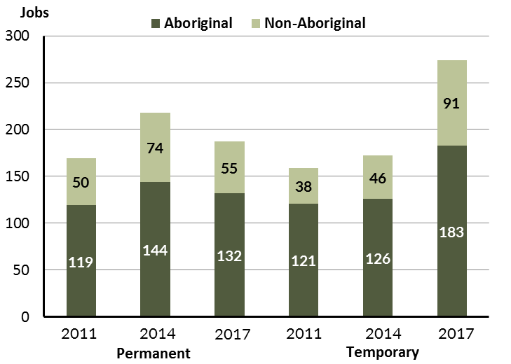

Source: Department of Trade, Business and Innovation

In 2017 in Wurrumiyanga (Nguiu):

* there were 187 **permanent** jobs, a decrease of 31 jobs from 2014, and an increase of 18 jobs from 2011, of which:
* 132 jobs were filled by **Aboriginal** persons, a decrease of 12 jobs from 2014 and an increase of 13 jobs from 2011
* 55 jobs were filled by **non-Aboriginal** persons, a decrease of 19 jobs from 2014 and an increase of 5 jobs from 2011
* there were 274 **temporary** jobs, an increase of 102 jobs from 2014 and an increase of 115 jobs from 2011, of which:
* 183 jobs were filled by **Aboriginal** persons, an increase of 57 jobs from 2014 and an increase of 62 jobs from 2011
* 91 jobs were filled by **non-Aboriginal** persons, an increase of 45 jobs from 2014 and an increase of 53 jobs from 2011.

Table 6: Count of filled jobs by sector, Aboriginal status and employment status of person in job, 2011, 2014 and 2017 (a)(c)(d)(e)

|  |  |  |  |  |  |  |  |  |  |
| --- | --- | --- | --- | --- | --- | --- | --- | --- | --- |
| **Indicator** | **2011** | | | | | | | | |
| **Aboriginal** | | | **Non-Aboriginal** | | | **Total** | | |
| **Perm** | **Temp** | **Total** | **Perm** | **Temp** | **Total** | **Perm** | **Temp** | **Total** |
| Public Sector | 59 | 20 | **79** | 10 | 10 | **20** | 69 | 30 | **99** |
| Private Sector | 60 | 101 | **161** | 40 | 28 | **68** | 100 | 129 | **229** |
| **Total** | **119** | **121** | **240** | **50** | **38** | **88** | **169** | **159** | **328** |

|  |  |  |  |  |  |  |  |  |  |
| --- | --- | --- | --- | --- | --- | --- | --- | --- | --- |
| **Indicator** | **2014** | | | | | | | | |
| **Aboriginal** | | | **Non-Aboriginal** | | | **Total** | | |
| **Perm** | **Temp** | **Total** | **Perm** | **Temp** | **Total** | **Perm** | **Temp** | **Total** |
| Public Sector | 80 | 3 | **83** | 33 | 3 | **36** | 113 | 6 | **119** |
| Private Sector | 64 | 123 | **187** | 41 | 43 | **84** | 105 | 166 | **271** |
| **Total** | **144** | **126** | **270** | **74** | **46** | **120** | **218** | **172** | **390** |

|  |  |  |  |  |  |  |  |  |  |
| --- | --- | --- | --- | --- | --- | --- | --- | --- | --- |
| **Indicator** | **2017** | | | | | | | | |
| **Aboriginal** | | | **Non-Aboriginal** | | | **Total** | | |
| **Perm** | **Temp** | **Total** | **Perm** | **Temp** | **Total** | **Perm** | **Temp** | **Total** |
| Public Sector | 67 | 19 | **86** | 25 | 18 | **43** | 92 | 37 | **129** |
| Private Sector | 65 | 164 | **229** | 30 | 73 | **103** | 95 | 237 | **332** |
| **Total** | **132** | **183** | **315** | **55** | **91** | **146** | **187** | **274** | **461** |

Source: Department of Trade, Business and Innovation

In 2017 in Wurrumiyanga (Nguiu):

* 129 jobs in the **public** se**c**tor, an increase of 10 jobs from 2014 and an increase of 30 jobs from 2011, of which:
* 92 jobs were **permanent**, a decrease of 21 jobs from 2014 and an increase of 23 jobs from 2011, of which:
* 67 jobs were filled by **Aboriginal** persons, a decrease of 13 jobs from 2014 and an increase of 8 jobs from 2011
* 25 jobs were filled by **non-Aboriginal** persons, a decrease of 8 jobs from 2014 and an increase of 15 jobs from 2011
* 37 jobs were **temporary**, an increase of 31 jobs from 2014 and an increase of 7 jobs from 2011, of which:
* 19 jobs were filled by **Aboriginal** persons, an increase of 16 jobs from 2014 and a decrease of 1 job from 2011
* 18 jobs were filled by **non-Aboriginal** persons, an increase of 15 jobs from 2014 and an increase of 8 jobs from 2011
* 332 jobs in the **private** **sector**, an increase of 61 jobs from 2014 and an increase of 103 jobs from 2011, of which:
* 95 jobs were **permanent**, a decrease of 10 jobs from 2014 and a decrease of 5 jobs from 2011, of which:
* 65 jobs were filled by **Aboriginal** persons, an increase of 1 job from 2014 and an increase of 5 jobs from 2011
* 30 jobs were filled by **non-Aboriginal** persons, a decrease of 11 jobs from 2014 and a decrease of 10 jobs from 2011
* 237 jobs were **temporary**, an increase of 71 jobs from 2014 and an increase of 108 jobs from 2011, of which:
* 164 jobs were filled by **Aboriginal** persons, an increase of 41 jobs from 2014 and an increase of 63 jobs from 2011
* 73 jobs were filled by **non-Aboriginal** persons, an increase of 30 jobs from 2014 and an increase of 45 jobs from 2011.

# Job Vacancies

Table 7: Job vacancies, 2011, 2014, and 2017

|  |  |  |  |  |  |
| --- | --- | --- | --- | --- | --- |
| **Indicator** | **2011** | **2014** | **2017** | **Change 2011-2014** | **Change 2014-2017** |
| **Job vacancies** | **10** | **17** | **34** | **7** | **17** |

Source: Department of Trade, Business and Innovation

Table 8: Job vacancies by occupation, 2011, 2014, and 2017 (f)(g)

|  |  |  |  |  |  |
| --- | --- | --- | --- | --- | --- |
| **Occupation (ANZSCO major group)** | **2011** | **2014** | **2017** | **Change 2011-2014** | **Change 2014-2017** |
| Clerical and Administrative Workers | 0 | 1 | 4 | 1 | 3 |
| Community and Personal Service Workers | 3 | 8 | 11 | 5 | 3 |
| Labourers | 0 | 2 | 6 | 2 | 4 |
| Managers | 0 | 1 | 0 | 1 | -1 |
| Professionals | 6 | 2 | 6 | -4 | 4 |
| Sales Workers | 1 | 0 | 3 | -1 | 3 |
| Technicians and Trades Workers | 0 | 3 | 4 | 3 | 1 |
| **Total** | **10** | **17** | **34** | **7** | **17** |

Source: Department of Trade, Business and Innovation

Table 9: Job vacancies by job title, July 2017 (f)

|  |  |
| --- | --- |
| **Job Vacancy** | **No.** |
| Aboriginal and Torres Strait Islander Health Worker | 3 |
| Aged or Disabled Carer | 2 |
| Builder's Labourer | 1 |
| Carpenter | 1 |
| Checkout Operator | 3 |
| Child Care Worker | 1 |
| Commercial Cleaner | 1 |
| Cook | 1 |
| Deck Hand | 1 |
| Diesel Motor Mechanic | 2 |
| Drug and Alcohol Counsellor | 2 |
| Family Support Worker | 3 |
| General Clerk | 4 |
| Handyperson | 1 |
| Labourers nec | 1 |
| Mechanic's Assistant | 1 |
| Out of School Hours Care Worker | 1 |
| Police Officer | 1 |
| Recreation Officer | 1 |
| Registered Nurses nec | 2 |
| University Lecturer | 1 |
| **Total** | **34** |

Source: Department of Trade, Business and Innovation

In 2017 in Wurrumiyanga (Nguiu):

* there were 34 **vacancies** reported, an increase of 17 vacancies from 2014 and an increase of 24 vacancies from 2011
* of the 34 reported vacancies, the largest requirements were for:
* 11 Community and Personal Service Workers, the majority of which are in the following jobs:
* Aboriginal and Torres Strait Islander Health Worker
* Family Support Worker
* 6 Labourers in the following jobs:
* Builder's Labourer
* Commercial Cleaner
* Deck Hand
* Handyperson
* Labourers nec
* Mechanic's Assistant
* 6 Professionals, the majority of which are in the following jobs:
* Drug and Alcohol Counsellor
* Registered Nurse nec.

# Jobs by Industry

Table 10: Count of filled jobs by industry of business, 2011, 2014 and 2017 (a)(h)

|  |  |  |  |  |  |  |  |  |
| --- | --- | --- | --- | --- | --- | --- | --- | --- |
| **Industry (ANZSIC Division)** | **2011** | | **2014** | | **2017** | | **Change 2011-2014** | **Change 2014-2017** |
| **Total** | **% of Total** | **Total** | **% of Total** | **Total** | **% of Total** | **Total** | **Total** |
| Accommodation and Food Services | 7 | 2.1% | 36 | 9.2% | 27 | 5.9% | 29 | -9 |
| Administrative and Support Services | 2 | 0.6% | 0 | 0.0% | 0 | 0.0% | -2 | 0 |
| Arts and Recreation Services | 18 | 5.5% | 15 | 3.8% | 49 | 10.6% | -3 | 34 |
| Construction | 27 | 8.2% | 15 | 3.8% | 22 | 4.8% | -12 | 7 |
| Education and Training | 69 | 21.0% | 126 | 32.3% | 132 | 28.6% | 57 | 6 |
| Financial and Insurance Services | 0 | 0.0% | 2 | 0.5% | 2 | 0.4% | 2 | 0 |
| Health Care and Social Assistance | 49 | 14.9% | 56 | 14.4% | 85 | 18.4% | 7 | 29 |
| Other Services | 1 | 0.3% | 2 | 0.5% | 1 | 0.2% | 1 | -1 |
| Public Administration and Safety | 103 | 31.4% | 91 | 23.3% | 94 | 20.4% | -12 | 3 |
| Rental, Hiring and Real Estate Services | 0 | 0.0% | 2 | 0.5% | 0 | 0.0% | 2 | -2 |
| Retail Trade | 52 | 15.9% | 44 | 11.3% | 48 | 10.4% | -8 | 4 |
| Transport, Postal and Warehousing | 0 | 0.0% | 1 | 0.3% | 1 | 0.2% | 1 | 0 |
| **Total** | **328** | **100.0%** | **390** | **100.0%** | **461** | **100.0%** | **62** | **71** |

Source: Department of Trade, Business and Innovation

In 2017 in Wurrumiyanga (Nguiu):

* the Education and Training industry was the **largest** **industry** **employer**, with 132 filled jobs or 28.6% of filled jobs, an increase of 6 jobs from 2014 and an increase of 63 jobs from 2011
* **other** **significant** industry employers were:
* Public Administration and Safety with 94 jobs (or 20.4% of filled jobs), an increase of 3 jobs from 2014 and a decrease of 9 jobs from 2011
* Health Care and Social Assistance with 85 jobs (or 18.4% of filled jobs), an increase of 29 jobs from 2014 and an increase of 36 jobs from 2011
* Arts and Recreation Services with 49 jobs (or 10.6% of filled jobs), an increase of 34 jobs from 2014 and an increase of 31 jobs from 2011.

Table 11: Count of filled jobs by industry of business and Aboriginal status of person in job, 2011, 2014, and 2017 (a)(c)(h)

|  |  |  |  |  |  |  |  |  |  |  |  |  |  |  |  |  |
| --- | --- | --- | --- | --- | --- | --- | --- | --- | --- | --- | --- | --- | --- | --- | --- | --- |
| **Industry (ANZSIC division)** | **2011** | | | **2014** | | | **2017** | | | **Change 2011-2014** | | | **Change  2014-2017** | | | |
| **Aboriginal** | **Non-Aboriginal** | **Total** | **Aboriginal** | **Non-Aboriginal** | **Total** | **Aboriginal** | **Non-Aboriginal** | **Total** | **Aboriginal** | **Non-Aboriginal** | **Total** | **Aboriginal** | **Non-Aboriginal** | **Total** |
| Accommodation and Food Services | 5 | 2 | **7** | 26 | 10 | **36** | 19 | 8 | **27** | 21 | 8 | **29** | -7 | -2 | **-9** |
| Administrative and Support Services | 2 | 0 | **2** | 0 | 0 | **0** | 0 | 0 | **0** | -2 | 0 | **-2** | 0 | 0 | **0** |
| Arts and Recreation Services | 12 | 6 | **18** | 12 | 3 | **15** | 47 | 2 | **49** | 0 | -3 | **-3** | 35 | -1 | **34** |
| Construction | 25 | 2 | **27** | 9 | 6 | **15** | 8 | 14 | **22** | -16 | 4 | **-12** | -1 | 8 | **7** |
| Education and Training | 38 | 31 | **69** | 89 | 37 | **126** | 83 | 49 | **132** | 51 | 6 | **57** | -6 | 12 | **6** |
| Financial and Insurance Services | 0 | 0 | **0** | 2 | 0 | **2** | 2 | 0 | **2** | 2 | 0 | **2** | 0 | 0 | **0** |
| Health Care and Social Assistance | 36 | 13 | **49** | 31 | 25 | **56** | 63 | 22 | **85** | -5 | 12 | **7** | 32 | -3 | **29** |
| Other Services | 0 | 1 | **1** | 0 | 2 | **2** | 0 | 1 | **1** | 0 | 1 | **1** | 0 | -1 | **-1** |
| Public Administration and Safety | 85 | 18 | **103** | 66 | 25 | **91** | 70 | 24 | **94** | -19 | 7 | **-12** | 4 | -1 | **3** |
| Rental, Hiring and Real Estate Services | 0 | 0 | **0** | 1 | 1 | **2** | 0 | 0 | **0** | 1 | 1 | **2** | -1 | -1 | **-2** |
| Retail Trade | 37 | 15 | **52** | 34 | 10 | **44** | 23 | 25 | **48** | -3 | -5 | **-8** | -11 | 15 | **4** |
| Transport, Postal and Warehousing | 0 | 0 | **0** | 0 | 1 | **1** | 0 | 1 | **1** | 0 | 1 | **1** | 0 | 0 | **0** |
| **Total** | **240** | **88** | **328** | **270** | **120** | **390** | **315** | **146** | **461** | **30** | **32** | **62** | **45** | **26** | **71** |

Source: Department of Trade, Business and Innovation

Chart 9: Count of filled jobs by top 5 industries of business and Aboriginal status of person in job, 2017 (a)(c)(h)

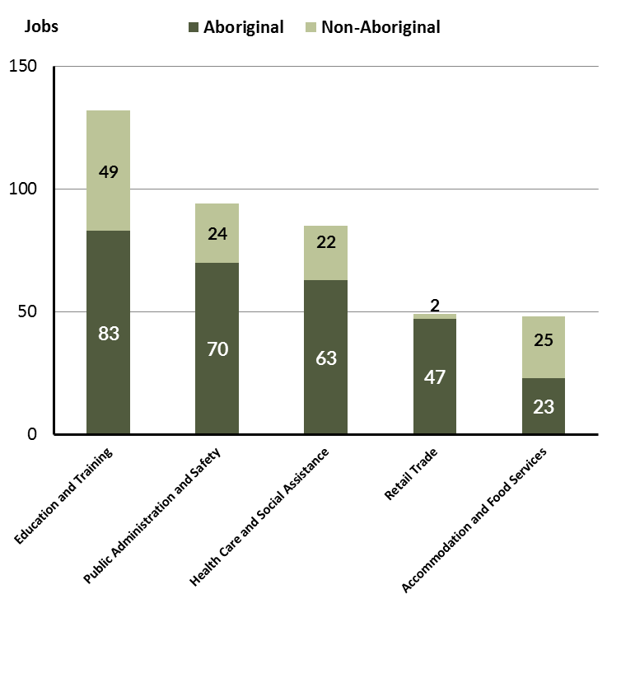

Source: Department of Trade, Business and Innovation

In 2017 in Wurrumiyanga (Nguiu):

* of the 315 jobs filled by **Aboriginal** persons, there were:
* 83 jobs in Education and Training, a decrease of 6 jobs from 2014 and an increase of 45 jobs from 2011
* 70 jobs in Public Administration and Safety, an increase of 4 jobs from 2014 and a decrease of 15 jobs from 2011
* 63 jobs in Health Care and Social Assistance, an increase of 32 jobs from 2014 and an increase of 27 jobs from 2011
* of the 146 jobs filled by **non-Aboriginal** persons, there were:
* 49 jobs in Education and Training, an increase of 12 jobs from 2014 and an increase of 18 jobs from 2011
* 24 jobs in Public Administration and Safety, a decrease of 1 job from 2014 and an increase of 6 jobs from 2011
* 22 jobs in Health Care and Social Assistance, a decrease of 3 jobs from 2014 and an increase of 9 jobs from 2011.

Table 12: Count of filled jobs by industry, employment status and Aboriginal status of person in job, 2011 (a)(c)(e)(h)

|  |  |  |  |  |  |  |  |  |  |
| --- | --- | --- | --- | --- | --- | --- | --- | --- | --- |
| **Industry (ANZSIC division)** | **2011** | | | | | | | | |
| **Aboriginal** | | | **Non-Aboriginal** | | | **Total** | | |
| **Perm** | **Temp** | **Total** | **Perm** | **Temp** | **Total** | **Perm** | **Temp** | **Total** |
| Accommodation and Food Services | 5 | 0 | **5** | 2 | 0 | **2** | 7 | 0 | **7** |
| Administrative and Support Services | 2 | 0 | **2** | 0 | 0 | **0** | 2 | 0 | **2** |
| Arts and Recreation Services | 0 | 12 | **12** | 2 | 4 | **6** | 2 | 16 | **18** |
| Construction | 6 | 19 | **25** | 1 | 1 | **2** | 7 | 20 | **27** |
| Education and Training | 26 | 12 | **38** | 22 | 9 | **31** | 48 | 21 | **69** |
| Health Care and Social Assistance | 5 | 31 | **36** | 2 | 11 | **13** | 7 | 42 | **49** |
| Other Services | 0 | 0 | **0** | 1 | 0 | **1** | 1 | 0 | **1** |
| Public Administration and Safety | 62 | 23 | **85** | 12 | 6 | **18** | 74 | 29 | **103** |
| Retail Trade | 13 | 24 | **37** | 8 | 7 | **15** | 21 | 31 | **52** |
| **Total** | **119** | **121** | **240** | **50** | **38** | **88** | **169** | **159** | **328** |

Source: Department of Trade, Business and Innovation

Table 13: Count of filled jobs by industry, employment status and Aboriginal status of person in job, 2014 (a)(c)(e)(h)

|  |  |  |  |  |  |  |  |  |  |
| --- | --- | --- | --- | --- | --- | --- | --- | --- | --- |
| **Industry (ANZSIC division)** | **2014** | | | | | | | | |
| **Aboriginal** | | | **Non-Aboriginal** | | | **Total** | | |
| **Perm** | **Temp** | **Total** | **Perm** | **Temp** | **Total** | **Perm** | **Temp** | **Total** |
| Accommodation and Food Services | 15 | 11 | **26** | 7 | 3 | **10** | 22 | 14 | **36** |
| Arts and Recreation Services | 0 | 12 | **12** | 1 | 2 | **3** | 1 | 14 | **15** |
| Construction | 9 | 0 | **9** | 6 | 0 | **6** | 15 | 0 | **15** |
| Education and Training | 19 | 70 | **89** | 20 | 17 | **37** | 39 | 87 | **126** |
| Financial and Insurance Services | 2 | 0 | **2** | 0 | 0 | **0** | 2 | 0 | **2** |
| Health Care and Social Assistance | 16 | 15 | **31** | 15 | 10 | **25** | 31 | 25 | **56** |
| Other Services | 0 | 0 | **0** | 0 | 2 | **2** | 0 | 2 | **2** |
| Public Administration and Safety | 65 | 1 | **66** | 22 | 3 | **25** | 87 | 4 | **91** |
| Rental, Hiring and Real Estate Services | 1 | 0 | **1** | 1 | 0 | **1** | 2 | 0 | **2** |
| Retail Trade | 17 | 17 | **34** | 2 | 8 | **10** | 19 | 25 | **44** |
| Transport, Postal and Warehousing | 0 | 0 | **0** | 0 | 1 | **1** | 0 | 1 | **1** |
| **Total** | **144** | **126** | **270** | **74** | **46** | **120** | **218** | **172** | **390** |

Source: Department of Trade, Business and Innovation

Table 14: Count of filled jobs by industry, employment status and Aboriginal status of person in job, 2017 (a)(c)(e)(h)

|  |  |  |  |  |  |  |  |  |  |
| --- | --- | --- | --- | --- | --- | --- | --- | --- | --- |
| **Industry (ANZSIC division)** | **2017** | | | | | | | | |
| **Aboriginal** | | | **Non-Aboriginal** | | | **Total** | | |
| **Perm** | **Temp** | **Total** | **Perm** | **Temp** | **Total** | **Perm** | **Temp** | **Total** |
| Accommodation and Food Services | 4 | 15 | **19** | 6 | 2 | **8** | 10 | 17 | **27** |
| Arts and Recreation Services | 15 | 32 | **47** | 0 | 2 | **2** | 15 | 34 | **49** |
| Construction | 0 | 8 | **8** | 1 | 13 | **14** | 1 | 21 | **22** |
| Education and Training | 0 | 83 | **83** | 0 | 49 | **49** | 0 | 132 | **132** |
| Financial and Insurance Services | 1 | 1 | **2** | 0 | 0 | **0** | 1 | 1 | **2** |
| Health Care and Social Assistance | 44 | 19 | **63** | 6 | 16 | **22** | 50 | 35 | **85** |
| Other Services | 0 | 0 | **0** | 1 | 0 | **1** | 1 | 0 | **1** |
| Public Administration and Safety | 64 | 6 | **70** | 21 | 3 | **24** | 85 | 9 | **94** |
| Rental, Hiring and Real Estate Services | 0 | 0 | **0** | 0 | 0 | **0** | 0 | 0 | **0** |
| Retail Trade | 4 | 19 | **23** | 20 | 5 | **25** | 24 | 24 | **48** |
| Transport, Postal and Warehousing | 0 | 0 | **0** | 0 | 1 | **1** | 0 | 1 | **1** |
| **Total** | **132** | **183** | **315** | **55** | **91** | **146** | **187** | **274** | **461** |

Source: Department of Trade, Business and Innovation

In 2017 in Wurrumiyanga (Nguiu):

* of the 187 **permanent** jobs, there were:
* 85 jobs in Public Administration and Safety, a decrease of 2 jobs from 2014 and an increase of 11 jobs from 2011, including:
* 64 jobs filled by **Aboriginal** persons, a decrease of 1 job from 2014 and an increase of 2 jobs from 2011
* 21 jobs filled by **non-Aboriginal** persons, a decrease of 1 job from 2014 and an increase of 9 jobs from 2011
* 50 jobs in Health Care and Social Assistance, an increase of 19 jobs from 2014 and an increase of 43 jobs from 2011, including:
* 44 jobs filled by **Aboriginal** persons, an increase of 28 jobs from 2014 and an increase of 39 jobs from 2011
* 6 jobs filled by **non-Aboriginal** persons, a decrease of 9 jobs from 2014 and an increase of 4 jobs from 2011
* 24 jobs in Retail Trade, an increase of 5 jobs from 2014 and an increase of 3 jobs from 2011, including:
* 4 jobs filled by **Aboriginal** persons, a decrease of 13 jobs from 2014 and a decrease of 9 jobs from 2011
* 20 jobs filled by **non-Aboriginal** persons, an increase of 18 jobs from 2014 and an increase of 12 jobs from 2011
* of the 274 **temporary** jobs, there were:
* 132 jobs in Education and Training, an increase of 45 jobs from 2014 and an increase of 111 jobs from 2011, including:
* 83 jobs filled by **Aboriginal** persons, an increase of 13 jobs from 2014 and an increase of 71 jobs from 2011
* 49 jobs filled by **non-Aboriginal** persons, an increase of 32 jobs from 2014 and an increase of 40 jobs from 2011
* 35 jobs in Health Care and Social Assistance, an increase of 10 jobs from 2014 and a decrease of 7 jobs from 2011, including:
* 19 jobs filled by **Aboriginal** persons, an increase of 4 jobs from 2014 and a decrease of 12 jobs from 2011
* 16 jobs filled by **non-Aboriginal** persons, an increase of 6 jobs from 2014 and an increase of 5 jobs from 2011
* 34 jobs in Arts and Recreation Services, an increase of 20 jobs from 2014 and an increase of 18 jobs from 2011, including:
* 32 jobs filled by **Aboriginal** persons, an increase of 20 jobs from 2014 and an increase of 20 jobs from 2011
* 2 jobs filled by **non-Aboriginal** persons, unchanged from 2014 and a decrease of 2 jobs from 2011.

# Jobs by Occupation

Table 15: Count of filled jobs by occupation, 2011, 2014 and 2017 (a)(f)(g)

|  |  |  |  |  |  |  |  |  |
| --- | --- | --- | --- | --- | --- | --- | --- | --- |
| **Occupation (ANZSCO major group)** | **2011** | | **2014** | | **2017** | | **Change 2011-2014** | **Change 2014-2017** |
| **Total** | **% of Total** | **Total** | **% of Total** | **Total** | **% of Total** | **Total** | **Total** |
| Clerical and Administrative Workers | 35 | 10.7% | 39 | 10.0% | 57 | 12.4% | 4 | 18 |
| Community and Personal Service Workers | 86 | 26.2% | 124 | 31.8% | 139 | 30.2% | 38 | 15 |
| Labourers | 56 | 17.1% | 103 | 26.4% | 75 | 16.3% | 47 | -28 |
| Machinery Operators and Drivers | 16 | 4.9% | 5 | 1.3% | 5 | 1.1% | -11 | 0 |
| Managers | 31 | 9.5% | 34 | 8.7% | 38 | 8.2% | 3 | 4 |
| Professionals | 67 | 20.4% | 50 | 12.8% | 84 | 18.2% | -17 | 34 |
| Sales Workers | 17 | 5.2% | 20 | 5.1% | 18 | 3.9% | 3 | -2 |
| Technicians and Trades Workers | 18 | 5.5% | 15 | 3.8% | 45 | 9.8% | -3 | 30 |
| **Total** | **328** | **100.0%** | **390** | **100.0%** | **461** | **100.0%** | **62** | **71** |

Source: Department of Trade, Business and Innovation

Chart 10: Percentage and count of top 6 filled jobs by occupation, 2011, 2014 and 2017 (a)(f)(g)

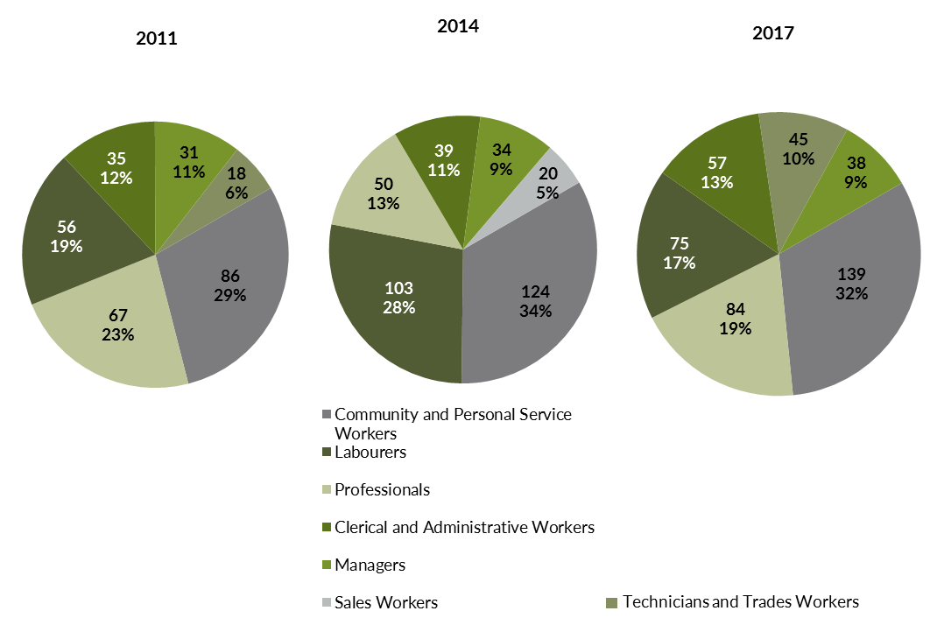

Source: Department of Trade, Business and Innovation

In 2017 in Wurrumiyanga (Nguiu):

* Community and Personal Service Workers was the **largest** **occupation** **classification** in terms of filled jobs, accounting for 139 jobs (30.2% of total filled jobs), an increase of 15 jobs from 2014 and an increase of 53 jobs from 2011
* **other** **significant** occupation classifications were:
* Professionals accounting for 84 jobs or 18.2% of total jobs an increase of 34 jobs from 2014 and an increase of 17 jobs from 2011
* Labourers accounting for 75 jobs or 16.3% of total jobs a decrease of 28 jobs from 2014 and an increase of 19 jobs from 2011
* Clerical and Administrative Workers accounting for 57 jobs or 12.4% of total jobs an increase of 18 jobs from 2014 and an increase of 22 jobs from 2011.

**Table 16 Count of filled jobs by ANZSCO occupation by Aboriginal status of person employed in job, 2011, 2014 and 2017 (a)(c)(f)(g)**

|  |  |  |  |  |  |  |  |  |  |  |  |  |  |  |  |  |
| --- | --- | --- | --- | --- | --- | --- | --- | --- | --- | --- | --- | --- | --- | --- | --- | --- |
| **Occupation (ANZSCO major group)** | **2011** | | | **2014** | | | **2017** | | | **Change 2011-2014** | | | **Change 2014-2017** | | | |
| **Aboriginal** | **Non-Aboriginal** | **Total** | **Aboriginal** | **Non-Aboriginal** | **Total** | **Aboriginal** | **Non-Aboriginal** | **Total** | **Aboriginal** | **Non-Aboriginal** | **Total** | **Aboriginal** | **Non-Aboriginal** | **Total** |
| Clerical and Administrative Workers | 26 | 9 | **35** | 22 | 17 | **39** | 38 | 19 | **57** | -4 | 8 | **4** | 16 | 2 | **18** |
| Community and Personal Service Workers | 74 | 12 | **86** | 102 | 22 | **124** | 126 | 13 | **139** | 28 | 10 | **38** | 24 | -9 | **15** |
| Labourers | 48 | 8 | **56** | 92 | 11 | **103** | 66 | 9 | **75** | 44 | 3 | **47** | -26 | -2 | **-28** |
| Machinery Operators and Drivers | 15 | 1 | **16** | 4 | 1 | **5** | 1 | 4 | **5** | -11 | 0 | **-11** | -3 | 3 | **0** |
| Managers | 11 | 20 | **31** | 8 | 26 | **34** | 9 | 29 | **38** | -3 | 6 | **3** | 1 | 3 | **4** |
| Professionals | 38 | 29 | **67** | 17 | 33 | **50** | 38 | 46 | **84** | -21 | 4 | **-17** | 21 | 13 | **34** |
| Sales Workers | 13 | 4 | **17** | 19 | 1 | **20** | 8 | 10 | **18** | 6 | -3 | **3** | -11 | 9 | **-2** |
| Technicians and Trades Workers | 14 | 4 | **18** | 6 | 9 | **15** | 29 | 16 | **45** | -8 | 5 | **-3** | 23 | 7 | **30** |
| **Total** | **240** | **88** | **328** | **270** | **120** | **390** | **315** | **146** | **461** | **30** | **32** | **62** | **45** | **26** | **71** |

Source: Department of Trade, Business and Innovation

In 2017 in Wurrumiyanga (Nguiu):

* of the 315 **jobs filled** by **Aboriginal** persons, there were:
* 126 Community and Personal Service Workers, an increase of 24 jobs from 2014 and an increase of 52 jobs from 2011
* 66 Labourers, a decrease of 26 jobs from 2014 and an increase of 18 jobs from 2011
* 38 Clerical and Administrative Workers, an increase of 16 jobs from 2014 and an increase of 12 jobs from 2011
* of the 146 **jobs filled** by **non-Aboriginal** persons, there were:
* 46 Professionals, an increase of 13 jobs from 2014 and an increase of 17 jobs from 2011
* 29 Managers, an increase of 3 jobs from 2014 and an increase of 9 jobs from 2011
* 19 Clerical and Administrative Workers, an increase of 2 jobs from 2014 and an increase of 10 jobs from 2011.

# Jobs by Industry by Occupation

Table 17: Count of filled jobs by industry by occupation, 2011 (a)(f)(g)(h)

|  |  |  |  |  |  |  |  |  |  |  |
| --- | --- | --- | --- | --- | --- | --- | --- | --- | --- | --- |
| **2011** | | | | | | | | | | |
| **Industry (ANZSIC Division)** |  | **Occupation (ANZSCO major group)** | | | | | | | | |
| **Clerical and Administrative Workers** | **Community and Personal Service Workers** | **Labourers** | **Machinery Operators and Drivers** | **Managers** | **Professionals** | **Sales Workers** | **Technicians and Trades Workers** | **Other occupations** | **Total** |
| Accommodation and Food Services | 0 | 5 | 0 | 0 | 2 | 0 | 0 | 0 | 0 | **7** |
| Administrative and Support Services | 0 | 0 | 0 | 0 | 0 | 2 | 0 | 0 | 0 | **2** |
| Arts and Recreation Services | 4 | 6 | 2 | 1 | 2 | 3 | 0 | 0 | 0 | **18** |
| Construction | 1 | 0 | 19 | 1 | 2 | 2 | 0 | 1 | 1 | **27** |
| Education and Training | 4 | 25 | 6 | 0 | 4 | 30 | 0 | 0 | 0 | **69** |
| Health Care and Social Assistance | 2 | 24 | 6 | 0 | 4 | 8 | 0 | 5 | 0 | **49** |
| Other Services | 0 | 0 | 0 | 0 | 0 | 1 | 0 | 0 | 0 | **1** |
| Public Administration and Safety | 21 | 26 | 14 | 4 | 10 | 20 | 2 | 5 | 1 | **103** |
| Retail Trade | 3 | 0 | 9 | 10 | 7 | 1 | 15 | 7 | 0 | **52** |
| **Total** | **35** | **86** | **56** | **16** | **31** | **67** | **17** | **18** | **2** | **328** |

Source: Department of Trade, Business and Innovation

Table 18: Count of filled jobs by industry by occupation, 2014 (a)(f)(g)(h)

|  |  |  |  |  |  |  |  |  |  |  |  |
| --- | --- | --- | --- | --- | --- | --- | --- | --- | --- | --- | --- |
| **2014** | | | | | | | | | | | |
| **Industry (ANZSIC Division)** |  | **Occupation (ANZSCO major group)** | | | | | | | | | |
| **Clerical and Administrative Workers** | **Community and Personal Service Workers** | **Labourers** | **Machinery Operators and Drivers** | **Managers** | **Professionals** | **Sales Workers** | **Technicians and Trades Workers** | **Other occupations** | **Total** |
| Accommodation and Food Services | 7 | 8 | 15 | 0 | 2 | 2 | 0 | 2 | 0 | **36** |
| Arts and Recreation Services | 2 | 4 | 1 | 0 | 3 | 4 | 0 | 1 | 0 | **15** |
| Construction | 2 | 1 | 5 | 0 | 1 | 0 | 0 | 6 | 0 | **15** |
| Education and Training | 8 | 44 | 35 | 1 | 9 | 29 | 0 | 0 | 0 | **126** |
| Financial and Insurance Services | 2 | 0 | 0 | 0 | 0 | 0 | 0 | 0 | 0 | **2** |
| Health Care and Social Assistance | 3 | 37 | 5 | 1 | 3 | 5 | 0 | 2 | 0 | **56** |
| Other Services | 0 | 0 | 0 | 0 | 0 | 2 | 0 | 0 | 0 | **2** |
| Public Administration and Safety | 13 | 30 | 27 | 0 | 11 | 7 | 0 | 3 | 0 | **91** |
| Rental, Hiring and Real Estate Services | 1 | 0 | 0 | 0 | 0 | 0 | 1 | 0 | 0 | **2** |
| Retail Trade | 1 | 0 | 15 | 3 | 4 | 1 | 19 | 1 | 0 | **44** |
| Transport, Postal and Warehousing | 0 | 0 | 0 | 0 | 1 | 0 | 0 | 0 | 0 | **1** |
| **Total** | **39** | **124** | **103** | **5** | **34** | **50** | **20** | **15** | **0** | **390** |

Source: Department of Trade, Business and Innovation

Table 19: Count of filled jobs by occupation and by industry, 2017 (a)(f)(g)(h)

|  |  |  |  |  |  |  |  |  |  |  |  |
| --- | --- | --- | --- | --- | --- | --- | --- | --- | --- | --- | --- |
| **2017** | | | | | | | | | | | |
| **Industry (ANZSIC Division)** |  | **Occupation (ANZSCO major group)** | | | | | | | | | |
| **Clerical and Administrative Workers** | **Community and Personal Service Workers** | **Labourers** | **Machinery Operators and Drivers** | **Managers** | **Professionals** | **Sales Workers** | **Technicians and Trades Workers** | **Other Occupations** | **Total** |
| Accommodation and Food Services | 6 | 0 | 14 | 0 | 0 | 3 | 0 | 4 | 0 | **27** |
| Arts and Recreation Services | 3 | 1 | 0 | 0 | 1 | 19 | 2 | 23 | 0 | **49** |
| Construction | 3 | 0 | 9 | 0 | 2 | 0 | 0 | 8 | 0 | **22** |
| Education and Training | 21 | 43 | 18 | 0 | 7 | 42 | 0 | 1 | 0 | **132** |
| Financial and Insurance Services | 2 | 0 | 0 | 0 | 0 | 0 | 0 | 0 | 0 | **2** |
| Health Care and Social Assistance | 8 | 48 | 6 | 1 | 8 | 12 | 0 | 2 | 0 | **85** |
| Other Services | 0 | 0 | 0 | 0 | 0 | 1 | 0 | 0 | 0 | **1** |
| Public Administration and Safety | 13 | 33 | 27 | 0 | 11 | 7 | 0 | 3 | 0 | **94** |
| Retail Trade | 1 | 14 | 1 | 3 | 9 | 0 | 16 | 4 | 0 | **48** |
| Transport, Postal and Warehousing | 0 | 0 | 0 | 1 | 0 | 0 | 0 | 0 | 0 | **1** |
| **Total** | **57** | **139** | **75** | **5** | **38** | **84** | **18** | **45** | **0** | **461** |

Source: Department of Trade, Business and Innovation

In 2017 in Wurrumiyanga (Nguiu):

* the majority of Community and Personal Service Workers (139) jobs (the largest occupation group) were shared across the Health Care and Social Assistance (48), Education and Training (43)and Public Administration and Safety(33) industries
* Education and Training (the largest industry), showed an increase of 6 filled jobs from 2014
* Health Care and Social Assistance, showed an increase of 29 filled jobs from 2014
* Community and Personal Service Workers showed an increase in filled jobs for each survey period with an increase of 15 jobs between 2017 and 2014 and an increase of 53 jobs between 2017 and 2011.

# Jobs by Gender

Table 20: Counts of filled jobs by gender[2] and Aboriginal status of person employed in job 2011, 2014 and 2017 (a)(c)(i)

|  |  |  |  |  |  |  |  |  |  |  |  |  |  |  |  |  |
| --- | --- | --- | --- | --- | --- | --- | --- | --- | --- | --- | --- | --- | --- | --- | --- | --- |
| **Indicator** | **2011** | | | **2014** | | | **2017** | | | **2011-2014  Change** | | | **2014-2017  Change** | | | |
| **Aboriginal** | **Non-Aboriginal** | **Total** | **Aboriginal** | **Non-Aboriginal** | **Total** | **Aboriginal** | **Non-Aboriginal** | **Total** | **Aboriginal** | **Non-Aboriginal** | **Total** | **Aboriginal** | **Non-Aboriginal** | **Total** |
| Male | 110 | 37 | **147** | 126 | 59 | **185** | 138 | 71 | **209** | 16 | 22 | **38** | 12 | 12 | **24** |
| Female | 94 | 21 | **115** | 144 | 61 | **205** | 166 | 75 | **241** | 50 | 40 | **90** | 22 | 14 | **36** |
| **Total** | **240** | **88** | **328** | **270** | **120** | **390** | **304** | **146** | **450** | **30** | **32** | **62** | **34** | **26** | **60** |

Source: Department of Trade, Business and Innovation

Chart 11: Count of filled jobs by gender and Aboriginal status of person in job, 2011, 2014 and 2017 (a)(c)(i)

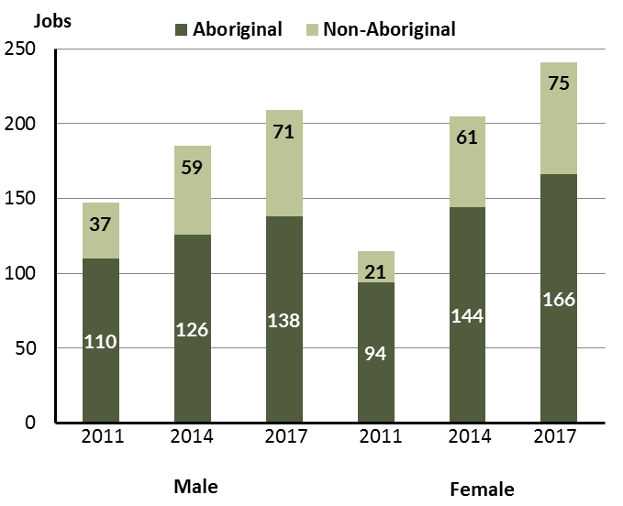

Source: Department of Trade, Business and Innovation

In 2017 in Wurrumiyanga (Nguiu):

* there were 209 **jobs** **filled by males**, an increase of 24 jobs from 2014 and an increase of 62 jobs from 2011
* of the 209 jobs **filled by males**:
* 138 were **Aboriginal**, an increase of 12 jobs from 2014 and an increase of 28 jobs from 2011
* 71 were **non-Aboriginal**, an increase of 12 jobs from 2014 and an increase of 34 jobs from 2011
* there were 241 **jobs filled by females**, an increase of 36 jobs from 2014 and an increase of 126 jobs from 2011
* of the 241 **jobs filled by females**:
* 166 were **Aboriginal**, an increase of 22 jobs from 2014 and an increase of 72 jobs from 2011
* 75 were **non-Aboriginal**, an increase of 14 jobs from 2014 and an increase of 54 jobs from 2011.

Table 21: Counts of filled jobs by gender, by Aboriginal status of person in the job, by full-time/part-time status, by job permanency and by sector 2011 (a)(b)(c)(d)(e)(i)

|  |  |  |  |  |  |  |  |  |  |
| --- | --- | --- | --- | --- | --- | --- | --- | --- | --- |
| **2011** | | | | | | | | | |
| **Indicator** | **Male** | | | **Female** | | | **Total** | | |
| **Aboriginal** | **Non-Aboriginal** | **Total** | **Aboriginal** | **Non-Aboriginal** | **Total** | **Aboriginal** | **Non-Aboriginal** | **Total** |
| Full-time | 86 | 34 | **120** | 70 | 20 | **90** | 182 | 78 | **260** |
| Part-time | 24 | 3 | **27** | 24 | 1 | **25** | 58 | 10 | **68** |
| **Total** | **110** | **37** | **147** | **94** | **21** | **115** | **240** | **88** | **328** |
| Permanent | 57 | 21 | **78** | 36 | 5 | **41** | 119 | 50 | **169** |
| Temporary | 53 | 16 | **69** | 58 | 16 | **74** | 121 | 38 | **159** |
| **Total** | **110** | **37** | **147** | **94** | **21** | **115** | **240** | **88** | **328** |
| Public Sector | 44 | 14 | **58** | 35 | 6 | **41** | 79 | 20 | **99** |
| Private Sector | 66 | 23 | **89** | 59 | 15 | **74** | 161 | 68 | **229** |
| **Total** | **110** | **37** | **147** | **94** | **21** | **115** | **240** | **88** | **328** |

Source: Department of Trade, Business and Innovation

Table 22: Counts of filled jobs by gender, by Aboriginal status of person in the job, by full-time/part-time status, by job permanency and by sector 2014 (a)(b)(c)(d)(e)(i)

|  |  |  |  |  |  |  |  |  |  |
| --- | --- | --- | --- | --- | --- | --- | --- | --- | --- |
| **2014** | | | | | | | | | |
| **Indicator** | **Male** | | | **Female** | | | **Total** | | |
| **Aboriginal** | **Non-Aboriginal** | **Total** | **Aboriginal** | **Non-Aboriginal** | **Total** | **Aboriginal** | **Non-Aboriginal** | **Total** |
| Full-time | 68 | 54 | **122** | 68 | 56 | **124** | 136 | 110 | **246** |
| Part-time | 58 | 5 | **63** | 76 | 5 | **81** | 134 | 10 | **144** |
| **Total** | **126** | **59** | **185** | **144** | **61** | **205** | **270** | **120** | **390** |
| Permanent | 78 | 37 | **115** | 66 | 37 | **103** | 144 | 74 | **218** |
| Temporary | 48 | 22 | **70** | 78 | 24 | **102** | 126 | 46 | **172** |
| **Total** | **126** | **59** | **185** | **144** | **61** | **205** | **270** | **120** | **390** |
| Public Sector | 38 | 19 | **57** | 45 | 17 | **62** | 83 | 36 | **119** |
| Private Sector | 88 | 40 | **128** | 99 | 44 | **143** | 187 | 84 | **271** |
| **Total** | **126** | **59** | **185** | **144** | **61** | **205** | **270** | **120** | **390** |

Source: Department of Trade, Business and Innovation

Table 23: Counts of filled jobs by gender[3], by Aboriginal status of person in the job, by full-time/part-time status, by job permanency and by sector 2017 (a)(b)(c)(d)(e)(i)

|  |  |  |  |  |  |  |  |  |  |
| --- | --- | --- | --- | --- | --- | --- | --- | --- | --- |
| **2017** | | | | | | | | | |
| **Indicator** | **Male** | | | **Female** | | | **Total** | | |
| **Aboriginal** | **Non-Aboriginal** | **Total** | **Aboriginal** | **Non-Aboriginal** | **Total** | **Aboriginal** | **Non-Aboriginal** | **Total** |
| Full-time | 60 | 66 | **126** | 55 | 68 | **123** | 115 | 134 | **249** |
| Part-time | 78 | 5 | **83** | 111 | 7 | **118** | 200 | 12 | **212** |
| **Total** | **138** | **71** | **209** | **166** | **75** | **241** | **315** | **146** | **461** |
| Permanent | 62 | 30 | **92** | 70 | 25 | **95** | 132 | 55 | **187** |
| Temporary | 76 | 41 | **117** | 96 | 50 | **146** | 183 | 91 | **274** |
| **Total** | **138** | **71** | **209** | **166** | **75** | **241** | **315** | **146** | **461** |
| Public Sector | 39 | 20 | **59** | 47 | 23 | **70** | 86 | 43 | **129** |
| Private Sector | 99 | 51 | **150** | 119 | 52 | **171** | 229 | 103 | **332** |
| **Total** | **138** | **71** | **209** | **166** | **75** | **241** | **315** | **146** | **461** |

Source: Department of Trade, Business and Innovation

In 2017 in Wurrumiyanga (Nguiu):

* of the 209 **jobs filled by males**, there were:
* 138 jobs filled by **Aboriginal** males, an increase of 12 jobs from 2014 and an increase of 28 jobs from 2011, including:
* 60 full-time jobs, a decrease of 8 jobs from 2014 and a decrease of 26 jobs from 2011
* 78 part-time jobs, an increase of 20 jobs from 2014 and an increase of 54 jobs from 2011
* 62 permanent jobs, a decrease of 16 jobs from 2014 and an increase of 5 jobs from 2011
* 76 temporary jobs, an increase of 28 jobs from 2014 and an increase of 23 jobs from 2011
* 39 public sector jobs, an increase of 1 job from 2014 and a decrease of 5 jobs from 2011
* 99 private sector jobs, an increase of 11 jobs from 2014 and an increase of 33 jobs from 2011
* 71 jobs filled by **non-Aboriginal males**, an increase of 12 jobs from 2014 and an increase of 34 jobs from 2011, including:
* 66 full-time jobs, an increase of 12 jobs from 2014 and an increase of 32 jobs from 2011
* 5 part-time jobs, unchanged from 2014 and an increase of 2 jobs from 2011
* 30 permanent jobs, a decrease of 7 jobs from 2014 and an increase of 9 jobs from 2011
* 41 temporary jobs, an increase of 19 jobs from 2014 and an increase of 25 jobs from 2011
* 20 public sector jobs, an increase of 1 job from 2014 and an increase of 6 jobs from 2011
* 51 private sector jobs, an increase of 11 jobs from 2014 and an increase of 28 jobs from 2011
* of the 241 **jobs filled by females**, there were:
* 166 jobs filled by **Aboriginal females**, an increase of 22 jobs from 2014 and an increase of 72 jobs from 2011, including:
* 55 full-time jobs, a decrease of 13 jobs from 2014 and a decrease of 15 jobs from 2011
* 111 part-time jobs, an increase of 35 jobs from 2014 and an increase of 87 jobs from 2011
* 70 permanent jobs, an increase of 4 jobs from 2014 and an increase of 34 jobs from 2011
* 96 temporary jobs, an increase of 18 jobs from 2014 and an increase of 38 jobs from 2011
* 47 public sector jobs, an increase of 2 jobs from 2014 and an increase of 12 jobs from 2011
* 119 private sector jobs, an increase of 20 jobs from 2014 and an increase of 60 jobs from 2011
* 75 jobs filled by **non-Aboriginal females**, an increase of 14 jobs from 2014 and an increase of 54 jobs from 2011, including:
* 68 full-time jobs, an increase of 12 jobs from 2014 and an increase of 48 jobs from 2011
* 7 part-time jobs, an increase of 2 jobs from 2014 and an increase of 6 jobs from 2011
* 25 permanent jobs, a decrease of 12 jobs from 2014 and an increase of 20 jobs from 2011
* 50 temporary jobs, an increase of 26 jobs from 2014 and an increase of 34 jobs from 2011
* 23 public sector jobs, an increase of 6 jobs from 2014 and an increase of 17 jobs from 2011
* 52 private sector jobs, an increase of 8 jobs from 2014 and an increase of 37 jobs from 2011.

# Jobs by Age

Table 24: Counts of filled jobs by age and Aboriginal status of person employed in job, 2011, 2014 and 2017 (a)(c)(j)

|  |  |  |  |  |  |  |  |  |  |  |  |  |  |  |  |
| --- | --- | --- | --- | --- | --- | --- | --- | --- | --- | --- | --- | --- | --- | --- | --- |
| **Indicator** | **2011** | | | **2014** | | | **2017** | | | **Change 2011-2014** | | | **Change 2014-2017** | | |
| **Aboriginal** | **Non-Aboriginal** | **Total** | **Aboriginal** | **Non-Aboriginal** | **Total** | **Aboriginal** | **Non-Aboriginal** | **Total** | **Aboriginal** | **Non-Aboriginal** | **Total** | **Aboriginal** | **Non-Aboriginal** | **Total** |
| 15-24 years | 19 | 0 | **19** | 35 | 14 | **49** | 44 | 9 | **53** | 16 | 14 | **30** | 9 | -5 | **4** |
| 25-44 years | 148 | 22 | **170** | 166 | 53 | **219** | 196 | 67 | **263** | 18 | 31 | **49** | 30 | 14 | **44** |
| 45+ years | 37 | 36 | **73** | 69 | 53 | **122** | 75 | 69 | **144** | 32 | 17 | **49** | 6 | 16 | **22** |
| **Total** | **240** | **88** | **328** | **270** | **120** | **390** | **315** | **146** | **461** | **30** | **32** | **62** | **45** | **26** | **71** |

Source: Department of Trade, Business and Innovation

Chart 12: Count of filled jobs by age and Aboriginal status of person in job, 2011, 2014 and 2017 (a)(c)(j)

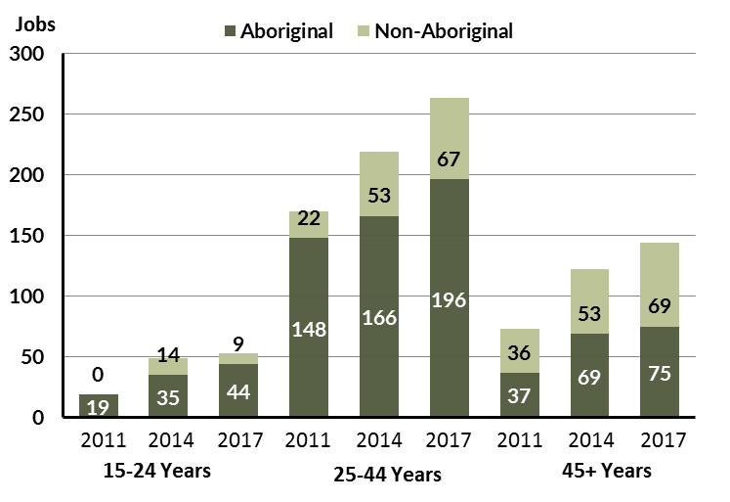

Source: Department of Trade, Business and Innovation

In 2017 in Wurrumiyanga (Nguiu):

* there were 53 jobs filled by persons aged **15-24 years**, an increase of 4 jobs from 2014 and an increase of 34 jobs from 2011, a decrease of 34 jobs from 2011. Of these:
* 44 jobs were filled by **Aboriginal** persons, an increase of 9 jobs from 2014 and an increase of 25 jobs from 2011
* 9 jobs were filled by **non-Aboriginal** persons, a decrease of 5 jobs from 2014 and an increase of 9 jobs from 2011
* there were 263 jobs filled by persons aged **25-44 years**, an increase of 44 jobs from 2014 and an increase of 93 jobs from 2011
* 196 jobs were filled by **Aboriginal** persons, an increase of 30 jobs from 2014 and an increase of 48 jobs from 2011
* 67 jobs were filled by **non-Aboriginal** persons, an increase of 14 jobs from 2014 and an increase of 45 jobs from 2011
* there were 144 jobs filled by persons aged **45+ years**, an increase of 22 jobs from 2011 and an increase of 71 jobs from 2011
* 75 jobs were filled by **Aboriginal** persons, an increase of 6 jobs from 2014 and an increase of 38 jobs from 2011
* 69 jobs were filled by **non-Aboriginal** persons, an increase of 16 jobs from 2014 and an increase of 33 jobs from 2011.

Table 25: Counts of filled jobs by age, by Aboriginal status of person in the job, by full-time/part-time status, by job permanency and by sector June-July 2011 (a)(b)(c)(d)(e)(i)

|  |  |  |  |  |  |  |  |  |  |  |  |  |  |
| --- | --- | --- | --- | --- | --- | --- | --- | --- | --- | --- | --- | --- | --- |
| **2011** | | | | | | | | | | | | | |
| **Indicator** | **15-24 years** | | | **25-44 years** | | | **45+ years** | | | **Total** | | |
| **Aboriginal** | **Non-Aboriginal** | **Total** | **Aboriginal** | **Non-Aboriginal** | **Total** | **Aboriginal** | **Non-Aboriginal** | **Total** | **Aboriginal** | **Non-Aboriginal** | **Total** |
| Full-time | 14 | 0 | **14** | 119 | 21 | **140** | 23 | 33 | **56** | 182 | 78 | **260** |
| Part-time | 5 | 0 | **5** | 29 | 1 | **30** | 14 | 3 | **17** | 58 | 10 | **68** |
| **Total** | **19** | **0** | **19** | **148** | **22** | **170** | **37** | **36** | **73** | **240** | **88** | **328** |
| Permanent | 11 | 0 | **11** | 69 | 11 | **80** | 13 | 15 | **28** | 119 | 50 | **169** |
| Temporary | 8 | 0 | **8** | 79 | 11 | **90** | 24 | 21 | **45** | 121 | 38 | **159** |
| **Total** | **19** | **0** | **19** | **148** | **22** | **170** | **37** | **36** | **73** | **240** | **88** | **328** |
| Public Sector | 14 | 0 | **14** | 49 | 6 | **55** | 16 | 14 | **30** | 79 | 20 | **99** |
| Private Sector | 5 | 0 | **5** | 99 | 16 | **115** | 21 | 22 | **43** | 161 | 68 | **229** |
| **Total** | **19** | **0** | **19** | **148** | **22** | **170** | **37** | **36** | **73** | **240** | **88** | **328** |

Source: Department of Trade, Business and Innovation

Table 26: Counts of filled jobs by age, by Aboriginal status of person in the job, by full-time/part-time status, by job permanency and by sector June-July 2014 (a)(b)(c)(d)(e)(i)

|  |  |  |  |  |  |  |  |  |  |  |  |  |
| --- | --- | --- | --- | --- | --- | --- | --- | --- | --- | --- | --- | --- |
| **2014** | | | | | | | | | | | | |
| **Indicator** | **15-24 years** | | | **25-44 years** | | | **45+ years** | | | **Total** | | |
| **Aboriginal** | **Non-Aboriginal** | **Total** | **Aboriginal** | **Non-Aboriginal** | **Total** | **Aboriginal** | **Non-Aboriginal** | **Total** | **Aboriginal** | **Non-Aboriginal** | **Total** |
| Full-time | 7 | 13 | **20** | 84 | 47 | **131** | 45 | 50 | **95** | 136 | 110 | **246** |
| Part-time | 28 | 1 | **29** | 82 | 6 | **88** | 24 | 3 | **27** | 134 | 10 | **144** |
| **Total** | **35** | **14** | **49** | **166** | **53** | **219** | **69** | **53** | **122** | **270** | **120** | **390** |
| Permanent | 13 | 8 | **21** | 88 | 38 | **126** | 43 | 28 | **71** | 144 | 74 | **218** |
| Temporary | 22 | 6 | **28** | 78 | 15 | **93** | 26 | 25 | **51** | 126 | 46 | **172** |
| **Total** | **35** | **14** | **49** | **166** | **53** | **219** | **69** | **53** | **122** | **270** | **120** | **390** |
| Public Sector | 6 | 0 | **6** | 53 | 16 | **69** | 24 | 20 | **44** | 83 | 36 | **119** |
| Private Sector | 29 | 14 | **43** | 113 | 37 | **150** | 45 | 33 | **78** | 187 | 84 | **271** |
| **Total** | **35** | **14** | **49** | **166** | **53** | **219** | **69** | **53** | **122** | **270** | **120** | **390** |

Source: Department of Trade, Business and Innovation

Table 27: Counts of filled jobs by age, by Aboriginal status of person in the job, by full-time/part-time status, by job permanency and by sector June-July 2017 (a)(b)(c)(d)(e)(i)

|  |  |  |  |  |  |  |  |  |  |  |  |  |  |
| --- | --- | --- | --- | --- | --- | --- | --- | --- | --- | --- | --- | --- | --- |
| **2017** | | | | | | | | | | | | | |
| **Indicator** | **15-24 years** | | | **25-44 years** | | | **45+ years** | | | **Total** | | | |
| **Aboriginal** | **Non-Aboriginal** | **Total** | **Aboriginal** | **Non-Aboriginal** | **Total** | **Aboriginal** | **Non-Aboriginal** | **Total** | **Aboriginal** | **Non-Aboriginal** | **Total** |
| Full-time | 6 | 7 | **13** | 74 | 61 | **135** | 35 | 66 | **101** | 115 | 134 | **249** |
| Part-time | 38 | 2 | **40** | 122 | 6 | **128** | 40 | 3 | **43** | 200 | 12 | **212** |
| **Total** | **44** | **9** | **53** | **196** | **67** | **263** | **75** | **69** | **144** | **315** | **146** | **461** |
| Permanent | 12 | 2 | **14** | 93 | 25 | **118** | 27 | 28 | **55** | 132 | 55 | **187** |
| Temporary | 32 | 7 | **39** | 103 | 42 | **145** | 48 | 41 | **89** | 183 | 91 | **274** |
| **Total** | **44** | **9** | **53** | **196** | **67** | **263** | **75** | **69** | **144** | **315** | **146** | **461** |
| Public Sector | 4 | 3 | **7** | 57 | 15 | **72** | 25 | 25 | **50** | 86 | 43 | **129** |
| Private Sector | 40 | 6 | **46** | 139 | 52 | **191** | 50 | 44 | **94** | 229 | 103 | **332** |
| **Total** | **44** | **9** | **53** | **196** | **67** | **263** | **75** | **69** | **144** | **315** | **146** | **461** |

Source: Department of Trade, Business and Innovation

In 2017 in Wurrumiyanga (Nguiu):

* of the 53 jobs filled by persons aged **15-24 years**, there were:
* 44 jobs filled by **Aboriginal** persons, of which:
* 6 were full-time jobs, a decrease of 1 job from 2014 and a decrease of 8 jobs from 2011
* 38 were part-time jobs, an increase of 10 jobs from 2014 and an increase of 33 jobs from 2011
* 12 were permanent jobs, a decrease of 1 job from 2014 and an increase of 1 job from 2011
* 32 were temporary jobs, an increase of 10 jobs from 2014 and an increase of 24 jobs from 2011
* 4 were public sector jobs, a decrease of 2 jobs from 2014 and a decrease of 10 jobs from 2011
* 40 were private sector jobs, an increase of 11 jobs from 2014 and an increase of 35 jobs from 2011
* 9 jobs filled by **non-Aboriginal** persons, of which:
* 7 were full-time jobs, a decrease of 6 jobs from 2014 and an increase of 7 jobs from 2011
* 2 were part-time jobs, an increase of 1 job from 2014 and an increase of 2 jobs from 2011
* 2 were permanent jobs, a decrease of 6 jobs from 2014 and an increase of 2 jobs from 2011
* 7 were temporary jobs, an increase of 1 job from 2014 and an increase of 7 jobs from 2011
* 3 were public sector jobs, an increase of 3 jobs from 2014 and an increase of 3 jobs from 2011
* 6 were private sector jobs, a decrease of 8 jobs from 2014 and an increase of 6 jobs from 2011
* of the 263 jobs filled by persons aged **25-44 years**, there were:
* 196 jobs filled by **Aboriginal** persons, of which:
* 74 were full-time jobs, a decrease of 10 jobs from 2014 and a decrease of 45 jobs from 2011
* 122 were part-time jobs, an increase of 40 jobs from 2014 and an increase of 93 jobs from 2011
* 93 were permanent jobs, an increase of 5 jobs from 2014 and an increase of 24 jobs from 2011
* 103 were temporary jobs, an increase of 25 jobs from 2014 and an increase of 24 jobs from 2011
* 57 were public sector jobs, an increase of 4 jobs from 2014 and an increase of 8 jobs from 2011
* 139 were private sector jobs, an increase of 26 jobs from 2014 and an increase of 40 jobs from 2011
* 67 jobs filled by **non-Aboriginal** persons, of which:
* 61 were full-time jobs, an increase of 14 jobs from 2014 and an increase of 40 jobs from 2011
* 6 were part-time jobs, unchanged from 2014 and an increase of 5 jobs from 2011
* 25 were permanent jobs, a decrease of 13 jobs from 2014 and an increase of 14 jobs from 2011
* 42 were temporary jobs, an increase of 27 jobs from 2014 and an increase of 31 jobs from 2011
* 15 were public sector jobs, a decrease of 1 job from 2014 and an increase of 9 jobs from 2011
* 52 were private sector jobs, an increase of 15 jobs from 2014 and an increase of 36 jobs from 2011
* of the 144 jobs filled by persons aged **45+ years**, there were:
* 75 jobs filled by **Aboriginal** persons, of which:
* 35 were full-time jobs, a decrease of 10 jobs from 2014 and an increase of 12 jobs from 2011
* 40 were part-time jobs, an increase of 16 jobs from 2014 and an increase of 26 jobs from 2011
* 27 were permanent jobs, a decrease of 16 jobs from 2014 and an increase of 14 jobs from 2011
* 48 were temporary jobs, an increase of 22 jobs from 2014 and an increase of 24 jobs from 2011
* 25 were public sector jobs, an increase of 1 job from 2014 and an increase of 9 jobs from 2011
* 50 were private sector jobs, an increase of 5 jobs from 2014 and an increase of 29 jobs from 2011
* 69 jobs filled by **non-Aboriginal** persons, of which:
* 66 were full-time jobs, an increase of 16 jobs from 2014 and an increase of 33 jobs from 2011
* 3 were part-time jobs, unchanged from 2014 and unchanged from 2011
* 28 were permanent jobs, unchanged from 2014 and an increase of 13 jobs from 2011
* 41 were temporary jobs, an increase of 16 jobs from 2014 and an increase of 20 jobs from 2011
* 25 were public sector jobs, an increase of 5 jobs from 2014 and an increase of 11 jobs from 2011
* 44 were private sector jobs, an increase of 11 jobs from 2014 and an increase of 22 jobs from 2011.

# Vocational Education and Training

Note: *Since previous publications, the 2010 data have fallen in line with the new standardised reporting practices with an emphasis of all training activity undertaken in the remote town regardless of funding stream. As such, figures for 2010 VET data in this publication may differ from previous publications.*

*The impact of the Remote Jobs and Communities Program (RJCP) being established in 2013 has played a significant role in the downturn of accredited training in many remote towns across the Territory.*

Table 28: Northern Territory Vocational Education and Training (VET) students, 2010, 2013 and 2016 (k)

|  |  |  |  |  |  |  |  |  |
| --- | --- | --- | --- | --- | --- | --- | --- | --- |
| **VET Funding Group** | **2010** | | **2013** | | **2016** | | **Change** | |
| **No.** | **% of Total** | **No.** | **% of Total** | **No.** | **% of Total** | **2010-2013** | **2013-2016** |
| Arts, Entertainment, Sports and Recreation | 22 | 11 | 0 | 0 | 0 | 0 | - 22 | 0 |
| Automotive | 8 | 4 | 0 | 0 | 0 | 0 | - 8 | 0 |
| Building and Construction | 28 | 14 | 5 | 6 | 1 | 1 | - 23 | - 4 |
| Business and Clerical | 18 | 9 | 4 | 5 | 15 | 9 | - 14 | 11 |
| Community Services, Health and Education | 43 | 22 | 21 | 24 | 77 | 46 | - 22 | 56 |
| Engineering and Mining | 0 | 0 | 7 | 8 | 0 | 0 | 7 | - 7 |
| Food Processing | 0 | 0 | 0 | 0 | 14 | 8 | 0 | 14 |
| General Education and Training | 34 | 17 | 39 | 45 | 27 | 16 | 5 | - 12 |
| Primary Industry | 6 | 3 | 0 | 0 | 16 | 10 | - 6 | 16 |
| Sales and Personal Service | 0 | 0 | 10 | 12 | 6 | 4 | 10 | - 4 |
| Transport and Storage | 36 | 18 | 0 | 0 | 12 | 7 | - 36 | 12 |
| **Total** | **195** | **100** | **86** | **100** | **168** | **100** | **- 109** | **82** |

Source: Department of Trade, Business and Innovation

In 2016 in Wurrumiyanga (Nguiu):

* there were 168 **VET students**, an increase of 82 students from 2013 and a decrease of 27 students from 2010
* the areas of VET activity with the most students were Community Services, Health and Education (77), General Education and Training (27), and Primary Industry (16)
* Community Services, Health and Education reported the largest increase in students (56) compared to 2013 and General Education and Training reported the largest decrease in students (-12) over the same period.

Table 29: Northern Territory Vocational Education and Training (VET) unit enrolments, 2010, 2013 and 2016 (l)

|  |  |  |  |  |  |  |  |  |
| --- | --- | --- | --- | --- | --- | --- | --- | --- |
| **VET Funding Group** | **2010** | | **2013** | | **2016** | | **Change** | |
| **No.** | **% of Total** | **No.** | **% of Total** | **No.** | **% of Total** | **2010-2013** | **2013-2016** |
| Arts, Entertainment, Sports and Recreation | 22 | 3 | 0 | 0 | 0 | 0 | - 22 | 0 |
| Automotive | 32 | 5 | 0 | 0 | 0 | 0 | - 32 | 0 |
| Building and Construction | 181 | 26 | 16 | 4 | 1 | 0 | - 165 | - 15 |
| Business and Clerical | 49 | 7 | 5 | 1 | 75 | 11 | - 44 | 70 |
| Community Services, Health and Education | 105 | 15 | 122 | 28 | 121 | 18 | 17 | - 1 |
| Engineering and Mining | 0 | 0 | 14 | 3 | 0 | 0 | 14 | - 14 |
| Food Processing | 0 | 0 | 0 | 0 | 126 | 19 | 0 | 126 |
| General Education and Training | 237 | 35 | 235 | 53 | 122 | 18 | - 2 | - 113 |
| Primary Industry | 16 | 2 | 0 | 0 | 46 | 7 | - 16 | 46 |
| Sales and Personal Service | 0 | 0 | 50 | 11 | 64 | 10 | 50 | 14 |
| Transport and Storage | 42 | 6 | 0 | 0 | 108 | 16 | - 42 | 108 |
| **Total** | **684** | **100** | **442** | **100** | **663** | **100** | **- 242** | **221** |

Source: Department of Trade, Business and Innovation

In 2016 in Wurrumiyanga (Nguiu):

* there were 663 **VET unit enrolments**, an increase of 221 unit enrolments from 2013 and a decrease of 21 unit enrolments from 2010
* the areas of VET activity with the most unit enrolments were Food Processing (126), General Education and Training (122), and Community Services, Health and Education (121)
* Food Processing reported the largest increase in unit enrolments (126) compared to 2013 and General Education and Training reported the largest decrease in unit enrolments (-113) over the same period.

Table 30: Northern Territory Vocational Education and Training (VET) nominal hours, 2010, 2013 and 2016 (m)

|  |  |  |  |  |  |  |  |  |
| --- | --- | --- | --- | --- | --- | --- | --- | --- |
| **VET Funding Group** | **2010** | | **2013** | | **2016** | | **Change** | |
| **No.** | **% of Total** | **No.** | **% of Total** | **No.** | **% of Total** | **2010-2013** | **2013-2016** |
| Arts, Entertainment, Sports and Recreation | 900 | 4 | 0 | 0 | 0 | 0 | - 900 | 0 |
| Automotive | 544 | 3 | 0 | 0 | 0 | 0 | - 544 | 0 |
| Building and Construction | 6 432 | 31 | 1 852 | 11 | 0 | 0 | -4 580 | -1 852 |
| Business and Clerical | 1 760 | 8 | 210 | 1 | 2 050 | 15 | -1 550 | 1 840 |
| Community Services, Health and Education | 2 972 | 14 | 4 405 | 26 | 1 109 | 8 | 1 433 | -3 296 |
| Engineering and Mining | 0 | 0 | 2 800 | 17 | 0 | 0 | 2 800 | -2 800 |
| Food Processing | 0 | 0 | 0 | 0 | 3 500 | 25 | 0 | 3 500 |
| General Education and Training | 6 430 | 31 | 6 160 | 36 | 160 | 1 | - 270 | -6 000 |
| Primary Industry | 480 | 2 | 0 | 0 | 1 780 | 13 | - 480 | 1 780 |
| Sales and Personal Service | 0 | 0 | 1 450 | 9 | 1 305 | 9 | 1 450 | - 145 |
| Transport and Storage | 1 200 | 6 | 0 | 0 | 4 020 | 29 | -1 200 | 4 020 |
| **Total** | **20 718** | **100** | **16 877** | **100** | **13 924** | **100** | **-3 841** | **-2 953** |

Source: Department of Trade, Business and Innovation

In 2016 in Wurrumiyanga (Nguiu):

* there were 13 924 **VET nominal hours** delivered, a decrease of 2953 nominal hours delivered from 2013 and a decrease of 6794 nominal hours delivered from 2010
* the areas of VET activity with the most nominal hours delivered were Transport and Storage (4020), Food Processing (3500), and Business and Clerical (2050)
* Transport and Storage reported the largest increase in nominal hours delivered (4020) compared to 2013 and General Education and Training reported the largest decrease in nominal hours delivered (-6000) over the same period.

Caveat: *Nominal hours are based on the hours funded through Department of Trade Business and Innovation contracts; students and units includes delivery that has been funded in a previous year, fee for service or training that did not meet the funding requirements. Because of this a direct match cannot be made between hours and student/units*.

Table 31: Northern Territory Vocational Education and Training (VET) Unit Completions, 2010, 2013 and 2016 (n)

|  |  |  |  |  |  |  |  |  |
| --- | --- | --- | --- | --- | --- | --- | --- | --- |
| **VET Funding Group** | **2010** | | **2013** | | **2016** | | **Change** | |
| **No.** | **% of Total** | **No.** | **% of Total** | **No.** | **% of Total** | **2010-2013** | **2013-2016** |
| Arts, Entertainment, Sports and Recreation | 20 | 3 | 0 | 0 | 0 | 0 | - 20 | 0 |
| Automotive | 32 | 6 | 0 | 0 | 0 | 0 | - 32 | 0 |
| Building and Construction | 106 | 18 | 8 | 3 | 1 | 0 | - 98 | - 7 |
| Business and Clerical | 49 | 8 | 5 | 2 | 72 | 13 | - 44 | 67 |
| Community Services, Health and Education | 82 | 14 | 16 | 5 | 91 | 16 | - 66 | 75 |
| Engineering and Mining | 0 | 0 | 14 | 5 | 0 | 0 | 14 | - 14 |
| Food Processing | 0 | 0 | 0 | 0 | 93 | 17 | 0 | 93 |
| General Education and Training | 237 | 41 | 235 | 79 | 120 | 22 | - 2 | - 115 |
| Primary Industry | 16 | 3 | 0 | 0 | 42 | 8 | - 16 | 42 |
| Sales and Personal Service | 0 | 0 | 21 | 7 | 38 | 7 | 21 | 17 |
| Transport and Storage | 36 | 6 | 0 | 0 | 98 | 18 | - 36 | 98 |
| **Total** | **578** | **100** | **299** | **100** | **555** | **100** | **- 279** | **256** |

Source: Department of Trade, Business and Innovation

In 2016 in Wurrumiyanga (Nguiu):

* there were 555 **VET unit completions**, an increase of 256 unit completions from 2013 and a decrease of 23 unit completions from 2010
* the areas of VET activity with the most unit completions were General Education and Training (120), Transport and Storage (98), and Food Processing (93)
* Transport and Storage reported the largest increase in nominal hours delivered (98) compared to 2013 and General Education and Training reported the largest decrease in nominal hours delivered (-115) over the same period.

# Population

**Table 32: Population distribution by gender and age (p)(r)**

|  |  |  |  |  |  |  |  |  |  |
| --- | --- | --- | --- | --- | --- | --- | --- | --- | --- |
| **Indicator** | **2006** | | | **2016** | | | **Change** | | |
| **Male** | **Female** | **Total** | **Male** | **Female** | **Total** | **Male** | **Female** | **Total** |
| **0-4 years** | 77 | 68 | 145 | 64 | 52 | 116 | -13 | -16 | -29 |
| **5-14 years** | 127 | 148 | 275 | 177 | 164 | 341 | 50 | 16 | 66 |
| **15-24 years** | 142 | 129 | 271 | 148 | 143 | 291 | 6 | 14 | 20 |
| **25-44 years** | 255 | 228 | 483 | 290 | 298 | 588 | 35 | 70 | 105 |
| **45-64 years** | 110 | 137 | 247 | 183 | 199 | 382 | 73 | 62 | 135 |
| **65+ years** | 14 | 12 | 26 | 36 | 33 | 69 | 22 | 21 | 43 |
| **TOTAL** | 725 | 722 | 1447 | 898 | 889 | 1787 | 173 | 167 | 340 |

*Source: Department of Trade, Business and Innovation*

In 2016 in Wurrumiyanga (Nguiu):

* there were an estimated 1787 persons, of which:
* 898 (50.3%) were male
* 889 (49.7%) were female
* between 2006 and 2016, the **overall population** in Wurrumiyanga (Nguiu) increased by 340 persons from 2006, or an average of 2.1% per year compared to 0.7% across the 28 remote towns and 1.5% Territory wide
* the **male population** increased by 173 persons from 2006
* the **female population** increased by 167 persons from 2006
* in 2016, the **working age population** (15 years and over) in Wurrumiyanga (Nguiu) was an estimated 1330 persons (74.4% of the total population) compared with 1027 persons (71% of the total population) in 2006. Of these:
* 291 (16.3%) were between 15 and 24 years of age
* 588 (32.9%) were between 25 and 44 years of age
* 382 (21.4%) were between 45 and 64 years of age
* 69 (3.9%) were over 65 years of age
* of the 1330 persons of **working age**:
* 657 (49.4%) were male
* 673 (50.6%) were female.

There were 0.4 jobs in Wurrumiyanga (Nguiu) per working age person compared to 0.4 jobs per working age person across the Northern Territory.

**Chart 13: Population by Aboriginal status compared to the 28 remote towns and the NT (p)(q)**

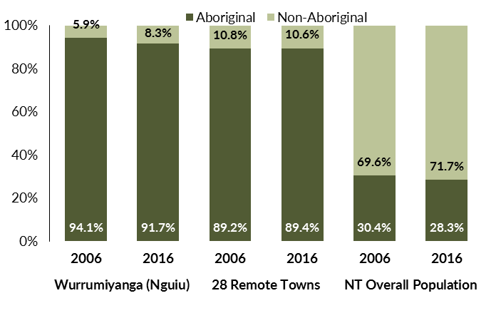

*Source: Department of Trade, Business and Innovation*

In 2016 in Wurrumiyanga (Nguiu):

* 91.7% of the population in Wurrumiyanga (Nguiu) were **Aboriginal**, compared to 94.1% in 2006
* 89.4% of the population across all 28 remote towns were **Aboriginal**
* 28.3% of the Northern Territory population were **Aboriginal**.

**Table 33: Unemployment and participation rates by Aboriginal status compared to the NT (q)**

|  |  |  |  |  |  |  |
| --- | --- | --- | --- | --- | --- | --- |
|  | **Wurrumiyanga (Nguiu)** | | | **Northern Territory** | | |
| **Aboriginal** | **Non-Aboriginal** | **Total** | **Aboriginal** | **Non-Aboriginal** | **Total** |
| **Unemployment rate** | 36.8% | 0.0% | 28.7% | 26.7% | 3.8% | 7.0% |
| **Participation rate** | 34.2% | 85.6% | 39.1% | 41.0% | 79.9% | 70.6% |

*Source: Department of Trade, Business and Innovation*

In 2016 in Wurrumiyanga (Nguiu) the:

* **total unemployment rate** was 28.7% compared to 7% for the total Northern Territory
* **Aboriginal unemployment rate** was 36.8% compared to 26.7% for the total Northern Territory
* **non-Aboriginal unemployment r**ate was 0% compared to 3.8% for the total Northern Territory
* **total participation rate** was 39.1% compared to 70.6% for the total Northern Territory
* **Aboriginal participation rate** was 34.2% compared to 41% for the total Northern Territory
* **non-Aboriginal participation rate** was 85.6% compared to 79.9% for the total Northern Territory.

# Community Development Programme

**Table 34: Community Development Programme Aboriginal Job Seekers, 30 April 2018 (o)**

|  |  |  |
| --- | --- | --- |
| **Indicator** | **Aboriginal** | |
| **No.** | **%** |
| **Total Aboriginal Job Seekers** | 361 | N/A |
| **Age (years)** | | |
| 15-24 | 111 | 30.7 |
| 25-44 | 170 | 47.1 |
| 45+ | 80 | 22.2 |
| **Total** | 361 | 100.0 |
| **Gender** | | |
| Male | 225 | 62.3 |
| Female | 136 | 37.7 |
| **Total** | 361 | 100.0 |
| **Employment Outcome - 1 July 2015 to 30 April 2018** | | |
| 13 Weeks | 76 | 57.1 |
| 26 Weeks | 57 | 42.9 |
| **Currently in Activities** | 305 |  |

*Source: Department of Prime Minister and Cabinet*

**Chart 14: Community Development Programme Aboriginal Job Seekers by Gender and Age Group, 30 April 2018 (o)**

See detailed description below.

*Source: Department of Prime Minister and Cabinet*

As at 30 April 2018, in Wurrumiyanga (Nguiu), there were 361 CDP **Aboriginal** job seekers, of these:

* 225 (62.3%) were male and 136 (37.7%) were female
* 111 (30.7%) were aged 15-24 years, 170 (47.1%) were aged 25-44 years, and 80 (22.2%) were aged 45+ years
* between 1 July 2015 and 30 April 2018, 76 had reached the 13 week reporting milestone and 57 had reached the 26 week reporting milestone
* 305 were currently in activities.

# Businesses

**Table 35: Businesses by Sector (d)(s)**

|  |  |  |  |
| --- | --- | --- | --- |
| **Business Name** | **Reported on in 2011** | **Reported on in 2014** | **Reported on in 2017** |
| **PUBLIC SECTOR** | | | |
| Department of Corrections | Yes | Yes | No |
| **Department of Health** | Yes | Yes | **Yes** |
| Department of Housing | Yes | Yes | No |
| **Department of Human Services trading as Centrelink** | Yes | Yes | **Yes** |
| **Department of the Prime Minister and Cabinet** | Yes | Yes | **Yes** |
| **Northern Territory Police, Fire Emergency Services** | Yes | Yes | **Yes** |
| **Territory Families** | No | Yes | **Yes** |
| Tiwi Islands Regional Council[4] | Yes | Yes | No |
| **PRIVATE SECTOR** | | | |
| AAT Australian Adventure Tours Pty Ltd trading as AAT Kings (Tiwi Tours) | Yes | Yes | No |
| **Australian Red Cross** | Yes | Yes | **Yes** |
| **Bathurst Island Housing Association (BIHA)** | Yes | Yes | **Yes** |
| **Bima Wear** | Yes | No | **Yes** |
| **Calvary Home Care Services Limited trading as Calvary Silver Circle** | Yes | Yes | **Yes** |
| **Catholic Care NT** | Yes | Yes | **Yes** |
| **Catholic Church of the Diocese of Darwin** | Yes | Yes | **Yes** |
| **Fly Tiwi** | Yes | Yes | **Yes** |
| ITEC Employment | Yes | No | No |
| Menzies School of Health Research | Yes | No | No |
| **Murrupurtiyanuwu Catholic Primary School** | Yes | Yes | **Yes** |
| Ngaruwanajirri Inc (The Keeping House) – Disability Art Centre | Yes | No | No |
| **Nguiu Club Association Inc** | Yes | Yes | **Yes** |
| **Nguiu Ullintjini Assoctiation Incorporated** | Yes | Yes | **Yes** |
| **Piliyamanyirra Supermarket** | No | Yes | **Yes** |
| Relationships Australia | Yes | No | No |
| **Tai Asian Food** | Yes | Yes | **Yes** |
| **Tiwi Designs Aboriginal Corporation Incorporated** | Yes | Yes | **Yes** |
| **Tiwi Enterprises Pty Ltd** | Yes | Yes | **Yes** |
| Tiwi Islands Football League Inc | Yes | No | No |
| **Tiwi Islands Training and Employment Board (TITEB)** | Yes | Yes | **Yes** |
| Tiwi Land Council | Yes | No | No |
| **Traditional Credit Union (TCU)** | No | Yes | **Yes** |
| **Xavier Catholic College Wurrumiyanga** | Yes | Yes | **Yes** |

*Source: Department of Trade, Business and Innovation*

*Note: Business names captured across the three survey periods have been identified by the current 2017 Business ABN name listed as at 2017.*

In 2017 in Wurrumiyanga (Nguiu):

* there were 22 businesses reported on, of which:
* 5 businesses were from the public sector (23%)
* 17 businesses were from the private sector (77 %)
* there were 3 businesses operating that were not operating in 2011.

# Notes

1. These counts represent numbers of filled jobs and not numbers of persons. As such the totals represent the total number of filled jobs, not the total number of employees. This count is not directly comparable to the total number of employed persons as a person may have several jobs or one job may be shared by more than one person.
2. Full-time is defined as a job usually requiring 35 hours or more per week or that required 35 hours or more work during the reference week. Part-time is defined as a job usually requiring less than 35 hours per week or that required less than 35 hours work during the reference week. The reference week refers to the period that respondents were asked to provide information about. In most instances it would be the week prior to the week the questionnaire was completed. Questionnaires were predominantly conducted in June and July.
3. Care needs to be taken when analysing the counts of filled jobs by the Aboriginal status of persons in the jobs. The Aboriginal status of the person employed in a job was reported by the business representative completing the questionnaire.
4. Sector was classified using the Standard Economic Sector of Classifications of Australia (SESCA), 2008.
5. Job permanency is classified according to what the business believes the level of job permanency is based on guidelines provided by data collectors. Those guidelines state a permanent job has paid annual and/or sick leave entitlements while a temporary job includes casual and fixed-term contract jobs.
6. Classified according to the Australian and New Zealand Standard Classification of Occupations (ANZSCO), 2006, major occupation level.
7. Other occupations include jobs where occupation was not stated, not known or inadequately described.
8. Classified using the Australian and New Zealand Standard Industrial Classification (ANZSIC), 2006, division level.
9. Care needs to be taken when analysing the counts of filled jobs by the gender of persons in the jobs. The gender of the person employed in a job is reported by the business representative completing the questionnaire.
10. Care needs to be taken when analysing the counts of filled jobs by the age of persons in the jobs. The age of the person employed in a job is reported by the business representative completing the questionnaire.
11. Students represent the number of individual clients that enrolled in a Vocational Education and Training unit during the calendar year.
12. Unit enrolments represent the count of individual units that students enrolled in during the calendar year.
13. Nominal hours delivered is the sum of the nominal hours of the units commenced during the calendar year regardless of when the course enrolment commenced.
14. Unit completions are the count of all successfully completed units reported in the calendar year regardless of the year of commencement of the units.
15. The Community Development Programme (CDP) supports job seekers in remote Australia to build skills, address barriers and contribute to their communities through a range of flexible activities. Under the CDP, job seekers with activity requirements are expected to do up to 25 hours per week of work-like activities that benefit their community. It should be noted that some CDP participants may be reported on within the profile if they are attached to a filled position with an employer captured in the survey. Due to confidentiality issues, data below 20 people is not published.
16. Population estimates for both 2006 and 2016 are taken from the estimated resident population (ERP) data produced by the Australian Bureau of Statistics (ABS) and based on Australian Statistical Geography Standard (ASGS) Statistical Area Level 1 (SA1) regions. ERP are official estimates of the Australian population, which link people to a place of usual residence with Australia. All ERP data sources, including the Census of Population and Housing (Census), are subject to error (including inaccuracies in collection, recording and processing data) and should be used with caution.
17. Indigenous population proportions, unemployment and workforce participation rates are based on ABS Census counts at ASGS Indigenous Locations (ILOCs) for each remote town.
18. Working-age population includes all residents aged 15 years and over (commonly referred to as the civilian population) and consists of persons that are employed, unemployed or not in the labour force.
19. A ‘business’ has been defined as any organisation that has undertaken productive activities in the last year, including companies, non-profit organisations, government departments and enterprises operating within the designated remote geography (town), and has one or more employees in paid employment and an Australian Business Number (ABN).

# Abbreviations and Acronyms

ABN Australian Business Number

ABS Australian Bureau of Statistics

ANZSCO Australian and New Zealand Standard Classification of Occupations

ANZSIC Australian and New Zealand Standard Industrial Classification

ASGS Australian Statistical Geography Standard

CDP Community Development Programme

ERP Estimated Resident Population

ILOC Indigenous Locations

nec Not Elsewhere Classified

No. Number

Perm Permanent

ppt Percentage point

RJCP Remote Jobs and Communities Program

Temp Temporary

SA1 Statistical Area Level 1

VET Vocational Education and Training

1. The number of filled jobs does not represent numbers of persons as a person may have several jobs or one job may be shared by more than one person.
2. 11 Aboriginal filled jobs gender status not identified in 2017
3. 11 Aboriginal filled jobs gender status not identified in 2017
4. Did not participate in the 2017 survey round – data imputed from previous surveys completed in 2014 or 2016.