Front cover page.
Heading of Remote Towns Jobs Profile 2017
Jobs profile remote town name Umbakumba
Remote Towns Jobs Profile

UMBAKUMBA

**© Northern Territory of Australia 2018**

**Preferred Reference:** Department of Trade, Business and Innovation, 2017 Remote Towns Jobs Profiles, Northern Territory Government, June 2018, Darwin.

**Disclaimer**

The data in this publication were predominantly collected by conducting a face-to-face survey of businesses within town boundaries during mid-2017. The collection methodology was created in accordance with Australian Bureau of Statistics data quality framework principles. Data in this publication are only reflective of those businesses reported on as operating in the town at the time of data collection (see table at the end of publication for list of businesses reported on).

To comply with privacy legislation or where appropriate, some data in this publication may have been adjusted and will not reflect the actual data reported by businesses. As a result of this, combined with certain data not being reported by some businesses, some components may not add to totals. Changes over time may also reflect business' change in propensity to report on certain data items rather than actual changes over time. Total figures have generally not been adjusted.

Caution is advised when interpreting the comparisons made to the earlier 2011 and 2014 publications as the businesses identified and reported on and the corresponding jobs may differ between publications.

Notes for each table and chart are alphabetically ordered and listed at the end of the publication.

Any use of this report for commercial purposes is not endorsed by the Department of Trade, Business and Innovation.

Contents

Umbakumba 4

Introduction 5

Summary 6

Jobs Overview 7

Jobs by Aboriginal Status 8

Jobs by Sector: Private and Public 10

Job Status: Permanent and Temporary 16

Job Vacancies 19

Jobs by Industry 21

Jobs by Occupation 27

Jobs by Industry by Occupation 30

Jobs by Gender 32

Jobs by Age 36

Vocational Education and Training 41

Population 44

Community Development Programme 46

Businesses 47

Notes 48

Abbreviations and Acronyms 49

# Umbakumba

Umbakumba is located on Groote Eylandt approximately 640 kilometres east-south-east of Darwin and south of Nhulunbuy (Gove), and 70 kilometres from the mining town of Alyangula, with a population of 569 residents.

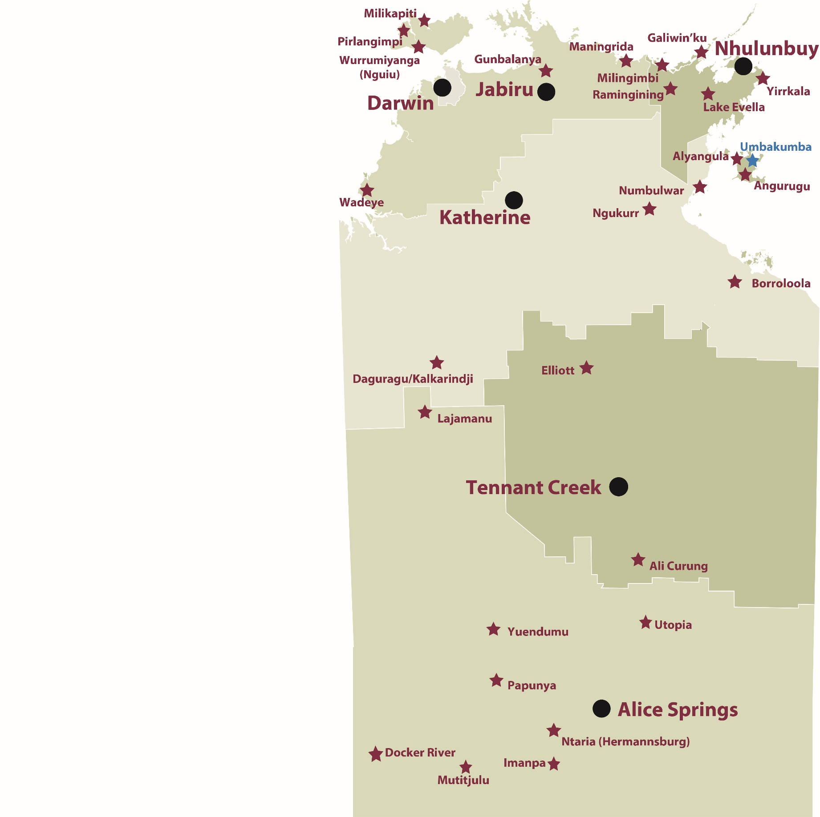

*Source: Department of Trade, Business and Innovation*

# Introduction

This jobs profile provides a snapshot of jobs and the characteristics of job holders in Umbakumba as at July 2017. It also outlines trends from the 2014 and 2011 surveys.

This job profile is one of 28 profiles developed for remote towns in the Northern Territory. It is anticipated these and subsequent profiles will contribute to a robust evidence base to inform decision making in and relating to these remote Territory towns.

This profile contains information collected by the Northern Territory Department of Trade, Business and Innovation from businesses operating within the town and is supplemented by other administrative data sets and information.

Each profile provides up-to-date information that is intended to inform the planning and design of current and future government programs and as an evidence base to inform decision making relating to workforce development, enterprise and job opportunities.

The data collection methodology and corresponding questionnaire were created in partnership with the Australian Bureau of Statistics (ABS) and in accordance with ABS data quality framework and survey principles.

The surveys were predominantly conducted by the Department’s Small Business Champions and Workforce Training Coordinators, on a face-to-face basis with business representatives.

The information collected and reported on represents a significant goodwill investment by those businesses and organisations that participated. Each business is listed at the end of this publication.

# Summary

The 2017 jobs profile was developed based on responses from 8 businesses operating within the Umbakumba town boundary, 2 more than in the 2014 survey. Of these, there were:

* 4 businesses from the private sector, accounting for 13 filled jobs or 24% of total filled jobs
* 4 businesses from the public sector, accounting for 42 filled jobs or 76% of total filled jobs
* 5 businesses participated in all three surveys (completed in 2011, 2014 and 2017).

A total of 68 filled and vacant jobs in Umbakumba were reported, a decrease of 18 jobs from 2014.[1]

The 2017 profile highlights:

* there were 55 filled jobs of which:
* 41 jobs (75%) were filled by Aboriginal persons, a decrease of 15 jobs from 2014
* 14 jobs (25%) were filled by non-Aboriginal persons, a decrease of 11 jobs from 2014
* 53% of employed Aboriginal people are working in the public sector
* Aboriginal persons accounted for 75% of job holders in the town compared to 69% in 2014
* Aboriginal females made up 68% of total Aboriginal filled jobs in the town compared to 66% in 2014
* there were 13 vacant jobs, of which:
* job vacancies as a percentage of jobs increased to 19% in 2017 from 6% in 2014
* job vacancies equate to 1 in 5 jobs
* 7 of the vacancies were in the Professional area
* Public Administration and Safety were the largest industry employer in 2017
* Education and Training and Retail Trade both had decreases of 8 filled jobs between 2017 and 2014
* training had a decrease in student numbers across all training sectors between 2016 and 2013
* Community Services, Health and Education had the largest decrease in student numbers of 24 between 2016 and 2013.

The overall population in Umbakumba increased by 112 persons (25%) between 2006 and 2016 to 569 persons

In comparison, the overall Northern Territory population increased by 16.5% between 2006 and 2016.

In 2016, the working age population (15 years and over) in Umbakumba was an estimated 406 persons compared to 317 in 2006 an increase by 28%.

There were 0.2 jobs in Umbakumba per working age person compared to 0.4 jobs per working age person across the 28 remote towns in the Northern Territory.

# Jobs Overview

Table 1: Count of filled jobs and vacancies, 2011, 2014 and 2017 (a)(b)

|  |  |  |  |  |  |
| --- | --- | --- | --- | --- | --- |
|  | **2011** | **2014** | **2017** | **Change 2011-2014** | **Change 2014-2017** |
| **Total All Jobs** | **114** | **86** | **68** | **-28** | **-18** |
| **Vacancies** | **4** | **5** | **13** | **1** | **8** |
| Vacancies as % of Total All Jobs | 3.5% | 5.8% | 19.1% | 2.3 ppt | 13.3 ppt |
| **Filled Jobs** | **110** | **81** | **55** | **-29** | **-26** |
| Full-time | 87 | 31 | 21 | -56 | -10 |
| Part-time | 23 | 50 | 34 | 27 | -16 |

Source: Department of Trade, Business and Innovation

Chart 1: Count of vacant jobs and filled jobs by full-time/part-time status, 2011, 2014 and 2017 (a)(b)

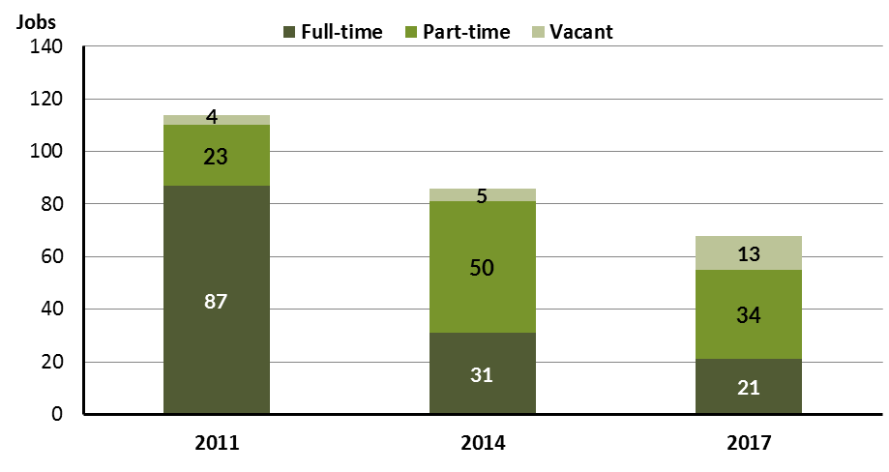

Source: Department of Trade, Business and Innovation

In 2017 in Umbakumba:

* there were a total of 55 **filled jobs**, a decrease of 26 jobs from 2014 and a decrease of 55 jobs from 2011
* of the 55 **filled jobs** in 2017:
* 21 were **full-time** jobs, a decrease of 10 jobs from 2014 and a decrease of 66 jobs from 2011
* 34 were **part-time** jobs, a decrease of 16 jobs from 2014 and an increase of 11 jobs from 2011
* there were 13 total job **vacancies** in 2017, an increase of 8 vacancies from 2014 and an increase of 9 vacancies from 2011.

# Jobs by Aboriginal Status

Chart 2: Count of filled jobs by Aboriginal status, 2011, 2014 and 2017 (a)(c)

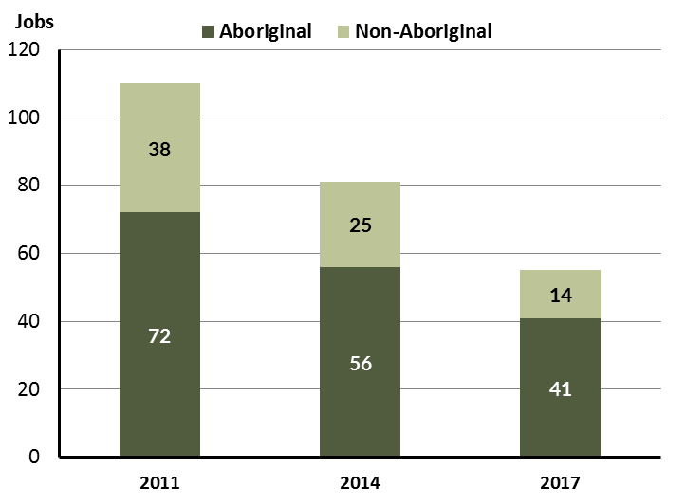

Source: Department of Trade, Business and Innovation

In 2017 in Umbakumba:

* of the 55 **filled jobs:**
* 41 jobs were filled by **Aboriginal** persons, a decrease of 15 jobs from 2014 and a decrease of 31 jobs from 2011
* 14 jobs were filled by **non-Aboriginal** persons, a decrease of 11 jobs from 2014 and a decrease of 24 jobs from 2011
* **Aboriginal** persons accounted for 75% of job holders compared to 69% in 2014 and 65% in 2011.

Table 2: Count of filled jobs by full-time/part-time status and Aboriginal status of person in job, 2011, 2014 and 2017 (a)(b)(c)

|  |  |  |  |  |  |  |  |  |  |  |  |  |  |  |  |
| --- | --- | --- | --- | --- | --- | --- | --- | --- | --- | --- | --- | --- | --- | --- | --- |
| **Indicator** | **2011** | | | **2014** | | | **2017** | | | **Change 2011-2014** | | | **Change 2014-2017** | | |
| **Aboriginal** | **Non-Aboriginal** | **Total** | **Aboriginal** | **Non-Aboriginal** | **Total** | **Aboriginal** | **Non-Aboriginal** | **Total** | **Aboriginal** | **Non-Aboriginal** | **Total** | **Aboriginal** | **Non-Aboriginal** | **Total** |
| Permanent | 62 | 24 | **86** | 24 | 19 | **43** | 19 | 9 | **28** | -38 | -5 | **-43** | -5 | -10 | **-15** |
| Temporary | 10 | 14 | **24** | 32 | 6 | **38** | 22 | 5 | **27** | 22 | -8 | **14** | -10 | -1 | **-11** |
| **Total** | **72** | **38** | **110** | **56** | **25** | **81** | **41** | **14** | **55** | **-16** | **-13** | **-29** | **-15** | **-11** | **-26** |

Source: Department of Trade, Business and Innovation

Chart 3: Count of filled jobs by full-time/part-time status and Aboriginal status of person in job, 2011, 2014 and 2017 (a)(b)(c)

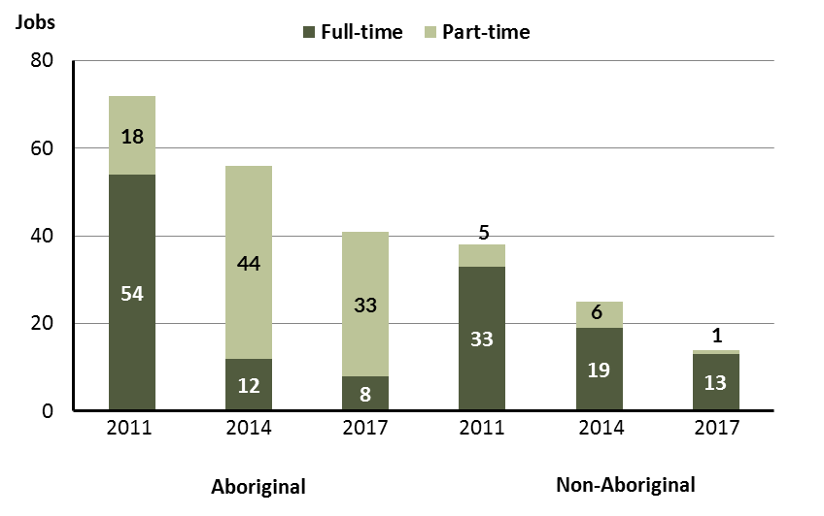

Source: Department of Trade, Business and Innovation

In 2017 in Umbakumba:

* of the 55 **filled jobs:**
* 8 were **full-time** jobs filled by **Aboriginal** persons, a decrease of 4 jobs from 2014 and a decrease of 46 jobs from 2011
* 33 were **part-time** jobs filled by **Aboriginal** persons, a decrease of 11 jobs from 2014 and an increase of 15 jobs from 2011
* 13 were **full-time** jobs filled by **non-Aboriginal** persons, a decrease of 6 jobs from 2014 and a decrease of 20 jobs from 2011
* 1 was a **part-time** job filled by a **non-Aboriginal** person, a decrease of 5 jobs from 2014 and a decrease of 4 jobs from 2011.

# Jobs by Sector: Private and Public

Table 3: Count of filled jobs by sector of business and by Aboriginal status of person employed in job, 2011, 2014 and 2017 (a)(b)(c)

|  |  |  |  |  |  |  |  |  |  |  |  |  |  |  |  |
| --- | --- | --- | --- | --- | --- | --- | --- | --- | --- | --- | --- | --- | --- | --- | --- |
| **Indicator** | **2011** | | | **2014** | | | **2017** | | | **Change 2011-2014** | | | **Change 2014-2017** | | |
| **Aboriginal** | **Non-Aboriginal** | **Total** | **Aboriginal** | **Non-Aboriginal** | **Total** | **Aboriginal** | **Non-Aboriginal** | **Total** | **Aboriginal** | **Non-Aboriginal** | **Total** | **Aboriginal** | **Non-Aboriginal** | **Total** |
| **Public Sector** | 34 | 20 | **54** | 41 | 20 | **61** | 29 | 13 | **42** | 7 | 0 | **7** | -12 | -7 | **-19** |
| Australian Government | 1 | 1 | **2** | 0 | 0 | **0** | 1 | 0 | **1** | -1 | -1 | **-2** | 1 | 0 | **1** |
| Territory Government | 9 | 13 | **22** | 16 | 13 | **29** | 7 | 9 | **16** | 7 | 0 | **7** | -9 | -4 | **-13** |
| Local Government | 24 | 6 | **30** | 25 | 7 | **32** | 21 | 4 | **25** | 1 | 1 | **2** | -4 | -3 | **-7** |
| **Private Sector** | 38 | 18 | **56** | 15 | 5 | **20** | 12 | 1 | **13** | -23 | -13 | **-36** | -3 | -4 | **-7** |
| **Total** | **72** | **38** | **110** | **56** | **25** | **81** | **41** | **14** | **55** | **-16** | **-13** | **-29** | **-15** | **-11** | **-26** |

Source: Department of Trade, Business and Innovation

Chart 4: Count of filled jobs by sector of business, 2011, 2014 and 2017 (a)(d)

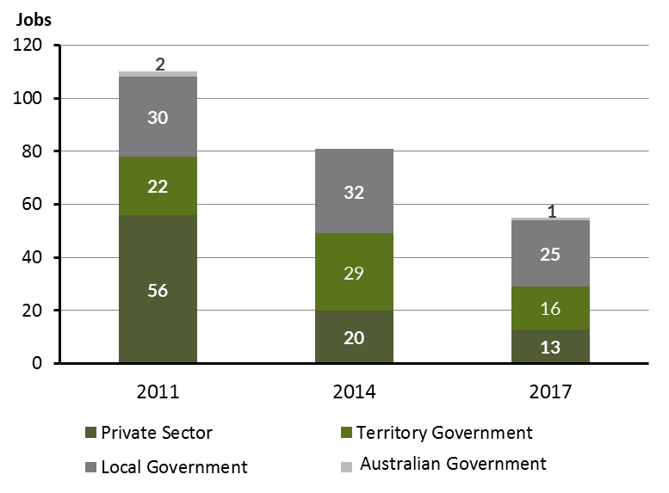

Source: Department of Trade, Business and Innovation

Chart 5: Percentage of filled jobs by sector of business in 2017 (a)(d)

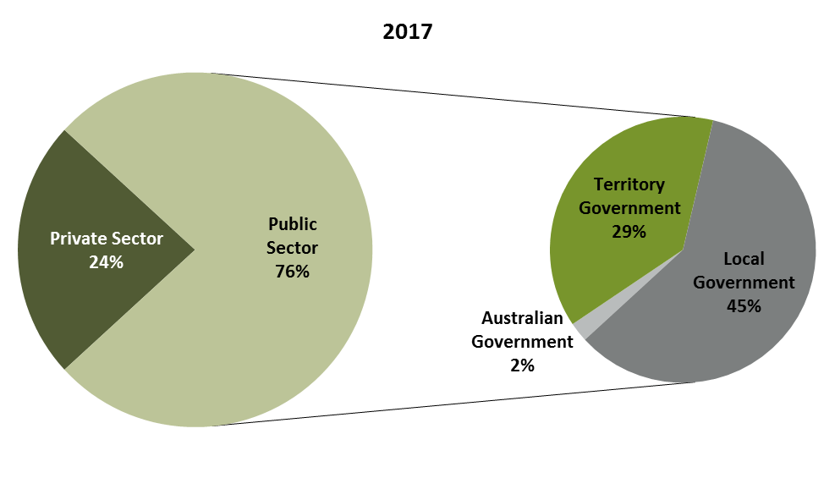

Source: Department of Trade, Business and Innovation

In 2017 in Umbakumba:

* there were 42 jobs in the **public sector**, a decrease of 19 jobs from 2014 and a decrease of 12 jobs from 2011
* of the 42 jobs in the **public sector** in 2017:
* 1 job was in the Australian Government, an increase of 1 job from 2014 and a decrease of 1 job from 2011
* 16 jobs were in the Territory Government, a decrease of 13 jobs from 2014 and a decrease of 6 jobs from 2011
* 25 jobs were in the Local Government, a decrease of 7 jobs from 2014 and a decrease of 5 jobs from 2011
* there were 13 jobs in the **private** **sector**, a decrease of 7 jobs from 2014 and a decrease of 43 jobs from 2011.

Chart 6: Count of filled jobs by sector and Aboriginal status of person in job, 2011, 2014 and 2017 (a)(c)(d)

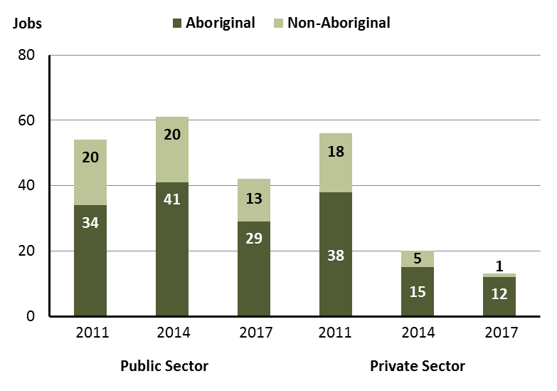

Source: Department of Trade, Business and Innovation

In 2017 in Umbakumba:

* of the 42 jobs in the **public** **sector**:
* 29 jobs were filled by **Aboriginal** persons, a decrease of 12 jobs from 2014 and a decrease of 5 jobs from 2011
* 13 jobs were filled by **non-Aboriginal** persons, a decrease of 7 jobs from 2014 and a decrease of 7 jobs from 2011
* of the 13 jobs in the **private** **sector**:
* 12 jobs were filled by **Aboriginal** persons, a decrease of 3 jobs from 2014 and a decrease of 26 jobs from 2011
* 1 job was filled by a **non-Aboriginal** person, a decrease of 4 jobs from 2014 and a decrease of 17 jobs from 2011

Chart 7: Count of filled jobs by sector and full-time/part-time status of person in job, 2011, 2014 and 2017 (a)(b)(d)

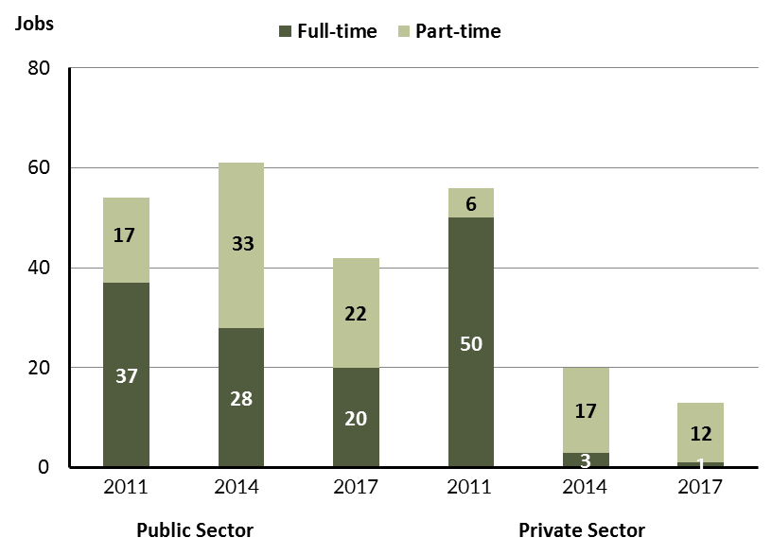

Source: Department of Trade, Business and Innovation

In 2017 in Umbakumba:

* of the 42 jobs in the **public sector**:
* 20 were full-time jobs, a decrease of 8 jobs from 2014 and a decrease of 17 jobs from 2011
* 22 were part-time jobs, a decrease of 11 jobs from 2014 and an increase of 5 jobs from 2011
* of the 13 jobs in the **private sector**:
* 1 was a full-time job, a decrease of 2 jobs from 2014 and a decrease of 49 jobs from 2011
* 12 were part-time jobs, a decrease of 5 jobs from 2014 and an increase of 6 jobs from 2011.

Table 4: Count of filled jobs by full-time/part-time status and Aboriginal status of person in job by sector, 2011, 2014, and 2017 (a)(b)(c)(d)

|  |  |  |  |  |  |  |  |  |  |  |
| --- | --- | --- | --- | --- | --- | --- | --- | --- | --- | --- |
| **Indicator** | **2011** | | | | | | | | | |
| **Aboriginal** | | | **Non-Aboriginal** | | | **Total** | | | |
| **Full-time** | **Part-time** | **Total** | **Full-time** | **Part-time** | **Total** | **Full-time** | **Part-time** | **Total** |
| Public Sector | 22 | 12 | **34** | 15 | 5 | **20** | 37 | 17 | **54** |
| Private Sector | 32 | 6 | **38** | 18 | 0 | **18** | 50 | 6 | **56** |
| **Total** | **54** | **18** | **72** | **33** | **5** | **38** | **87** | **23** | **110** |

|  |  |  |  |  |  |  |  |  |  |  |
| --- | --- | --- | --- | --- | --- | --- | --- | --- | --- | --- |
| **Indicator** | **2014** | | | | | | | | | |
| **Aboriginal** | | | **Non-Aboriginal** | | | **Total** | | | |
| **Full-time** | **Part-time** | **Total** | **Full-time** | **Part-time** | **Total** | **Full-time** | **Part-time** | **Total** |
| Public Sector | 12 | 29 | **41** | 16 | 4 | **20** | 28 | 33 | **61** |
| Private Sector | 0 | 15 | **15** | 3 | 2 | **5** | 3 | 17 | **20** |
| **Total** | **12** | **44** | **56** | **19** | **6** | **25** | **31** | **50** | **81** |

|  |  |  |  |  |  |  |  |  |  |
| --- | --- | --- | --- | --- | --- | --- | --- | --- | --- |
| **Indicator** | **2017** | | | | | | | | |
| **Aboriginal** | | | **Non-Aboriginal** | | | **Total** | | |
| **Full-time** | **Part-time** | **Total** | **Full-time** | **Part-time** | **Total** | **Full-time** | **Part-time** | **Total** |
| Public Sector | 8 | 21 | **29** | 12 | 1 | **13** | 20 | 22 | **42** |
| Private Sector | 0 | 12 | **12** | 1 | 0 | **1** | 1 | 12 | **13** |
| **Total** | **12** | **44** | **41** | **13** | **1** | **14** | **21** | **34** | **55** |

Source: Department of Trade, Business and Innovation

In 2017 in Umbakumba there were:

* 29 jobs in the **public** **sector** filled by **Aboriginal** persons, a decrease of 12 jobs from 2014 and a decrease of 5 jobs from 2011, of which:
* 8 were **full-time** jobs, a decrease of 4 jobs from 2014 and a decrease of 14 jobs from 2011
* 21 were **part-time** jobs, a decrease of 8 jobs from 2014 and an increase of 9 jobs from 2011
* 12 jobs in the **private** **sector** filled by **Aboriginal** persons, a decrease of 3 jobs from 2014 and a decrease of 26 jobs from 2011, of which:
* none were **full-time** jobs, unchanged from 2014 and a decrease of 32 jobs from 2011
* 12 were **part-time** jobs, a decrease of 3 jobs from 2014 and an increase of 6 jobs from 2011
* 13 jobs in the **public** **sector** filled by **non-Aboriginal** persons, a decrease of 7 jobs from 2014 and a decrease of 7 jobs from 2011, of which:
* 12 were **full-time** jobs, a decrease of 4 jobs from 2014 and a decrease of 3 jobs from 2011
* 1 was a **part-time** job, a decrease of 3 jobs from 2014 and a decrease of 4 jobs from 2011
* 1 job was in the **private** **sector** filled by a **non-Aboriginal** person, a decrease of 4 jobs from 2014 and a decrease of 17 jobs from 2011, of which:
* 1 was a **full-time** job, a decrease of 2 jobs from 2014 and a decrease of 17 jobs from 2011
* none **were part**-time jobs, a decrease of 2 jobs from 2014 and unchanged from 2011.

# Job Status: Permanent and Temporary

Table 5: Count of filled jobs by employment status and Aboriginal status of person in job, 2011, 2014, and 2017 (a)(c)(e)

|  |  |  |  |  |  |  |  |  |  |  |  |  |  |  |  |  |
| --- | --- | --- | --- | --- | --- | --- | --- | --- | --- | --- | --- | --- | --- | --- | --- | --- |
| **Indicator** | **2011** | | | **2014** | | | **2017** | | | **Change 2011-2014** | | | **Change 2014-2017** | | | |
| **Aboriginal** | **Non-Aboriginal** | **Total** | **Aboriginal** | **Non-Aboriginal** | **Total** | **Aboriginal** | **Non-Aboriginal** | **Total** | **Aboriginal** | **Non-Aboriginal** | **Total** | **Aboriginal** | **Non-Aboriginal** | **Total** |
| Permanent | 62 | 24 | **86** | 24 | 19 | **43** | 19 | 9 | **28** | -38 | -5 | **-43** | -5 | -10 | **-15** |
| Temporary | 10 | 14 | **24** | 32 | 6 | **38** | 22 | 5 | **27** | 22 | -8 | **14** | -10 | -1 | **-11** |
| **Total** | **72** | **38** | **110** | **56** | **25** | **81** | **41** | **14** | **55** | **-16** | **-13** | **-29** | **-15** | **-11** | **-26** |

Source: Department of Trade, Business and Innovation

Chart 8: Count of filled jobs by employment status and Aboriginal status of person in job, 2011, 2014 and 2017 (a)(c)(e)

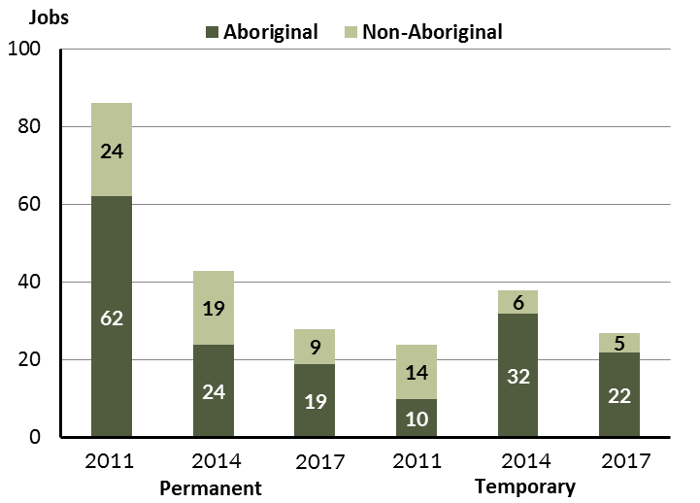

Source: Department of Trade, Business and Innovation

In 2017 in Umbakumba:

* there were 28 **permanent** jobs, a decrease of 15 jobs from 2014, and a decrease of 58 jobs from 2011, of which:
* 19 jobs were filled by **Aboriginal** persons, a decrease of 5 jobs from 2014 and a decrease of 43 jobs from 2011
* 9 jobs were filled by **non-Aboriginal** persons, a decrease of 10 jobs from 2014 and a decrease of 15 jobs from 2011
* there were 27 **temporary** jobs, a decrease of 11 jobs from 2014 and an increase of 3 jobs from 2011, of which:
* 22 jobs were filled by **Aboriginal** persons, a decrease of 10 jobs from 2014 and an increase of 12 jobs from 2011
* 5 jobs were filled by **non-Aboriginal** persons, a decrease of 1 job from 2014 and a decrease of 9 jobs from 2011.

Table 6: Count of filled jobs by sector, Aboriginal status and employment status of person in job, 2011, 2014 and 2017 (a)(c)(d)(e)

|  |  |  |  |  |  |  |  |  |  |
| --- | --- | --- | --- | --- | --- | --- | --- | --- | --- |
| **Indicator** | **2011** | | | | | | | | |
| **Aboriginal** | | | **Non-Aboriginal** | | | **Total** | | |
| **Perm** | **Temp** | **Total** | **Perm** | **Temp** | **Total** | **Perm** | **Temp** | **Total** |
| Public Sector | 24 | 10 | **34** | 8 | 12 | **20** | 32 | 22 | **54** |
| Private Sector | 38 | 0 | **38** | 16 | 2 | **18** | 54 | 2 | **56** |
| **Total** | **62** | **10** | **72** | **24** | **14** | **38** | **86** | **24** | **110** |

|  |  |  |  |  |  |  |  |  |  |
| --- | --- | --- | --- | --- | --- | --- | --- | --- | --- |
| **Indicator** | **2014** | | | | | | | | |
| **Aboriginal** | | | **Non-Aboriginal** | | | **Total** | | |
| **Perm** | **Temp** | **Total** | **Perm** | **Temp** | **Total** | **Perm** | **Temp** | **Total** |
| Public Sector | 9 | 32 | **41** | 15 | 5 | **20** | 24 | 37 | **61** |
| Private Sector | 15 | 0 | **15** | 4 | 1 | **5** | 19 | 1 | **20** |
| **Total** | **24** | **32** | **56** | **19** | **6** | **25** | **43** | **38** | **81** |

|  |  |  |  |  |  |  |  |  |  |
| --- | --- | --- | --- | --- | --- | --- | --- | --- | --- |
| **Indicator** | **2017** | | | | | | | | |
| **Aboriginal** | | | **Non-Aboriginal** | | | **Total** | | |
| **Perm** | **Temp** | **Total** | **Perm** | **Temp** | **Total** | **Perm** | **Temp** | **Total** |
| Public Sector | 18 | 11 | **29** | 9 | 4 | **13** | 27 | 15 | **42** |
| Private Sector | 1 | 11 | **12** | 0 | 1 | **1** | 1 | 12 | **13** |
| **Total** | **19** | **22** | **41** | **9** | **5** | **14** | **28** | **27** | **55** |

Source: Department of Trade, Business and Innovation

In 2017 in Umbakumba there were:

* 42 jobs in the **public** **sector**, a decrease of 19 jobs from 2014 and a decrease of 12 jobs from 2011, of which:
* 27 jobs were **permanent**, an increase of 3 jobs from 2014 and a decrease of 5 jobs from 2011, of which:
* 18 jobs were filled by **Aboriginal** persons, an increase of 9 jobs from 2014 and a decrease of 6 jobs from 2011
* 9 jobs were filled by **non-Aboriginal** persons, a decrease of 6 jobs from 2014 and an increase of 1 job from 2011
* 15 jobs were **temporary**, a decrease of 22 jobs from 2014 and a decrease of 7 jobs from 2011, of which:
* 11 jobs were filled by **Aboriginal** persons, a decrease of 21 jobs from 2014 and an increase of 1 job from 2011
* 4 jobs were filled by **non-Aboriginal** persons, a decrease of 1 job from 2014 and a decrease of 8 jobs from 2011
* 13 jobs in the **private** **sector**, a decrease of 7 jobs from 2014 and a decrease of 43 jobs from 2011, of which:
* 1 job was **permanent**, a decrease of 18 jobs from 2014 and a decrease of 53 jobs from 2011, of which:
* 1 job was filled by a **Aboriginal** person, a decrease of 14 jobs from 2014 and a decrease of 37 jobs from 2011
* none were filled by **non-Aboriginal** persons, a decrease of 4 jobs from 2014 and a decrease of 16 jobs from 2011
* 12 jobs were **temporary**, an increase of 11 jobs from 2014 and an increase of 10 jobs from 2011, of which:
* 11 jobs were filled by **Aboriginal** persons, an increase of 11 jobs from 2014 and an increase of 11 jobs from 2011
* 1 job was filled by a **non-Aboriginal** person, unchanged from 2014 and a decrease of 1 job from 2011.

# Job Vacancies

Table 7: Job vacancies, 2011, 2014, and 2017

|  |  |  |  |  |  |
| --- | --- | --- | --- | --- | --- |
| **Indicator** | **2011** | **2014** | **2017** | **Change 2011-2014** | **Change 2014-2017** |
| **Job vacancies** | **4** | **5** | **13** | **1** | **8** |

Source: Department of Trade, Business and Innovation

Table 8: Job vacancies by occupation, 2011, 2014, and 2017 (f)(g)

|  |  |  |  |  |  |
| --- | --- | --- | --- | --- | --- |
| **Occupation (ANZSCO major group)** | **2011** | **2014** | **2017** | **Change 2011-2014** | **Change 2014-2017** |
| Clerical and Administrative Workers | 0 | 0 | 3 | 0 | 3 |
| Community and Personal Service Workers | 3 | 0 | 2 | -3 | 2 |
| Labourers | 1 | 1 | 1 | 0 | 0 |
| Professionals | 0 | 4 | 7 | 4 | 3 |
| **Total** | **4** | **5** | **13** | **1** | **8** |

Source: Department of Trade, Business and Innovation

Table 9: Job vacancies by job title, July 2017 (f)

|  |  |
| --- | --- |
| **Job Vacancy** | **No.** |
| Community Worker | 1 |
| General Clerk | 2 |
| Handyperson | 1 |
| Liaison Officer | 1 |
| Primary School Teacher | 4 |
| Program or Project Administrator | 1 |
| Registered Nurses nec | 1 |
| Teachers' Aide | 1 |
| Vocational Education Teacher | 1 |
| **Total** | **13** |

Source: Department of Trade, Business and Innovation

In 2017 in Umbakumba:

* there were 13 **vacancies** reported, an increase of 8 vacancies from 2014 and an increase of 9 vacancies from 2011
* of the 13 reported vacancies, the largest requirements were for:
* 7 Professionals, the majority of which is in the following job:
* Primary School Teacher
* 3 Clerical and Administrative Workers in the following jobs:
* General Clerk
* Program or Project Administrator
* 2 Community and Personal Service Workers in the following jobs:
* Community Worker
* Teacher’s Aide.

# Jobs by Industry

Table 10: Count of filled jobs by industry of business, 2011, 2014 and 2017 (a)(h)

|  |  |  |  |  |  |  |  |  |
| --- | --- | --- | --- | --- | --- | --- | --- | --- |
| **Industry (ANZSIC Division)** | **2011** | | **2014** | | **2017** | | **Change 2011-2014** | **Change 2014-2017** |
| **Total** | **% of Total** | **Total** | **% of Total** | **Total** | **% of Total** | **Total** | **Total** |
| Arts and Recreation Services | 2 | 1.8% | 0 | 0.0% | 0 | 0.0% | -2 | 0 |
| Construction | 44 | 40.0% | 0 | 0.0% | 0 | 0.0% | -44 | 0 |
| Education and Training | 15 | 13.6% | 20 | 24.7% | 12 | 21.8% | 5 | -8 |
| Electricity, Gas, Water and Waste Services | 1 | 0.9% | 1 | 1.2% | 1 | 1.8% | 0 | 0 |
| Financial and Insurance Services | 0 | 0.0% | 0 | 0.0% | 0 | 0.0% | 0 | 0 |
| Health Care and Social Assistance | 6 | 5.5% | 9 | 11.1% | 5 | 9.1% | 3 | -4 |
| Public Administration and Safety | 33 | 30.0% | 32 | 39.5% | 26 | 47.3% | -1 | -6 |
| Retail Trade | 8 | 7.3% | 19 | 23.5% | 11 | 20.0% | 11 | -8 |
| **Total** | **110** | **100.0%** | **81** | **100.0%** | **55** | **100.0%** | **-29** | **-26** |

Source: Department of Trade, Business and Innovation

In 2017 in Umbakumba:

* the Public Administration and Safety industry was the **largest** **industry** **employer**, with 26 filled jobs or 47.3% of filled jobs, a decrease of 6 jobs from 2014 and a decrease of 7 jobs from 2011
* **other** **significant** industry employers were:
* Education and Training with 12 jobs (or 21.8% of filled jobs), a decrease of 8 jobs from 2014 and a decrease of 3 jobs from 2011
* Retail Trade with 11 jobs (or 20% of filled jobs), a decrease of 8 jobs from 2014 and an increase of 3 jobs from 2011
* Health Care and Social Assistance with 5 jobs (or 9.1% of filled jobs), a decrease of 4 jobs from 2014 and a decrease of 1 jobs from 2011.

Table 11: Count of filled jobs by industry of business and Aboriginal status of person in job, 2011, 2014, and 2017 (a)(c)(h)

|  |  |  |  |  |  |  |  |  |  |  |  |  |  |  |  |  |
| --- | --- | --- | --- | --- | --- | --- | --- | --- | --- | --- | --- | --- | --- | --- | --- | --- |
| **Industry (ANZSIC division)** | **2011** | | | **2014** | | | **2017** | | | **Change 2011-2014** | | | **Change  2014-2017** | | | |
| **Aboriginal** | **Non-Aboriginal** | **Total** | **Aboriginal** | **Non-Aboriginal** | **Total** | **Aboriginal** | **Non-Aboriginal** | **Total** | **Aboriginal** | **Non-Aboriginal** | **Total** | **Aboriginal** | **Non-Aboriginal** | **Total** |
| Arts and Recreation Services | 0 | 2 | **2** | 0 | 0 | **0** | 0 | 0 | **0** | 0 | -2 | **-2** | 0 | 0 | **0** |
| Construction | 30 | 14 | **44** | 0 | 0 | **0** | 0 | 0 | **0** | -30 | -14 | **-44** | 0 | 0 | **0** |
| Education and Training | 3 | 12 | **15** | 11 | 9 | **20** | 5 | 7 | **12** | 8 | -3 | **5** | -6 | -2 | **-8** |
| Electricity, Gas, Water and Waste Services | 1 | 0 | **1** | 0 | 1 | **1** | 0 | 1 | **1** | -1 | 1 | **0** | 0 | 0 | **0** |
| Health Care and Social Assistance | 6 | 0 | **6** | 5 | 4 | **9** | 3 | 2 | **5** | -1 | 4 | **3** | -2 | -2 | **-4** |
| Public Administration and Safety | 26 | 7 | **33** | 25 | 7 | **32** | 22 | 4 | **26** | -1 | 0 | **-1** | -3 | -3 | **-6** |
| Retail Trade | 6 | 2 | **8** | 15 | 4 | **19** | 11 | 0 | **11** | 9 | 2 | **11** | -4 | -4 | **-8** |
| **Total** | **72** | **38** | **110** | **56** | **25** | **81** | **41** | **14** | **55** | **-16** | **-13** | **-29** | **-15** | **-11** | **-26** |

Source: Department of Trade, Business and Innovation

Chart 9: Count of filled jobs by top 5 industries of business and Aboriginal status of person in job, 2017 (a)(c)(h)

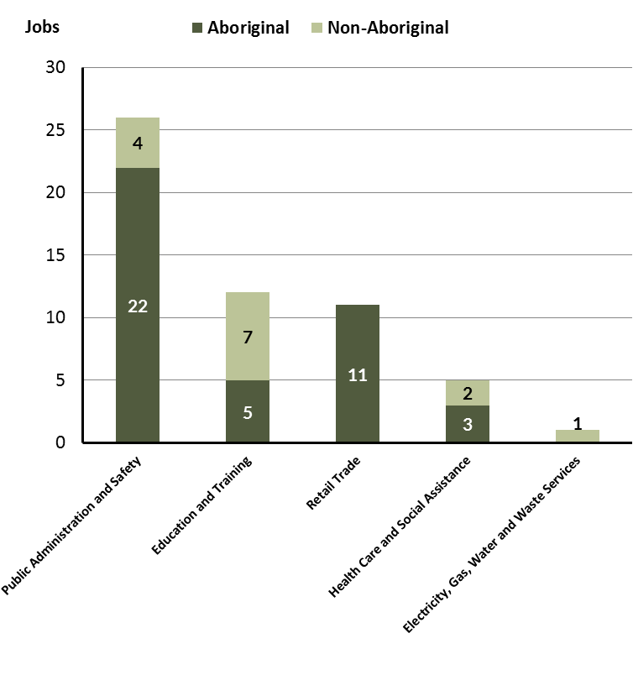

Source: Department of Trade, Business and Innovation

In 2017 in Umbakumba:

* of the 41 **jobs filled** by **Aboriginal** persons, there were:
* 22 jobs in Public Administration and Safety, a decrease of 3 jobs from 2014 and a decrease of 4 jobs from 2011
* 5 jobs in Education and Training, a decrease of 6 jobs from 2014 and an increase of 2 jobs from 2011
* 11 jobs in Retail Trade, a decrease of 4 jobs from 2014 and an increase of 5 jobs from 2011
* of the 14 **jobs filled** by **non-Aboriginal** persons, there were:
* 4 jobs in Public Administration and Safety, a decrease of 3 jobs from 2014 and a decrease of 3 jobs from 2011
* 7 jobs in Education and Training, a decrease of 2 jobs from 2014 and a decrease of 5 jobs from 2011
* none were in Retail Trade, a decrease of 4 jobs from 2014 and a decrease of 2 jobs from 2011.

Table 12: Count of filled jobs by industry, employment status and Aboriginal status of person in job, 2011 (a)(c)(e)(h)

|  |  |  |  |  |  |  |  |  |  |
| --- | --- | --- | --- | --- | --- | --- | --- | --- | --- |
| **Industry (ANZSIC division)** | **2011** | | | | | | | | |
| **Aboriginal** | | | **Non-Aboriginal** | | | **Total** | | |
| **Perm** | **Temp** | **Total** | **Perm** | **Temp** | **Total** | **Perm** | **Temp** | **Total** |
| Arts and Recreation Services | 0 | 0 | **0** | 2 | 0 | **2** | 2 | 0 | **2** |
| Construction | 30 | 0 | **30** | 14 | 0 | **14** | 44 | 0 | **44** |
| Education and Training | 0 | 3 | **3** | 3 | 9 | **12** | 3 | 12 | **15** |
| Electricity, Gas, Water and Waste Services | 1 | 0 | **1** | 0 | 0 | **0** | 1 | 0 | **1** |
| Health Care and Social Assistance | 2 | 4 | **6** | 0 | 0 | **0** | 2 | 4 | **6** |
| Public Administration and Safety | 23 | 3 | **26** | 5 | 2 | **7** | 28 | 5 | **33** |
| Retail Trade | 6 | 0 | **6** | 0 | 2 | **2** | 6 | 2 | **8** |
| **Total** | **62** | **10** | **72** | **24** | **14** | **38** | **86** | **24** | **110** |

Source: Department of Trade, Business and Innovation

Table 13: Count of filled jobs by industry, employment status and Aboriginal status of person in job, 2014 (a)(c)(e)(h)

|  |  |  |  |  |  |  |  |  |  |
| --- | --- | --- | --- | --- | --- | --- | --- | --- | --- |
| **Industry (ANZSIC division)** | **2014** | | | | | | | | |
| **Aboriginal** | | | **Non-Aboriginal** | | | **Total** | | |
| **Perm** | **Temp** | **Total** | **Perm** | **Temp** | **Total** | **Perm** | **Temp** | **Total** |
| Education and Training | 2 | 9 | **11** | 6 | 3 | **9** | 8 | 12 | **20** |
| Electricity, Gas, Water and Waste Services | 0 | 0 | **0** | 0 | 1 | **1** | 0 | 1 | **1** |
| Health Care and Social Assistance | 5 | 0 | **5** | 4 | 0 | **4** | 9 | 0 | **9** |
| Public Administration and Safety | 2 | 23 | **25** | 5 | 2 | **7** | 7 | 25 | **32** |
| Retail Trade | 15 | 0 | **15** | 4 | 0 | **4** | 19 | 0 | **19** |
| **Total** | **24** | **32** | **56** | **19** | **6** | **25** | **43** | **38** | **81** |

Source: Department of Trade, Business and Innovation

Table 14: Count of filled jobs by industry, employment status and Aboriginal status of person in job, 2017 (a)(c)(e)(h)

|  |  |  |  |  |  |  |  |  |  |
| --- | --- | --- | --- | --- | --- | --- | --- | --- | --- |
| **Industry (ANZSIC division)** | **2017** | | | | | | | | |
| **Aboriginal** | | | **Non-Aboriginal** | | | **Total** | | |
| **Perm** | **Temp** | **Total** | **Perm** | **Temp** | **Total** | **Perm** | **Temp** | **Total** |
| Education and Training | 4 | 1 | **5** | 5 | 2 | **7** | 9 | 3 | **12** |
| Electricity, Gas, Water and Waste Services | 0 | 0 | **0** | 0 | 1 | **1** | 0 | 1 | **1** |
| Health Care and Social Assistance | 1 | 2 | **3** | 0 | 2 | **2** | 1 | 4 | **5** |
| Public Administration and Safety | 14 | 8 | **22** | 4 | 0 | **4** | 18 | 8 | **26** |
| Retail Trade | 0 | 11 | **11** | 0 | 0 | **0** | 0 | 11 | **11** |
| **Total** | **19** | **22** | **41** | **9** | **5** | **14** | **28** | **27** | **55** |

Source: Department of Trade, Business and Innovation

In 2017 in Umbakumba:

* of the 28 **permanent** **jobs,** there were:
* 18 jobs in Public Administration and Safety, an increase of 11 jobs from 2014 and a decrease of 10 jobs from 2011, including:
* 14 jobs filled by **Aboriginal** persons, an increase of 12 jobs from 2014 and a decrease of 9 jobs from 2011
* 4 jobs filled by **non-Aboriginal** persons, a decrease of 1 job from 2014 and a decrease of 1 job from 2011
* 9 jobs in Education and Training, an increase of 1 job from 2014 and an increase of 6 jobs from 2011, including:
* 4 jobs filled by **Aboriginal** persons, an increase of 2 jobs from 2014 and an increase of 4 jobs from 2011
* 5 jobs filled by **non-Aboriginal** persons, a decrease of 1 job from 2014 and an increase of 2 jobs from 2011
* 1 job in Health Care and Social Assistance, a decrease of 8 jobs from 2014 and a decrease of 1 job from 2011, including:
* 1 job was filled by an **Aboriginal** person, a decrease of 4 jobs from 2014 and a decrease of 1 job from 2011
* none were filled by **non-Aboriginal** persons, a decrease of 4 jobs from 2014 and unchanged from 2011
* of the 27 **temporary jobs,** there were:
* 11 jobs in Retail Trade, an increase of 11 jobs from 2014 and an increase of 9 jobs from 2011, including:
* 11 jobs filled by **Aboriginal** persons, an increase of 11 jobs from 2014 and an increase of 11 jobs from 2011
* none were filled by **non-Aboriginal** persons, unchanged from 2014 and a decrease of 2 jobs from 2011
* 8 jobs in Public Administration and Safety, a decrease of 17 jobs from 2014 and an increase of 3 jobs from 2011, including:
* 8 jobs filled by **Aboriginal** persons, a decrease of 15 jobs from 2014 and an increase of 5 jobs from 2011
* none were filled by **non-Aboriginal** persons, a decrease of 2 jobs from 2014 and a decrease of 2 jobs from 2011
* 4 jobs in Health Care and Social Assistance, an increase of 4 jobs from 2014 and unchanged from 2011, including
* 2 jobs filled by **Aboriginal** persons, an increase of 2 jobs from 2014 and a decrease of 2 jobs from 2011
* 2 jobs filled by **non-Aboriginal** persons, an increase of 2 jobs from 2014 and an increase of 2 jobs from 2011.

# Jobs by Occupation

Table 15: Count of filled jobs by occupation, 2011, 2014 and 2017 (a)(f)(g)

|  |  |  |  |  |  |  |  |  |
| --- | --- | --- | --- | --- | --- | --- | --- | --- |
| **Occupation (ANZSCO major group)** | **2011** | | **2014** | | **2017** | | **Change 2011-2014** | **Change 2014-2017** |
| **Total** | **% of Total** | **Total** | **% of Total** | **Total** | **% of Total** | **Total** | **Total** |
| Clerical and Administrative Workers | 6 | 5.5% | 4 | 4.9% | 2 | 3.6% | -2 | -2 |
| Community and Personal Service Workers | 22 | 20.0% | 30 | 37.0% | 17 | 30.9% | 8 | -13 |
| Labourers | 35 | 31.8% | 11 | 13.6% | 8 | 14.5% | -24 | -3 |
| Machinery Operators and Drivers | 6 | 5.5% | 0 | 0.0% | 0 | 0.0% | -6 | 0 |
| Managers | 8 | 7.3% | 4 | 4.9% | 5 | 9.1% | -4 | 1 |
| Professionals | 14 | 12.7% | 15 | 18.5% | 10 | 18.2% | 1 | -5 |
| Sales Workers | 4 | 3.6% | 17 | 21.0% | 11 | 20.0% | 13 | -6 |
| Technicians and Trades Workers | 12 | 10.9% | 0 | 0.0% | 2 | 3.6% | -12 | 2 |
| Other occupations | 3 | 2.7% | 0 | 0.0% | 0 | 0.0% | -3 | 0 |
| **Total** | **110** | **100.0%** | **81** | **100.0%** | **55** | **100.0%** | **-29** | **-26** |

Source: Department of Trade, Business and Innovation

Chart 10: Percentage and count of top 6 filled jobs by occupation, 2011, 2014 and 2017 (a)(f)(g)

Pie Chart breakdown of occupation for 
Technicians and Tarde Workers. 
Total and percentage breakdown provided in table above - Table 15.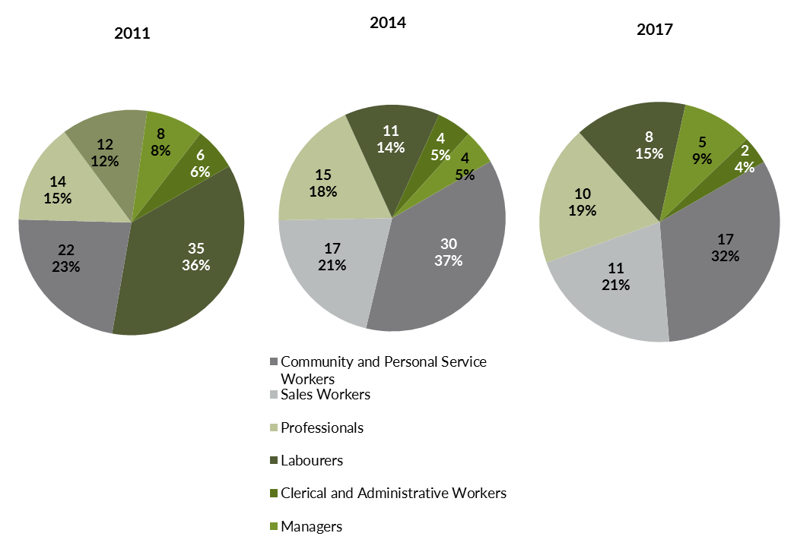

Source: Department of Trade, Business and Innovation

In 2017 in Umbakumba:

* Community and Personal Service Workers was the **largest** **occupation** **classification** in terms of filled jobs, accounting for 17 jobs (30.9% of total filled jobs), a decrease of 13 jobs from 2014 and a decrease of 5 jobs from 2011
* **other** **significant** occupation classifications were:
* Sales Workers accounting for 11 jobs or 20% of total jobs a decrease of 6 jobs from 2014 and an increase of 7 jobs from 2011
* Professionals accounting for 10 jobs or 18.2% of total jobs a decrease of 5 jobs from 2014 and a decrease of 4 jobs from 2011
* Labourers accounting for 8 jobs or 14.5% of total jobs a decrease of 3 jobs from 2014 and a decrease of 27 jobs from 2011.

**Table 16 Count of filled jobs by ANZSCO occupation by Aboriginal status of person employed in job, 2011, 2014 and 2017 (a)(c)(f)(g)**

|  |  |  |  |  |  |  |  |  |  |  |  |  |  |  |  |
| --- | --- | --- | --- | --- | --- | --- | --- | --- | --- | --- | --- | --- | --- | --- | --- |
| **Occupation (ANZSCO major group)** | **2011** | | | **2014** | | | **2017** | | | **Change 2011-2014** | | | **Change 2014-2017** | | |
| **Aboriginal** | **Non-Aboriginal** | **Total** | **Aboriginal** | **Non-Aboriginal** | **Total** | **Aboriginal** | **Non-Aboriginal** | **Total** | **Aboriginal** | **Non-Aboriginal** | **Total** | **Aboriginal** | **Non-Aboriginal** | **Total** |
| Clerical and Administrative Workers | 1 | 5 | **6** | 1 | 3 | **4** | 1 | 1 | **2** | 0 | -2 | **-2** | 0 | -2 | **-2** |
| Community and Personal Service Workers | 14 | 8 | **22** | 24 | 6 | **30** | 14 | 3 | **17** | 10 | -2 | **8** | -10 | -3 | **-13** |
| Labourers | 32 | 3 | **35** | 9 | 2 | **11** | 4 | 4 | **8** | -23 | -1 | **-24** | -5 | 2 | **-3** |
| Machinery Operators and Drivers | 4 | 2 | **6** | 0 | 0 | **0** | 0 | 0 | **0** | -4 | -2 | **-6** | 0 | 0 | **0** |
| Managers | 3 | 5 | **8** | 0 | 4 | **4** | 2 | 3 | **5** | -3 | -1 | **-4** | 2 | -1 | **1** |
| Professionals | 8 | 6 | **14** | 7 | 8 | **15** | 7 | 3 | **10** | -1 | 2 | **1** | 0 | -5 | **-5** |
| Sales Workers | 4 | 0 | **4** | 15 | 2 | **17** | 11 | 0 | **11** | 11 | 2 | **13** | -4 | -2 | **-6** |
| Technicians and Trades Workers | 3 | 9 | **12** | 0 | 0 | **0** | 2 | 0 | **2** | -3 | -9 | **-12** | 2 | 0 | **2** |
| Other occupations | 3 | 0 | **3** | 0 | 0 | **0** | 0 | 0 | **0** | -3 | 0 | **-3** | 0 | 0 | **0** |
| **Total** | **72** | **38** | **110** | **56** | **25** | **81** | **41** | **14** | **55** | **-16** | **-13** | **-29** | **-15** | **-11** | **-26** |

Source: Department of Trade, Business and Innovation

In 2017 in Umbakumba:

* of the 41 **jobs filled** by **Aboriginal** persons, there:
* 14 Community and Personal Service Workers, a decrease of 10 jobs from 2014 and unchanged from 2011
* 11 Sales Workers, a decrease of 4 jobs from 2014 and an increase of 7 jobs from 2011
* 7 Professionals, unchanged from 2014 and a decrease of 1 job from 2011
* of the 14 **jobs filled** by **non-Aboriginal** persons, there were:
* 4 Labourers, an increase of 2 jobs from 2014 and an increase of 1 job from 2011
* 3 Community and Personal Service Workers, a decrease of 3 jobs from 2014 and a decrease of 5 jobs from 2011
* 3 Managers, a decrease of 1 job from 2014 and a decrease of 2 jobs from 2011.

# Jobs by Industry by Occupation

Table 17: Count of filled jobs by industry by occupation, 2011 (a)(f)(g)(h)

|  |  |  |  |  |  |  |  |  |  |  |
| --- | --- | --- | --- | --- | --- | --- | --- | --- | --- | --- |
| **2011** | | | | | | | | | | |
| **Industry (ANZSIC Division)** |  | **Occupation (ANZSCO major group)** | | | | | | | | |
| **Clerical and Administrative Workers** | **Community and Personal Service Workers** | **Labourers** | **Machinery Operators and Drivers** | **Managers** | **Professionals** | **Sales Workers** | **Technicians and Trades Workers** | **Other occupations** | **Total** |
| Arts and Recreation Services | 0 | 0 | 1 | 0 | 0 | 0 | 0 | 1 | 0 | **2** |
| Construction | 2 | 0 | 25 | 4 | 2 | 1 | 0 | 10 | 0 | **44** |
| Education and Training | 0 | 5 | 1 | 0 | 1 | 8 | 0 | 0 | 0 | **15** |
| Electricity, Gas, Water and Waste Services | 0 | 0 | 0 | 0 | 0 | 0 | 0 | 1 | 0 | **1** |
| Health Care and Social Assistance | 0 | 2 | 1 | 0 | 0 | 0 | 0 | 0 | 3 | **6** |
| Public Administration and Safety | 3 | 15 | 6 | 0 | 3 | 5 | 1 | 0 | 0 | **33** |
| Retail Trade | 0 | 0 | 1 | 2 | 2 | 0 | 3 | 0 | 0 | **8** |
| **Total** | **6** | **22** | **35** | **6** | **8** | **14** | **4** | **12** | **3** | **110** |

Source: Department of Trade, Business and Innovation

Table 18: Count of filled jobs by industry by occupation, 2014 (a)(f)(g)(h)

|  |  |  |  |  |  |  |  |  |  |  |
| --- | --- | --- | --- | --- | --- | --- | --- | --- | --- | --- |
| **2014** | | | | | | | | | | |
| **Industry (ANZSIC Division)** |  | **Occupation (ANZSCO major group)** | | | | | | | | |
| **Clerical and Administrative Workers** | **Community and Personal Service Workers** | **Labourers** | **Machinery Operators and Drivers** | **Managers** | **Professionals** | **Sales Workers** | **Technicians and Trades Workers** | **Other Occupations** | **Total** |
| Education and Training | 1 | 7 | 2 | 0 | 1 | 9 | 0 | 0 | 0 | **20** |
| Electricity, Gas, Water and Waste Services | 0 | 0 | 1 | 0 | 0 | 0 | 0 | 0 | 0 | **1** |
| Health Care and Social Assistance | 1 | 4 | 1 | 0 | 1 | 2 | 0 | 0 | 0 | **9** |
| Public Administration and Safety | 2 | 19 | 7 | 0 | 0 | 4 | 0 | 0 | 0 | **32** |
| Retail Trade | 0 | 0 | 0 | 0 | 2 | 0 | 17 | 0 | 0 | **19** |
| **Total** | **4** | **30** | **11** | **0** | **4** | **15** | **17** | **0** | **0** | **81** |

Source: Department of Trade, Business and Innovation

Table 19: Count of filled jobs by occupation and by industry, 2017 (a)(f)(g)(h)

|  |  |  |  |  |  |  |  |  |  |  |
| --- | --- | --- | --- | --- | --- | --- | --- | --- | --- | --- |
| **2017** | | | | | | | | | | |
| **Industry (ANZSIC Division)** |  | **Occupation (ANZSCO major group)** | | | | | | | | |
| **Clerical and Administrative Workers** | **Community and Personal Service Workers** | **Labourers** | **Machinery Operators and Drivers** | **Managers** | **Professionals** | **Sales Workers** | **Technicians and Trades Workers** | **Other Occupations** | **Total** |
| Education and Training | 1 | 4 | 2 | 0 | 1 | 4 | 0 | 0 | 0 | **12** |
| Electricity, Gas, Water and Waste Services | 0 | 0 | 1 | 0 | 0 | 0 | 0 | 0 | 0 | **1** |
| Health Care and Social Assistance | 0 | 2 | 0 | 0 | 1 | 2 | 0 | 0 | 0 | **5** |
| Public Administration and Safety | 1 | 11 | 5 | 0 | 3 | 4 | 0 | 2 | 0 | **26** |
| Retail Trade | 0 | 0 | 0 | 0 | 0 | 0 | 11 | 0 | 0 | **11** |
| **Total** | **2** | **17** | **8** | **0** | **5** | **10** | **11** | **2** | **0** | **55** |

Source: Department of Trade, Business and Innovation

In 2017 in Umbakumba:

* the majority of Community and Personal Service Workers (17) jobs (the largest occupation group) were in the Public Administration and Safety (11) and Education and Training (4) industries
* all industries, except for Electricity, Gas, Water and Waste Services which remained static, had a decrease in filled jobs between 2017 and 2014.

# Jobs by Gender

Table 20: Counts of filled jobs by gender and Aboriginal status of person employed in job 2011, 2014 and 2017 (a)(c)(i)

|  |  |  |  |  |  |  |  |  |  |  |  |  |  |  |  |
| --- | --- | --- | --- | --- | --- | --- | --- | --- | --- | --- | --- | --- | --- | --- | --- |
| **Indicator** | **2011** | | | **2014** | | | **2017** | | | **2011-2014 Change** | | | **2014-2017**  **Change** | | |
| **Aboriginal** | **Non-Aboriginal** | **Total** | **Aboriginal** | **Non-Aboriginal** | **Total** | **Aboriginal** | **Non-Aboriginal** | **Total** | **Aboriginal** | **Non-Aboriginal** | **Total** | **Aboriginal** | **Non-Aboriginal** | **Total** |
| Male | 41 | 23 | **64** | 19 | 12 | **31** | 13 | 7 | **20** | -22 | -11 | **-33** | -6 | -5 | **-11** |
| Female | 30 | 15 | **45** | 37 | 13 | **50** | 28 | 7 | **35** | 7 | -2 | **5** | -9 | -6 | **-15** |
| **Total** | **72** | **38** | **110** | **56** | **25** | **81** | **41** | **14** | **55** | **-16** | **-13** | **-29** | **-15** | **-11** | **-26** |

Source: Department of Trade, Business and Innovation

Chart 11: Count of filled jobs by gender and Aboriginal status of person in job, 2011, 2014 and 2017 (a)(c)(i)

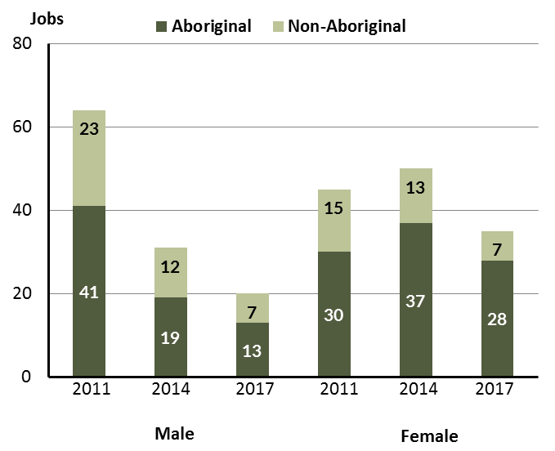

Source: Department of Trade, Business and Innovation

In 2017 in Umbakumba:

* there were 20 **jobs** **filled** **by** **males**, a decrease of 11 jobs from 2014 and a decrease of 44 jobs from 2011
* of the 20 **jobs filled by males**:
* 13 were **Aboriginal**, a decrease of 6 jobs from 2014 and a decrease of 28 jobs from 2011
* 7 were **non-Aboriginal**, a decrease of 5 jobs from 2014 and a decrease of 16 jobs from 2011
* there were 35 **jobs** **filled** **by** **females**, a decrease of 15 jobs from 2014 and a decrease of 10 jobs from 2011
* of the 35 **jobs filled by females**:
* 28 were **Aboriginal**, a decrease of 9 jobs from 2014 and a decrease of 2 jobs from 2011
* 7 were **non-Aboriginal**, a decrease of 6 jobs from 2014 and a decrease of 8 jobs from 2011.

Table 21: Counts of filled jobs by gender, by Aboriginal status of person in the job, by full-time/part-time status, by job permanency and by sector 2011 (a)(b)(c)(d)(e)(i)

|  |  |  |  |  |  |  |  |  |  |
| --- | --- | --- | --- | --- | --- | --- | --- | --- | --- |
| **2011** | | | | | | | | | |
| **Indicator** | **Male** | | | **Female** | | | **Total** | | |
| **Aboriginal** | **Non-Aboriginal** | **Total** | **Aboriginal** | **Non-Aboriginal** | **Total** | **Aboriginal** | **Non-Aboriginal** | **Total** |
| Full-time | 35 | 22 | **57** | 18 | 11 | **29** | 54 | 33 | **87** |
| Part-time | 6 | 1 | **7** | 12 | 4 | **16** | 18 | 5 | **23** |
| **Total** | **41** | **23** | **64** | **30** | **15** | **45** | **72** | **38** | **110** |
| Permanent | 38 | 18 | **56** | 24 | 6 | **30** | 62 | 24 | **86** |
| Temporary | 3 | 5 | **8** | 6 | 9 | **15** | 10 | 14 | **24** |
| **Total** | **41** | **23** | **64** | **30** | **15** | **45** | **72** | **38** | **110** |
| Public Sector | 14 | 7 | **21** | 19 | 13 | **32** | 34 | 20 | **54** |
| Private Sector | 27 | 16 | **43** | 11 | 2 | **13** | 38 | 18 | **56** |
| **Total** | **41** | **23** | **64** | **30** | **15** | **45** | **72** | **38** | **110** |

Source: Department of Trade, Business and Innovation

Table 22: Counts of filled jobs by gender, by Aboriginal status of person in the job, by full-time/part-time status, by job permanency and by sector 2014 (a)(b)(c)(d)(e)(i)

|  |  |  |  |  |  |  |  |  |  |  |
| --- | --- | --- | --- | --- | --- | --- | --- | --- | --- | --- |
| **2014** | | | | | | | | | | |
| **Indicator** | **Male** | | | **Female** | | | **Total** | | | |
| **Aboriginal** | **Non-Aboriginal** | **Total** | **Aboriginal** | **Non-Aboriginal** | **Total** | **Aboriginal** | **Non-Aboriginal** | **Total** |
| Full-time | 4 | 9 | **13** | 8 | 10 | **18** | 12 | 19 | **31** |
| Part-time | 15 | 3 | **18** | 29 | 3 | **32** | 44 | 6 | **50** |
| **Total** | **19** | **12** | **31** | **37** | **13** | **50** | **56** | **25** | **81** |
| Permanent | 8 | 9 | **17** | 16 | 10 | **26** | 24 | 19 | **43** |
| Temporary | 11 | 3 | **14** | 21 | 3 | **24** | 32 | 6 | **38** |
| **Total** | **19** | **12** | **31** | **37** | **13** | **50** | **56** | **25** | **81** |
| Public Sector | 14 | 9 | **23** | 27 | 11 | **38** | 41 | 20 | **61** |
| Private Sector | 5 | 3 | **8** | 10 | 2 | **12** | 15 | 5 | **20** |
| **Total** | **19** | **12** | **31** | **37** | **13** | **50** | **56** | **25** | **81** |

Source: Department of Trade, Business and Innovation

Table 23: Counts of filled jobs by gender, by Aboriginal status of person in the job, by full-time/part-time status, by job permanency and by sector 2017 (a)(b)(c)(d)(e)(i)

|  |  |  |  |  |  |  |  |  |  |
| --- | --- | --- | --- | --- | --- | --- | --- | --- | --- |
| **2017** | | | | | | | | | |
| **Indicator** | **Male** | | | **Female** | | | **Total** | | |
| **Aboriginal** | **Non-Aboriginal** | **Total** | **Aboriginal** | **Non-Aboriginal** | **Total** | **Aboriginal** | **Non-Aboriginal** | **Total** |
| Full-time | 1 | 7 | **8** | 7 | 6 | **13** | 8 | 13 | **21** |
| Part-time | 12 | 0 | **12** | 21 | 1 | **22** | 33 | 1 | **34** |
| **Total** | **13** | **7** | **20** | **28** | **7** | **35** | **41** | **14** | **55** |
| Permanent | 8 | 4 | **12** | 11 | 5 | **16** | 19 | 9 | **28** |
| Temporary | 5 | 3 | **8** | 17 | 2 | **19** | 22 | 5 | **27** |
| **Total** | **13** | **7** | **20** | **28** | **7** | **35** | **41** | **14** | **55** |
| Public Sector | 9 | 6 | **15** | 20 | 7 | **27** | 29 | 13 | **42** |
| Private Sector | 4 | 1 | **5** | 8 | 0 | **8** | 12 | 1 | **13** |
| **Total** | **13** | **7** | **20** | **28** | **7** | **35** | **41** | **14** | **55** |

Source: Department of Trade, Business and Innovation

In 2017 in Umbakumba:

* of the 20 **jobs** **filled** **by** **males**, there were:
* 13 jobs filled by **Aboriginal** males, a decrease of 6 jobs from 2014 and a decrease of 28 jobs from 2011, including:
* 1 was a full-time job, a decrease of 3 jobs from 2014 and a decrease of 34 jobs from 2011
* 12 part-time jobs, a decrease of 3 jobs from 2014 and an increase of 6 jobs from 2011
* 8 permanent jobs, unchanged from 2014 and a decrease of 30 jobs from 2011
* 5 temporary jobs, a decrease of 6 jobs from 2014 and an increase of 2 jobs from 2011
* 9 public sector jobs, a decrease of 5 jobs from 2014 and a decrease of 5 jobs from 2011
* 4 private sector jobs, a decrease of 1 job from 2014 and a decrease of 23 jobs from 2011
* 7 jobs filled by **non-Aboriginal** males, a decrease of 5 jobs from 2014 and a decrease of 16 jobs from 2011, including:
* 7 full-time jobs, a decrease of 2 jobs from 2014 and a decrease of 15 jobs from 2011
* none were part-time jobs, a decrease of 3 jobs from 2014 and a decrease of 1 job from 2011
* 4 permanent jobs, a decrease of 5 jobs from 2014 and a decrease of 14 jobs from 2011
* 3 temporary jobs, unchanged from 2014 and a decrease of 2 jobs from 2011
* 6 public sector jobs, a decrease of 3 jobs from 2014 and a decrease of 1 job from 2011
* 1 private sector job, a decrease of 2 jobs from 2014 and a decrease of 15 jobs from 2011
* of the 35 **jobs** **filled** **by** **females**, there were:
* 28 jobs filled by **Aboriginal** females, a decrease of 9 jobs from 2014 and a decrease of 2 jobs from 2011, including:
* 7 full-time jobs, a decrease of 1 job from 2014 and a decrease of 11 jobs from 2011
* 21 part-time jobs, a decrease of 8 jobs from 2014 and an increase of 9 jobs from 2011
* 11 permanent jobs, a decrease of 5 jobs from 2014 and a decrease of 13 jobs from 2011
* 17 temporary jobs, a decrease of 4 jobs from 2014 and an increase of 11 jobs from 2011
* 20 public sector jobs, a decrease of 7 jobs from 2014 and an increase of 1 job from 2011
* 8 private sector jobs, a decrease of 2 jobs from 2014 and a decrease of 3 jobs from 2011
* 7 jobs filled by **non-Aboriginal** females, a decrease of 6 jobs from 2014 and a decrease of 8 jobs from 2011, including:
* 6 full-time jobs, a decrease of 4 jobs from 2014 and a decrease of 5 jobs from 2011
* 1 part-time job, a decrease of 2 jobs from 2014 and a decrease of 3 jobs from 2011
* 5 permanent jobs, a decrease of 5 jobs from 2014 and a decrease of 1 job from 2011
* 2 temporary jobs, a decrease of 1 job from 2014 and a decrease of 7 jobs from 2011
* 7 public sector jobs, a decrease of 4 jobs from 2014 and a decrease of 6 jobs from 2011
* none were private sector jobs, a decrease of 2 jobs from 2014 and a decrease of 2 jobs from 2011.

# Jobs by Age

Table 24: Counts of filled jobs by age and Aboriginal status of person employed in job, 2011, 2014 and 2017 (a)(c)(j)

|  |  |  |  |  |  |  |  |  |  |  |  |  |  |  |  |
| --- | --- | --- | --- | --- | --- | --- | --- | --- | --- | --- | --- | --- | --- | --- | --- |
| **Indicator** | **2011** | | | **2014** | | | **2017** | | | **Change 2011-2014** | | | **Change 2014-2017** | | |
| **Aboriginal** | **Non-Aboriginal** | **Total** | **Aboriginal** | **Non-Aboriginal** | **Total** | **Aboriginal** | **Non-Aboriginal** | **Total** | **Aboriginal** | **Non-Aboriginal** | **Total** | **Aboriginal** | **Non-Aboriginal** | **Total** |
| 15-24 years | 11 | 1 | **12** | 6 | 1 | **7** | 6 | 2 | **8** | -5 | 0 | **-5** | 0 | 1 | **1** |
| 25-44 years | 49 | 20 | **69** | 33 | 7 | **40** | 24 | 7 | **31** | -16 | -13 | **-29** | -9 | 0 | **-9** |
| 45+ years | 11 | 17 | **28** | 17 | 17 | **34** | 11 | 5 | **16** | 6 | 0 | **6** | -6 | -12 | **-18** |
| **Total** | **72** | **38** | **110** | **56** | **25** | **81** | **41** | **14** | **55** | **-16** | **-13** | **-29** | **-15** | **-11** | **-26** |

Source: Department of Trade, Business and Innovation

Chart 12: Count of filled jobs by age and Aboriginal status of person in job, 2011, 2014 and 2017 (a)(c)(j)

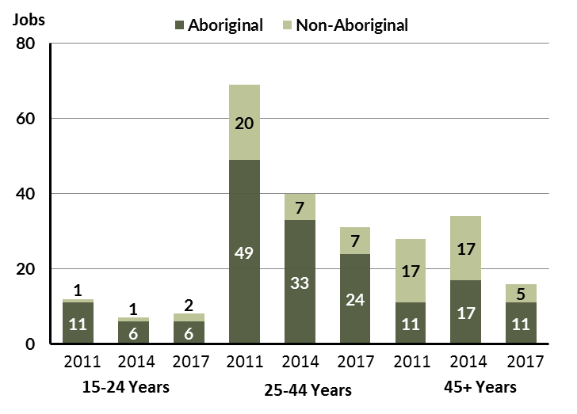

Source: Department of Trade, Business and Innovation

In 2017 in Umbakumba:

* there were 8 **jobs** **filled** by persons aged **15-24 years**, an increase of 1 job from 2014 and a decrease of 4 jobs from 2011. Of these:
* 6 jobs were filled by **Aboriginal** persons, unchanged from 2014 and a decrease of 5 jobs from 2011
* 2 jobs were filled by **non-Aboriginal** persons, an increase of 1 job from 2014 and an increase of 1 job from 2011
* there were 31 **jobs filled** by persons aged **25-44 years**, a decrease of 9 jobs from 2014 and a decrease of 38 jobs from 2011. Of these:
* 24 jobs were filled by **Aboriginal** persons, a decrease of 9 jobs from 2014 and a decrease of 25 jobs from 2011
* 7 jobs were filled by **non-Aboriginal** persons, unchanged from 2014 and a decrease of 13 jobs from 2011
* there were 16 **jobs** **filled** by persons aged **45+ years**, a decrease of 18 jobs from 2011 and a decrease of 12 jobs from 2011. Of these:
* 11 jobs were filled by **Aboriginal** persons, a decrease of 6 jobs from 2014 and unchanged from 2011
* 5 jobs were filled by **non-Aboriginal** persons, a decrease of 12 jobs from 2014 and a decrease of 12 jobs from 2011.

Table 25: Counts of filled jobs by age, by Aboriginal status of person in the job, by full-time/part-time status, by job permanency and by sector June-July 2011 (a)(b)(c)(d)(e)(i)

|  |  |  |  |  |  |  |  |  |  |  |  |  |  |
| --- | --- | --- | --- | --- | --- | --- | --- | --- | --- | --- | --- | --- | --- |
| **2011** | | | | | | | | | | | | | |
| **Indicator** | **15-24 years** | | | **25-44 years** | | | **45+ years** | | | **Total** | | | |
| **Aboriginal** | **Non-Aboriginal** | **Total** | **Aboriginal** | **Non-Aboriginal** | **Total** | **Aboriginal** | **Non-Aboriginal** | **Total** | **Aboriginal** | **Non-Aboriginal** | **Total** |
| Full-time | 8 | 0 | **8** | 36 | 19 | **55** | 9 | 14 | **23** | 54 | 33 | **87** |
| Part-time | 3 | 1 | **4** | 13 | 1 | **14** | 2 | 3 | **5** | 18 | 5 | **23** |
| **Total** | **11** | **1** | **12** | **49** | **20** | **69** | **11** | **17** | **28** | **72** | **38** | **110** |
| Permanent | 10 | 0 | **10** | 44 | 13 | **57** | 8 | 11 | **19** | 62 | 24 | **86** |
| Temporary | 1 | 1 | **2** | 5 | 7 | **12** | 3 | 6 | **9** | 10 | 14 | **24** |
| **Total** | **11** | **1** | **12** | **49** | **20** | **69** | **11** | **17** | **28** | **72** | **38** | **110** |
| Public Sector | 4 | 1 | **5** | 23 | 12 | **35** | 6 | 7 | **13** | 34 | 20 | **54** |
| Private Sector | 7 | 0 | **7** | 26 | 8 | **34** | 5 | 10 | **15** | 38 | 18 | **56** |
| **Total** | **11** | **1** | **12** | **49** | **20** | **69** | **11** | **17** | **28** | **72** | **38** | **110** |

Source: Department of Trade, Business and Innovation

Table 26: Counts of filled jobs by age, by Aboriginal status of person in the job, by full-time/part-time status, by job permanency and by sector June-July 2014 (a)(b)(c)(d)(e)(i)

|  |  |  |  |  |  |  |  |  |  |  |  |  |  |
| --- | --- | --- | --- | --- | --- | --- | --- | --- | --- | --- | --- | --- | --- |
| **2014** | | | | | | | | | | | | | |
| **Indicator** | **15-24 years** | | | **25-44 years** | | | **45+ years** | | | **Total** | | | |
| **Aboriginal** | **Non-Aboriginal** | **Total** | **Aboriginal** | **Non-Aboriginal** | **Total** | **Aboriginal** | **Non-Aboriginal** | **Total** | **Aboriginal** | **Non-Aboriginal** | **Total** |
| Full-time | 0 | 0 | **0** | 8 | 5 | **13** | 4 | 14 | **18** | 12 | 19 | **31** |
| Part-time | 6 | 1 | **7** | 25 | 2 | **27** | 13 | 3 | **16** | 44 | 6 | **50** |
| **Total** | **6** | **1** | **7** | **33** | **7** | **40** | **17** | **17** | **34** | **56** | **25** | **81** |
| Permanent | 3 | 1 | **4** | 12 | 5 | **17** | 9 | 13 | **22** | 24 | 19 | **43** |
| Temporary | 3 | 0 | **3** | 21 | 2 | **23** | 8 | 4 | **12** | 32 | 6 | **38** |
| **Total** | **6** | **1** | **7** | **33** | **7** | **40** | **17** | **17** | **34** | **56** | **25** | **81** |
| Public Sector | 3 | 0 | **3** | 25 | 7 | **32** | 13 | 13 | **26** | 41 | 20 | **61** |
| Private Sector | 3 | 1 | **4** | 8 | 0 | **8** | 4 | 4 | **8** | 15 | 5 | **20** |
| **Total** | **6** | **1** | **7** | **33** | **7** | **40** | **17** | **17** | **34** | **56** | **25** | **81** |

Source: Department of Trade, Business and Innovation

Table 27: Counts of filled jobs by age, by Aboriginal status of person in the job, by full-time/part-time status, by job permanency and by sector June-July 2017 (a)(b)(c)(d)(e)(i)

|  |  |  |  |  |  |  |  |  |  |  |  |  |  |
| --- | --- | --- | --- | --- | --- | --- | --- | --- | --- | --- | --- | --- | --- |
| **2017** | | | | | | | | | | | | | |
| **Indicator** | **15-24 years** | | | **25-44 years** | | | **45+ years** | | | **Total** | | | |
| **Aboriginal** | **Non-Aboriginal** | **Total** | **Aboriginal** | **Non-Aboriginal** | **Total** | **Aboriginal** | **Non-Aboriginal** | **Total** | **Aboriginal** | **Non-Aboriginal** | **Total** |
| Full-time | 0 | 2 | **2** | 2 | 6 | **8** | 6 | 5 | **11** | 8 | 13 | **21** |
| Part-time | 6 | 0 | **6** | 22 | 1 | **23** | 5 | 0 | **5** | 33 | 1 | **34** |
| **Total** | **6** | **2** | **8** | **24** | **7** | **31** | **11** | **5** | **16** | **41** | **14** | **55** |
| Permanent | 1 | 1 | **2** | 10 | 5 | **15** | 8 | 3 | **11** | 19 | 9 | **28** |
| Temporary | 5 | 1 | **6** | 14 | 2 | **16** | 3 | 2 | **5** | 22 | 5 | **27** |
| **Total** | **6** | **2** | **8** | **24** | **7** | **31** | **11** | **5** | **16** | **41** | **14** | **55** |
| Public Sector | 3 | 1 | **4** | 17 | 7 | **24** | 9 | 5 | **14** | 29 | 13 | **42** |
| Private Sector | 3 | 1 | **4** | 7 | 0 | **7** | 2 | 0 | **2** | 12 | 1 | **13** |
| **Total** | **6** | **2** | **8** | **24** | **7** | **31** | **11** | **5** | **16** | **41** | **14** | **55** |

Source: Department of Trade, Business and Innovation

In 2017 in Umbakumba:

* of the 8 **jobs** **filled** by persons aged **15-24 years**, there were:
* 6 jobs filled by **Aboriginal** persons, of which
* none were full-time jobs, unchanged from 2014 and a decrease of 8 jobs from 2011
* 6 were part-time jobs, unchanged from 2014 and an increase of 3 jobs from 2011
* 1 was a permanent job, a decrease of 2 jobs from 2014 and a decrease of 9 jobs from 2011
* 5 were temporary jobs, an increase of 2 jobs from 2014 and an increase of 4 jobs from 2011
* 3 were public sector jobs, unchanged from 2014 and a decrease of 1 job from 2011
* 3 were private sector jobs, unchanged from 2014 and a decrease of 4 jobs from 2011
* 2 jobs filled by **non-Aboriginal** persons, of which:
* 2 were full-time jobs, an increase of 2 jobs from 2014 and an increase of 2 jobs from 2011
* none were part-time jobs, a decrease of 1 job from 2014 and a decrease of 1 job from 2011
* 1 was a permanent job, unchanged from 2014 and an increase of 1 job from 2011
* 1 was a temporary job, an increase of 1 job from 2014 and unchanged from 2011
* 1 was a public sector job, an increase of 1 job from 2014 and unchanged from 2011
* 1 was a private sector job, unchanged from 2014 and an increase of 1 job from 2011
* of the 31 **jobs** **filled** by persons aged **25-44 years**, there were:
* 24 jobs filled by **Aboriginal** persons, of which:
* 2 were full-time jobs, a decrease of 6 jobs from 2014 and a decrease of 34 jobs from 2011
* 22 were part-time jobs, a decrease of 3 jobs from 2014 and an increase of 9 jobs from 2011
* 10 were permanent jobs, a decrease of 2 jobs from 2014 and a decrease of 34 jobs from 2011
* 14 were temporary jobs, a decrease of 7 jobs from 2014 and an increase of 9 jobs from 2011
* 17 were public sector jobs, a decrease of 8 jobs from 2014 and a decrease of 6 jobs from 2011
* 7 were private sector jobs, a decrease of 1 job from 2014 and a decrease of 19 jobs from 2011
* 7 jobs filled by **non-Aboriginal** persons, of which:
* 6 were full-time jobs, an increase of 1 job from 2014 and a decrease of 13 jobs from 2011
* 1 was a part-time job, a decrease of 1 job from 2014 and unchanged from 2011
* 5 were permanent jobs, unchanged from 2014 and a decrease of 8 jobs from 2011
* 2 were temporary jobs, unchanged from 2014 and a decrease of 5 jobs from 2011
* 7 were public sector jobs, unchanged from 2014 and a decrease of 5 jobs from 2011
* none were private sector jobs, unchanged from 2014 and a decrease of 8 jobs from 2011
* of the 16 **jobs** **filled** by persons aged **45+ years**, there were:
* 11 jobs filled by **Aboriginal** persons, of which:
* 6 were full-time jobs, an increase of 2 jobs from 2014 and a decrease of 3 jobs from 2011
* 5 were part-time jobs, a decrease of 8 jobs from 2014 and an increase of 3 jobs from 2011
* 8 were permanent jobs, a decrease of 1 job from 2014 and unchanged from 2011
* 3 were temporary jobs, a decrease of 5 jobs from 2014 and unchanged from 2011
* 9 were public sector jobs, a decrease of 4 jobs from 2014 and an increase of 3 jobs from 2011
* 2 were private sector jobs, a decrease of 2 jobs from 2014 and a decrease of 3 jobs from 2011
* 5 jobs filled by **non-Aboriginal** persons, of which:
* 5 were full-time jobs, a decrease of 9 jobs from 2014 and a decrease of 9 jobs from 2011
* none were part-time jobs, a decrease of 3 jobs from 2014 and a decrease of 3 jobs from 2011
* 3 were permanent jobs, a decrease of 10 jobs from 2014 and a decrease of 8 jobs from 2011
* 2 were temporary jobs, a decrease of 2 jobs from 2014 and a decrease of 4 jobs from 2011
* 5 were public sector jobs, a decrease of 8 jobs from 2014 and a decrease of 2 jobs from 2011
* none were private sector jobs, a decrease of 4 jobs from 2014 and a decrease of 10 jobs from 2011.

# Vocational Education and Training

Note: *Since previous publications, the 2010 data have fallen in line with the new standardised reporting practices with an emphasis of all training activity undertaken in the remote town regardless of funding stream. As such, figures for 2010 VET data in this publication may differ from previous publications.*

*The impact of the Remote Jobs and Communities Program (RJCP) being established in 2013 has played a significant role in the downturn of accredited training in many remote towns across the Territory.*

Table 28: Northern Territory Vocational Education and Training (VET) students, 2010, 2013 and 2016 (k)

|  |  |  |  |  |  |  |  |  |
| --- | --- | --- | --- | --- | --- | --- | --- | --- |
| **VET Funding Group** | **2010** | | **2013** | | **2016** | | **Change** | |
| **No.** | **% of Total** | **No.** | **% of Total** | **No.** | **% of Total** | **2010-2013** | **2013-2016** |
| Building and Construction | 0 | 0 | 14 | 21 | 4 | 33 | 14 | - 10 |
| Business and Clerical | 3 | 17 | 1 | 1 | 0 | 0 | - 2 | - 1 |
| Community Services, Health and Education | 9 | 50 | 31 | 46 | 7 | 58 | 22 | - 24 |
| Sales and Personal Service | 6 | 33 | 21 | 31 | 1 | 8 | 15 | - 20 |
| **Total** | **18** | **100** | **67** | **100** | **12** | **100** | **49** | **- 55** |

Source: Department of Trade, Business and Innovation

In 2016 in Umbakumba:

* there were 12 **VET students**, a decrease of 55 students from 2013 and a decrease of 6 students from 2010
* the areas of VET activity with the most students were Community Services, Health and Education (7), Building and Construction (4), and Sales and Personal Service (1)
* Community Services, Health and Education reported the largest decrease in students (-24) between 2016 and 2013.

Table 29: Northern Territory Vocational Education and Training (VET) unit enrolments, 2010, 2013 and 2016 (l)

|  |  |  |  |  |  |  |  |  |
| --- | --- | --- | --- | --- | --- | --- | --- | --- |
| **VET Funding Group** | **2010** | | **2013** | | **2016** | | **Change** | |
| **No.** | **% of Total** | **No.** | **% of Total** | **No.** | **% of Total** | **2010-2013** | **2013-2016** |
| Building and Construction | 0 | 0 | 94 | 29 | 28 | 60 | 94 | - 66 |
| Business and Clerical | 3 | 3 | 1 | 0 | 0 | 0 | - 2 | - 1 |
| Community Services, Health and Education | 93 | 78 | 76 | 23 | 18 | 38 | - 17 | - 58 |
| Sales and Personal Service | 24 | 20 | 158 | 48 | 1 | 2 | 134 | - 157 |
| **Total** | **120** | **100** | **329** | **100** | **47** | **100** | **209** | **- 282** |

Source: Department of Trade, Business and Innovation

In 2016 in Umbakumba:

* there were 47 **VET unit enrolments**, a decrease of 282 unit enrolments from 2013 and a decrease of 73 unit enrolments from 2010
* the areas of VET activity with the most unit enrolments were Building and Construction (28), Community Services, Health and Education (18), and Sales and Personal Service (1)
* Sales and Personal Service reported the largest decrease in unit enrolments (-157) between 2016 and 2013.

Table 30: Northern Territory Vocational Education and Training (VET) nominal hours, 2010, 2013 and 2016 (m)

|  |  |  |  |  |  |  |  |  |
| --- | --- | --- | --- | --- | --- | --- | --- | --- |
| **VET Funding Group** | **2010** | | **2013** | | **2016** | | **Change** | |
| **No.** | **% of Total** | **No.** | **% of Total** | **No.** | **% of Total** | **2010-2013** | **2013-2016** |
| Building and Construction | 0 | 0 | 2 448 | 26 | 276 | 25 | 2 448 | -2 172 |
| Business and Clerical | 90 | 2 | 20 | 0 | 0 | 0 | - 70 | - 20 |
| Community Services, Health and Education | 3 848 | 83 | 2 812 | 30 | 785 | 72 | -1 036 | -2 027 |
| Sales and Personal Service | 705 | 15 | 4 195 | 44 | 35 | 3 | 3 490 | -4 160 |
| **Total** | **4 643** | **100** | **9 475** | **100** | **1 096** | **100** | **4 832** | **-8 379** |

Source: Department of Trade, Business and Innovation

In 2016 in Umbakumba:

* there were 1096 **VET nominal hours** delivered, a decrease of 8379 nominal hours delivered from 2013 and a decrease of 3547 nominal hours delivered from 2010
* the areas of VET activity with the most nominal hours delivered were Community Services, Health and Education (785), Building and Construction (276), and Sales and Personal Service (35)
* Sales and Personal Service reported the largest decrease in nominal hours delivered (-4160) between 2016 and 2013.

Caveat: *Nominal hours are based on the hours funded through Department of Trade Business and Innovation contracts; students and units includes delivery that has been funded in a previous year, fee for service or training that did not meet the funding requirements. Because of this a direct match cannot be made between hours and student/units*.

Table 31: Northern Territory Vocational Education and Training (VET) unit completions, 2010, 2013 and 2016 (n)

|  |  |  |  |  |  |  |  |  |
| --- | --- | --- | --- | --- | --- | --- | --- | --- |
| **VET Funding Group** | **2010** | | **2013** | | **2016** | | **Change** | |
| **No.** | **% of Total** | **No.** | **% of Total** | **No.** | **% of Total** | **2010-2013** | **2013-2016** |
| Building and Construction | 0 | 0 | 55 | 44 | 27 | 75 | 55 | - 28 |
| Business and Clerical | 3 | 3 | 0 | 0 | 0 | 0 | - 3 | 0 |
| Community Services, Health and Education | 88 | 79 | 49 | 39 | 8 | 22 | - 39 | - 41 |
| Sales and Personal Service | 21 | 19 | 21 | 17 | 1 | 3 | 0 | - 20 |
| **Total** | **112** | **100** | **125** | **100** | **36** | **100** | **13** | **- 89** |

Source: Department of Trade, Business and Innovation

In 2016 in Umbakumba:

* there were 36 **VET unit completions**, a decrease of 89 unit completions from 2013 and a decrease of 76 unit completions from 2010
* the areas of VET activity with the most unit completions were Building and Construction (27), Community Services, Health and Education (8), and Sales and Personal Service (1)
* Community Services, Health and Education reported the largest decrease in nominal hours delivered (-41) between 2016 and 2013.

# Population

**Table 32: Population distribution by gender and age (p)(r)**

|  |  |  |  |  |  |  |  |  |  |  |
| --- | --- | --- | --- | --- | --- | --- | --- | --- | --- | --- |
| **Indicator** | **2006** | | | **2016** | | | **Change** | | | |
| **Male** | **Female** | **Total** | **Male** | **Female** | **Total** | **Male** | **Female** | **Total** |
| **0-4 years** | 13 | 22 | 35 | 22 | 33 | 55 | 9 | 11 | 20 |
| **5-14 years** | 57 | 48 | 105 | 54 | 54 | 108 | -3 | 6 | 3 |
| **15-24 years** | 63 | 60 | 123 | 73 | 60 | 133 | 10 | 0 | 10 |
| **25-44 years** | 37 | 81 | 118 | 99 | 83 | 182 | 62 | 2 | 64 |
| **45-64 years** | 28 | 39 | 67 | 35 | 54 | 89 | 7 | 15 | 22 |
| **65+ years** | 8 | 1 | 9 | 2 | 0 | 2 | -6 | -1 | -7 |
| **TOTAL** | 206 | 251 | 457 | 285 | 284 | 569 | 79 | 33 | 112 |

*Source: Dep18artment of Trade, Business and Innovation*

In 2016 in Umbakumba:

* there were an estimated 569 persons, of which:
* 285 (50.1%) were male
* 284 (49.9%) were female
* between 2006 and 2016, the **overall population** in Umbakumba increased by 112 persons from 2006, or an average of 2.2% per year compared to 0.7% across the 28 remote towns and 1.5% Territory wide
* the **male population** increased by 79 persons from 2006
* the **female population** increased by 33 persons from 2006
* in 2016, the **working age population** (15 years and over) in Umbakumba was an estimated 406 persons (71.4% of the total population) compared with 317 persons (69.4% of the total population) in 2006. Of these:
* 133 (23.4%) were between 15 and 24 years of age
* 182 (32%) were between 25 and 44 years of age
* 89 (15.6%) were between 45 and 64 years of age
* 2 (0.4%) were over 65 years of age
* of the 406 persons of **working age:**
* 209 (51.5%) were male
* 197 (48.5%) were female.

There were 0.2 jobs in Umbakumba per working age person compared to 0.4 jobs per working age person across the 28 remote towns in the Northern Territory.

**Chart 13: Population by Aboriginal status compared to the 28 remote towns and the NT (p)(q)**

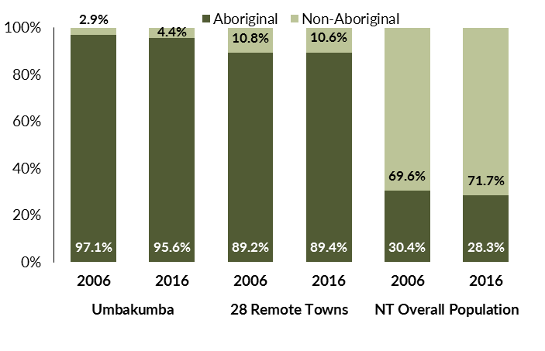

*Source: Department of Trade, Business and Innovation*

In 2016 in Umbakumba:

* 95.6% of the population in Umbakumba were **Aboriginal**, compared to 97.1% in 2006
* 89.4% of the population across all 28 remote towns were **Aboriginal**
* 28.3% of the Northern Territory population were **Aboriginal**.

**Table 33: Unemployment and participation rates by Aboriginal status compared to the NT (q)**

|  |  |  |  |  |  |  |
| --- | --- | --- | --- | --- | --- | --- |
|  | **Umbakumba** | | | **Northern Territory** | | |
| **Aboriginal** | **Non-Aboriginal** | **Total** | **Aboriginal** | **Non-Aboriginal** | **Total** |
| **Unemployment rate** | 21.4% | 0.0% | 19.8% | 26.7% | 3.8% | 7.0% |
| **Participation rate** | 32.9% | 100.0% | 36.6% | 41.0% | 79.9% | 70.6% |

*Source: Department of Trade, Business and Innovation*

In 2016 in Umbakumba the:

* **total unemployment rate** was 19.8% compared to 7% for the total Northern Territory
* **Aboriginal** **unemployment rate** was 21.4% compared to 26.7% for the total Northern Territory
* **non-Aboriginal** **unemployment rate** was 0% compared to 3.8% for the total Northern Territory
* **total participation rate** was 36.6% compared to 70.6% for the total Northern Territory
* **Aboriginal** **participation rate** was 32.9% compared to 41% for the total Northern Territory
* **non-Aboriginal** **participation rate** was 100% compared to 79.9% for the total Northern Territory.

# Community Development Programme

**Table 34: Community Development Programme Aboriginal Job Seekers, 30 April 2018 (o)**

|  |  |  |
| --- | --- | --- |
| **Indicator** | **Aboriginal** | |
| **No.** | **%** |
| **Total Aboriginal Job Seekers** | 118 | N/A |
| **Age (years)** | | |
| 15-24 | 41 | 34.7 |
| 25-44 | 51 | 43.2 |
| 45+ | 26 | 22.0 |
| **Total** | 118 | 100.0 |
| **Gender** | | |
| Male | 53 | 44.9 |
| Female | 65 | 55.1 |
| **Total** | 118 | 100.0 |
| **Employment Outcome - 1 July 2015 to 30 April 2018** | | |
| 13 Weeks | < 20 | N/A |
| 26 Weeks | < 20 | N/A |
| **Currently in Activities** | 78 |  |

*Source: Department of Prime Minister and Cabinet*

**Chart 14: Community Development Programme Aboriginal Job Seekers by Gender and Age Group, 30 April 2018 (o)**

See detailed description below.

*Source: Department of Prime Minister and Cabinet*

As at 30 April 2018, in Umbakumba, there were 118 CDP **Aboriginal** job seekers, of these:

* 53 (44.9%) were male and 65 (55.1%) were female
* 41 (34.7%) were aged 15-24 years, 51 (43.2%) were aged 25-44 years, and 26 (22%) were aged 45+ years
* between 1 July 2015 and 30 April 2018, < 20 had reached the 13 week reporting milestone and < 20 had reached the 26 week reporting milestone
* 78 were currently in activities.

# Businesses

**Table 35: Businesses by sector (d)(s)**

|  |  |  |  |
| --- | --- | --- | --- |
| **Business Name** | **Reported on in 2011?** | **Reported on in 2014?** | **Reported on in 2017?** |
| **PUBLIC SECTOR** | | | |
| **Department of Education** | Yes | Yes | **Yes** |
| **Department of Health** | Yes | Yes | **Yes** |
| **Department of the Prime Minister and Cabinet** | Yes | No | **Yes** |
| **East Arnhem Regional Council** | Yes | Yes | **Yes** |
| **PRIVATE SECTOR** | | | |
| AA Electrical Pty Ltd | Yes | No | No |
| Aminjarrinja Enterprises | Yes | No | No |
| **Mikbamurra Store** | Yes | Yes | **Yes** |
| **MJD Foundation** | No | No | **Yes** |
| **The Arnhem Land Progress Aboriginal Corporation (ALPA)** | Yes | Yes | **Yes** |
| **The Trustee for AA Essential Services Trust** | No | Yes | **Yes** |

*Source: Department of Trade, Business and Innovation*

*Note: Business names captured across the three survey periods have been identified by the current 2017 Business ABN name listed as at 2017.*

In 2017 in Umbakumba:

* there were 8 businesses reported on, of which:
* 4 businesses were from the public sector (50%)
* 4 businesses were from the private sector (50%)
* there were 2 businesses operating that were not operating in 2011.

# Notes

1. These counts represent numbers of filled jobs and not numbers of persons. As such the totals represent the total number of filled jobs, not the total number of employees. This count is not directly comparable to the total number of employed persons as a person may have several jobs or one job may be shared by more than one person.
2. Full-time is defined as a job usually requiring 35 hours or more per week or that required 35 hours or more work during the reference week. Part-time is defined as a job usually requiring less than 35 hours per week or that required less than 35 hours work during the reference week. The reference week refers to the period that respondents were asked to provide information about. In most instances it would be the week prior to the week the questionnaire was completed. Questionnaires were predominantly conducted in June and July.
3. Care needs to be taken when analysing the counts of filled jobs by the Aboriginal status of persons in the jobs. The Aboriginal status of the person employed in a job was reported by the business representative completing the questionnaire.
4. Sector was classified using the Standard Economic Sector of Classifications of Australia (SESCA), 2008.
5. Job permanency is classified according to what the business believes the level of job permanency is based on guidelines provided by data collectors. Those guidelines state a permanent job has paid annual and/or sick leave entitlements while a temporary job includes casual and fixed-term contract jobs.
6. Classified according to the Australian and New Zealand Standard Classification of Occupations (ANZSCO), 2006, major occupation level.
7. Other occupations include jobs where occupation was not stated, not known or inadequately described.
8. Classified using the Australian and New Zealand Standard Industrial Classification (ANZSIC), 2006, division level.
9. Care needs to be taken when analysing the counts of filled jobs by the gender of persons in the jobs. The gender of the person employed in a job is reported by the business representative completing the questionnaire.
10. Care needs to be taken when analysing the counts of filled jobs by the age of persons in the jobs. The age of the person employed in a job is reported by the business representative completing the questionnaire.
11. Students represent the number of individual clients that enrolled in a Vocational Education and Training unit during the calendar year.
12. Unit enrolments represent the count of individual units that students enrolled in during the calendar year.
13. Nominal hours delivered is the sum of the nominal hours of the units commenced during the calendar year regardless of when the course enrolment commenced.
14. Unit completions are the count of all successfully completed units reported in the calendar year regardless of the year of commencement of the units.
15. The Community Development Programme (CDP) supports job seekers in remote Australia to build skills, address barriers and contribute to their communities through a range of flexible activities. Under the CDP, job seekers with activity requirements are expected to do up to 25 hours per week of work-like activities that benefit their community. It should be noted that some CDP participants may be reported on within the profile if they are attached to a filled position with an employer captured in the survey. Due to confidentiality issues, data below 20 people is not published.
16. Population estimates for both 2006 and 2016 are taken from the estimated resident population (ERP) data produced by the Australian Bureau of Statistics (ABS) and based on Australian Statistical Geography Standard (ASGS) Statistical Area Level 1 (SA1) regions. ERP are official estimates of the Australian population, which link people to a place of usual residence with Australia. All ERP data sources, including the Census of Population and Housing (Census), are subject to error (including inaccuracies in collection, recording and processing data) and should be used with caution.
17. Indigenous population proportions, unemployment and workforce participation rates are based on ABS Census counts at ASGS Indigenous Locations (ILOCs) for each remote town.
18. Working-age population includes all residents aged 15 years and over (commonly referred to as the civilian population) and consists of persons that are employed, unemployed or not in the labour force.
19. A ‘business’ has been defined as any organisation that has undertaken productive activities in the last year, including companies, non-profit organisations, government departments and enterprises operating within the designated remote geography (town), and has one or more employees in paid employment and an Australian Business Number (ABN).

# Abbreviations and Acronyms

ABN Australian Business Number

ABS Australian Bureau of Statistics

ANZSCO Australian and New Zealand Standard Classification of Occupations

ANZSIC Australian and New Zealand Standard Industrial Classification

ASGS Australian Statistical Geography Standard

CDP Community Development Programme

ERP Estimated Resident Population

ILOC Indigenous Locations

nec Not Elsewhere Classified

No. Number

Perm Permanent

ppt Percentage point

RJCP Remote Jobs and Communities Program

Temp Temporary

SA1 Statistical Area Level 1

VET Vocational Education and Training

1. The number of filled jobs does not represent numbers of persons as a person may have several jobs or one job may be shared by more than one person.