Front cover page.
Heading of Remote Towns Jobs Profile 2017
Jobs profile remote town name Galiwin'ku
**Remote Towns Jobs Profile**

GALIWIN’KU

**© Northern Territory of Australia 2018**

**Preferred Reference:** Department of Trade, Business and Innovation, 2017 Remote Towns Jobs Profiles, Northern Territory Government, June 2018, Darwin.

**Disclaimer**

The data in this publication were predominantly collected by conducting a face-to-face survey of businesses within town boundaries during mid-2017. The collection methodology was created in accordance with Australian Bureau of Statistics data quality framework principles. Data in this publication are only reflective of those businesses reported on as operating in the town at the time of data collection (see table at the end of publication for list of businesses reported on).

To comply with privacy legislation or where appropriate, some data in this publication may have been adjusted and will not reflect the actual data reported by businesses. As a result of this, combined with certain data not being reported by some businesses, some components may not add to totals. Changes over time may also reflect business' change in propensity to report on certain data items rather than actual changes over time. Total figures have generally not been adjusted.

Caution is advised when interpreting the comparisons made to the earlier 2011 and 2014 publications as the businesses identified and reported on and the corresponding jobs may differ between publications.

Notes for each table and chart are alphabetically ordered and listed at the end of the publication.

Any use of this report for commercial purposes is not endorsed by the Department of Trade, Business and Innovation.

Contents

Galiwin’ku 4

Introduction 5

Summary 6

Jobs Overview 7

Jobs by Aboriginal Status 8

Jobs by Sector: Private and Public 10

Job Status: Permanent and Temporary 16

Job Vacancies 19

Jobs by Industry 21

Jobs by Occupation 27

Jobs by Industry by Occupation 30

Jobs by Gender 32

Jobs by Age 37

Vocational Education and Training 42

Population 46

Community Development Programme 48

Businesses 49

Notes 50

Abbreviations and Acronyms 51

.

# Galiwin’ku

Galiwin’ku is located on Elcho Island in the East Arnhem region 550 kilometres north-east of Darwin, with a population of 2410 residents.

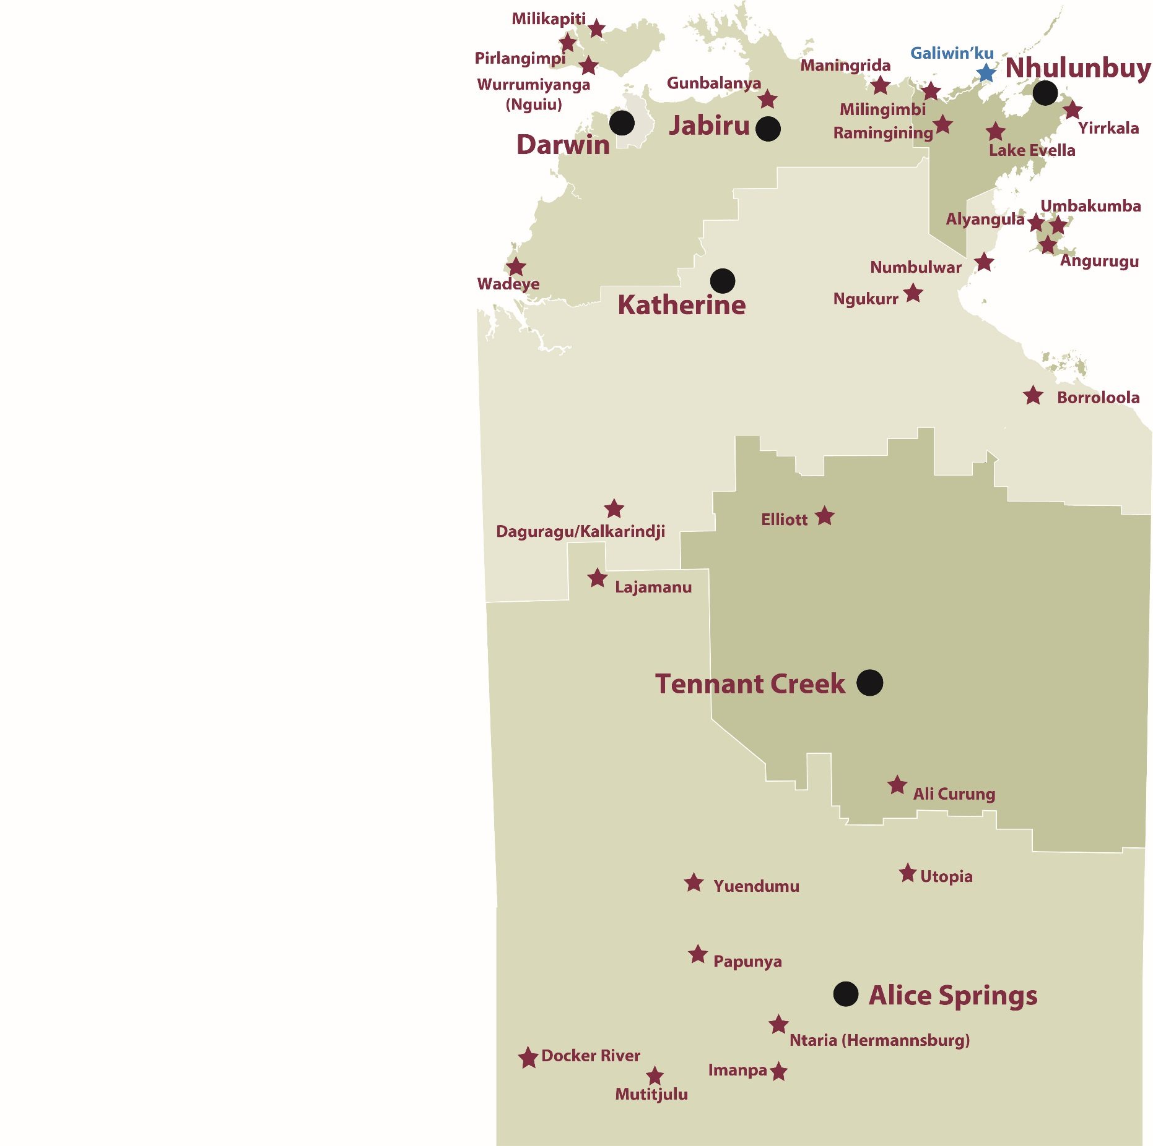

*Source: Department of Trade, Business and Innovation*

# Introduction

This jobs profile provides a snapshot of jobs and the characteristics of job holders in Galiwin’ku as at July 2017. It also outlines trends from the 2014 and 2011 surveys.

This job profile is one of 28 profiles developed for remote towns in the Northern Territory. It is anticipated these and subsequent profiles will contribute to a robust evidence base to inform decision making in and relating to these remote Territory towns.

This profile contains information collected by the Northern Territory Department of Trade, Business and Innovation from businesses operating within the town and is supplemented by other administrative data sets and information.

Each profile provides up-to-date information that is intended to inform the planning and design of current and future government programs and as an evidence base to inform decision making relating to workforce development, enterprise and job opportunities.

The data collection methodology and corresponding questionnaire were created in partnership with the Australian Bureau of Statistics (ABS) and in accordance with ABS data quality framework and survey principles.

The surveys were predominantly conducted by the Department’s Small Business Champions and Workforce Training Coordinators, on a face-to-face basis with business representatives.

The information collected and reported on represents a significant goodwill investment by those businesses and organisations that participated. Each business is listed at the end of this publication.

# Summary

The 2017 jobs profile was developed based on responses from 27 businesses operating within the Galiwin’ku town boundary, 6 more than in the 2014 survey. Of these, there were:

* 21 businesses from the private sector, accounting for 402 filled jobs or 76% of total filled jobs
* 6 businesses from the public sector, accounting for 127 filled jobs or 24% of total filled jobs
* 11 businesses participated in all three surveys (completed in 2011, 2014 and 2017)

A total of 561 filled and vacant jobs in Galiwin’ku were reported, an increase of 107 jobs from 2014.[1]

The 2017 profile highlights:

* there were 529 filled jobs of which:
* 359 jobs (68%) were filled by Aboriginal persons, an increase of 92 jobs from 2014
* 170 jobs (32%) were filled by non-Aboriginal persons, an increase of 15 jobs from 2014
* 55% of employed Aboriginal people are working in the private sector
* Aboriginal persons accounted for 68% of job holders in the town compared to 63% in 2014
* Aboriginal females made up 44.5% of total Aboriginal filled jobs in the town compared to 55% in 2014.
* there were 32 vacant jobs, of which:
* job vacancies as a percentage of jobs decreased to 6% in 2017 from 7% in 2014. (1 in 17.5 jobs vacant)
* 22 of the vacancies were in Professionals and Clerical and Administrative Workers areas
* Retail Trade has steadily increased its filled jobs over the three survey periods and is the largest industry employer in 2016.
* the Construction industry filled 121 jobs in 2016 after recording nil jobs in 2014 and 2011
* Public Administration and Safety had a decrease of 126 filled jobs between 2017 and 2014
* training had an increase of 152 student numbers between 2016 and 2013
* Building and Construction was the largest training activity sector in 2016, followed by Community Services, Health and Education
* new training activities, Textiles, Clothing, Footwear and Furnishings and Transport and Storage was delivered to 11 and 12 students respectively; these two training areas were not delivered in 2013 and 2010.

The overall population in Galiwin’ku increased by 482 persons (25%) between 2006 and 2016 to 2410 persons.

In comparison, the overall Northern Territory population increased by 16.5% between 2006 and 2016.

In 2016, the working age population (15 years and over) in Galiwin’ku was an estimated 1,667 persons compared to 1,228 in 2006 an increase of 36%.

There were 0.3 jobs in Galiwin'ku per working age person compared to 0.4 jobs per working age person across the 28 remote towns in the Northern Territory.

# Jobs Overview

Table 1: Count of filled jobs and vacancies, 2011, 2014 and 2017 (a)(b)

|  |  |  |  |  |  |
| --- | --- | --- | --- | --- | --- |
|  | **2011** | **2014** | **2017** | **Change 2011-2014** | **Change 2014-2017** |
| **Total All Jobs** | **423** | **454** | **561** | **31** | **107** |
| **Vacancies** | **28** | **32** | **32** | **4** | **0** |
| Vacancies as % of Total All Jobs | 6.6% | 7.0% | 5.7% | 0.4 ppt | -1.3 ppt |
| **Filled Jobs** | **395** | **422** | **529** | **27** | **107** |
| Full-time | 303 | 268 | 270 | -35 | 2 |
| Part-time | 92 | 154 | 259 | 62 | 105 |

Source: Department of Trade, Business and Innovation

Chart 1: Count of vacant jobs and filled jobs by full-time/part-time status, 2011, 2014 and 2017 (a)(b)

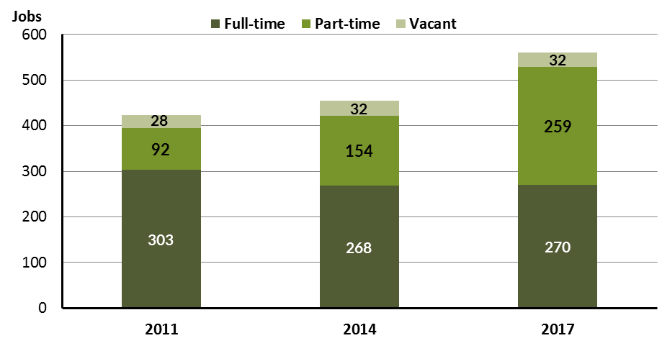

Source: Department of Trade, Business and Innovation

In 2017 in Galiwin'ku:

* there were a total of 529 **filled jobs**, an increase of 107 jobs from 2011 and an increase of 134 jobs from 2011
* of the 529 **filled jobs** in 2017:
* 270 were full-time jobs, an increase of 2 jobs from 2011 and a decrease of 33 jobs from 2011
* 259 were part-time jobs, an increase of 105 jobs from 2011 and an increase of 167 jobs from 2011
* there were 32 total **job vacancies** in 2017, unchanged from 2011 and an increase of 4 vacancies from 2011.

# Jobs by Aboriginal Status

Chart 2: Count of filled jobs by Aboriginal status, 2011, 2014 and 2017 (a)(c)

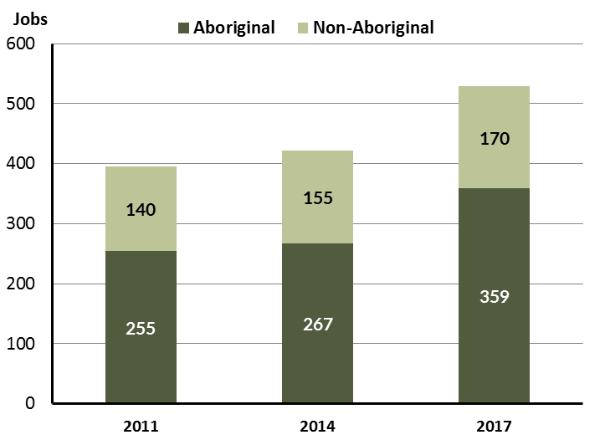

Source: Department of Trade, Business and Innovation

In 2017 in Galiwin'ku:

* of the 529 **filled jobs**:
* 359 jobs were filled by **Aboriginal** persons, an increase of 92 jobs from 2014 and an increase of 104 jobs from 2011
* 170 jobs were filled by **non-Aboriginal** persons, an increase of 15 jobs from 2014 and an increase of 30 jobs from 2011
* **Aboriginal** persons accounted for 68% of job holders compared to 63% in 2014 and 65% in 2011.

Table 2: Count of filled jobs by full-time/part-time status and Aboriginal status of person in job, 2011, 2014 and 2017 (a)(b)(c)

|  |  |  |  |  |  |  |  |  |  |  |  |  |  |  |  |
| --- | --- | --- | --- | --- | --- | --- | --- | --- | --- | --- | --- | --- | --- | --- | --- |
| **Indicator** | **2011** | | | **2014** | | | **2017** | | | **Change 2011-2014** | | | **Change 2014-2017** | | |
| **Aboriginal** | **Non-Aboriginal** | **Total** | **Aboriginal** | **Non-Aboriginal** | **Total** | **Aboriginal** | **Non-Aboriginal** | **Total** | **Aboriginal** | **Non-Aboriginal** | **Total** | **Aboriginal** | **Non-Aboriginal** | **Total** |
| Full-time | 165 | 138 | **303** | 120 | 148 | **268** | 115 | 155 | **270** | -45 | 10 | **-35** | -5 | 7 | **2** |
| Part-time | 90 | 2 | **92** | 147 | 7 | **154** | 244 | 15 | **259** | 57 | 5 | **62** | 97 | 8 | **105** |
| **Total** | **255** | **140** | **395** | **267** | **155** | **422** | **359** | **170** | **529** | **12** | **15** | **27** | **92** | **15** | **107** |

Source: Department of Trade, Business and Innovation

Chart 3: Count of filled jobs by full-time/part-time status and Aboriginal status of person in job, 2011, 2014 and 2017 (a)(b)(c)

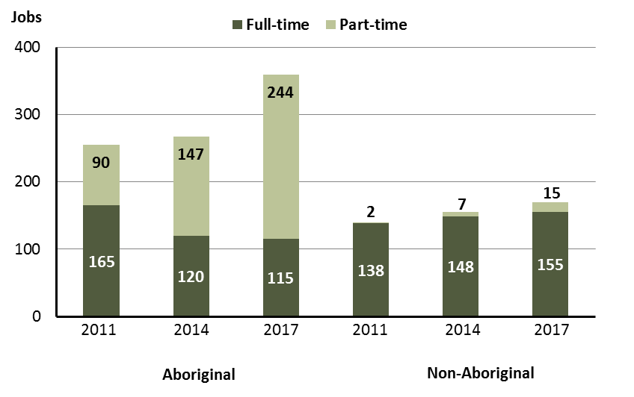

Source: Department of Trade, Business and Innovation

In 2017 in Galiwin'ku:

* of the 529 **filled jobs**:
* 115 were **full-time jobs** filled by **Aboriginal** persons, a decrease of 5 jobs from 2014 and a decrease of 50 jobs from 2011
* 244 were **part-time jobs** filled by **Aboriginal** persons, an increase of 97 jobs from 2014 and an increase of 154 jobs from 2011
* 155 were **full-time jobs** filled by **non-Aboriginal** persons, an increase of 7 jobs from 2014 and an increase of 17 jobs from 2011
* 15 were **part-time jobs** filled by **non-Aboriginal** persons, an increase of 8 jobs from 2014 and an increase of 13 jobs from 2011.

# Jobs by Sector: Private and Public

Table 3: Count of filled jobs by sector of business and by Aboriginal status of person employed in job, 2011, 2014 and 2017 (a)(b)(c)

|  |  |  |  |  |  |  |  |  |  |  |  |  |  |  |  |
| --- | --- | --- | --- | --- | --- | --- | --- | --- | --- | --- | --- | --- | --- | --- | --- |
| **Indicator** | **2011** | | | **2014** | | | **2017** | | | **Change 2011-2014** | | | **Change 2014-2017** | | |
| **Aboriginal** | **Non-Aboriginal** | **Total** | **Aboriginal** | **Non-Aboriginal** | **Total** | **Aboriginal** | **Non-Aboriginal** | **Total** | **Aboriginal** | **Non-Aboriginal** | **Total** | **Aboriginal** | **Non-Aboriginal** | **Total** |
| **Public Sector** | 77 | 77 | **154** | 78 | 62 | **140** | 70 | 57 | **127** | 1 | -15 | **-14** | -8 | -5 | **-13** |
| Australian Government | 4 | 2 | **6** | 7 | 1 | **8** | 6 | 1 | **7** | 3 | -1 | **2** | -1 | 0 | **-1** |
| Territory Government | 23 | 59 | **82** | 27 | 52 | **79** | 25 | 45 | **70** | 4 | -7 | **-3** | -2 | -7 | **-9** |
| Local Government | 50 | 16 | **66** | 44 | 9 | **53** | 39 | 11 | **50** | -6 | -7 | **-13** | -5 | 2 | **-3** |
| **Private Sector** | 178 | 63 | **241** | 189 | 93 | **282** | 289 | 113 | **402** | 11 | 30 | **41** | 100 | 20 | **120** |
| **Total** | **255** | **140** | **395** | **267** | **155** | **422** | **359** | **170** | **529** | **12** | **15** | **27** | **92** | **15** | **107** |

Source: Department of Trade, Business and Innovation

Chart 4: Count of filled jobs by sector of business, 2011, 2014 and 2017 (a)(d)

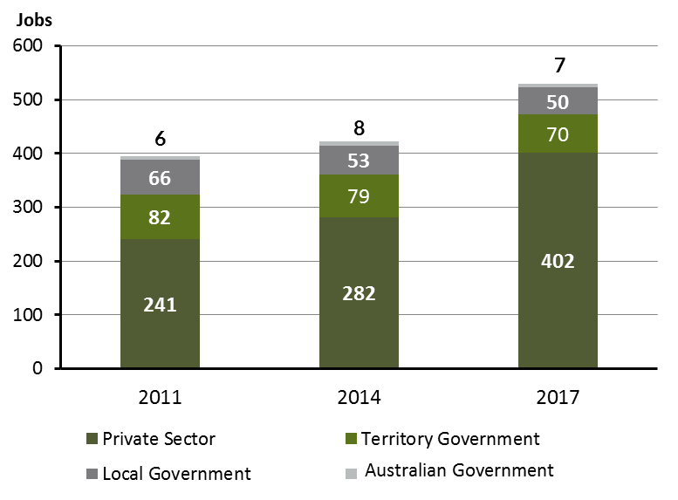

Source: Department of Trade, Business and Innovation

Chart 5: Percentage of filled jobs by sector of business in 2017 (a)(d)

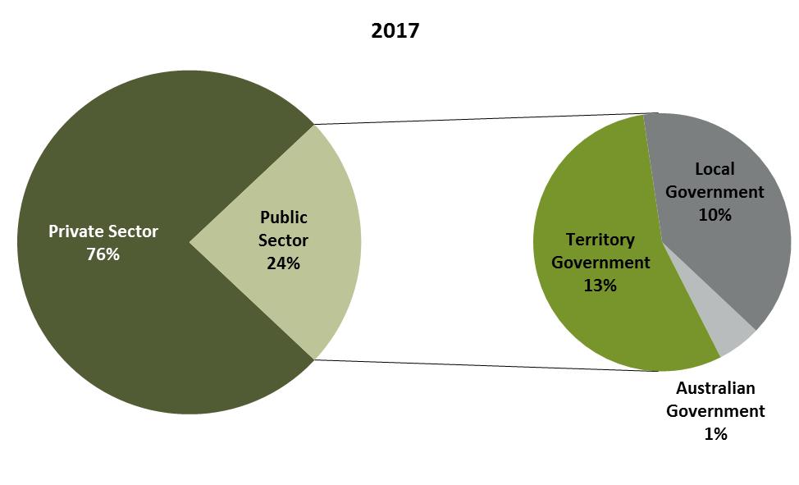

Source: Department of Trade, Business and Innovation

In 2017 in Galiwin'ku:

* there were 127 jobs in the **public sector**, a decrease of 13 jobs from 2014 and a decrease of 27 jobs from 2011
* of the 127 jobs in the **public sector**:
* 7 jobs were in the Australian Government, a decrease of 1 job from 2014 and an increase of 1 job from 2011
* 50 jobs were in the Local Government, a decrease of 3 jobs from 2014 and a decrease of 16 jobs from 2011
* there were 402 jobs in the **private sector**, an increase of 120 jobs from 2014 and an increase of 161 jobs from 2011.

Chart 6: Count of filled jobs by sector and Aboriginal status of person in job, 2011, 2014 and 2017 (a)(c)(d)

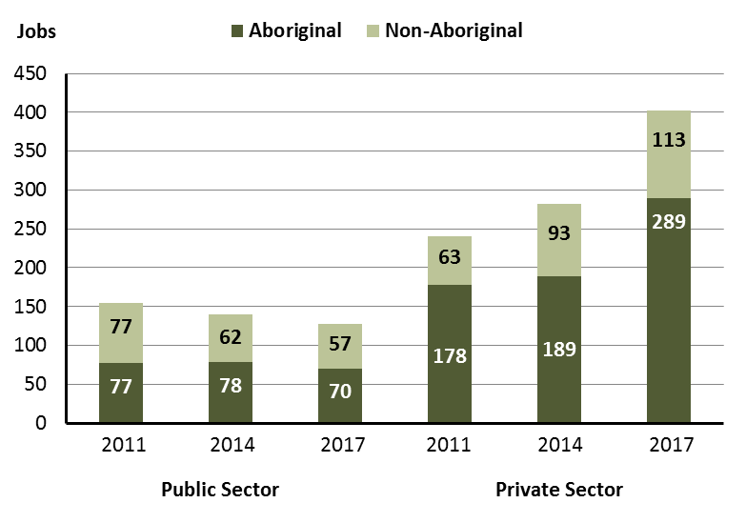

Source: Department of Trade, Business and Innovation

In 2017 in Galiwin'ku:

* of the 127 jobs in the **public sector**:
* 70 jobs were filled by **Aboriginal** persons, a decrease of 8 jobs from 2014 and a decrease of 7 jobs from 2011
* 57 jobs were filled by **non-Aboriginal** persons, a decrease of 5 jobs from 2014 and a decrease of 20 jobs from 2011
* of the 402 jobs in the **private sector**:
* 289 jobs were filled by **Aboriginal** persons, an increase of 100 jobs from 2014 and an increase of 111 jobs from 2011
* 113 jobs were filled by **non-Aboriginal** persons, an increase of 20 jobs from 2014 and an increase of 50 jobs from 2011.

Chart 7: Count of filled jobs by sector and full-time/part-time status of person in job, 2011, 2014 and 2017 (a)(b)(d)

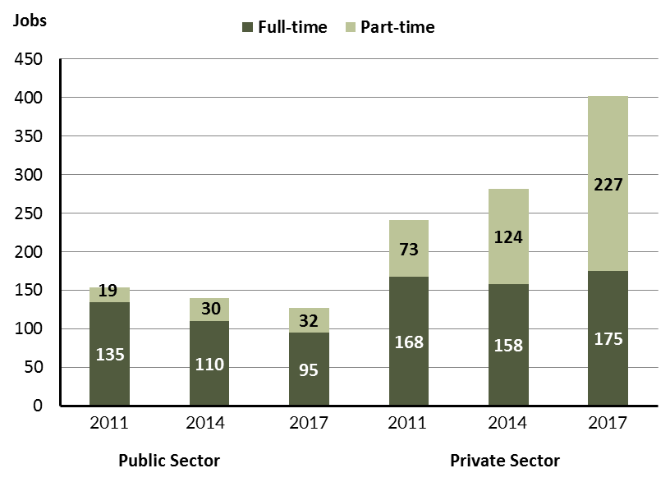

Source: Department of Trade, Business and Innovation

In 2017 in Galiwin'ku:

* of the 127 jobs in the **public sector**:
* 95 were **full-time** jobs, a decrease of 15 jobs from 2014 and a decrease of 40 jobs from 2011
* 32 were **part-time** jobs, an increase of 2 jobs from 2014 and an increase of 13 jobs from 2011
* of the 402 jobs in the **private sector**:
* 175 were **full-time** jobs, an increase of 17 jobs from 2014 and an increase of 7 jobs from 2011
* 227 were **part-time** jobs, an increase of 103 jobs from 2014 and an increase of 154 jobs from 2011.

Table 4: Count of filled jobs by full-time/part-time status and Aboriginal status of person in job by sector, 2011, 2014, and 2017 (a)(b)(c)(d)

|  |  |  |  |  |  |  |  |  |  |
| --- | --- | --- | --- | --- | --- | --- | --- | --- | --- |
| **Indicator** | **2011** | | | | | | | | |
| **Aboriginal** | | | **Non-Aboriginal** | | | **Total** | | |
| **Full-time** | **Part-time** | **Total** | **Full-time** | **Part-time** | **Total** | **Full-time** | **Part-time** | **Total** |
| Public Sector | 59 | 18 | **77** | 76 | 1 | **77** | 135 | 19 | **154** |
| Private sector | 106 | 72 | **178** | 62 | 1 | **63** | 168 | 73 | **241** |
| **Total** | **165** | **90** | **255** | **138** | **2** | **140** | **303** | **92** | **395** |

|  |  |  |  |  |  |  |  |  |  |
| --- | --- | --- | --- | --- | --- | --- | --- | --- | --- |
| **Indicator** | **2014** | | | | | | | | |
| **Aboriginal** | | | **Non-Aboriginal** | | | **Total** | | |
| **Full-time** | **Part-time** | **Total** | **Full-time** | **Part-time** | **Total** | **Full-time** | **Part-time** | **Total** |
| Public Sector | 51 | 27 | **78** | 59 | 3 | **62** | 110 | 30 | **140** |
| Private sector | 69 | 120 | **189** | 89 | 4 | **93** | 158 | 124 | **282** |
| **Total** | **120** | **147** | **267** | **148** | **7** | **155** | **268** | **154** | **422** |

|  |  |  |  |  |  |  |  |  |  |
| --- | --- | --- | --- | --- | --- | --- | --- | --- | --- |
| **Indicator** | **2017** | | | | | | | | |
| **Aboriginal** | | | **Non-Aboriginal** | | | **Total** | | |
| **Full-time** | **Part-time** | **Total** | **Full-time** | **Part-time** | **Total** | **Full-time** | **Part-time** | **Total** |
| Public Sector | 43 | 27 | **70** | 52 | 5 | **57** | 95 | 32 | **127** |
| Private Sector | 72 | 217 | **289** | 103 | 10 | **113** | 175 | 227 | **402** |
| **Total** | **120** | **147** | **359** | **155** | **15** | **170** | **270** | **259** | **529** |

Source: Department of Trade, Business and Innovation

In 2017 in Galiwin'ku there were:

* 70 jobs in the **public sector** filled by **Aboriginal** persons, a decrease of 8 jobs from 2014 and a decrease of 7 jobs from 2011, of which:
* 43 were **full-time** jobs, a decrease of 8 jobs from 2014 and a decrease of 16 jobs from 2011
* 27 were **part-time** jobs, unchanged from 2014 and an increase of 9 jobs from 2011
* 289 jobs in the **private sector** filled by **Aboriginal** persons, an increase of 100 jobs from 2014 and an increase of 111 jobs from 2011, of which:
* 72 were **full-time** jobs, an increase of 3 jobs from 2014 and a decrease of 34 jobs from 2011
* 217 were **part-time** jobs, an increase of 97 jobs from 2014 and an increase of 145 jobs from 2011
* 57 jobs in the **public sector** filled by **non-Aboriginal** persons, a decrease of 5 jobs from 2014 and a decrease of 20 jobs from 2011, of which:
* 52 were **full-time** jobs, a decrease of 7 jobs from 2014 and a decrease of 24 jobs from 2011
* 5 were **part-time** jobs, an increase of 2 jobs from 2014 and an increase of 4 jobs from 2011
* 113 jobs in the **private** **sector** filled by **non-Aboriginal** persons, an increase of 20 jobs from 2014 and an increase of 50 jobs from 2011, of which:
* 103 were **full-time** jobs, an increase of 14 jobs from 2014 and an increase of 41 jobs from 2011
* 10 were **part-time** jobs, an increase of 6 jobs from 2014 and an increase of 9 jobs from 2011.

# Job Status: Permanent and Temporary

Table 5: Count of filled jobs by employment status and Aboriginal status of person in job, 2011, 2014, and 2017 (a)(c)(e)

|  |  |  |  |  |  |  |  |  |  |  |  |  |  |  |  |
| --- | --- | --- | --- | --- | --- | --- | --- | --- | --- | --- | --- | --- | --- | --- | --- |
| **Indicator** | **2011** | | | **2014** | | | **2017** | | | **Change 2011-2014** | | | **Change 2014-2017** | | |
| **Aboriginal** | **Non-Aboriginal** | **Total** | **Aboriginal** | **Non-Aboriginal** | **Total** | **Aboriginal** | **Non-Aboriginal** | **Total** | **Aboriginal** | **Non-Aboriginal** | **Total** | **Aboriginal** | **Non-Aboriginal** | **Total** |
| Permanent | 187 | 92 | **279** | 163 | 125 | **288** | 157 | 76 | **233** | -24 | 33 | **9** | -6 | -49 | **-55** |
| Temporary | 68 | 48 | **116** | 104 | 30 | **134** | 202 | 94 | **296** | 36 | -18 | **18** | 98 | 64 | **162** |
| **Total** | **255** | **140** | **395** | **267** | **155** | **422** | **359** | **170** | **529** | **12** | **15** | **27** | **92** | **15** | **107** |

Source: Department of Trade, Business and Innovation

Chart 8: Count of filled jobs by employment status and Aboriginal status of person in job, 2011, 2014 and 2017 (a)(c)(e)

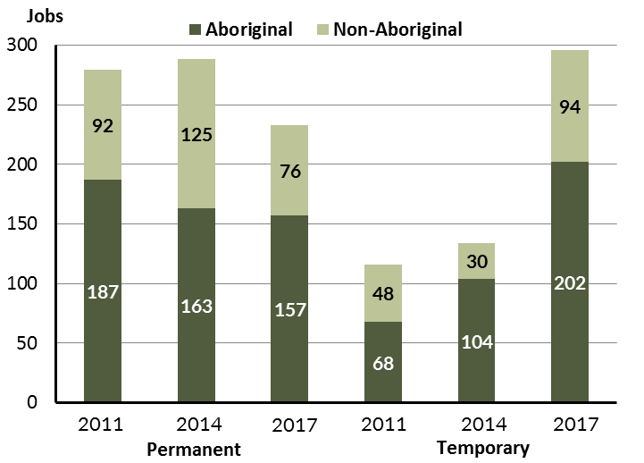

Source: Department of Trade, Business and Innovation

In 2017 in Galiwin'ku:

* there were 233 **permanent** jobs, a decrease of 55 jobs from 2014, and a decrease of 46 jobs from 2011, of which:
* 157 jobs were filled by **Aboriginal** persons, a decrease of 6 jobs from 2014 and a decrease of 30 jobs from 2011
* 76 jobs were filled by **non-Aboriginal** persons, a decrease of 49 jobs from 2014 and a decrease of 16 jobs from 2011
* there were 296 **temporary** jobs, an increase of 162 jobs from 2014 and an increase of 180 jobs from 2011, of which:
* 202 jobs were filled by **Aboriginal** persons, an increase of 98 jobs from 2014 and an increase of 134 jobs from 2011
* 94 jobs were filled by **non-Aboriginal** persons, an increase of 64 jobs from 2014 and an increase of 46 jobs from 2011.

Table 6: Count of filled jobs by sector, Aboriginal status and employment status of person in job, 2011, 2014 and 2017 (a)(c)(d)(e)

|  |  |  |  |  |  |  |  |  |  |
| --- | --- | --- | --- | --- | --- | --- | --- | --- | --- |
| **Indicator** | **2011** | | | | | | | | |
| **Aboriginal** | | | **Non-Aboriginal** | | | **Total** | | |
| **Perm** | **Temp** | **Total** | **Perm** | **Temp** | **Total** | **Perm** | **Temp** | **Total** |
| Public Sector | 53 | 24 | **77** | 41 | 36 | **77** | 94 | 60 | **154** |
| Private Sector | 134 | 44 | **178** | 51 | 12 | **63** | 185 | 56 | **241** |
| **Total** | **187** | **68** | **255** | **92** | **48** | **140** | **279** | **116** | **395** |

|  |  |  |  |  |  |  |  |  |  |
| --- | --- | --- | --- | --- | --- | --- | --- | --- | --- |
| **Indicator** | **2014** | | | | | | | | |
| **Aboriginal** | | | **Non-Aboriginal** | | | **Total** | | |
| **Perm** | **Temp** | **Total** | **Perm** | **Temp** | **Total** | **Perm** | **Temp** | **Total** |
| Public Sector | 42 | 36 | **78** | 49 | 13 | **62** | 91 | 49 | **140** |
| Private Sector | 121 | 68 | **189** | 76 | 17 | **93** | 197 | 85 | **282** |
| **Total** | **163** | **104** | **267** | **125** | **30** | **155** | **288** | **134** | **422** |

|  |  |  |  |  |  |  |  |  |  |
| --- | --- | --- | --- | --- | --- | --- | --- | --- | --- |
| **Indicator** | **2017** | | | | | | | | |
| **Aboriginal** | | | **Non-Aboriginal** | | | **Total** | | |
| **Perm** | **Temp** | **Total** | **Perm** | **Temp** | **Total** | **Perm** | **Temp** | **Total** |
| Public Sector | 39 | 31 | **70** | 22 | 35 | **57** | 61 | 66 | **127** |
| Private Sector | 118 | 171 | **289** | 54 | 59 | **113** | 172 | 230 | **402** |
| **Total** | **157** | **202** | **359** | **76** | **94** | **170** | **233** | **296** | **529** |

Source: Department of Trade, Business and Innovation

In 2017 in Galiwin'ku there were:

* 127 jobs in the **public** **sector**, a decrease of 13 jobs from 2014 and a decrease of 27 jobs from 2011, of which:
* 61 jobs were **permanent**, a decrease of 30 jobs from 2014 and a decrease of 33 jobs from 2011, of which:
* 39 jobs were filled by **Aboriginal** persons, a decrease of 3 jobs from 2014 and a decrease of 14 jobs from 2011
* 22 jobs were filled by **non-Aboriginal** persons, a decrease of 27 jobs from 2014 and a decrease of 19 jobs from 2011
* 66 jobs were **temporary**, an increase of 17 jobs from 2014 and an increase of 6 jobs from 2011, of which:
* 31 jobs were filled by **Aboriginal** persons, a decrease of 5 jobs from 2014 and an increase of 7 jobs from 2011
* 35 jobs were filled by **non-Aboriginal** persons, an increase of 22 jobs from 2014 and a decrease of 1 job from 2011
* 402 jobs in the **private** **sector**, an increase of 120 jobs from 2014 and an increase of 161 jobs from 2011, of which:
* 172 jobs were **permanent**, a decrease of 25 jobs from 2014 and a decrease of 13 jobs from 2011, of which:
* 118 jobs were filled by **Aboriginal** persons, a decrease of 3 jobs from 2014 and a decrease of 16 jobs from 2011
* 54 jobs were filled by **non-Aboriginal** persons, a decrease of 22 jobs from 2014 and an increase of 3 jobs from 2011
* 230 jobs were **temporary**, an increase of 145 jobs from 2014 and an increase of 174 jobs from 2011, of which:
* 171 jobs were filled by **Aboriginal** persons, an increase of 103 jobs from 2014 and an increase of 127 jobs from 2011
* 59 jobs were filled by **non-Aboriginal** persons, an increase of 42 jobs from 2014 and an increase of 47 jobs from 2011.

# Job Vacancies

Table 7: Job vacancies, 2011, 2014, and 2017

|  |  |  |  |  |  |
| --- | --- | --- | --- | --- | --- |
| **Indicator** | **2011** | **2014** | **2017** | **Change 2011-2014** | **Change 2014-2017** |
| **Job vacancies** | **28** | **32** | **32** | **4** | **0** |

Source: Department of Trade, Business and Innovation

Table 8: Job vacancies by occupation, 2011, 2014, and 2017 (f)(g)

|  |  |  |  |  |  |
| --- | --- | --- | --- | --- | --- |
| **Occupation (ANZSCO major group)** | **2011** | **2014** | **2017** | **Change 2011-2014** | **Change 2014-2017** |
| Clerical and Administrative Workers | 4 | 3 | 8 | -1 | 5 |
| Community and Personal Service Workers | 9 | 13 | 2 | 4 | -11 |
| Labourers | 2 | 2 | 5 | 0 | 3 |
| Machinery Operators and Drivers | 0 | 1 | 1 | 1 | 0 |
| Managers | 5 | 1 | 1 | -4 | 0 |
| Professionals | 7 | 12 | 14 | 5 | 2 |
| Technicians and Trades Workers | 1 | 0 | 1 | -1 | 1 |
| **Total** | **28** | **32** | **32** | **4** | **0** |

Source: Department of Trade, Business and Innovation

Table 9: Job vacancies by job title, July 2017 (f)

|  |  |  |  |
| --- | --- | --- | --- |
| **Job Vacancy** | **No.** | **Job Vacancy** | **No.** |
| Aboriginal and Torres Strait Islander Education Worker | 1 | Park Ranger | 1 |
| Aircraft Baggage Handler and Airline Ground Crew | 1 | Primary School Teacher | 6 |
| Arts Administrator or Manager | 1 | Program or Project Administrator | 1 |
| Clerical and Administrative Workers nec | 3 | Receptionist (General) | 1 |
| Commercial Cleaner | 1 | Registered Nurse (Community Health) | 1 |
| Commercial Housekeeper | 1 | Teacher of English to Speakers of Other Languages | 1 |
| Electrician (General) | 1 | Teachers' Aide | 1 |
| General Clerk | 3 | Training and Development Professional | 1 |
| General Practitioner | 2 | Vocational Education Teacher | 1 |
| Handyperson | 3 | Liaison Officer | 1 |
| **Total** | **32** |  |  |

Source: Department of Trade, Business and Innovation

In 2017 in Galiwin'ku:

* there were 32 **vacancies** reported, unchanged from 2014 and an increase of 4 vacancies from 2011
* of the 32 reported **vacancies,** the largest requirements were for:
* 14 Professionals, the majority of which are in the following jobs:
* Primary School Teacher
* General Medical Practitioner
* 8 Clerical and Administrative Workers, the majority of which are in the following jobs:
* Clerical and Administrative Worker
* General Clerk
* 5 Labourers, the majority of which is in the following job:
* Handyperson.

# Jobs by Industry

Table 10: Count of filled jobs by industry of business, 2011, 2014 and 2017 (a)(h)

|  |  |  |  |  |  |  |  |  |
| --- | --- | --- | --- | --- | --- | --- | --- | --- |
| **Industry (ANZSIC Division)** | **2011** | | **2014** | | **2017** | | **Change 2011-2014** | **Change 2014-2017** |
| **Total** | **% of Total** | **Total** | **% of Total** | **Total** | **% of Total** | **Total** | **Total** |
| Accommodation and Food Services | 0 | 0.0% | 0 | 0.0% | 8 | 1.5% | 0 | 8 |
| Arts and Recreation Services | 6 | 1.5% | 1 | 0.2% | 4 | 0.8% | -5 | 3 |
| Construction | 0 | 0.0% | 0 | 0.0% | 121 | 22.9% | 0 | 121 |
| Education and Training | 78 | 19.7% | 87 | 20.6% | 83 | 15.7% | 9 | -4 |
| Electricity, Gas, Water and Waste Services | 1 | 0.3% | 10 | 2.4% | 2 | 0.4% | 9 | -8 |
| Financial and Insurance Services | 4 | 1.0% | 4 | 0.9% | 5 | 0.9% | 0 | 1 |
| Health Care and Social Assistance | 62 | 15.7% | 48 | 11.4% | 83 | 15.7% | -14 | 35 |
| Other Services | 0 | 0.0% | 1 | 0.2% | 7 | 1.3% | 1 | 6 |
| Public Administration and Safety | 182 | 46.1% | 189 | 44.8% | 63 | 11.9% | 7 | -126 |
| Retail Trade | 55 | 13.9% | 77 | 18.2% | 139 | 26.3% | 22 | 62 |
| Transport, Postal and Warehousing | 5 | 1.3% | 5 | 1.2% | 14 | 2.6% | 0 | 9 |
| **Total** | **395** | **100.0%** | **422** | **100.0%** | **529** | **100.0%** | **27** | **107** |

Source: Department of Trade, Business and Innovation

In 2017 in Galiwin'ku:

* the Retail Trade industry was the **largest industry employer**, with 139 filled jobs or 26.3% of filled jobs, an increase of 62 jobs from 2014 and an increase of 84 jobs from 2011
* **other significant** industry employers were:
* Construction with 121 jobs (or 22.9% of filled jobs), an increase of 121 jobs from 2014 and an increase of 121 jobs from 2011
* Education and Training with 83 jobs (or 15.7% of filled jobs), a decrease of 4 jobs from 2014 and an increase of 5 jobs from 2011
* Health Care and Social Assistance with 83 jobs (or 15.7% of filled jobs), an increase of 35 jobs from 2014 and an increase of 21 jobs from 2011.

Table 11: Count of filled jobs by industry of business and Aboriginal status of person in job, 2011, 2014, and 2017 (a)(c)(h)

|  |  |  |  |  |  |  |  |  |  |  |  |  |  |  |  |
| --- | --- | --- | --- | --- | --- | --- | --- | --- | --- | --- | --- | --- | --- | --- | --- |
| **Industry (ANZSIC division)** | **2011** | | | **2014** | | | **2017** | | | **Change 2011-2014** | | | **Change  2014-2017** | | |
| **Aboriginal** | **Non-Aboriginal** | **Total** | **Aboriginal** | **Non-Aboriginal** | **Total** | **Aboriginal** | **Non-Aboriginal** | **Total** | **Aboriginal** | **Non-Aboriginal** | **Total** | **Aboriginal** | **Non-Aboriginal** | **Total** |
| Accommodation and Food Services | 0 | 0 | **0** | 0 | 0 | **0** | 6 | 2 | **8** | 0 | 0 | **0** | 6 | 2 | **8** |
| Arts and Recreation Services | 3 | 3 | **6** | 1 | 0 | **1** | 3 | 1 | **4** | -2 | -3 | **-5** | 2 | 1 | **3** |
| Construction | 0 | 0 | **0** | 0 | 0 | **0** | 86 | 35 | **121** | 0 | 0 | **0** | 86 | 35 | **121** |
| Education and Training | 24 | 54 | **78** | 36 | 51 | **87** | 40 | 43 | **83** | 12 | -3 | **9** | 4 | -8 | **-4** |
| Electricity, Gas, Water and Waste Services | 0 | 1 | **1** | 2 | 8 | **10** | 1 | 1 | **2** | 2 | 7 | **9** | -1 | -7 | **-8** |
| Financial and Insurance Services | 4 | 0 | **4** | 4 | 0 | **4** | 4 | 1 | **5** | 0 | 0 | **0** | 0 | 1 | **1** |
| Health Care and Social Assistance | 49 | 13 | **62** | 34 | 14 | **48** | 51 | 32 | **83** | -15 | 1 | **-14** | 17 | 18 | **35** |
| Other Services | 0 | 0 | **0** | 1 | 0 | **1** | 3 | 4 | **7** | 1 | 0 | **1** | 2 | 4 | **6** |
| Public Administration and Safety | 123 | 59 | **182** | 129 | 60 | **189** | 46 | 17 | **63** | 6 | 1 | **7** | -83 | -43 | **-126** |
| Retail Trade | 51 | 4 | **55** | 60 | 17 | **77** | 116 | 23 | **139** | 9 | 13 | **22** | 56 | 6 | **62** |
| Transport, Postal and Warehousing | 0 | 5 | **5** | 0 | 5 | **5** | 3 | 11 | **14** | 0 | 0 | **0** | 3 | 6 | **9** |
| **Total** | **255** | **140** | **395** | **267** | **155** | **422** | **359** | **170** | **529** | **12** | **15** | **27** | **92** | **15** | **107** |

Source: Department of Trade, Business and Innovation

Chart 9: Count of filled jobs by top 5 industries of business and Aboriginal status of person in job, 2017 (a)(c)(h)

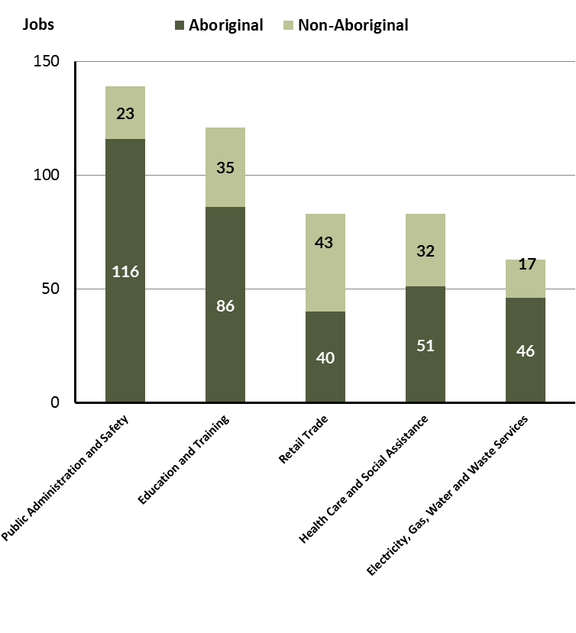

Source: Department of Trade, Business and Innovation

In 2017 in Galiwin'ku:

* of the 359 jobs filled by **Aboriginal** persons, there were:
* 116 jobs in Retail Trade, an increase of 56 jobs from 2014 and an increase of 65 jobs from 2011
* 86 jobs in Construction, an increase of 86 jobs from 2014 and an increase of 86 jobs from 2011
* 40 jobs in Education and Training, an increase of 4 jobs from 2014 and an increase of 16 jobs from 2011
* of the 170 jobs filled by **non-Aboriginal** persons, there were:
* 23 jobs in Retail Trade, an increase of 6 jobs from 2014 and an increase of 19 jobs from 2011
* 35 jobs in Construction, an increase of 35 jobs from 2014 and an increase of 35 jobs from 2011
* 43 jobs in Education and Training, a decrease of 8 jobs from 2014 and a decrease of 11 jobs from 2011.

Table 12: Count of filled jobs by industry, employment status and Aboriginal status of person in job, 2011 (a)(c)(e)(h)

|  |  |  |  |  |  |  |  |  |  |
| --- | --- | --- | --- | --- | --- | --- | --- | --- | --- |
| **Industry (ANZSIC division)** | **2011** | | | | | | | | |
| **Aboriginal** | | | **Non-Aboriginal** | | | **Total** | | |
| **Perm** | **Temp** | **Total** | **Perm** | **Temp** | **Total** | **Perm** | **Temp** | **Total** |
| Arts and Recreation Services | 3 | 0 | **3** | 0 | 3 | **3** | 3 | 3 | **6** |
| Education and Training | 10 | 14 | **24** | 25 | 29 | **54** | 35 | 43 | **78** |
| Electricity, Gas, Water and Waste Services | 0 | 0 | **0** | 1 | 0 | **1** | 1 | 0 | **1** |
| Financial and Insurance Services | 3 | 1 | **4** | 0 | 0 | **0** | 3 | 1 | **4** |
| Health Care and Social Assistance | 35 | 14 | **49** | 13 | 0 | **13** | 48 | 14 | **62** |
| Public Administration and Safety | 112 | 11 | **123** | 52 | 7 | **59** | 164 | 18 | **182** |
| Retail Trade | 23 | 28 | **51** | 0 | 4 | **4** | 23 | 32 | **55** |
| Transport, Postal and Warehousing | 0 | 0 | **0** | 1 | 4 | **5** | 1 | 4 | **5** |
| **Total** | **187** | **68** | **255** | **92** | **48** | **140** | **279** | **116** | **395** |

Source: Department of Trade, Business and Innovation

Table 13: Count of filled jobs by industry, employment status and Aboriginal status of person in job, 2014 (a)(c)(e)(h)

|  |  |  |  |  |  |  |  |  |  |
| --- | --- | --- | --- | --- | --- | --- | --- | --- | --- |
| **Industry (ANZSIC division)** | **2014** | | | | | | | | |
| **Aboriginal** | | | **Non-Aboriginal** | | | **Total** | | |
| **Perm** | **Temp** | **Total** | **Perm** | **Temp** | **Total** | **Perm** | **Temp** | **Total** |
| Arts and Recreation Services | 0 | 1 | **1** | 0 | 0 | **0** | 0 | 1 | **1** |
| Education and Training | 12 | 24 | **36** | 37 | 14 | **51** | 49 | 38 | **87** |
| Electricity, Gas, Water and Waste Services | 1 | 1 | **2** | 1 | 7 | **8** | 2 | 8 | **10** |
| Financial and Insurance Services | 4 | 0 | **4** | 0 | 0 | **0** | 4 | 0 | **4** |
| Health Care and Social Assistance | 32 | 2 | **34** | 9 | 5 | **14** | 41 | 7 | **48** |
| Other Services | 0 | 1 | **1** | 0 | 0 | **0** | 0 | 1 | **1** |
| Public Administration and Safety | 89 | 40 | **129** | 59 | 1 | **60** | 148 | 41 | **189** |
| Retail Trade | 25 | 35 | **60** | 17 | 0 | **17** | 42 | 35 | **77** |
| Transport, Postal and Warehousing | 0 | 0 | **0** | 2 | 3 | **5** | 2 | 3 | **5** |
| **Total** | **163** | **104** | **267** | **125** | **30** | **155** | **288** | **134** | **422** |

Source: Department of Trade, Business and Innovation

Table 14: Count of filled jobs by industry, employment status and Aboriginal status of person in job, 2017 (a)(c)(e)(h)

|  |  |  |  |  |  |  |  |  |  |
| --- | --- | --- | --- | --- | --- | --- | --- | --- | --- |
| **Industry (ANZSIC division)** | **2017** | | | | | | | | |
| **Aboriginal** | | | **Non-Aboriginal** | | | **Total** | | |
| **Perm** | **Temp** | **Total** | **Perm** | **Temp** | **Total** | **Perm** | **Temp** | **Total** |
| Accommodation and Food Services | 4 | 2 | **6** | 1 | 1 | **2** | 5 | 3 | **8** |
| Arts and Recreation Services | 3 | 0 | **3** | 1 | 0 | **1** | 4 | 0 | **4** |
| Construction | 9 | 77 | **86** | 11 | 24 | **35** | 20 | 101 | **121** |
| Education and Training | 17 | 23 | **40** | 18 | 25 | **43** | 35 | 48 | **83** |
| Electricity, Gas, Water and Waste Services | 1 | 0 | **1** | 1 | 0 | **1** | 2 | 0 | **2** |
| Financial and Insurance Services | 3 | 1 | **4** | 0 | 1 | **1** | 3 | 2 | **5** |
| Health Care and Social Assistance | 39 | 12 | **51** | 22 | 10 | **32** | 61 | 22 | **83** |
| Other Services | 2 | 1 | **3** | 2 | 2 | **4** | 4 | 3 | **7** |
| Public Administration and Safety | 25 | 21 | **46** | 6 | 11 | **17** | 31 | 32 | **63** |
| Retail Trade | 52 | 64 | **116** | 6 | 17 | **23** | 58 | 81 | **139** |
| Transport, Postal and Warehousing | 2 | 1 | **3** | 8 | 3 | **11** | 10 | 4 | **14** |
| **Total** | **157** | **202** | **359** | **76** | **94** | **170** | **233** | **296** | **529** |

Source: Department of Trade, Business and Innovation

In 2017 in Galiwin'ku:

* of the 233 **permanent** jobs**,** there were: a
* 61 jobs in Health Care and Social Assistance, an increase of 20 jobs from 2014 and an increase of 13 jobs from 2011, including:
* 39 jobs filled by **Aboriginal** persons, an increase of 7 jobs from 2014 and an increase of 4 jobs from 2011
* 22 jobs filled by **non-Aboriginal** persons, an increase of 13 jobs from 2014 and an increase of 9 jobs from 2011
* 58 jobs in Retail Trade, an increase of 16 jobs from 2014 and an increase of 35 jobs from 2011, including:
* 52 jobs filled by **Aboriginal** persons, an increase of 27 jobs from 2014 and an increase of 29 jobs from 2011
* 6 jobs filled by **non-Aboriginal** persons, a decrease of 11 jobs from 2014 and an increase of 6 jobs from 2011
* 35 jobs in Education and Training, a decrease of 14 jobs from 2014 and unchanged from 2011, including:
* 17 jobs filled by **Aboriginal** persons, an increase of 5 jobs from 2014 and an increase of 7 jobs from 2011
* 18 jobs filled by **non-Aboriginal** persons, a decrease of 19 jobs from 2014 and a decrease of 7 jobs from 2011
* of the 296 **temporary** jobs, there were:
* 101 jobs in Construction, an increase of 101 jobs from 2014 and an increase of 101 jobs from 2011, including:
* 77 jobs filled by **Aboriginal** persons, an increase of 77 jobs from 2014 and an increase of 77 jobs from 2011
* 24 jobs filled by **non-Aboriginal** persons, an increase of 24 jobs from 2014 and an increase of 24 jobs from 2011
* 81 jobs in Retail Trade, an increase of 46 jobs from 2014 and an increase of 49 jobs from 2011, including:
* 64 jobs filled by **Aboriginal** persons, an increase of 29 jobs from 2014 and an increase of 36 jobs from 2011
* 17 jobs filled by **non-Aboriginal** persons, an increase of 17 jobs from 2014 and an increase of 13 jobs from 2011
* 48 jobs in Education and Training, an increase of 10 jobs from 2014 and an increase of 5 jobs from 2011, including:
* 23 jobs filled by **Aboriginal** persons, a decrease of 1 job from 2014 and an increase of 9 jobs from 2011
* 25 jobs filled by **non-Aboriginal** persons, an increase of 11 jobs from 2014 and a decrease of 4 jobs from 2011.

# Jobs by Occupation

Table 15: Count of filled jobs by occupation, 2011, 2014 and 2017 (a)(f)(g)

|  |  |  |  |  |  |  |  |  |
| --- | --- | --- | --- | --- | --- | --- | --- | --- |
| **Occupation (ANZSCO major group)** | **2011** | | **2014** | | **2017** | | **Change 2011-2014** | **Change 2014-2017** |
| **Total** | **% of Total** | **Total** | **% of Total** | **Total** | **% of Total** | **Total** | **Total** |
| Clerical and Administrative Workers | 57 | 14.4% | 70 | 16.6% | 70 | 13.2% | 13 | 0 |
| Community and Personal Service Workers | 87 | 22.0% | 120 | 28.4% | 105 | 19.8% | 33 | -15 |
| Labourers | 44 | 11.1% | 35 | 8.3% | 118 | 22.3% | -9 | 83 |
| Machinery Operators and Drivers | 5 | 1.3% | 6 | 1.4% | 8 | 1.5% | 1 | 2 |
| Managers | 16 | 4.1% | 26 | 6.2% | 33 | 6.2% | 10 | 7 |
| Professionals | 110 | 27.8% | 90 | 21.3% | 90 | 17.0% | -20 | 0 |
| Sales Workers | 53 | 13.4% | 58 | 13.7% | 74 | 14.0% | 5 | 16 |
| Technicians and Trades Workers | 23 | 5.8% | 17 | 4.0% | 31 | 5.9% | -6 | 14 |
| **Total** | **395** | **100.0%** | **422** | **100.0%** | **529** | **100.0%** | **27** | **107** |

Source: Department of Trade, Business and Innovation

Chart 10: Percentage and count of top 6 filled jobs by occupation, 2011, 2014 and 2017 (a)(f)(g)

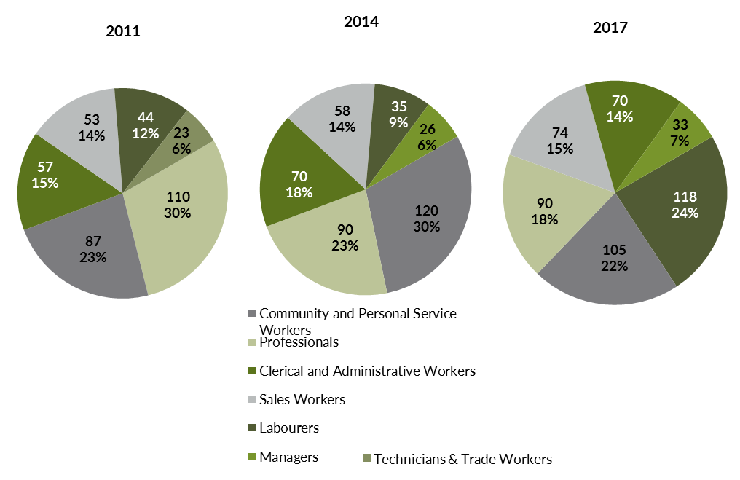

Source: Department of Trade, Business and Innovation

In 2017 in Galiwin'ku:

* Labourers was the **largest occupation classification** in terms of filled jobs, accounting for 118 jobs (22.3% of total filled jobs), an increase of 83 jobs from 2014 and an increase of 74 jobs from 2011
* **other significant** occupation classifications were:
* Community and Personal Service Workers accounting for 105 jobs or 19.8% of total jobs a decrease of 15 jobs from 2014 and an increase of 18 jobs from 2011
* Professionals accounting for 90 jobs or 17% of total jobs unchanged from 2014 and a decrease of 20 jobs from 2011
* Sales Workers accounting for 74 jobs or 14% of total jobs an increase of 16 jobs from 2014 and an increase of 21 jobs from 2011.

**Table 16 Count of filled jobs by ANZSCO occupation by Aboriginal status of person employed in job, 2011, 2014 and 2017 (a)(c)(f)(g)**

|  |  |  |  |  |  |  |  |  |  |  |  |  |  |  |  |
| --- | --- | --- | --- | --- | --- | --- | --- | --- | --- | --- | --- | --- | --- | --- | --- |
| **Occupation (ANZSCO major group)** | **2011** | | | **2014** | | | **2017** | | | **Change 2011-2014** | | | **Change 2014-2017** | | |
| **Aboriginal** | **Non-Aboriginal** | **Total** | **Aboriginal** | **Non-Aboriginal** | **Total** | **Aboriginal** | **Non-Aboriginal** | **Total** | **Aboriginal** | **Non-Aboriginal** | **Total** | **Aboriginal** | **Non-Aboriginal** | **Total** |
| Clerical and Administrative Workers | 40 | 17 | **57** | 49 | 21 | **70** | 55 | 15 | **70** | 9 | 4 | **13** | 6 | -6 | **0** |
| Community and Personal Service Workers | 72 | 15 | **87** | 102 | 18 | **120** | 90 | 15 | **105** | 30 | 3 | **33** | -12 | -3 | **-15** |
| Labourers | 36 | 8 | **44** | 29 | 6 | **35** | 105 | 13 | **118** | -7 | -2 | **-9** | 76 | 7 | **83** |
| Machinery Operators and Drivers | 5 | 0 | **5** | 4 | 2 | **6** | 3 | 5 | **8** | -1 | 2 | **1** | -1 | 3 | **2** |
| Managers | 1 | 15 | **16** | 3 | 23 | **26** | 8 | 25 | **33** | 2 | 8 | **10** | 5 | 2 | **7** |
| Professionals | 35 | 75 | **110** | 26 | 64 | **90** | 27 | 63 | **90** | -9 | -11 | **-20** | 1 | -1 | **0** |
| Sales Workers | 53 | 0 | **53** | 52 | 6 | **58** | 66 | 8 | **74** | -1 | 6 | **5** | 14 | 2 | **16** |
| Technicians and Trades Workers | 13 | 10 | **23** | 2 | 15 | **17** | 5 | 26 | **31** | -11 | 5 | **-6** | 3 | 11 | **14** |
| **Total** | **255** | **140** | **395** | **267** | **155** | **422** | **359** | **170** | **529** | **12** | **15** | **27** | **92** | **15** | **107** |

Source: Department of Trade, Business and Innovation

In 2017 in Galiwin'ku:

* of the 359 **jobs filled** by **Aboriginal** persons, there were:
* 105 Labourers, an increase of 76 jobs from 2014 and an increase of 69 jobs from 2011
* 90 Community and Personal Service Workers, a decrease of 12 jobs from 2014 and an increase of 18 jobs from 2011
* 66 Sales Workers, an increase of 14 jobs from 2014 and an increase of 13 jobs from 2011
* of the 170 **jobs filled** by **non-Aboriginal** persons, there were:
* 63 Professionals, a decrease of 1 job from 2014 and a decrease of 12 jobs from 2011
* 26 Technicians and Trades Workers, an increase of 11 jobs from 2014 and an increase of 16 jobs from 2011
* 25 Managers, an increase of 2 jobs from 2014 and an increase of 10 jobs from 2011.

# Jobs by Industry by Occupation

Table 17: Count of filled jobs by industry by occupation, 2011 (a)(f)(g)(h)

|  |  |  |  |  |  |  |  |  |  |  |  |
| --- | --- | --- | --- | --- | --- | --- | --- | --- | --- | --- | --- |
| **2011** | | | | | | | | | | | |
| **Industry (ANZSIC Division)** |  | **Occupation (ANZSCO major group)** | | | | | | | | | |
| **Clerical and Administrative Workers** | **Community and Personal Service Workers** | **Labourers** | **Machinery Operators and Drivers** | **Managers** | **Professionals** | **Sales Workers** | **Technicians and Trades Workers** | **Other occupations** | **Total** |
| Arts and Recreation Services | 2 | 0 | 0 | 0 | 1 | 3 | 0 | 0 | 0 | **6** |
| Education and Training | 6 | 25 | 3 | 0 | 1 | 43 | 0 | 0 | 0 | **78** |
| Electricity, Gas, Water and Waste Services | 0 | 0 | 0 | 0 | 0 | 0 | 0 | 1 | 0 | **1** |
| Financial and Insurance Services | 3 | 0 | 0 | 0 | 0 | 1 | 0 | 0 | 0 | **4** |
| Health Care and Social Assistance | 5 | 27 | 6 | 1 | 1 | 16 | 0 | 6 | 0 | **62** |
| Public Administration and Safety | 40 | 35 | 34 | 4 | 9 | 42 | 2 | 16 | 0 | **182** |
| Retail Trade | 0 | 0 | 0 | 0 | 4 | 0 | 51 | 0 | 0 | **55** |
| Transport, Postal and Warehousing | 1 | 0 | 0 | 0 | 0 | 4 | 0 | 0 | 0 | **5** |
| **Total** | **57** | **87** | **44** | **5** | **16** | **110** | **53** | **23** | **0** | **395** |

Source: Department of Trade, Business and Innovation

Table 18: Count of filled jobs by industry by occupation, 2014 (a)(f)(g)(h)

|  |  |  |  |  |  |  |  |  |  |  |  |
| --- | --- | --- | --- | --- | --- | --- | --- | --- | --- | --- | --- |
| **2014** | | | | | | | | | | | |
| **Industry (ANZSIC Division)** |  | **Occupation (ANZSCO major group)** | | | | | | | | | |
| **Clerical and Administrative Workers** | **Community and Personal Service Workers** | **Labourers** | **Machinery Operators and Drivers** | **Managers** | **Professionals** | **Sales Workers** | **Technicians and Trades Workers** | **Other occupations** | **Total** |
| Arts and Recreation Services | 0 | 0 | 0 | 0 | 0 | 1 | 0 | 0 | 0 | **1** |
| Education and Training | 6 | 28 | 2 | 0 | 5 | 46 | 0 | 0 | 0 | **87** |
| Electricity, Gas, Water and Waste Services | 0 | 0 | 4 | 0 | 2 | 0 | 0 | 4 | 0 | **10** |
| Financial and Insurance Services | 4 | 0 | 0 | 0 | 0 | 0 | 0 | 0 | 0 | **4** |
| Health Care and Social Assistance | 6 | 28 | 3 | 2 | 2 | 6 | 0 | 1 | 0 | **48** |
| Other Services | 0 | 0 | 0 | 0 | 0 | 1 | 0 | 0 | 0 | **1** |
| Public Administration and Safety | 52 | 58 | 26 | 2 | 12 | 31 | 0 | 8 | 0 | **189** |
| Retail Trade | 2 | 6 | 0 | 2 | 5 | 0 | 58 | 4 | 0 | **77** |
| Transport, Postal and Warehousing | 0 | 0 | 0 | 0 | 0 | 5 | 0 | 0 | 0 | **5** |
| **Total** | **70** | **120** | **35** | **6** | **26** | **90** | **58** | **17** | **0** | **422** |

Source: Department of Trade, Business and Innovation

Table 19: Count of filled jobs by occupation and by industry, 2017 (a)(f)(g)(h)

|  |  |  |  |  |  |  |  |  |  |  |  |
| --- | --- | --- | --- | --- | --- | --- | --- | --- | --- | --- | --- |
| **2017** | | | | | | | | | | | |
| **Industry (ANZSIC Division)** |  | **Occupation (ANZSCO major group)** | | | | | | | | | |
| **Clerical and Administrative Workers** | **Community and Personal Service Workers** | **Labourers** | **Machinery Operators and Drivers** | **Managers** | **Professionals** | **Sales Workers** | **Technicians and Trades Workers** | **Other Occupations** | **Total** |
| Accommodation and Food Services | 0 | 2 | 4 | 0 | 1 | 0 | 0 | 1 | 0 | **8** |
| Arts and Recreation Services | 1 | 0 | 0 | 0 | 1 | 2 | 0 | 0 | 0 | **4** |
| Construction | 0 | 0 | 87 | 4 | 6 | 0 | 0 | 24 | 0 | **121** |
| Education and Training | 7 | 26 | 3 | 0 | 5 | 42 | 0 | 0 | 0 | **83** |
| Electricity, Gas, Water and Waste Services | 0 | 0 | 0 | 0 | 0 | 0 | 0 | 2 | 0 | **2** |
| Financial and Insurance Services | 5 | 0 | 0 | 0 | 0 | 0 | 0 | 0 | 0 | **5** |
| Health Care and Social Assistance | 14 | 25 | 7 | 0 | 9 | 28 | 0 | 0 | 0 | **83** |
| Other Services | 1 | 0 | 1 | 0 | 2 | 0 | 0 | 3 | 0 | **7** |
| Public Administration and Safety | 10 | 34 | 7 | 0 | 5 | 6 | 0 | 1 | 0 | **63** |
| Retail Trade | 30 | 18 | 9 | 3 | 3 | 2 | 74 | 0 | 0 | **139** |
| Transport, Postal and Warehousing | 2 | 0 | 0 | 1 | 1 | 10 | 0 | 0 | 0 | **14** |
| **Total** | **70** | **105** | **118** | **8** | **33** | **90** | **74** | **31** | **0** | **529** |

Source: Department of Trade, Business and Innovation

In 2017 in Galiwin'ku:

* the majority of Labourers (118) filled jobs (the largest occupation group) were in the Construction industry (87)
* the majority of Community and Personal Service Workers (105) filled jobs (the second largest occupation group) were in the Public Administration and Safety (34), Education and Training (26) and Health Care and Social Assistance (25) industries
* in Retail Trade (the largest industry), there were 139 filled jobs for Sales Workers, an increase of 62 jobs from 2014
* the Public Administration and Safety industry showed a decrease of 126 jobs between 2017 and 2014
* new industries in 2017 were Accommodation and Food Services and Construction which filled 129 jobs; these industries had nil jobs filled in 2014.

# Jobs by Gender

Table 20: Counts of filled jobs by gender[2] and Aboriginal status of person employed in job 2011, 2014 and 2017 (a)(c)(i)

|  |  |  |  |  |  |  |  |  |  |  |  |  |  |  |  |
| --- | --- | --- | --- | --- | --- | --- | --- | --- | --- | --- | --- | --- | --- | --- | --- |
| **Indicator** | **2011** | | | **2014** | | | **2017** | | | **2011-2014 Change** | | | **2014-2017 Change** | | |
| **Aboriginal** | **Non-Aboriginal** | **Total** | **Aboriginal** | **Non-Aboriginal** | **Total** | **Aboriginal** | **Non-Aboriginal** | **Total** | **Aboriginal** | **Non-Aboriginal** | **Total** | **Aboriginal** | **Non-Aboriginal** | **Total** |
| Male | 87 | 62 | **149** | 120 | 77 | **197** | 194 | 94 | **288** | 33 | 15 | **48** | 74 | 17 | **91** |
| Female | 168 | 78 | **246** | 147 | 78 | **225** | 160 | 73 | **233** | -21 | 0 | **-21** | 13 | -5 | **8** |
| **Total** | **255** | **140** | **395** | **267** | **155** | **422** | **354** | **167** | **521** | **12** | **15** | **27** | **87** | **12** | **99** |

Source: Department of Trade, Business and Innovation

Chart 11: Count of filled jobs by gender and Aboriginal status of person in job, 2011, 2014 and 2017 (a)(c)(i)

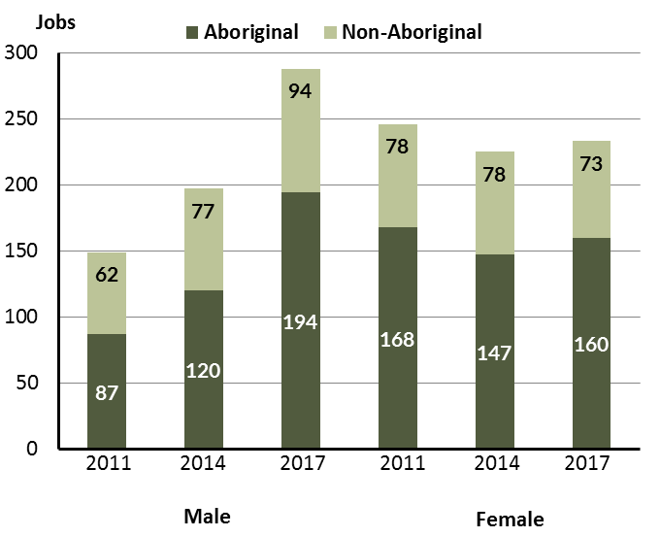

Source: Department of Trade, Business and Innovation

In 2017 in Galiwin'ku:

* there were 288 **jobs filled by males**, an increase of 91 jobs from 2014 and an increase of 139 jobs from 2011
* of the 288 jobs **filled by males**:
* 194 were **Aboriginal**, an increase of 74 jobs from 2014 and an increase of 107 jobs from 2011
* 94 were **non-Aboriginal**, an increase of 17 jobs from 2014 and an increase of 32 jobs from 2011
* there were 233 **jobs filled by females**, an increase of 8 jobs from 2014 and a decrease of 13 jobs from 2011
* of the 233 jobs **filled by females**:
* 160 were **Aboriginal**, an increase of 13 jobs from 2014 and a decrease of 8 jobs from 2011
* 73 were **non-Aboriginal**, a decrease of 5 jobs from 2014 and a decrease of 5 jobs from 2011.

Table 21: Counts of filled jobs by gender, by Aboriginal status of person in the job, by full-time/part-time status, by job permanency and by sector 2011 (a)(b)(c)(d)(e)(i)

|  |  |  |  |  |  |  |  |  |  |
| --- | --- | --- | --- | --- | --- | --- | --- | --- | --- |
| **2011** | | | | | | | | | |
| **Indicator** | **Male** | | | **Female** | | | **Total** | | |
| **Aboriginal** | **Non-Aboriginal** | **Total** | **Aboriginal** | **Non-Aboriginal** | **Total** | **Aboriginal** | **Non-Aboriginal** | **Total** |
| Full-time | 63 | 62 | **125** | 102 | 76 | **178** | 165 | 138 | **303** |
| Part-time | 24 | 0 | **24** | 66 | 2 | **68** | 90 | 2 | **92** |
| **Total** | **87** | **62** | **149** | **168** | **78** | **246** | **255** | **140** | **395** |
|  | | | | | | | | | |
| Permanent | 65 | 44 | **109** | 122 | 48 | **170** | 187 | 92 | **279** |
| Temporary | 22 | 18 | **40** | 46 | 30 | **76** | 68 | 48 | **116** |
| **Total** | **87** | **62** | **149** | **168** | **78** | **246** | **255** | **140** | **395** |
|  | | | | | | | | | |
| Public Sector | 30 | 32 | **62** | 47 | 45 | **92** | 77 | 77 | **154** |
| Private Sector | 57 | 30 | **87** | 121 | 33 | **154** | 178 | 63 | **241** |
| **Total** | **87** | **62** | **149** | **168** | **78** | **246** | **255** | **140** | **395** |

Source: Department of Trade, Business and Innovation

Table 22: Counts of filled jobs by gender, by Aboriginal status of person in the job, by full-time/part-time status, by job permanency and by sector 2014 (a)(b)(c)(d)(e)(i)

|  |  |  |  |  |  |  |  |  |  |
| --- | --- | --- | --- | --- | --- | --- | --- | --- | --- |
| **2014** | | | | | | | | | |
| **Indicator** | **Male** | | | **Female** | | | **Total** | | |
| **Aboriginal** | **Non-Aboriginal** | **Total** | **Aboriginal** | **Non-Aboriginal** | **Total** | **Aboriginal** | **Non-Aboriginal** | **Total** |
| Full-time | 59 | 72 | **131** | 61 | 76 | **137** | 120 | 148 | **268** |
| Part-time | 61 | 5 | **66** | 86 | 2 | **88** | 147 | 7 | **154** |
| **Total** | **120** | **77** | **197** | **147** | **78** | **225** | **267** | **155** | **422** |
| Permanent | 88 | 58 | **146** | 75 | 67 | **142** | 163 | 125 | **288** |
| Temporary | 32 | 19 | **51** | 72 | 11 | **83** | 104 | 30 | **134** |
| **Total** | **120** | **77** | **197** | **147** | **78** | **225** | **267** | **155** | **422** |
| Public Sector | 27 | 22 | **49** | 51 | 40 | **91** | 78 | 62 | **140** |
| Private Sector | 93 | 55 | **148** | 96 | 38 | **134** | 189 | 93 | **282** |
| **Total** | **120** | **77** | **197** | **147** | **78** | **225** | **267** | **155** | **422** |

Source: Department of Trade, Business and Innovation

Table 23: Counts of filled jobs by gender[3], by Aboriginal status of person in the job, by full-time/part-time status, by job permanency and by sector 2017 (a)(b)(c)(d)(e)(i)

|  |  |  |  |  |  |  |  |  |  |  |
| --- | --- | --- | --- | --- | --- | --- | --- | --- | --- | --- |
| **2017** | | | | | | | | | | |
| **Indicator** | **Male** | | | **Female** | | | **Total** | | | |
| **Aboriginal** | **Non-Aboriginal** | **Total** | **Aboriginal** | **Non-Aboriginal** | **Total** | **Aboriginal** | **Non-Aboriginal** | **Total** |
| Full-time | 58 | 89 | **147** | 52 | 63 | **115** | 115 | 155 | **270** |
| Part-time | 136 | 5 | **141** | 108 | 10 | **118** | 244 | 15 | **259** |
| **Total** | **194** | **94** | **288** | **160** | **73** | **233** | **359** | **170** | **529** |
| Permanent | 70 | 43 | **113** | 82 | 33 | **115** | 157 | 76 | **233** |
| Temporary | 124 | 51 | **175** | 78 | 40 | **118** | 202 | 94 | **296** |
| **Total** | **194** | **94** | **288** | **160** | **73** | **233** | **359** | **170** | **529** |
| Public Sector | 25 | 26 | **51** | 40 | 31 | **71** | 70 | 57 | **127** |
| Private Sector | 169 | 68 | **237** | 120 | 42 | **162** | 289 | 113 | **402** |
| **Total** | **194** | **94** | **288** | **160** | **73** | **233** | **359** | **170** | **529** |

Source: Department of Trade, Business and Innovation

In 2017 in Galiwin'ku:

* of the 288 **jobs** **filled** b**y** **males,** there were:
* 194 jobs filled by **Aboriginal males**, an increase of 74 jobs from 2014 and an increase of 107 jobs from 2011, including:
* 58 full-time jobs, a decrease of 1 job from 2014 and a decrease of 5 jobs from 2011
* 136 part-time jobs, an increase of 75 jobs from 2014 and an increase of 112 jobs from 2011
* 70 permanent jobs, a decrease of 18 jobs from 2014 and an increase of 5 jobs from 2011
* 124 temporary jobs, an increase of 92 jobs from 2014 and an increase of 102 jobs from 2011
* 25 public sector jobs, a decrease of 2 jobs from 2014 and a decrease of 5 jobs from 2011
* 169 private sector jobs, an increase of 76 jobs from 2014 and an increase of 112 jobs from 2011
* 94 jobs filled by **non-Aboriginal males**, an increase of 17 jobs from 2014 and an increase of 32 jobs from 2011, including:
* 89 full-time jobs, an increase of 17 jobs from 2014 and an increase of 27 jobs from 2011
* 5 part-time jobs, unchanged from 2014 and an increase of 5 jobs from 2011
* 43 permanent jobs, a decrease of 15 jobs from 2014 and a decrease of 1 job from 2011
* 51 temporary jobs, an increase of 32 jobs from 2014 and an increase of 33 jobs from 2011
* 26 public sector jobs, an increase of 4 jobs from 2014 and a decrease of 6 jobs from 2011
* 68 private sector jobs, an increase of 13 jobs from 2014 and an increase of 38 jobs from 2011
* of the 233 **jobs** **filled** **by** **females,** there were:
* 160 jobs filled by **Aboriginal females**, an increase of 13 jobs from 2014 and a decrease of 8 jobs from 2011, including:
* 52 full-time jobs, a decrease of 9 jobs from 2014 and a decrease of 50 jobs from 2011
* 108 part-time jobs, an increase of 22 jobs from 2014 and an increase of 42 jobs from 2011
* 82 permanent jobs, an increase of 7 jobs from 2014 and a decrease of 40 jobs from 2011
* 78 temporary jobs, an increase of 6 jobs from 2014 and an increase of 32 jobs from 2011
* 40 public sector jobs, a decrease of 11 jobs from 2014 and a decrease of 7 jobs from 2011
* 120 private sector jobs, an increase of 24 jobs from 2014 and a decrease of 1 job from 2011
* 73 jobs filled by **non-Aboriginal females**, a decrease of 5 jobs from 2014 and a decrease of 5 jobs from 2011, including:
* 63 full-time jobs, a decrease of 13 jobs from 2014 and a decrease of 13 jobs from 2011
* 10 part-time jobs, an increase of 8 jobs from 2014 and an increase of 8 jobs from 2011
* 33 permanent jobs, a decrease of 34 jobs from 2014 and a decrease of 15 jobs from 2011
* 40 temporary jobs, an increase of 29 jobs from 2014 and an increase of 10 jobs from 2011
* 31 public sector jobs, a decrease of 9 jobs from 2014 and a decrease of 14 jobs from 2011
* 42 private sector jobs, an increase of 4 jobs from 2014 and an increase of 9 jobs from 2011.

# Jobs by Age

Table 24: Counts of filled jobs by age and Aboriginal status of person employed in job, 2011, 2014 and 2017 (a)(c)(j)

|  |  |  |  |  |  |  |  |  |  |  |  |  |  |  |  |  |
| --- | --- | --- | --- | --- | --- | --- | --- | --- | --- | --- | --- | --- | --- | --- | --- | --- |
| **Indicator** | **2011** | | | **2014** | | | **2017** | | | **Change 2011-2014** | | | **Change 2014-2017** | | | |
| **Aboriginal** | **Non-Aboriginal** | **Total** | **Aboriginal** | **Non-Aboriginal** | **Total** | **Aboriginal** | **Non-Aboriginal** | **Total** | **Aboriginal** | **Non-Aboriginal** | **Total** | **Aboriginal** | **Non-Aboriginal** | **Total** |
| 15-24 years | 17 | 1 | **18** | 20 | 3 | **23** | 40 | 9 | **49** | 3 | 2 | **5** | 20 | 6 | **26** |
| 25-44 years | 123 | 70 | **193** | 181 | 92 | **273** | 198 | 91 | **289** | 58 | 22 | **80** | 17 | -1 | **16** |
| 45+ years | 115 | 69 | **184** | 66 | 60 | **126** | 116 | 67 | **183** | -49 | -9 | **-58** | 50 | 7 | **57** |
| **Total** | **255** | **140** | **395** | **267** | **155** | **422** | **359** | **170** | **529** | **12** | **15** | **27** | **92** | **15** | **107** |

Source: Department of Trade, Business and Innovation

Chart 12: Count of filled jobs by age and Aboriginal status of person in job, 2011, 2014 and 2017 (a)(c)(j)

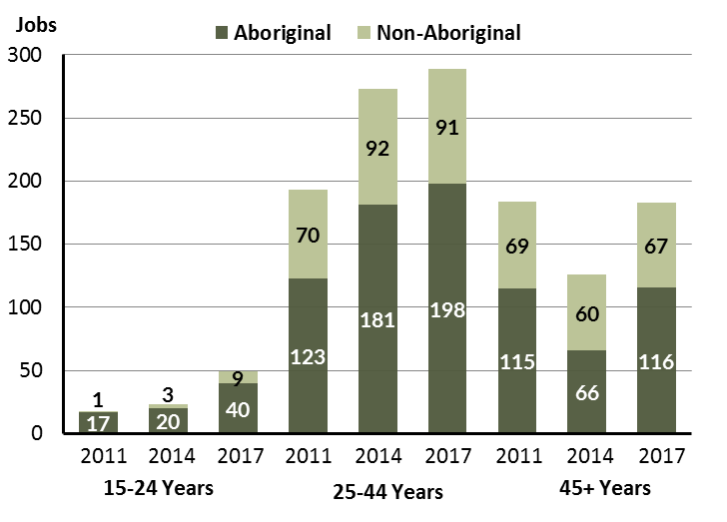

Source: Department of Trade, Business and Innovation

In 2017 in Galiwin'ku there were:

* 49 **jobs** **filled** by persons aged **15-24** **years**, an increase of 26 jobs from 2014 and an increase of 31 jobs from 2011. Of these:
* 40 jobs were filled by **Aboriginal** persons, an increase of 20 jobs from 2014 and an increase of 23 jobs from 2011
* 9 jobs were filled by **non-Aboriginal** persons, an increase of 6 jobs from 2014 and an increase of 8 jobs from 2011
* 289 **jobs** **filled** by persons aged **25-44 years**, an increase of 16 jobs from 2014 and an increase of 96 jobs from 2011. Of these:
* 198 jobs were filled by **Aboriginal** persons, an increase of 17 jobs from 2014 and an increase of 75 jobs from 2011
* 91 jobs were filled by **non-Aboriginal** persons, a decrease of 1 job from 2014 and an increase of 21 jobs from 2011
* 183 **jobs** filled by persons aged **45+ years**, an increase of 57 jobs from 2011 and a decrease of 1 job from 2011. Of these:
* 116 jobs were filled by **Aboriginal** persons, an increase of 50 jobs from 2014 and an increase of 1 job from 2011
* 67 jobs were filled by **non-Aboriginal** persons, an increase of 7 jobs from 2014 and a decrease of 2 jobs from 2011.

Table 25: Counts of filled jobs by age, by Aboriginal status of person in the job, by full-time/part-ime status, by job permanency and by sector June-July 2011 (a)(b)(c)(d)(e)(i)

|  |  |  |  |  |  |  |  |  |  |  |  |  |  |
| --- | --- | --- | --- | --- | --- | --- | --- | --- | --- | --- | --- | --- | --- |
| **2011** | | | | | | | | | | | | | |
| **Indicator** | **15-24 years** | | | **25-44 years** | | | **45+ years** | | | **Total** | | | |
| **Aboriginal** | **Non-Aboriginal** | **Total** | **Aboriginal** | **Non-Aboriginal** | **Total** | **Aboriginal** | **Non-Aboriginal** | **Total** | **Aboriginal** | **Non-Aboriginal** | **Total** |
| Full-time | 13 | 1 | **14** | 83 | 69 | **152** | 69 | 68 | **137** | 165 | 138 | **303** |
| Part-time | 4 | 0 | **4** | 40 | 1 | **41** | 46 | 1 | **47** | 90 | 2 | **92** |
| **Total** | **17** | **1** | **18** | **123** | **70** | **193** | **115** | **69** | **184** | **255** | **140** | **395** |
| Permanent | 16 | 1 | **17** | 81 | 44 | **125** | 90 | 47 | **137** | 187 | 92 | **279** |
| Temporary | 1 | 0 | **1** | 42 | 26 | **68** | 25 | 22 | **47** | 68 | 48 | **116** |
| **Total** | **17** | **1** | **18** | **123** | **70** | **193** | **115** | **69** | **184** | **255** | **140** | **395** |
| Public Sector | 7 | 0 | **7** | 37 | 38 | **75** | 33 | 39 | **72** | 77 | 77 | **154** |
| Private Sector | 10 | 1 | **11** | 86 | 32 | **118** | 82 | 30 | **112** | 178 | 63 | **241** |
| **Total** | **17** | **1** | **18** | **123** | **70** | **193** | **115** | **69** | **184** | **255** | **140** | **395** |

Source: Department of Trade, Business and Innovation

Table 26: Counts of filled jobs by age, by Aboriginal status of person in the job, by full-time/part-time status, by job permanency and by sector June-July 2014 (a)(b)(c)(d)(e)(i)

|  |  |  |  |  |  |  |  |  |  |  |  |  |
| --- | --- | --- | --- | --- | --- | --- | --- | --- | --- | --- | --- | --- |
| **2014** | | | | | | | | | | | | |
| **Indicator** | **15-24 years** | | | **25-44 years** | | | **45+ years** | | | **Total** | | |
| **Aboriginal** | **Non-Aboriginal** | **Total** | **Aboriginal** | **Non-Aboriginal** | **Total** | **Aboriginal** | **Non-Aboriginal** | **Total** | **Aboriginal** | **Non-Aboriginal** | **Total** |
| Full-time | 8 | 3 | **11** | 80 | 90 | **170** | 32 | 55 | **87** | 120 | 148 | **268** |
| Part-time | 12 | 0 | **12** | 101 | 2 | **103** | 34 | 5 | **39** | 147 | 7 | **154** |
| **Total** | **20** | **3** | **23** | **181** | **92** | **273** | **66** | **60** | **126** | **267** | **155** | **422** |
| Permanent | 8 | 2 | **10** | 118 | 74 | **192** | 37 | 49 | **86** | 163 | 125 | **288** |
| Temporary | 12 | 1 | **13** | 63 | 18 | **81** | 29 | 11 | **40** | 104 | 30 | **134** |
| **Total** | **20** | **3** | **23** | **181** | **92** | **273** | **66** | **60** | **126** | **267** | **155** | **422** |
| Public Sector | 6 | 1 | **7** | 37 | 27 | **64** | 35 | 34 | **69** | 78 | 62 | **140** |
| Private Sector | 14 | 2 | **16** | 144 | 65 | **209** | 31 | 26 | **57** | 189 | 93 | **282** |
| **Total** | **20** | **3** | **23** | **181** | **92** | **273** | **66** | **60** | **126** | **267** | **155** | **422** |

Source: Department of Trade, Business and Innovation

Table 27: Counts of filled jobs by age, by Aboriginal status of person in the job, by full-time/part-time status, by job permanency and by sector June-July 2017 (a)(b)(c)(d)(e)(i)

|  |  |  |  |  |  |  |  |  |  |  |  |  |  |
| --- | --- | --- | --- | --- | --- | --- | --- | --- | --- | --- | --- | --- | --- |
| **2017** | | | | | | | | | | | | | |
| **Indicator** | **15-24 years** | | | **25-44 years** | | | **45+ years** | | | **Total** | | |
| **Aboriginal** | **Non-Aboriginal** | **Total** | **Aboriginal** | **Non-Aboriginal** | **Total** | **Aboriginal** | **Non-Aboriginal** | **Total** | **Aboriginal** | **Non-Aboriginal** | **Total** |
| Full-time | 1 | 9 | **10** | 53 | 80 | **133** | 56 | 63 | **119** | 115 | 155 | **270** |
| Part-time | 39 | 0 | **39** | 145 | 11 | **156** | 60 | 4 | **64** | 244 | 15 | **259** |
| **Total** | **40** | **9** | **49** | **198** | **91** | **289** | **116** | **67** | **183** | **359** | **170** | **529** |
| Permanent | 4 | 4 | **8** | 73 | 34 | **107** | 75 | 38 | **113** | 157 | 76 | **233** |
| Temporary | 36 | 5 | **41** | 125 | 57 | **182** | 41 | 29 | **70** | 202 | 94 | **296** |
| **Total** | **40** | **9** | **49** | **198** | **91** | **289** | **116** | **67** | **183** | **359** | **170** | **529** |
| Public Sector | 7 | 3 | **10** | 31 | 28 | **59** | 27 | 26 | **53** | 70 | 57 | **127** |
| Private Sector | 33 | 6 | **39** | 167 | 63 | **230** | 89 | 41 | **130** | 289 | 113 | **402** |
| **Total** | **40** | **9** | **49** | **198** | **91** | **289** | **116** | **67** | **183** | **359** | **170** | **529** |

Source: Department of Trade, Business and Innovation

In 2017 in Galiwin'ku:

* of the 49 **jobs** **filled** by persons aged **15-24 years**, there were:
* 40 jobs filled by **Aboriginal** persons, of which:
* 1 was a full-time job, a decrease of 7 jobs from 2014 and a decrease of 12 jobs from 2011
* 39 were part-time jobs, an increase of 27 jobs from 2014 and an increase of 35 jobs from 2011
* 4 were permanent jobs, a decrease of 4 jobs from 2014 and a decrease of 12 jobs from 2011
* 36 were temporary jobs, an increase of 24 jobs from 2014 and an increase of 35 jobs from 2011
* 7 were public sector jobs, an increase of 1 job from 2014 and unchanged from 2011
* 33 were private sector jobs, an increase of 19 jobs from 2014 and an increase of 23 jobs from 2011
* 9 jobs filled by **non-Aboriginal** persons, of which:
* 9 were full-time jobs, an increase of 6 jobs from 2014 and an increase of 8 jobs from 2011
* none were part-time jobs, unchanged from 2014 and unchanged from 2011
* 4 were permanent jobs, an increase of 2 jobs from 2014 and an increase of 3 jobs from 2011
* 5 were temporary jobs, an increase of 4 jobs from 2014 and an increase of 5 jobs from 2011
* 3 were public sector jobs, an increase of 2 jobs from 2014 and an increase of 3 jobs from 2011
* 6 were private sector jobs, an increase of 4 jobs from 2014 and an increase of 5 jobs from 2011
* of the 289 **jobs** **filled** by persons aged **25-44 years**, there were:
* 198 jobs filled by **Aboriginal** persons, of which:
* 53 were full-time jobs, a decrease of 27 jobs from 2014 and a decrease of 30 jobs from 2011
* 145 were part-time jobs, an increase of 44 jobs from 2014 and an increase of 105 jobs from 2011
* 73 were permanent jobs, a decrease of 45 jobs from 2014 and a decrease of 8 jobs from 2011
* 125 were temporary jobs, an increase of 62 jobs from 2014 and an increase of 83 jobs from 2011
* 31 were public sector jobs, a decrease of 6 jobs from 2014 and a decrease of 6 jobs from 2011
* 167 were private sector jobs, an increase of 23 jobs from 2014 and an increase of 81 jobs from 2011
* 91 jobs filled by **non-Aboriginal** persons, of which:
* 80 were full-time jobs, a decrease of 10 jobs from 2014 and an increase of 11 jobs from 2011
* 11 were part-time jobs, an increase of 9 jobs from 2014 and an increase of 10 jobs from 2011
* 34 were permanent jobs, a decrease of 40 jobs from 2014 and a decrease of 10 jobs from 2011
* 57 were temporary jobs, an increase of 39 jobs from 2014 and an increase of 31 jobs from 2011
* 28 were public sector jobs, an increase of 1 job from 2014 and a decrease of 10 jobs from 2011
* 63 were private sector jobs, a decrease of 2 jobs from 2014 and an increase of 31 jobs from 2011
* of the 183 **jobs** **filled** by persons aged **45+ years**, there were:
* 116 jobs filled by **Aboriginal** persons, of which:
* 56 were full-time jobs, an increase of 24 jobs from 2014 and a decrease of 13 jobs from 2011
* 60 were part-time jobs, an increase of 26 jobs from 2014 and an increase of 14 jobs from 2011
* 75 were permanent jobs, an increase of 38 jobs from 2014 and a decrease of 15 jobs from 2011
* 41 were temporary jobs, an increase of 12 jobs from 2014 and an increase of 16 jobs from 2011
* 27 were public sector jobs, a decrease of 8 jobs from 2014 and a decrease of 6 jobs from 2011
* 89 were private sector jobs, an increase of 58 jobs from 2014 and an increase of 7 jobs from 2011
* 67 jobs filled by **non-Aboriginal** persons, of which:
* 63 were full-time jobs, an increase of 8 jobs from 2014 and a decrease of 5 jobs from 2011
* 4 were part-time jobs, a decrease of 1 job from 2014 and an increase of 3 jobs from 2011
* 38 were permanent jobs, a decrease of 11 jobs from 2014 and a decrease of 9 jobs from 2011
* 29 were temporary jobs, an increase of 18 jobs from 2014 and an increase of 7 jobs from 2011
* 26 were public sector jobs, a decrease of 8 jobs from 2014 and a decrease of 13 jobs from 2011
* 41 were private sector jobs, an increase of 15 jobs from 2014 and an increase of 11 jobs from 2011.

# Vocational Education and Training

Note: *Since previous publications, the 2010 data have fallen in line with the new standardised reporting practices with an emphasis of all training activity undertaken in the remote town regardless of funding stream. As such, figures for 2010 VET data in this publication may differ from previous publications.*

*The impact of the Remote Jobs and Communities Program (RJCP) being established in 2013 has played a significant role in the downturn of accredited training in many remote towns across the Territory.*

Table 28: Northern Territory Vocational Education and Training (VET) students, 2010, 2013 and 2016 (k)

|  |  |  |  |  |  |  |  |  |
| --- | --- | --- | --- | --- | --- | --- | --- | --- |
| **VET Funding Group** | **2010** | | **2013** | | **2016** | | **Change** | |
| **No.** | **% of Total** | **No.** | **% of Total** | **No.** | **% of Total** | **2010-2013** | **2013-2016** |
| Arts, Entertainment, Sports and Recreation | 0 | 0 | 28 | 11 | 14 | 3 | 28 | - 14 |
| Automotive | 3 | 1 | 2 | 1 | 0 | 0 | - 1 | - 2 |
| Building and Construction | 98 | 26 | 25 | 10 | 136 | 33 | - 73 | 111 |
| Business and Clerical | 18 | 5 | 15 | 6 | 36 | 9 | - 3 | 21 |
| Community Services, Health and Education | 26 | 7 | 73 | 28 | 115 | 28 | 47 | 42 |
| Engineering and Mining | 31 | 8 | 30 | 12 | 15 | 4 | - 1 | - 15 |
| Finance, Banking and Insurance | 6 | 2 | 7 | 3 | 5 | 1 | 1 | - 2 |
| General Education and Training | 1 | 0 | 0 | 0 | 2 | 0 | - 1 | 2 |
| Primary Industry | 79 | 21 | 22 | 8 | 34 | 8 | - 57 | 12 |
| Sales and Personal Service | 115 | 31 | 41 | 16 | 22 | 5 | - 74 | - 19 |
| Textiles, Clothing, Footwear and Furnishings | 0 | 0 | 0 | 0 | 11 | 3 | 0 | 11 |
| Tourism and Hospitality | 0 | 0 | 16 | 6 | 9 | 2 | 16 | - 7 |
| Transport and Storage | 0 | 0 | 0 | 0 | 12 | 3 | 0 | 12 |
| **Total** | **377** | **100** | **259** | **100** | **411** | **100** | **- 118** | **152** |

Source: Department of Trade, Business and Innovation

In 2016 in Galiwin'ku:

* there were 411 **VET students**, an increase of 152 students from 2013 and an increase of 34 students from 2010
* the areas of VET activity with the most students were Building and Construction (136), Community Services, Health and Education (115), and Business and Clerical (36)
* Building and Construction reported the largest increase in students (111) compared to 2013 and Sales and Personal Service reported the largest decrease in students (-19) over the same period.

Table 29: Northern Territory Vocational Education and Training (VET) unit enrolments, 2010, 2013 and 2016 (l)

|  |  |  |  |  |  |  |  |  |
| --- | --- | --- | --- | --- | --- | --- | --- | --- |
| **VET Funding Group** | **2010** | | **2013** | | **2016** | | **Change** | |
| **No.** | **% of Total** | **No.** | **% of Total** | **No.** | **% of Total** | **2010-2013** | **2013-2016** |
| Arts, Entertainment, Sports and Recreation | 0 | 0 | 281 | 21 | 53 | 4 | 281 | - 228 |
| Automotive | 8 | 0 | 5 | 0 | 0 | 0 | - 3 | - 5 |
| Building and Construction | 583 | 36 | 111 | 8 | 420 | 28 | - 472 | 309 |
| Business and Clerical | 41 | 3 | 140 | 10 | 178 | 12 | 99 | 38 |
| Community Services, Health and Education | 121 | 8 | 327 | 24 | 353 | 23 | 206 | 26 |
| Engineering and Mining | 137 | 9 | 75 | 6 | 15 | 1 | - 62 | - 60 |
| Finance, Banking and Insurance | 21 | 1 | 31 | 2 | 16 | 1 | 10 | - 15 |
| General Education and Training | 2 | 0 | 0 | 0 | 5 | 0 | - 2 | 5 |
| Primary Industry | 252 | 16 | 119 | 9 | 91 | 6 | - 133 | - 28 |
| Sales and Personal Service | 439 | 27 | 233 | 17 | 164 | 11 | - 206 | - 69 |
| Textiles, Clothing, Footwear and Furnishings | 0 | 0 | 0 | 0 | 66 | 4 | 0 | 66 |
| Tourism and Hospitality | 0 | 0 | 32 | 2 | 34 | 2 | 32 | 2 |
| Transport and Storage | 0 | 0 | 0 | 0 | 108 | 7 | 0 | 108 |
| **Total** | **1 604** | **100** | **1 354** | **100** | **1 503** | **100** | **- 250** | **149** |

Source: Department of Trade, Business and Innovation

In 2016 in Galiwin'ku:

* there were 1503 **VET unit enrolments**, an increase of 149 unit enrolments from 2013 and a decrease of 101 unit enrolments from 2010
* the areas of VET activity with the most unit enrolments were Building and Construction (420), Community Services, Health and Education (353), and Business and Clerical (178)
* Building and Construction reported the largest increase in unit enrolments (309) compared to 2013 and Arts, Entertainment, Sports and Recreation reported the largest decrease in unit enrolments (-228) over the same period.

Table 30: Northern Territory Vocational Education and Training (VET) nominal hours, 2010, 2013 and 2016 (m)

|  |  |  |  |  |  |  |  |  |
| --- | --- | --- | --- | --- | --- | --- | --- | --- |
| **VET Funding Group** | **2010** | | **2013** | | **2016** | | **Change** | |
| **No.** | **% of Total** | **No.** | **% of Total** | **No.** | **% of Total** | **2010-2013** | **2013-2016** |
| Arts, Entertainment, Sports and Recreation | 0 | 0 | 6 171 | 15 | 2 390 | 7 | 6 171 | -3 781 |
| Automotive | 315 | 1 | 85 | 0 | 0 | 0 | - 230 | - 85 |
| Building and Construction | 19 154 | 36 | 2 780 | 7 | 6 980 | 21 | -16 374 | 4 200 |
| Business and Clerical | 920 | 2 | 5 510 | 14 | 4 320 | 13 | 4 590 | -1 190 |
| Community Services, Health and Education | 5 168 | 10 | 11 130 | 27 | 3 917 | 12 | 5 962 | -7 213 |
| Engineering and Mining | 4 570 | 9 | 4 742 | 12 | 280 | 1 | 172 | -4 462 |
| Finance, Banking and Insurance | 630 | 1 | 915 | 2 | 370 | 1 | 285 | - 545 |
| General Education and Training | 180 | 0 | 0 | 0 | 0 | 0 | - 180 | 0 |
| Primary Industry | 8 840 | 17 | 1 615 | 4 | 3 100 | 10 | -7 225 | 1 485 |
| Sales and Personal Service | 12 806 | 24 | 7 205 | 18 | 4 105 | 13 | -5 601 | -3 100 |
| Textiles, Clothing, Footwear and Furnishings | 0 | 0 | 0 | 0 | 2 470 | 8 | 0 | 2 470 |
| Tourism and Hospitality | 0 | 0 | 464 | 1 | 573 | 2 | 464 | 109 |
| Transport and Storage | 0 | 0 | 0 | 0 | 4 020 | 12 | 0 | 4 020 |
| **Total** | **52 583** | **100** | **40 617** | **100** | **32 525** | **100** | **-11 966** | **-8 092** |

Source: Department of Trade, Business and Innovation

In 2016 in Galiwin'ku:

* there were 32 525 **VET nominal hours** delivered, a decrease of 8092 nominal hours delivered from 2013 and a decrease of 20 058 nominal hours delivered from 2010
* the areas of VET activity with the most nominal hours delivered were Building and Construction (6980), Business and Clerical (4320), and Sales and Personal Service (4105)
* Building and Construction reported the largest increase in nominal hours delivered (4200) compared to 2013 and Community Services, Health and Education reported the largest decrease in nominal hours delivered (-7213) over the same period.

Caveat: *Nominal hours are based on the hours funded through Department of Trade Business and Innovation contracts; students and units includes delivery that has been funded in a previous year, fee for service or training that did not meet the funding requirements. Because of this a direct match cannot be made between hours and student/units.*

Table 31: Northern Territory Vocational Education and Training (VET) unit completions, 2010, 2013 and 2016 (n)

|  |  |  |  |  |  |  |  |  |
| --- | --- | --- | --- | --- | --- | --- | --- | --- |
| **VET Funding Group** | **2010** | | **2013** | | **2016** | | **Change** | |
| **No.** | **% of Total** | **No.** | **% of Total** | **No.** | **% of Total** | **2010-2013** | **2013-2016** |
| Arts, Entertainment, Sports and Recreation | 0 | 0 | 175 | 26 | 47 | 4 | 175 | - 128 |
| Automotive | 8 | 1 | 2 | 0 | 0 | 0 | - 6 | - 2 |
| Building and Construction | 224 | 22 | 15 | 2 | 261 | 25 | - 209 | 246 |
| Business and Clerical | 0 | 0 | 5 | 1 | 14 | 1 | 5 | 9 |
| Community Services, Health and Education | 93 | 9 | 152 | 23 | 324 | 31 | 59 | 172 |
| Engineering and Mining | 63 | 6 | 56 | 8 | 14 | 1 | - 7 | - 42 |
| Finance, Banking and Insurance | 1 | 0 | 3 | 0 | 4 | 0 | 2 | 1 |
| General Education and Training | 0 | 0 | 0 | 0 | 3 | 0 | 0 | 3 |
| Primary Industry | 195 | 20 | 55 | 8 | 70 | 7 | - 140 | 15 |
| Sales and Personal Service | 415 | 42 | 172 | 26 | 131 | 12 | - 243 | - 41 |
| Textiles, Clothing, Footwear and Furnishings | 0 | 0 | 0 | 0 | 58 | 5 | 0 | 58 |
| Tourism and Hospitality | 0 | 0 | 32 | 5 | 33 | 3 | 32 | 1 |
| Transport and Storage | 0 | 0 | 0 | 0 | 103 | 10 | 0 | 103 |
| **Total** | **999** | **100** | **667** | **100** | **1 062** | **100** | **- 332** | **395** |

Source: Department of Trade, Business and Innovation

In 2016 in Galiwin'ku:

* there were 1062 **VET unit completions**, an increase of 395 unit completions from 2013 and an increase of 63 unit completions from 2010
* the areas of VET activity with the most unit completions were Community Services, Health and Education (324), Building and Construction (261), and Sales and Personal Service (131)
* Building and Construction reported the largest increase in nominal hours delivered (246) compared to 2013 and Arts, Entertainment, Sports and Recreation reported the largest decrease in nominal hours delivered (-128) over the same period.

# Population

**Table 32: Population distribution by gender and age (p)(r)**

|  |  |  |  |  |  |  |  |  |  |  |
| --- | --- | --- | --- | --- | --- | --- | --- | --- | --- | --- |
| **Indicator** | **2006** | | | **2016** | | | **Change** | | | |
| **Male** | **Female** | **Total** | **Male** | **Female** | **Total** | **Male** | **Female** | **Total** |
| **0-4 years** | 150 | 101 | 251 | 134 | 96 | 230 | -16 | -5 | -21 |
| **5-14 years** | 211 | 238 | 449 | 277 | 236 | 513 | 66 | -2 | 64 |
| **15-24 years** | 196 | 168 | 364 | 214 | 235 | 449 | 18 | 67 | 85 |
| **25-44 years** | 249 | 285 | 534 | 351 | 389 | 740 | 102 | 104 | 206 |
| **45-64 years** | 125 | 163 | 288 | 195 | 240 | 435 | 70 | 77 | 147 |
| **65+ years** | 13 | 29 | 42 | 20 | 23 | 43 | 7 | -6 | 1 |
| **TOTAL** | 944 | 984 | 1928 | 1191 | 1219 | 2410 | 247 | 235 | 482 |

*Source: Department of Trade, Business and Innovation*

In 2016 in Galiwin'ku:

* there were an estimated 2410 persons, of which:
* 1191 (49.4%) were male
* 1219 (50.6%) were female
* between 2006 and 2016, the **overall population** in Galiwin'ku increased by 482 persons from 2006, or an average of 2.3% per year compared to 0.7% across the 28 remote towns and 1.5% Territory wide
* the **male population** increased by 247 persons from 2006
* the **female population** increased by 235 persons from 2006
* in 2016, the **working age population** (15 years and over) in Galiwin'ku was an estimated 1667 persons (69.2% of the total population) compared with 1228 persons (63.7% of the total population) in 2006. Of these:
* 449 (18.6%) were between 15 and 24 years of age
* 740 (30.7%) were between 25 and 44 years of age
* 435 (18%) were between 45 and 64 years of age
* 43 (1.8%) were over 65 years of age
* of the 1667 persons of **working age:**
* 780 (46.8%) were male
* 887 (53.2%) were female.

There were 0.3 jobs in Galiwin'ku per working age person compared to 0.4 jobs per working age person across the 28 remote towns in the Northern Territory.

**Chart 13: Population by Aboriginal status compared to the 28 remote towns and the NT (p)(q)**

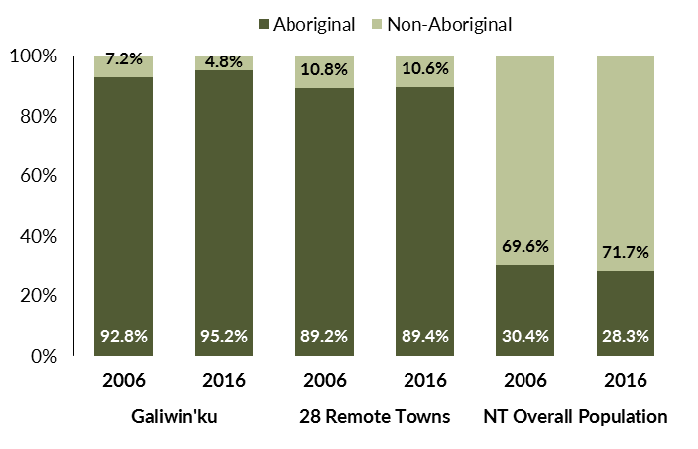

*Source: Department of Trade, Business and Innovation*

In 2016 in Galiwin'ku:

* 95.2% of the population in Galiwin'ku were **Aboriginal**, compared to 92.8% in 2006
* 89.4% of the population across all 28 remote towns were **Aboriginal**
* 28.3% of the NT population were **Aboriginal**.

**Table 33: Unemployment and participation rates by Aboriginal status compared to the NT (q)**

|  |  |  |  |  |  |  |
| --- | --- | --- | --- | --- | --- | --- |
|  | **Galiwin'ku** | | | **Northern Territory** | | |
| **Aboriginal** | **Non-Aboriginal** | **Total** | **Aboriginal** | **Non-Aboriginal** | **Total** |
| **Unemployment rate** | 21.0% | 0.0% | 17.4% | 26.7% | 3.8% | 7.0% |
| **Participation rate** | 28.2% | 91.5% | 31.9% | 41.0% | 79.9% | 70.6% |

Source: Department of Trade, Business and Innovation

In 2016 in Galiwin'ku the:

* **total unemployment rate** was 17.4% compared to 7% for the total Northern Territory
* **Aboriginal** **unemployment rate** was 21% compared to 26.7% for the total Northern Territory
* **non-Aboriginal unemployment rate** was 0% compared to 3.8% for the total Northern Territory
* **total participation rate** was 31.9% compared to 70.6% for the total Northern Territory
* **Aboriginal participation rate** was 28.2% compared to 41% for the total Northern Territory
* **non-Aboriginal participation rate** was 91.5% compared to 79.9% for the total Northern Territory.

# Community Development Programme

**Table 34: Community Development Programme Aboriginal Job Seekers, 30 April 2018 (o)**

|  |  |  |
| --- | --- | --- |
| **Indicator** | **Aboriginal** | |
| **No.** | **%** |
| **Total Aboriginal Job Seekers** | 407 | N/A |
| **Age (years)** | | |
| 15-24 | 76 | 18.7 |
| 25-44 | 242 | 59.5 |
| 45+ | 89 | 21.9 |
| **Total** | 407 | 100.0 |
| **Gender** | | |
| Male | 224 | 55.0 |
| Female | 183 | 45.0 |
| **Total** | 407 | 100.0 |
| **Employment Outcome - 1 July 2015 to 30 April 2018** | | |
| 13 Weeks | 182 | 64.8 |
| 26 Weeks | 99 | 35.2 |
| **Currently in Activities** | 300 |  |

*Source: Department of Prime Minister and Cabinet*

**Chart 14: Community Development Programme Aboriginal Job Seekers by Gender and Age Group, 30 April 2018 (o)**

See detailed description below.

*Source: Department of Prime Minister and Cabinet*

As at 30 April 2018, in Galiwin'ku, there were 407 CDP **Aboriginal** job seekers, of these:

* 224 (55%) were male and 183 (45%) were female
* 76 (18.7%) were aged 15-24 years, 242 (59.5%) were aged 25-44 years, and 89 (21.9%) were aged 45+ years
* between 1 July 2015 and 30 April 2018, 182 had reached the 13 week reporting milestone and 99 had reached the 26 week reporting milestone
* 300 were currently in activities.

# Businesses

**Table 35: Businesses by Sector (d)(s)**

|  |  |  |  |
| --- | --- | --- | --- |
| **Business Name** | **Reported on in 2011?** | **Reported on in 2014?** | **Reported on in 2017?** |
| **PUBLIC SECTOR** | | | |
| **Department of Education** | Yes | Yes | **Yes** |
| **Department of Human Services trading as Centrelink** | Yes | Yes | **Yes** |
| **Department of the Prime Minister and Cabinet** | Yes | Yes | **Yes** |
| **East Arnhem Regional Council** | Yes | Yes | **Yes** |
| **Northern Territory Police, Fire Emergency Services** | Yes | Yes | **Yes** |
| **Territory Families** | No | No | **Yes** |
| **PRIVATE SECTOR** | | | |
| AA Electrical Pty Ltd | Yes | No | No |
| **AEC Building Electrical & Plumbing** | No | Yes | **Yes** |
| **Air Frontier Pty Ltd** | Yes | Yes | **Yes** |
| Batchelor Institute of Indigenous Tertiary Education (BIITE) | Yes | No | No |
| **Deltareef Pty Ltd** | No | No | **Yes** |
| Enterprise Management Group Pty Ltd trading as My Pathways | No | Yes | No |
| Gandhuwuy, Richard trading as Gawudal - Pudal | No | Yes | No |
| Garrawurra Aboriginal Corporation | No | Yes | No |
| **GPT Enterprises Pty Ltd (Elcho Fuel)** | No | No | **Yes** |
| **Ironbark Construction Pty Ltd** | No | No | **Yes** |
| **Karen Sheldon Training and Development Pty Ltd** | No | No | **Yes** |
| **MAF International trading as Mission Aviation Fellowship** | Yes | Yes | **Yes** |
| **Marthakal Business Enterprises Pty Ltd** | Yes | No | **Yes** |
| **Marthakal Homelands and Resource Centre Aboriginal Corporation** | Yes | Yes | **Yes** |
| **Marthakal Yolngu Airline Pty Ltd** | No | No | **Yes** |
| Menzies School of Health Research | Yes | No | No |
| **Miwatj Health Aboriginal Corporation** | Yes | Yes | **Yes** |
| **MJD Foundation** | No | No | **Yes** |
| **Nhawe Enterprises Pty Ltd** | No | No | **Yes** |
| **Probuild (NT) Pty Ltd** | No | No | **Yes** |
| **Steps Group Australia Limited** | No | Yes | **Yes** |
| Sunrise Alliance Inc | No | Yes | No |
| **The Arnhem Land Progress Aboriginal Corporation - ALPA** | Yes | Yes | **Yes** |
| **The Elcho Group Pty Ltd** | No | Yes | **Yes** |
| **The Trustee for AA Essential Services Trust** | No | Yes | **Yes** |
| **The Trustee for Bukmak Constructions Trust - Bukmak Constructions - ALPA** | No | No | **Yes** |
| **Traditional Credit Union (TCU)** | Yes | Yes | **Yes** |
| Why Warriors Pty Ltd | No | Yes | No |
| **Yalu Marnggithinyaraw Indigenous Corporation** | No | Yes | **Yes** |

*Source: Department of Trade, Business and Innovation*

*Note: Business names captured across the three survey periods have been identified by the current 2017 Business ABN name listed as at 2017.*

In 2017 in Galiwin'ku:

* there were 27 businesses reported on, of which:
* 6 businesses were from the public sector (22 %)
* 21 businesses were from the private sector (7%)
* there were 15 businesses operating that were not operating in 2011.

# Notes

1. These counts represent numbers of filled jobs and not numbers of persons. As such the totals represent the total number of filled jobs, not the total number of employees. This count is not directly comparable to the total number of employed persons as a person may have several jobs or one job may be shared by more than one person.
2. Full-time is defined as a job usually requiring 35 hours or more per week or that required 35 hours or more work during the reference week. Part-time is defined as a job usually requiring less than 35 hours per week or that required less than 35 hours work during the reference week. The reference week refers to the period that respondents were asked to provide information about. In most instances it would be the week prior to the week the questionnaire was completed. Questionnaires were predominantly conducted in June and July.
3. Care needs to be taken when analysing the counts of filled jobs by the Aboriginal status of persons in the jobs. The Aboriginal status of the person employed in a job was reported by the business representative completing the questionnaire.
4. Sector was classified using the Standard Economic Sector of Classifications of Australia (SESCA), 2008.
5. Job permanency is classified according to what the business believes the level of job permanency is based on guidelines provided by data collectors. Those guidelines state a permanent job has paid annual and/or sick leave entitlements while a temporary job includes casual and fixed-term contract jobs.
6. Classified according to the Australian and New Zealand Standard Classification of Occupations (ANZSCO), 2006, major occupation level.
7. Other occupations include jobs where occupation was not stated, not known or inadequately described.
8. Classified using the Australian and New Zealand Standard Industrial Classification (ANZSIC), 2006, division level.
9. Care needs to be taken when analysing the counts of filled jobs by the gender of persons in the jobs. The gender of the person employed in a job is reported by the business representative completing the questionnaire.
10. Care needs to be taken when analysing the counts of filled jobs by the age of persons in the jobs. The age of the person employed in a job is reported by the business representative completing the questionnaire.
11. Students represent the number of individual clients that enrolled in a Vocational Education and Training unit during the calendar year.
12. Unit enrolments represent the count of individual units that students enrolled in during the calendar year.
13. Nominal hours delivered is the sum of the nominal hours of the units commenced during the calendar year regardless of when the course enrolment commenced.
14. Unit completions are the count of all successfully completed units reported in the calendar year regardless of the year of commencement of the units.
15. The Community Development Programme (CDP) supports job seekers in remote Australia to build skills, address barriers and contribute to their communities through a range of flexible activities. Under the CDP, job seekers with activity requirements are expected to do up to 25 hours per week of work-like activities that benefit their community. It should be noted that some CDP participants may be reported on within the profile if they are attached to a filled position with an employer captured in the survey. Due to confidentiality issues, data below 20 people is not published.
16. Population estimates for both 2006 and 2016 are taken from the estimated resident population (ERP) data produced by the Australian Bureau of Statistics (ABS) and based on Australian Statistical Geography Standard (ASGS) Statistical Area Level 1 (SA1) regions. ERP are official estimates of the Australian population, which link people to a place of usual residence with Australia. All ERP data sources, including the Census of Population and Housing (Census), are subject to error (including inaccuracies in collection, recording and processing data) and should be used with caution.
17. Indigenous population proportions, unemployment and workforce participation rates are based on ABS Census counts at ASGS Indigenous Locations (ILOCs) for each remote town.
18. Working-age population includes all residents aged 15 years and over (commonly referred to as the civilian population) and consists of persons that are employed, unemployed or not in the labour force.
19. A ‘business’ has been defined as any organisation that has undertaken productive activities in the last year, including companies, non-profit organisations, government departments and enterprises operating within the designated remote geography (town), and has one or more employees in paid employment and an Australian Business Number (ABN).

# Abbreviations and Acronyms

ABN Australian Business Number

ABS Australian Bureau of Statistics

ANZSCO Australian and New Zealand Standard Classification of Occupations

ANZSIC Australian and New Zealand Standard Industrial Classification

ASGS Australian Statistical Geography Standard

CDP Community Development Programme

ERP Estimated Resident Population

ILOC Indigenous Locations

nec Not Elsewhere Classified

No. Number

Perm Permanent

ppt Percentage point

RJCP Remote Jobs and Communities Program

Temp Temporary

SA1 Statistical Area Level 1

VET Vocational Education and Training

1. The number of filled jobs does not represent numbers of persons as a person may have several jobs or one job may be shared by more than one person.
2. 8 filled jobs gender status not identified in 2017
3. 8 filled jobs gender status not identified in 2017