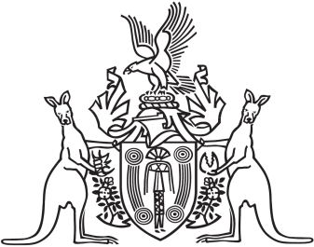
Northern Territory of Australia

Government Gazette
ISSN-0157-833X
No. S73 11 September 2018

Assent to Proposed Laws
Her Honour the Administrator declared assent to the following proposed laws:
6 September 2018
Monetary Units Act 2018 (Act No. 17 of 2018)
Monitoring of Places of Detention (Optional Protocol to the Convention Against Torture) Act 2018 (Act No. 18 of 2018)
Parks and Wildlife Commission Amendment Act 2018 (Act No. 19 of 2018)
Pastoral Land Legislation Amendment Act 2018 (Act No. 20 of 2018)
Michael Tatham
Clerk of the Legislative Assembly
10 September 2018

