Northern Territory of Australia

Government Gazette
ISSN-0157-8324
No. G36 5 September 2018

General information
The Gazette is published by the Office of the Parliamentary Counsel.
The Gazette will be published every Wednesday, with the closing date for notices being the previous Friday at 4.00 pm.
Notices not received by the closing time will be held over until the next issue.
Notices will not be published unless a Gazette notice request form together with a copy of the signed notice and a clean copy of the notice in Word or PDF is emailed to gazettes@nt.gov.au
Notices will be published in the next issue, unless urgent publication is requested.

Availability
The Gazette will be available online at 12 Noon on the day of publication at https://nt.gov.au/about-government/gazettes
Unauthorised versions of Northern Territory Acts and Subordinate legislation are available online at https://legislation.nt.gov.au/

Northern Territory of Australia

Weeds Management Act
Revocation of Declaration and
Declaration of Quarantine Area
I, Eva Dina Lawler, Minister for Environment and Natural Resources:
(a) under section 21 of the Weeds Management Act and with reference to section 43 of the Interpretation Act, revoke the declaration made by the notice entitled "Revocation of declaration and declaration of quarantine area" dated 4 October 2017 and published in Gazette No. G41 on 11 October 2017; and
(b) under section 21 of the Weeds Management Act:
(i) declare the land described in the Schedule, Part A, and shown on the map in the Schedule, Part B, for information purposes only to be a quarantine area to manage Cabomba (Cabomba caroliniana), a declared Class A and Class C weed, in that part of the Territory; and
(ii) specify that this declaration is to remain in force for 5 years on and from the date this instrument is published in the Gazette; and
(iii) prohibit the movement of persons (other than persons performing functions under the Act), animals, vehicles, vessels (including boats), plant material, fodder, soil or any other thing in, into or out of the quarantine area except movement:
(A) by crossing the Darwin River using a causeway constructed on Old Bynoe Road; or
(B) in accordance with an access permit.
Dated 8 August 2018
E. D. Lawler
Minister for Environment and Natural Resources
Schedule
Part A
That part of the Darwin River commencing from the most seaward point of the river’s intersection with the Cox Peninsula Road and extending up river to the most seaward point of the river’s intersection with Old Bynoe Road and the water or land surrounding or abutting the said part of the river for 5 metres landward from the water edge as exists from time to time, but at all times including a billabong contiguous with the main body of water of the river in a wet season and 5 metres landward from the billabong’s water edge as exists from time to time.
That part of Reedbeds Road extending southerly from the westerly prolongation of the southern boundary of Kentish Road to the westerly prolongation of the southern boundary of Section 631 Hundred of Cavenagh.
Part B
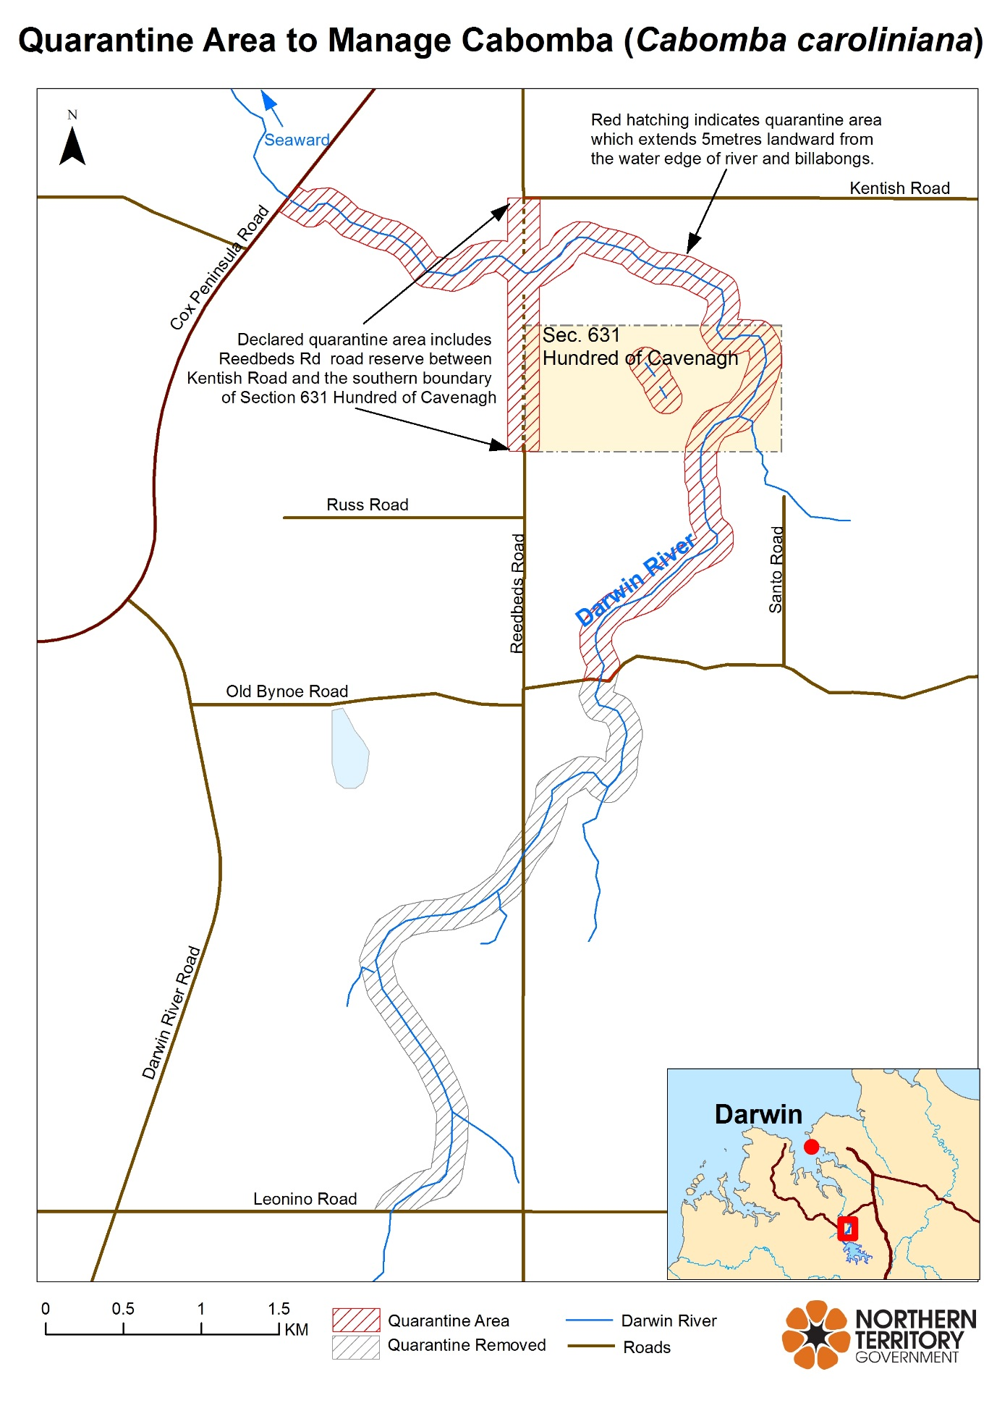

Northern Territory of Australia
Transport of Dangerous Goods by Road and Rail
(National Uniform Legislation) Act
Appointment of Officers
I, Stephen Hugh Gelding, the Competent Authority:
- under section 23(1) of the Transport of Dangerous Goods by Road and Rail (National Uniform Legislation) Act and with reference to section 44 (1) of the Interpretation Act, terminate all appointments of authorised officers in force immediately before the date of this instrument; and
- under section 23(1) of the Transport of Dangerous Goods by Road and Rail (National Uniform Legislation) Act, appoint the people named in the Schedule to be authorised officers and exercise the powers under:
- sections 31, 32, 33, 34, 35, 36, 37, 38, 39, 40, 44, 45, 46, 47, 48, 49, 50, 54, 55, 56, 57, 58, 59, 62, 63, 64, 65, 86, 88, 90, 93, 95, 96 and 99 of the Transport of Dangerous Goods by Road and Rail (National Uniform Legislation) Act; and
- regulation 232 of the Transport of Dangerous Goods by Road and Rail (National Uniform Legislation) Regulations.
The power to amend a notice pursuant to sections 88 and 96 is restricted to minor amendments:
- for clarification; or
- to correct errors or references; or
- to reflect changes of address or other circumstances.
Dated 29 August 2018
S. H. Gelding
Work Health Authority
_________________________________
Schedule
Allan Crombie Fischer
Amber Louise Sayers
Andrew James Lucas
Anthony Clifford
Anthony John Waite
Brian Cleary
Brian Wingrove
Carolynne Murrell
Christos Despotis
Collins Dubere Gipey
David James Mallett
Fiona Louise Peters
Fred James Munro
Gillian Hylton
Joseph Peter Pisani
Kerry Lee-Anne Barnaart
Maria Staunton
Maria Rigas
Neil William Burgess
Nigel Butler
Rebecca Sue Trimble
Robert Stanley Fereday
Robin Leslie Paget Smith
Stewart Pritchard
Stuart Dean Hand
_________________________________

Police Administration Act

Sale of Goods
Notice is hereby given that pursuant to Section 166 of the Police Administration Act, the following property as shown on the attached schedule has been in the possession of the Officer in Charge, Police Station, Peter McAulay Centre, for a period in excess of 3 months and this property will be sold or otherwise disposed of in a manner as determined by the Commissioner of Police, if after twenty-eight (28) days from the publication of this notice the property remains unclaimed.
Antony Deutrom
Superintendent
Palmerston Division
30 August 2018
Exhibit number | Item Description
512979/001 | Gold coloured ring with Egyptian design
490155/003 | Gold coloured necklace with blue stone
508078/001 | Stihl leaf blower
507980/001  507980/002 | Large painting – blue canvas with silver squares and white flowers  Medium painting – orange canvas with two oriental faces
507880/001 | Red Seiko lady’s watch
507714/001  507714/002 | Silver coloured chain with cross  Silver Elite lady’s watch with square face
497504/001 | Silver pocket watch with engraving GSTP 343141
508457/002 | $6.85
508325/002 | $5.00
508283/001 | $20.10
507967/001/001 | $100
507793/002 | $149.30
507746/002 | $190.00
507435/002  507435/004  507435/008 | $3.80  $1.85  $1.10
507238/002 | $1075.95
506880/001 | US $100.00
506849/001 | $40.15
506749/001 | $100.00
506631/001 | $26.10
508560/002  508560/003 | Alcotel mobile  Black LG mobile
508504/001 | Black Alcotel mobile
508496/001 | White/silver Telstra mobile
508457/001 | Blue/brown purse
508325/001 | Black VCL wallet and contents
508283/001 | Black Benzoni wallet and contents
508269/001 | Silver iPhone
507967/001  507967/002  507967/003  507967/004  507967/005 | Black Electric wallet and contents  Black Telstra mobile  White Opo mobile  Black Nokia mobile  Black Telstra mobile
507817/001 | Gold iPhone
507817/002 | Black iPhone
507793/001  507793/003 | Black Quicksilver wallet and contents  Multiple bank cards and ID
507746/001  507746/003 | Black makeup bag  CBA card
507727/001 | Black leather Laura Jane handbag and contents
507727/001/001  507727/001/002 | Blue iPhone  Silver iPhone
507691/001 | Grey ZTE mobile
507665/001 | Black Telstra mobile
507647/001  507647/002 | Black Telstra mobile  Grey Telstra mobile
507631/001 | Brown leather wallet and contents
507435/001  507435/003  507435/007 | Maroon Gainsborough purse and contents  Black/white wallet and contents  Brown leather Polo wallet and contents
507432/001 | Black Nokia mobile
507412/001 | Black ZTE mobile
507411/001 | Black Samsung mobile
507386/001  507386/002 | Black ZTE mobile  Walk and talk phone charger
507353/001  507353/002 | White Samsung tablet  Silver Wicksees tablet in black case and keyboard
507317/001 | Gold Huawei mobile
507297/001 | Black Telstra mobile
507256/001 | Black Telstra tablet
507238/001 | Black Laura Jones purse and contents
507219/001 | Silver iPhone
506886/001  506889/002 | White ZTE mobile  Larakia Nation ID card
506880/002 | NT MDL
506849/001 | Black wallet and contents
506841/001 | Grey iPhone
506749/001 | Black Valenti wallet and contents
506726/001 | Blue Samsung mobile
506705/001 | Silver iPhone
506704/001 | Gold Samsung mobile
506658/001 | White Oscar mobile
506656/001 | Black Telstra mobile
506601/001 | Black ZTE mobile
508564/001 | HP laptop
506609/001 | Grey Samsung mobile
482968/003 | Black Samsung mobile
481675/001 | White Telstra mobile
480944/037 | Telstra mobile
478855/002  478855/003 | White HTC mobile  Black Telstra mobile
482871/001  482871/002  482871/003  482871/004 | Black Samsung mobile  White iPhone  Black iPhone  Black Samsung mobile
463895/001 | Black iPhone
507462/001 | Black Samsung mobile
504526/010 | Black Optus mobile
500483/002 | White iPhone
500088/001 | NT drivers licence
506526/007 | Baikal 12g SUO S/N H08891
505139/003 | Light blue Merida Juliet
508466/001 | Black/yellow Nitro BMX
508091/001 | White Kmart kids bike
508064/001 | White/purple cyclops bicycle
508043/001 | Grey/purple Terrain MTB
507860/001 | Blue/grey Everest XCR MTB
507748/001 | Blue/white Huffy MTB
507552/001 | Blue/grey Everest XCR MTB
507518/001 | Black Flight MTB
507333/001 | White GT MTB
507114/001 | Mongoose Salvo MTB
507039/001 | Grey/white Giant Talon MTB
506923/001  506923/002 | Grey/green Huffy Savoy MTB  Grey/white Flight City3 MTB
506897/001 | Black/white Merida Matts MTB
507192/001 | Blue/black Giant Boulder MTB
506581/001 | Black/white Rhythm BMX
506571/001 | Razor Scooter
506568/001 | Grey/white Merida Crossway MTB
506394/001 | Red Merida MTB
506828/001 | Red Repco BMX
506828/002 | Green Avanti MTB
484784/001 | NT CC11SO – white Subaru Impreza
493299/001  493299/002 | NT 626648 – Blue Holden Commodore  Keys for NT 626648

Northern Territory of Australia

Museum and Art Gallery of the Northern Territory Act
Board of the Museum and Art Gallery of the Northern Territory
Appointment of Members
I, Lauren Jane Moss, Minister for Tourism and Culture, under section 16(1) of the Museum and Art Gallery of the Northern Territory Act, appoint each person named in the Schedule to be a member of the Board of the Museum and Art Gallery of the Northern Territory for 3 years on and from 1 September 2018.
Dated 31 August 2018
L. J. Moss
Minister for Tourism and Culture
Schedule
Franchesca Juanita Cubillo
Clare Majella Martin
James Nicholas Edward Paspaley
Philip Anthony Watkins

Northern Territory
Associations Act
Notice of Intention to Dissolve Associations
I, Malcolm John Bryant, as a delegate of the Commissioner, pursuant to section 65(4)(c) of the Associations Act, give notice that the associations specified in the Schedule will be dissolved after 3 months after the date of this notice unless cause to the contrary is shown.
Dated: 3 September 2018
M. J. Bryant
Delegate of Commissioner
Note: Enquiries should be directed to Malcolm Bryant at Licensing NT, Department of the Attorney-General and Justice, Level 3, NAB House, 71 Smith Street, Darwin. Phone: (08) 8999 1339 or email agd.licensingnt@nt.gov.au
____________________________
Schedule
01761c | Just Rock Alice Springs Incorporated
IA02899 | Capoeira Angola Cultural Centre Australia (NT Branch) Incorporated
IA03013 | COAT NT Chapter Incorporated
IA03044 | Darwin Football League Incorporated
IA03084 | Streetz Incorporated
IA03200 | Omada Ellinon Greek Language Book Club Incorporated
IA03273 | NT Fly Fishers Incorporated
IA03285 | Territory Trails Incorporated
_____________________________

