 | - Questions are followed by answer fields. Use the ‘Tab’ key to navigate through. Replace Y/N or Yes/No fields with your answer.
To: Registrar LISA / Brands Clerk
GPO Box 3000 Phone: 08 8999 2033
Darwin NT 0801 Email: adele.kluth@nt.gov.au
I / WE
The registered owner/s of the registered three-letter brand as describe below, hereby request to have the Earmark position/s changed, as set out hereunder:-
Brand Registration details
Three-letter brand registered:
Distinctive (symbol) brand:
Registered Earmark (code and position):
Earmark Code and NEW position:
Run where Brand is registered for use (branding iron used):
Contact details
Postal address of applicant/s:
Telephone: |  |  |  |  |  |  |  |  |  |  |  |  | Fax:
Mobile: |  |  |  |  |  |  |  |  |  |  |  |  | Email:
Dated this: |  |  |  |  |  |  |  |  |  |  |  |  | day of: |  |  |  |  |  |  |  |  |  |  |  | 20
All registered owner/s of brand to sign
Applicant 1 – I am over the age of 18 years
I (print name) |  |  |  |  |  |  |  |  |  |  |  |  |  |  |  |  | Signature:
Applicant 2 – I am over the age of 18 years
I (print name) |  |  |  |  |  |  |  |  |  |  |  |  |  |  |  |  | Signature:
 |  | I am returning the Original Certificate/s
Three-letter Brand certificate, Earmark certificate, Distinctive (symbol) certificate, Transfer certificate (please cross out which is not applicable) to Registrar of Brands for changes. Once certificate/s are amended they will be returned to you for safekeeping. Note: All original certificates must be amended - Do not send photocopies.
Original Certificates enclosed |  |  |  |  |  |  |  |  | B |  |  | E |  | DB |  |  |  |  | TB |  |  |  | Other:
 |  | OR – if original cert/s LOST
The original certificate/s have been lost/misplaced – Three-letter Brand certificate, Earmark certificate, Distinctive (symbol) certificate, Transfer certificate (cross out which is not applicable).
Please issue me with a replacement Certificate at a cost of $63.
Payment
RTM – Issue replacement certificate – Note Fees subject to change 1st July each year
Payment type: |  |  |  |  |  | $63 CHEQUE attached (made payable to RTM) |  |  |  |  |  |  |  |  |  |  |  | Please charge my Credit Card $63
B/CARD / M/CARD / VISA |  |  |  |  |  |  |  | Card number: |  |  | _ _ _ _/_ _ _ _/ _ _ _ _ /_ _ _ _ |  |  |  |  |  |  | Expiry: |  |  | _ _/_ _ |  |  | CCV: |  | _ _ _
Name on credit card: |  |  |  |  |  |  |  |  |  |  |  |  | Signature:
Office use only
LISA / Brands, Livestock Biosecurity, BAW, DITT – Cost Code: 92 HF1N 03 D 131111 N00 = no GST
NT Code index of registered Earmarks for use with registered Brands in the NT  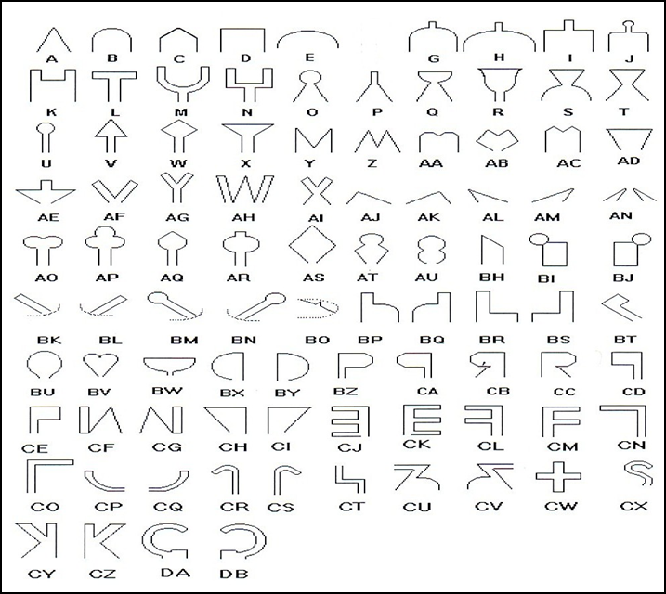 |  |  |  |  |  |  |  |  |  |  |  |  |  |  |  |  |  |  |  | 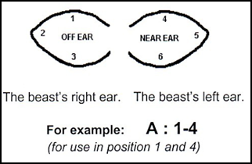  Choose new position number/s. eg 1 to 6 or a combination of numbers 3 and 6 etc. See example above.
  - End of form

