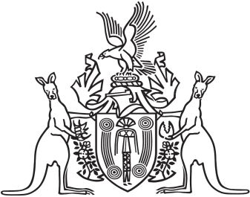
Northern Territory of Australia

Government Gazette
ISSN-0157-833X
No. S42 22 June 2018
Northern Territory of Australia

Bushfires Management Act
Appointment of Senior Fire Control Officer
I, Lauren Jane Moss, Minister for Environment and Natural Resources, under section 17(1) of the Bushfires Management Act, appoint Lee Ann Humphris to be a senior fire control officer.
Dated 20 June 2018
L. J. Moss
Minister for Environment and Natural Resources

