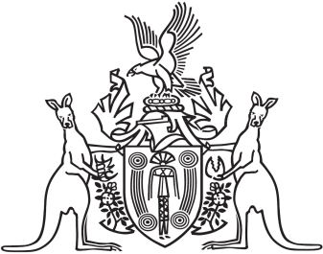
Northern Territory of Australia

Government Gazette
ISSN-0157-833X
No. S41 20 June 2018
Northern Territory of Australia

Statute Law Revision Act 2018
Commencement Notice
I, Vicki Susan O'Halloran, Administrator of the Northern Territory of Australia, under section 2 of the Statute Law Revision Act 2018 (No. 10 of 2018), fix the day on which this notice is published in the Gazette as the day on which the Act commences.
Dated 18 June 2018
V. S. O'Halloran
Administrator
Northern Territory of Australia
Residential Tenancies Amendment Act 2018
Commencement Notice
I, Vicki Susan O'Halloran, Administrator of the Northern Territory of Australia, under section 2 of the Residential Tenancies Amendment Act 2018 (No. 11 of 2018), fix 1 July 2018 as the day on which the Act commences.
Dated 18 June 2018
V. S. O'Halloran
Administrator

