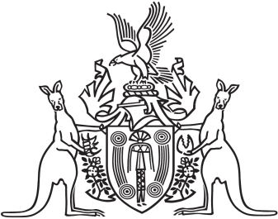
Northern Territory of Australia

Government Gazette
ISSN-0157-8324
No. G16 18 April 2018

Anzac Day
There will be no Gazette publication on Wednesday 25 April due to the ANZAC Day public holiday.
The General Gazette G17 will be published on Tuesday 24 April.

General information
The Gazette is published by the Office of the Parliamentary Counsel.
The Gazette will be published every Wednesday, with the closing date for notices being the previous Friday at 4.00 pm.
Notices not received by the closing time will be held over until the next issue.
Notices will not be published unless a Gazette notice request form together with a copy of the signed notice and a clean copy of the notice in Word or PDF is emailed to gazettes@nt.gov.au
Notices will be published in the next issue, unless urgent publication is requested.

Availability
The Gazette will be available online at 12 Noon on the day of publication at https://nt.gov.au/about-government/gazettes
Unauthorised versions of Northern Territory Acts and Subordinate legislation are available online at https://legislation.nt.gov.au/

Northern Territory of Australia

Misuse of Drugs Act
Appointment of Analyst
I, Natasha Kate Fyles, Attorney-General and Minster for Justice, under section 3(8) of the Misuse of Drugs Act, appoint Hien Thi Ngoc Huynh to be an analyst for the purposes of the Act while she is a public sector employee employed in the Police Civil Employment Unit.
Dated 26 March 2018
N. K. Fyles
Attorney-General and Minister for Justice
Northern Territory of Australia

Kava Management Act
Appointment of Analyst
I, Natasha Kate Fyles, Attorney-General and Minister for Justice, under section 33 of the Kava Management Act, appoint Hien Thi Ngoc Huynh to be an analyst for the purposes of carrying out the sampling, analysis or examination of a thing seized under the Act while she is a public sector employee employed in the Police Civil Employment Unit.
Dated 27 March 2018
N. K. Fyles
Attorney-General and Minister for Justice
Northern Territory of Australia
Mineral Titles Act

General Reservation of Land

(RL 23446)
I, Alan Charles Holland, Senior Director Mines/Director Mineral Titles, as the delegate of the Minister for Primary Industry and Resources, under section 113(2) of the Mineral Titles Act:
- reserve the land in the locality of Noonamah that is shown unshaded within the thick black lines on the plan in the Schedule from the following activities:
  - exploration for minerals generally;
  - extraction of minerals generally;
  - exploration for extractive minerals;
  - extraction of extractive minerals; and
- give notice that:
  - the reservation takes effect on the day this notice is published in the Gazette; and
  - the land specified in paragraph (a) is being reserved to enable the future protection of extractive resources; and
  - a person is not entitled to apply for the grant of any mineral title in relation to the land.
Dated 28 March 2018
A. C. Holland
Senior Director Mines/Director Mineral Titles
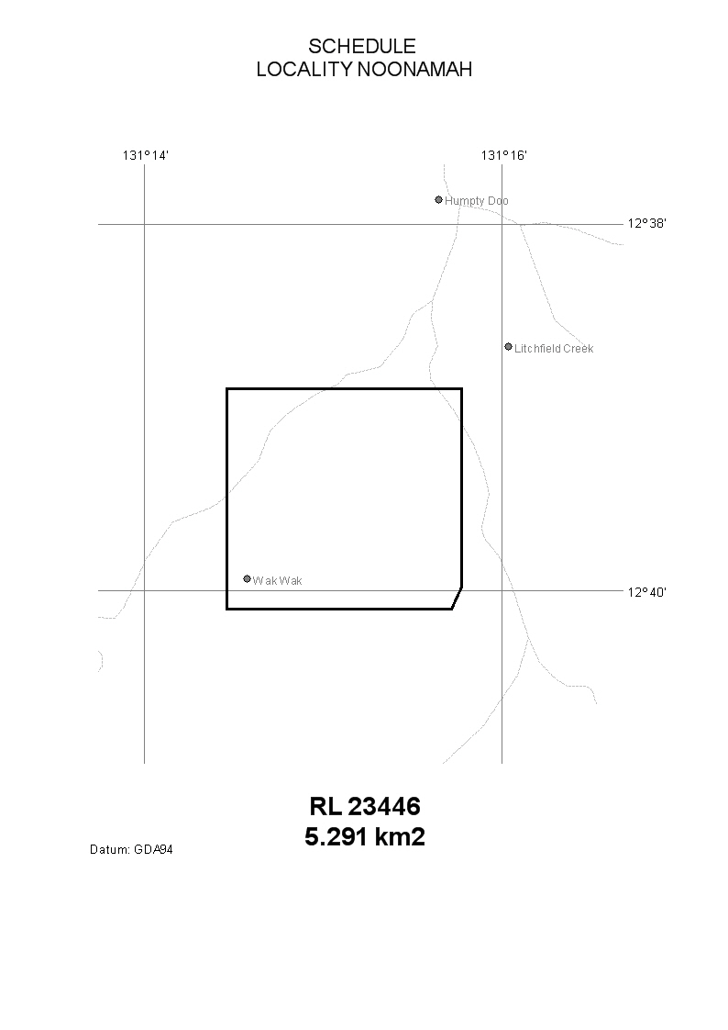
Northern Territory of Australia

Volatile Substance Abuse Prevention Act
Declaration of Place of Safety
I, Denise Mary Riordan, Chief Psychiatrist, as the delegate for the Minister for Health, under section 63 of the Volatile Substance Abuse Prevention Act, declare the premises specified in the Schedule to be a place of safety.
Dated 11 April 2018
D. M. Riordan
Chief Psychiatrist
Schedule
Darwin Sobering Up Shelter
Lot 2173, Tivendale Road, Berrimah,
Town of Darwin

