Form 60:71M

This form applies only to applications for groundwater extraction licences in the Darwin Rural Adelaide River Water Control District, where water taken was previously exempt from licensing requirements, as prescribed in Regulation 14A and 14AB.

The opportunity to apply for a licence using this form for:

1. The **former Darwin Rural Water Control District** **will expire** **31 July 2025** in accordance with regulation 14A(1)(e).
2. The **Darwin Rural** **Adelaide River Water Control District** **will expire** **30 July 2026** in accordance with regulation 14AB(1)(e).

## Instructions and applicant’s responsibilities

To ensure efficient assessment and processing of this application:

1. Provide a response to all questions and include attachments where indicated.
2. Review the completed application form and supporting documents to ensure that they are concise, complete, relevant, and accurate.
3. Please use the checklist provided on Page 8 to ensure all requirements are met.

Should you have any queries, email [water.licensing@nt.gov.au](mailto:water.licensing@nt.gov.au) or phone (08) 8999 4455.

## How to submit this form

Email your completed application to [water.licensing@nt.gov.au](mailto:water.licensing@nt.gov.au)

## Meaning of icons in this form

🛈 Important information to assist you with completing this form.

🖉 Indicates an instruction for completing this form.

🗎 Indicates a document or supporting evidence to be provided with this form.

🕮 Indicates a definition available in footnotes.

## Collection notice and privacy

The details you provide in this application may be published on the Northern Territory water extraction licence website. If you have any questions about how your personal information will be handled or would like to gain access to your personal information, you can contact the Water Resources Division. The Northern Territory Government complies with the [Information Privacy Principles](https://legislation.nt.gov.au/en/Legislation/INFORMATION-ACT-2002#page=109&zoom=auto,88,747) scheduled by the [*Information Act 2002*](https://legislation.nt.gov.au/en/Legislation/INFORMATION-ACT-2002)([1]🕮). For more information, read our [privacy policy](https://depws.nt.gov.au/consultation-publications/privacy-policy) ([2]🕮).

## Eligibility

🛈 Using the map below, you will need to identify which location the land applies to.

Former Darwin Rural Water Control District – *go to question 1A*.

Darwin Rural Adelaide River Water Control District – *go to question 1B*.

If you are unable to answer ‘yes’ to all questions in section 1A or 1B, you cannot use this application form.

Please contact Water Regulation on (08) 8999 4455 if you want to discuss the location of your land or the eligibility criteria at question 1.

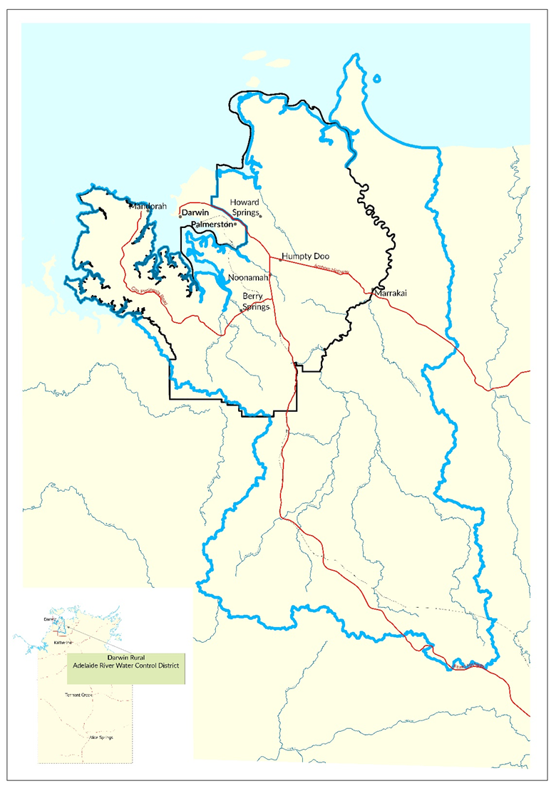

|  |  |  |
| --- | --- | --- |
| 1. **Are you eligible to apply for a groundwater licence for an exempt activity?** | | |
| **1A. Former Darwin Rural water control district** | | |
| **The proposed licence will be within the former Darwin Rural water control district.** | Yes | No |
| **Between 6 July 2015 and 5 July 2016, water was routinely ([3]🕮) taken from a bore on the land for a commercial undertaking (****[4]🕮) that occurred and was reliant on groundwater on the land.** | Yes | No |
| **Between 6 July 2016 and the making of this application, water continued to be routinely taken from a bore on the land for the commercial undertaking.** | Yes | No |
| **The commercial undertaking is not a mining or petroleum activity.**  If you answer no to this question, you cannot complete this form. Refer to [*Form 45/60 - Apply to take water*](https://nt.gov.au/environment/water/licensing/water-extraction-licence/apply-for-a-water-extraction-licence/darwin-rural)*.* | Yes | No |
|  | | |
| **1B. Darwin Rural Adelaide River water control district** | | |
| **The proposed licence will be within the Adelaide River area of the Darwin Rural Adelaide River water control district.** | Yes | No |
| **Between 1 July 2023 and 30 June 2024, water was routinely ([5]🕮) taken from a bore on the land for a commercial undertaking ([6]🕮) that occurred and was reliant on groundwater on the land.** | ☐ Yes | ☐ No |
| **Between 1 July 2024 and the making of this application, water continued to be routinely taken from a bore on the land for the commercial undertaking.** | Yes | No |
| **The commercial undertaking is not a mining or petroleum activity.**  If you answer no to this question, you cannot complete this form. Refer to [*Form 45/60 - Apply to take water*](https://nt.gov.au/environment/water/licensing/water-extraction-licence/apply-for-a-water-extraction-licence/darwin-rural)*.*[7] | Yes | No |

## Applicant details

|  |  |  |  |  |  |  |
| --- | --- | --- | --- | --- | --- | --- |
| 1. **Who is the applicant for this licence?**   🛈 The applicant name will appear as the licence holder on the licence.   * Provide details of the person or legal entity that the water extraction licence is for. If the licence is for a joint application, please provide details for all applicants. | | | | | | |
| **Applicant name:** |  | | | | | |
| **Individual** | | | **Joint** | | | **Company/Business**  (complete below) |
| Registered Business  ABN:  🗎 Attach a current Business Name Extract | | | | Company  ACN:  🗎 Attach a current ASIC Company Extract | | |
| **Not a registered business or company?**  🗎 Provide information to support your claim that your activity is a commercial undertaking. | | | | | | |
| 1. **Who is the contact for this application?**  * Provide details of your primary and secondary contacts | | | | | | |
|  | | **Primary contact** | | | **Secondary contact** | |
| **Full name:** | |  | | |  | |
| **Postal address:** | |  | | |  | |
| **Contact number:** | |  | | |  | |
| **Email address:**  🛈correspondence will be sent to this email | |  | | |  | |

## Property information

|  |  |  |  |
| --- | --- | --- | --- |
| 1. **What is the physical address of the land on which the commercial undertaking operates and the water take occurs?** | | | |
| **Street address:**  (number/street/suburb) |  | | |
| **Parcel number:** |  | **Location/hundred:** |  |

|  |  |  |
| --- | --- | --- |
| 1. **Which of the following is the most accurate description of your right to access the land described above?** | | |
| **I am the:** | **Tick (✓)** | **🗎 Evidence required & attached** |
| Landowner |  | Copy of your land title |
| Authorised land occupier ([8]🕮) |  | Copy of your authorisation or written approval and term of approval |
| Other, please provide details: |  | Supporting documentation: |

Commercial undertaking

|  |
| --- |
| 1. **What type of commercial undertaking currently occurs on the land?**  * Provide details of the business or activities that are currently carried out as part of the commercial undertaking. This may include a brief description of the business, estimates of the area of land used commercially, crop variety/types, number of people employed and estimated annual water use.   If the commercial undertaking has developed over time or you have plans to develop in future, please include details of each stage of the development. If you are unsure of an exact date, please include an approximate date.   * Provide evidence of the commercial undertaking occurring and a detailed map of the land that identifies area used for the commercial undertaking, domestic dwellings or existing bores. Examples include photos of land use identifying crop types, crop details for each year, installation or operation of infrastructure |
|  |

|  |  |  |  |  |  |  |  |  |  |  |  |  |  |  |  |  |  |  |  |  |  |  |  |
| --- | --- | --- | --- | --- | --- | --- | --- | --- | --- | --- | --- | --- | --- | --- | --- | --- | --- | --- | --- | --- | --- | --- | --- |
| Groundwater use and extraction infrastructure | | | | | | | | | | | | | | | | | | | | | | | |
| 1. **Complete the table with the estimated water use in megalitres (ML) per month for each year.**   If the bore is not currently registered, please provide the GPS coordinates.  Copy and paste this table for each extraction point. | | | | | | | | | | | | | | | | | | | | | | | |
| **Extraction point:**  (provide bore RN number) | | |  | | | | | | | | **GPS coordinates:** | | | | **Latitude:** | |  | | | | | | |
| **Longitude:** | |  | | | | | | |
| **Water meter details** (if already installed)**:** | | | | | **Make:** | |  | | | | **Model:** | |  | | | | | | **Serial No.:** | |  | | |
| **Units of measurement:** | | | | |  | | | | | **Reading:** | |  | | | | | | |
| **Year** | **Jan** | **Feb** | | **Mar** | | **Apr** | | **May** | **Jun** | | | **Jul** | | **Aug** | | **Sep** | | **Oct** | | **Nov** | | **Dec** | **Total** |
| 20….. |  |  | |  | |  | |  |  | | |  | |  | |  | |  | |  | |  |  |
| 20….. |  |  | |  | |  | |  |  | | |  | |  | |  | |  | |  | |  |  |
| 20….. |  |  | |  | |  | |  |  | | |  | |  | |  | |  | |  | |  |  |
| 20….. |  |  | |  | |  | |  |  | | |  | |  | |  | |  | |  | |  |  |
| 20….. |  |  | |  | |  | |  |  | | |  | |  | |  | |  | |  | |  |  |
| 20….. |  |  | |  | |  | |  |  | | |  | |  | |  | |  | |  | |  |  |
| 20….. |  |  | |  | |  | |  |  | | |  | |  | |  | |  | |  | |  |  |
| 20….. |  |  | |  | |  | |  |  | | |  | |  | |  | |  | |  | |  |  |
| 20….. |  |  | |  | |  | |  |  | | |  | |  | |  | |  | |  | |  |  |

# Acknowledgement

|  |  |  |  |  |  |
| --- | --- | --- | --- | --- | --- |
| 1. **Public register and commercially confidential information**  * In accordance with section 95 of the Act, the Controller of Water Resources must keep a register of water extraction licences. The register must be publicly available on the department’s website and must include, the: * name and address of the licence holder * date on which the licence is due to expire * location of the property from which the water is currently taken * maximum quantity of water that may be taken annually * source of the water that may be taken.   The Controller of Water Resources will also make a copy of this application, any attachments to the application and any licence granted, publicly available on the department’s website. The Controller of Water Resources has the power to suppress information if satisfied there are grounds of commercial confidentiality. You may apply to have commercially confidential information withheld by using the appropriate approved application form available on the department’s website. | | | | | |
| I acknowledge that the information described above will be freely available from the department’s website. | | | Yes | No | |
| I have completed and attached an application to have commercially confidential information withheld. | | | Yes | No | |
| 1. **Consent** | | | | | |
| Do you consent to receive all ongoing service of documents associated with this application and any future licence via the email address, as provided above? | | | Yes | No | |
| 1. **Declaration**  * A person with legal authority must sign the declaration. For a licence to be granted in the name of each person in a partnership or a joint interest, each partner or joint interest must sign the declaration. | | | | | |
| I hereby declare that the information provided in this notification and accompanying document is to the best of my knowledge, true and correct. | | | | | |
|  | **Applicant 1** | **Applicant 2** | | | |
| Name: |  |  | | | |
| Position: |  |  | | | |
| Signature: |  |  | | | |
| Date: |  |  | | | |
| Applicant checklist  * Confirm you have completed the application form and included the associated evidence as attachments | | | | | |
| **Indicate the number of pages attached to this application** | | | | | |
| **Eligibility**   * **Question 1A:** Identified the location of the land as in the Former Darwin Rural water control district; **or** * **Question 1B:** Identified the location of the land as in the Adelaide River area of the Darwin Rural Adelaide River water control district. | | | | |  |
| **Applicant details**   * **Question 2:** Provided applicant details and attached a business or ASIC Company Extract which includes the company office holders. If not registered, information to support your claim that your activity is a commercial undertaking. * **Question 3:** Provided contact details foraprimary and secondary person. | | | | |  |
| **Property information**   * **Question 4:** Provided details of the physical address where the commercial undertaking operates. * **Question 5:** Legal access to land * Attached a copy of your land title showing you as the owner of the land; or * Attached a copy of a lease or the landowner’s written agreement granting access to the property. A lease contract or agreement or must include permission to be on the land and permission to undertake the activities associated with the licence. | | | | |  |
| **Commercial undertaking**   * **Question 6:** Provided details of the business or activities that are currently carried out as part of the commercial undertaking. * Attached a detailed property map and evidence of the commercial undertaking occurring. * Attached other relevant supporting evidence that demonstrates commercial undertaking. | | | | |  |
| **Groundwater use and extraction infrastructure**   * **Question 7:** Provided details of all bores used for extraction and the estimated water usage per year. | | | | |  |
| **Acknowledgement**   * **Question 8:** Public register and commercially confidential information * **Question 9:** Consent * **Question 10:** Declaration | | | | |  |

1. 🕮 **Darwin Rural Adelaide River Water Control District** means the part of the Territory declared by the Minister under section 22 of the Act on 28 June 2024 published in *Gazette* No. s61 of 1 July 2024 respectively. More information is available at <https://nt.gov.au/environment/water/water-resources-of-the-nt/water-control-districts>

   🕮 <https://nt.gov.au/page/copyright-disclaimer-and-privacy>
2. 🕮 <https://environment.nt.gov.au/consultations-decisions-policies/privacy-policy>
3.
4.
5.
6.
7. 🕮 **Routinely** refers to the regular taking of water from a bore as part of the operation of the commercial undertaking, in a predictable manner. An example of routinely taking water could include the yearly activity of watering crops consistently during the dry season, even if you didn’t water during the wet season.

   🕮 A **commercial undertaking** refers to any business or enterprise conducted for the purpose of making a profit. Commercial undertaking can be carried out by individuals, partnerships, or corporations.
8. 🕮 **Authorised land occupier** may include a tenant, lessee, or sub-lessee.