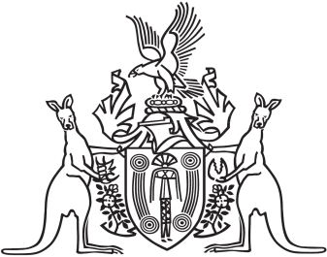
Northern Territory of Australia

Government Gazette
ISSN-0157-833X
No. S78 6 November 2017
Interpretation Act
Notice of Making of Administrative
Arrangements Order
Notice is given of the making of an Administrative Arrangements Order on
6 November 2017, for section 35 of the Interpretation Act, to take effect from
6 November 2017.
An electronic version of the Administrative Arrangements Order will be made available on the Current Northern Territory Legislation database at:
https://legislation.nt.gov.au/
Copies of the Order may also be obtained from the Cabinet Office in the Department of the Chief Minister by telephoning 8999 6949.

