Northern Territory of Australia

Government Gazette
ISSN-0157-8324
No. G44 1 November 2017

General information
The Gazette is published by the Office of the Parliamentary Counsel.
The Gazette will be published every Wednesday, with the closing date for notices being the previous Friday at 4.00 pm.
Notices not received by the closing time will be held over until the next issue.
Notices will not be published unless a Gazette notice request form together with a copy of the signed notice and a clean copy of the notice in Word or PDF is emailed to gazettes@nt.gov.au
Notices will be published in the next issue, unless urgent publication is requested.

Availability
The Gazette will be available online at 12 Noon on the day of publication at https://nt.gov.au/about-government/gazettes
Unauthorised versions of Northern Territory Acts and Subordinate legislation are available online at https://legislation.nt.gov.au/

Northern Territory of Australia
Emergency Management Act
Realignment of Territory Emergency Management Regions
The Territory Emergency Management Council, under section 27 of the Emergency Management Act, divide the Territory into Northern Region (Darwin Metropolitan including the Tiwi Islands through to Daly Waters) and Southern Region, as shown on the attached map.
Dated 20 October 2017 20 October 2017
Reece Philip Kershaw Jodie Elizabeth Ryan
Territory Emergency Controller Territory Recovery Coordinator
Co-chairperson of the Territory Co-chairperson of the Territory Emergency Management Council Emergency Management Council
Northern and Southern emergency management regions
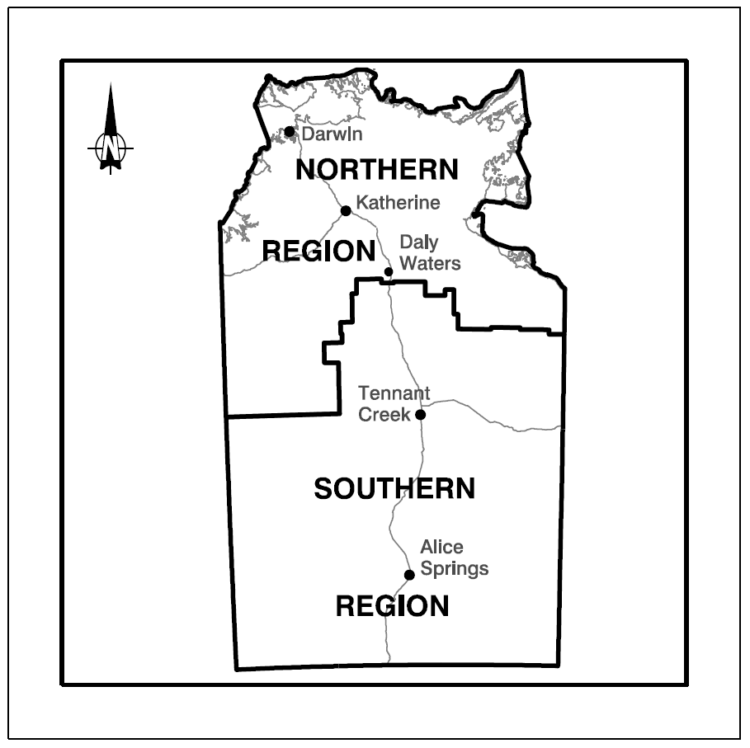

Police Administration Act

Sale of Goods
Notice is hereby given that pursuant to Section 166 of the Police Administration Act, the following property as shown on the attached schedule has been in the possession of the Officer in Charge, Police Station, Peter McAulay Centre, for a period in excess of 3 months and this property will be sold or otherwise disposed of in a manner as determined by the Commissioner of Police, if after twenty-eight (28) days from the publication of this notice the property remains unclaimed.
Antony S. Deutrom 1799
for
Nouvelle Reed
Superintendent
Palmerston Division
26 October 2017
Exhibit number | Item Description
456034/001 | 1 x Grey/green Southern Star
455319/001 | WIFI digital action camera in clear case
467167/002  467167/003  467167/006 | Black cloth toolbox containing assorted tools  2 x VE/VF Holden Comm Stock Exhaust Systems  1 x Air tool kit in black case
489694/001  498694/002 | 1 x Red/black Honda handy blower HHB-25  1 x Red/black Honda hedge trimmer HHH-25
491961/001 | Black Laser Blue tooth speaker SPK-BT510CD
487631/002 | Black Cannon G5X camera in brown case
488576/001 | Gold ring with white stones
488576/002 | Silver ring with white stones
488576/003 | Silver wedding ring with white stones
488576/004 | Silver Pulsar watch
466255/046 | 2.20 Euro
488824/001 | $1.05
488580/001 | $11.50
488839/001  488839/003 | $6.95  2 x Singapore Dollars
488838/001 | $2.35
488829/001 | $20.20
488825/001 | $3.05
488578/002 | $2.85
487453/001 | $20.00
487337/003 | $21.70
488780/006/001  487780/006/002  488780/010/001 | $200 USA Dollars + 86400 Rupiah  $7.40  $730.00
488037/001 | $100.00
488605/001 | $10.00
487790/002 | $18.30
488150/001/001 | $3.80
487672/001 | $5.00
487925/002 | $4.75
488177/001 | $1.60
487907/001 | $50.00
488201/001 | $50.00
488230/002 | $52.20
488265/002 | $16.90
487668/001/001 | $10.50
485448/001 | Pink Apple iPad with cracked screen
485463/001 | White Huawei
485467/001 | Orange Alcatel mobile phone
485473/001 | Grey/black Apple iPad
455319/002 | Red Phillips MP4 player
488265/001 | Brown wallet
488605/001 | Black wallet
487790/001 | Grey wallet
488780/010 | Black wallet
487668/001 | Black clutch wallet
488839/002 | Blue wallet
488150/001 | Black wallet
489071/001 | Silver/grey Telstra phone
489028/001 | Gold Huawei
488992/001 | Blue Samsung Galaxy 5
488870/001 | White Telstra touch phone
488869/001 | Black Telstra touch phone
488868/001 | White Telstra touch phone
488846/001 | Silver Telstra touch phone
488830/002 | White Telstra phone
488780/002 | Blue iPhone 5S
488780/003 | Black Samsung phone
488780/004 | Black Telstra phone
488780/005 | Black iPhone 5S
488780/007 | Blue Nokia phone
488709/001 | Black Alcatel one touch phone
488635/001 | Black Apple iPhone
488633/001 | Samsung Galaxy A7 Edge phone
488581/001 | White/silver Telstra phone
488526/001 | Black Apple iPhone 5
488519/001 | Black Telstra phone
488333/001 | Black ZTE Blade phone
488297/001 | Black Samsung phone
488293/001 | White HTC phone
488267/001 | Grey Telstra phone
488190/001 | Silver/white Apple iPhone
488177/003 | White mobile phone
488063/001 | Black LG touch screen phone
487910/001 | Grey Telstra HTC phone
487827/001 | Black Huawei phone
487826/001 | White Vodaphone
487700/001 | Black Apple phone
487588/001 | Black Telstra touch phone
487587/001 | White Samsung touch screen
487553/001 | Black Apple IPhone 5
487553/002 | Black Alcatel phone
487498/001 | Black Telstra phone
497497/001 | White Telstra phone
497496/001 | Black Telstra phone
487337/004 | White Huawei phone
487220/001 | Black Telstra ZTE phone
487220/002 | Black Kogan phone
488849/001 | Black laptop
488849/002 | Black Samsung phone
488849/003 | Black Samsung phone
488849/004 | Black ZTE phone
488849/005 | White Samsung phone
488849/006 | White Apple iPhone
488849/007 | White Huawei phone
488849/008 | Black Samsung phone
488849/009 | Black LG phone
488849/010 | Black Apple phone
488849/011 | Black Apple iPhone
488849/012 | White Apple phone
488849/013 | Black Vodaphone
488849/014 | Black Apple iPod
488849/015 | Black Alcatel phone
488849/016 | Black/silver Samsung S5
488849/017 | Black ZTE smart phone
488849/018 | Black Microsoft phone
488849/019 | Black Apple iPhone
488849/020 | Black Samsung phone
488849/021 | White HTC phone
488849/022 | Black Apple iPhone
488849/023 | White ZTE phone
488849/024 | Black Alcatel phone
488849/025 | White Samsung phone
488849/026 | Black Samsung phone
488849/027 | Black Alcatel phone
488849/028 | Black Huawei phone
488849/029 | White Samsung phone
488849/030 | Black HTC phone
488849/031 | Black HTC phone
488849/032 | Black ZTE Blade phone
488849/033 | White Apple iPhone
488849/034 | Black Huawei phone
488849/035 | Black ZTE phone
488849/036 | Black Sony phone
488849/037 | Black ZTE phone
488849/038 | Blue ZTE phone
488849/039 | Black/red ZTE phone
488849/040 | Black ZTE phone
488849/041 | Black ZTE phone
488849/042 | Black ZTE phone
488849/043 | Black ZTE phone
488849/044 | Black Samsung phone
488849/045 | Black Huawei phone
488849/046 | Black Huawei phone
488849/047 | Black Alcatel phone
488849/048 | Black Huawei phone
488849/049 | Black Samsung phone
488849/050 | Black Samsung phone
488849/051 | Black Samsung phone
488849/052 | Black Huawei phone
488849/053 | Black Sony phone
488849/054 | Black E2053 phone
488849/055 | White ZTE phone
488849/056 | White ZTE phone
488849/057 | Black/green Samsung phone
488849/058 | Black Vodafone
488849/059 | Black Microsoft phone
488849/060 | White Samsung phone
488849/061 | Black ZTE phone
488849/062 | Black ZTE phone
488849/063 | Black ZTE phone
488849/064 | Black Huawei phone
488849/065 | White Samsung phone
488849/066 | White Samsung phone
488849/067 | Black Alcatel phone
488849/068 | Black ZTE T20 phone
488849/069 | Black ZTE phone
488849/070 | Black ZTE phone
488849/071 | Silver LG phone
488849/072 | White Samsung phone
488849/073 | Black ZTE phone
488849/074 | Black ZTE phone
488849/075 | Black ZTE phone
488849/076 | Black/pink Samsung phone
488849/077 | Black/red Samsung phone
488849/078 | Black Motorola GP328
488849/079 | Silver HTC phone
488849/080 | White ZTE phone
488849/081 | White/lime green Apple iPod
488849/082 | Silver Apple iPod
488849/083 | Silver Apple iPod
488849/084 | Silver Apple iPod
488849/085 | Silver Apple iPod
488849/086 | White Apple iPod
488580/002 | Blue purse
480578/001 | Black purse
488519/002 | ID card
487337/001 | Black handbag
487337/002 | Floral handbag
488230/001 | Black purse
488177/001 | Floral purse
487925/001 | Brown purse
487631/001 | Grey backpack
488830/001 | Black canvas bum bag
488829/002 | Blue purse
488828/002 | Yellow purse
488825/002 | White/pink purse
488824/002 | Blue purse
487452/001 | Bronze/black Fitbit
487545/001 | Black laptop
488780/006 | Black Kathmandu bum bag
488780/008 | Black iPod
488780/009 | Black Tom Tom
488780/011 | White Samsung Tab 3
488618/001 | White Apple IPad
488618/002 | Grey Samsung Galaxy Tab A
487773/001 | Blue/black Telstra tablet
477689/002  477689/006  477689/006/001 | Black Samsung  Samsung G  ZTE phone
460651/003 | 1 x external hard drive
464884/006 | White Telstra mobile phone – smashed screen
471075/001  471075/002 | Black/silver iPhone  White/silver mobile phone
482982/004  452982/005 | Black Samsung mobile phone  Black Nokia mobile phone
485924/002 | Huawei mobile phone
444195/016  444195/017  444195/018  444195/019 | Black Nokia mobile  Silver iPhone  Black Nokia mobile  White Samsung mobile
488176/001 | Black and green BMX bike
487784/001 | Blue/silver Giant
487844/001 | White/orange Crest mountain bike
487698/001 | Blue/silver Repco
487559/001 | Black/green Apollo mountain bike
487295/001 | Blue/silver Apollo mountain bike
488407/001 | Black/white Scott Sportster mountain bike
488281/001 | Grey GT Mountain bike
477043/001 | Browning Arms .22 LR S/N# 106295
477043/002 | Mossberg .22 MAG S/N# 1392115
477043/003 | Remington 243 RBA S/N# 6087193
477043/004 | Gevarm .22 RSA S/N# not known
455844/027 | Dienst Automatisch pistol S/N# 382480
491471/001 | Sportco shotgun S/N # not known
460661/001  466061/002 | NT CB88YV 1993 white Toyota Landcruiser swgn  1 x Kenda Klever tyre
Northern Territory of Australia

Local Government Act
Local Government Subsidiary
Establishment as Body Corporate
I, Gerald Francis McCarthy, Minister for Local Government, under section 28(1) of the Local Government Act, fix 1 November 2017 as the date on which the local government subsidiary known as "Latitude 12" comes into existence as a body corporate.
Dated 26 October 2017
G. F. McCarthy
Minister for Local Government
Note
The East Arnhem Regional Council is the constituent council of Latitude 12.

