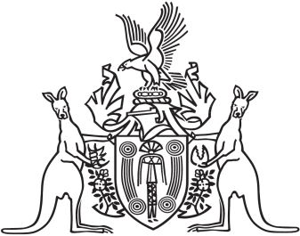
Northern Territory of Australia

Government Gazette
ISSN-0157-833X
No. S70 11 October 2017
Northern Territory of Australia

Professional Standards Act
Notification
The Institute of Public Accountants Professional Standards Scheme
I, Natasha Kate Fyles, Attorney-General and Minister for Justice, under section 13(1) of the Professional Standards Act and with reference to section 14(1)(b) of the Act, give notice that:
(a) a scheme entitled "The Institute of Public Accountants Professional Standards Scheme" has been approved by the Professional Standards Council established by section 39 of the Professional Standards Act 1994 (NSW); and
(b) the scheme commences 2 months after the date on which this notice is published in the Gazette; and
(c) copies of the scheme are available from the Council at Level 2 St James Centre, 111 Elizabeth Street, Sydney NSW 2000 and the Council’s website at www.psc.gov.au.
Dated 9 October 2017
N. K. Fyles
Attorney-General and Minister for Justice

