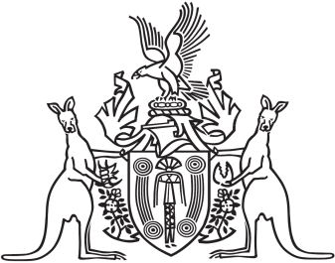
Northern Territory of Australia

Government Gazette
ISSN-0157-833X
No. S48 10 July 2017
Northern Territory of Australia

Medicines, Poisons and Therapeutic Goods Act
Healthcare Australia
Declarations and Approval
I, Hugh Crosbie Heggie, Chief Health Officer:
- under section 252 of the Medicines, Poisons and Therapeutic Goods Act, declare the health centre specified in the Schedule, Part A, to be a place to which Part 2.6 of the Act applies; and
- under section 254(1) of the Act, approve each Scheduled substance treatment protocol specified in the Schedule, Part B, for the health centre specified in the Schedule, Part A; and
- under section 250(1)(a) of the Act, declare each nurse practising at the health centre specified in the Schedule, Part A who has the qualifications specified in the Schedule, Part C, to be an approved nurse to supply, administer to another person and possess the Schedule 4 substances specified in the Schedule, Part D, in accordance with the applicable Scheduled substance treatment protocols specified in the Schedule, Part B.
Dated 6 July 2017
H. C. Heggie
Chief Health Officer
Schedule
Part A
Healthcare Australia (HCA)
Unit 2/3 Whitfield Street
Darwin NT 0800
Part B
Title | Publication date | Author
Immunisation Health Management Protocol | 19 July 2016 | Healthcare Australia Corporate Health
Scheduled Substance Treatment Protocol – Adrenaline | 19 July 2016 | Healthcare Australia Corporate Health
Scheduled Substance Treatment Protocol – Influenza Vaccine | 19 July 2016 | Healthcare Australia Corporate Health
Standard Operating Procedures – Vaccine Management | 19 July 2016 | Healthcare Australia Corporate Health
Part C
- The qualifications prescribed under section 65(1A) of the Act.
- Successful completion of the unit of competency HLTAID001 - Provide cardiopulmonary resuscitation.
Part D
Adrenaline
Influenza vaccine

