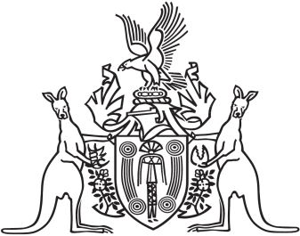
Northern Territory of Australia

Government Gazette
ISSN-0157-833X
No. S39 29 June 2017

Notification of Subordinate Legislation
Notice is given of the making of the following subordinate legislation, effective from the date specified:
Subordinate Legislation | Commencement details | Empowering Act
Police Administration (Fees) Amendment Regulations 2017  (No. 13 of 2017) | These Regulations commence on 1 July 2017 | Police Administration Act
Fire and Emergency Amendment Regulations 2017  (No. 14 of 2017) | These Regulations commence on 1 July 2017 | Fire and Emergency Act
Weapons Control Amendment Regulations 2017  (No. 15 of 2017) | These Regulations commence on 1 July 2017 | Weapons Control Act
Care and Protection of Children (Screening) Amendment Regulations 2017  (No. 16 of 2017) | These Regulations commence on 1 July 2017 | Care and Protection of Children Act
National Electricity (Northern Territory) (National Uniform Legislation) (Modification) Amendment Regulations 2017  (No. 17 of 2017) | These Regulations commence on 1 July 2017 | National Electricity (Northern Territory) (National Uniform Legislation) Act
National Electricity (Northern Territory) (National Uniform Legislation) (Act Amendment) Regulations 2017  (No. 18 of 2017) | These Regulations commence immediately after the commencement of the National Electricity (Northern Territory) (National Uniform Legislation) Amendment Act 2017 | National Electricity (Northern Territory) (National Uniform Legislation) Act
Work Health and Safety (National Uniform Legislation) Amendment Regulations 2017  (No. 19 of 2017) | These Regulations commence on 1 July 2017 | Work Health and Safety (National Uniform Legislation) Act
Termination of Pregnancy Law Reform Regulations  (No. 20 of 2017) | These Regulations commence on the commencement of the Termination of Pregnancy Law Reform Act 2017 | Termination of Pregnancy Law Reform Act
Motor Vehicles (Fees and Charges) Amendment Regulations (No. 2) 2017  (No. 21 of 2017) | These Regulations commence on 1 July 2017 | Motor Vehicles Act
For copies of legislation please direct your request to the Print Management Unit, email pmu.ntg@nt.gov.au or phone (08) 8999 6727

