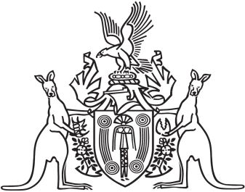
Northern Territory of Australia

Government Gazette
ISSN-0157-833X
No. S38 28 June 2017
Northern Territory of Australia

Termination of Pregnancy Law Reform Act 2017
Commencement Notice
I, John Laurence Hardy, Administrator of the Northern Territory of Australia, under section 2 of the Termination of Pregnancy Law Reform Act 2017
(No. 7 of 2017), fix 1 July 2017 as the day on which the Act commences.
Dated 27 June 2017
J. L. Hardy
Administrator

