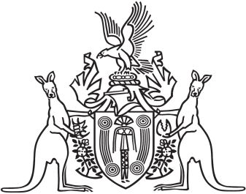
Northern Territory of Australia

Government Gazette
ISSN-0157-833X
No. S12 22 March 2017
Northern Territory of Australia

Weeds Management Act
Approval of Weed Management Plan
for Athel Pine (Tamarix Aphylla)
I, Lauren Jane Moss, Minister for Environment and Natural Resources:
(a) under section 10(1) of the Weeds Management Act, approve the plan entitled "Weed Management Plan for Athel Pine (Tamarix aphylla) 2016" and prepared by the Weed Management Branch of the Department of Environment and Natural Resources, as a weed management plan for the purposes mentioned in section 10(1)(a) to (d) of the Act; and
(b) under section 11(4) of the Act, specify that the plan is to remain in force for 10 years on and from the date on which this instrument is published in the Gazette.
Dated 23 February 2017
L. J. Moss
Minister for Environment and Natural Resources
Northern Territory of Australia

Weeds Management Act
Appointment of Weed Management Officer
I, Joanne Townsend, Acting Chief Executive Officer of the Department of Environment and Natural Resources, as the delegate of the Minister for Environment and Natural Resources, under section 24(1) of the Weeds Management Act, appoint Ranid Peter May to be a weed management officer.
Dated 15 March 2017
J. Townsend
Acting Chief Executive Officer

