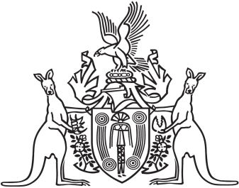
Northern Territory of Australia

Government Gazette
ISSN-0157-833X
No. S85 5 August 2016
Northern Territory of Australia

Parole Amendment Act 2016
Commencement Notice
I, John Laurence Hardy, Administrator of the Northern Territory of Australia, under section 2 of the Parole Amendment Act 2016 (No. 28 of 2016), fix the day on which this notice is published in the Gazette as the day on which that Act commences.
Dated 2 August 2016
J. L. Hardy
Administrator

