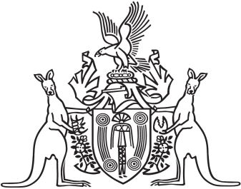
Northern Territory of Australia

Government Gazette
ISSN-0157-833X
No. S78 29 July 2016
Northern Territory of Australia

Public Holidays Act
Appointment of Additional Public Holidays
I, Peter Donald Styles, Minister for Public Employment, under section 6 of the Public Holidays Act, appoint each of the following days to be a public holiday to be observed in the Territory by all of the community of the Territory:
(a) Sunday 25 December 2016;
(b) Sunday 1 January 2017.
Dated 26 July 2016
P. D. STYLES
Minister for Public Employment
Note
Schedule 2 of the Act provides that if New Year's Day or Christmas Day falls on a Sunday, the public holiday is the following Monday. The purpose of this instrument is to appoint each of Sunday 25 December 2016 and Sunday 1 January 2017 to be a public holiday in addition to Monday 26 and Tuesday 27 December 2016 and Monday 2 January 2017.

