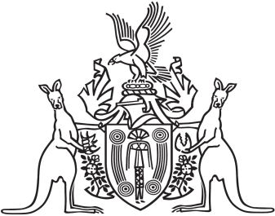
Northern Territory of Australia

Government Gazette
ISSN-0157-833X
No. S60 1 July 2016

Notification of Subordinate Legislation
Notice is given of the making of the following subordinate legislation, effective from the date specified:
Subordinate Legislation | Commencement details | Empowering Act
Return to Work Amendment Regulations 2016  (No. 26 of 2016) | Date of this Gazette | Return to Work Act
Local Court Amendment Regulations 2016  (No. 28 of 2016) | Date of this Gazette | Local Court Act
Administration and Probate Amendment Regulations 2016  (No. 29 of 2016) | Date of this Gazette | Administration and Probate Act
For copies of legislation please direct your request to the Print Management Unit, email pmu.dcm@nt.gov.au or phone (08) 8999 6727

