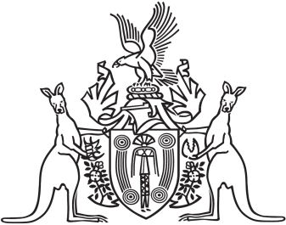

Northern Territory of Australia

Government Gazette

ISSN-0157-833X

No. S43 16 May 2016

Northern Territory of Australia

*Pastoral Land Act*

Pastoral Land Board

Appointment of Member

I, Gary John Higgins, Minister for Land Resource Management, under section 12(1) of the *Pastoral Land Act*, appoint Steven Craig to be a member of the Pastoral Land Board from 1 May 2016 to 30 April 2019.

Dated 12 May 2016

G. J. Higgins

Minister for Land Resource Management