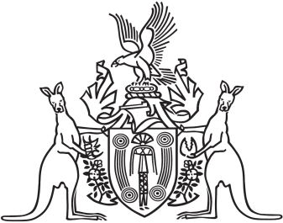
Northern Territory of Australia

Government Gazette
ISSN-0157-833X
No. S25 8 April 2016

Assent to Proposed Laws
His Honour the Administrator assented to the following proposed law:
6 April 2016
Building Amendment (Occupancy Certification) Act 2016 (Act No. 6 of 2016)
Inquiries Amendment Act 2016 (Act No. 7 of 2016)
Local Court (Related Amendments) Act 2016 (Act No. 8 of 2016)
Local Court (Repeals and Related Amendments) Act 2016 (Act No. 9 of 2016)
Yours sincerely

Michael Tatham
Clerk of the Legislative Assembly

