Mineral Titles Act 2010
NOTICE OF LAND CEASING TO BE A MINERAL TITLE AREA
Title Type and Number: | Exploration Licence 32282
Area Ceased on: | 15 September 2026
Area: | 113 Blocks, 365.53 km²
Locality: | GOSSE RIVER
Name of Applicant(s)/Holder(s): | 100% KNOX RESOURCES PTY LTD* [ACN. 623 480 286]
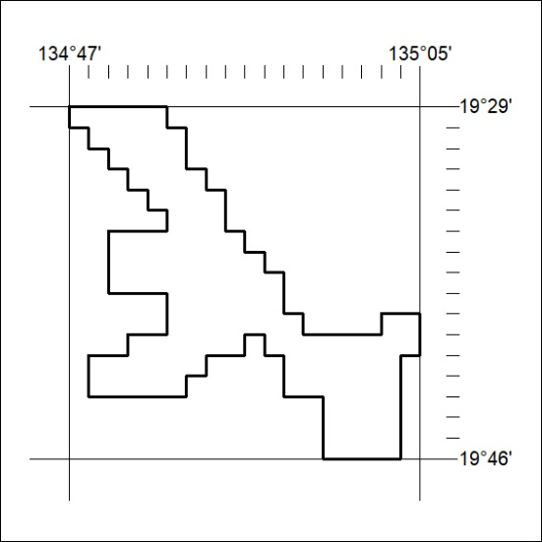
(Area now amalgamated into Exploration Licence 34498 under s102 – EL moratorium period does not apply)

383/26

Mineral Titles Act 2010
NOTICE OF LAND CEASING TO BE A MINERAL TITLE AREA
Title Type and Number: | Exploration Licence 32285
Area Ceased on: | 15 September 2026
Area: | 12 Blocks, 38.85 km²
Locality: | LULU
Name of Applicant(s)/Holder(s): | 100% KNOX RESOURCES PTY LTD* [ACN. 623 480 286]
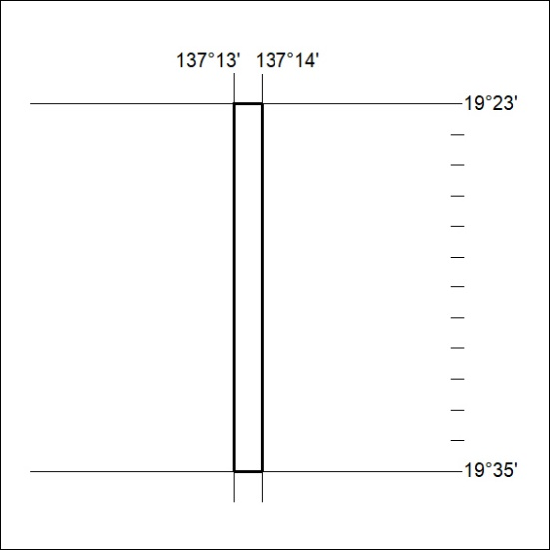
(Area now amalgamated into Exploration Licence 34499 under s102 – EL moratorium period does not apply)

384/26

Mineral Titles Act 2010
NOTICE OF LAND CEASING TO BE A MINERAL TITLE AREA
Title Type and Number: | Exploration Licence 32286
Area Ceased on: | 15 September 2026
Area: | 132 Blocks, 427.40 km²
Locality: | LULU
Name of Applicant(s)/Holder(s): | 100% KNOX RESOURCES PTY LTD* [ACN. 623 480 286]
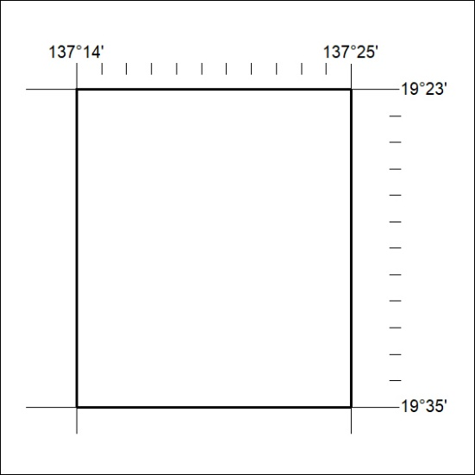
(Area now amalgamated into Exploration Licence 34499 under s102 – EL moratorium period does not apply)

385/26

Mineral Titles Act 2010
NOTICE OF LAND CEASING TO BE A MINERAL TITLE AREA
Title Type and Number: | Exploration Licence 32296
Area Ceased on: | 23 September 2024
Area: | 20 Blocks, 64.66 km²
Locality: | FAVENC
Name of Applicant(s)/Holder(s): | 100% KNOX RESOURCES PTY LTD* [ACN. 623 480 286]
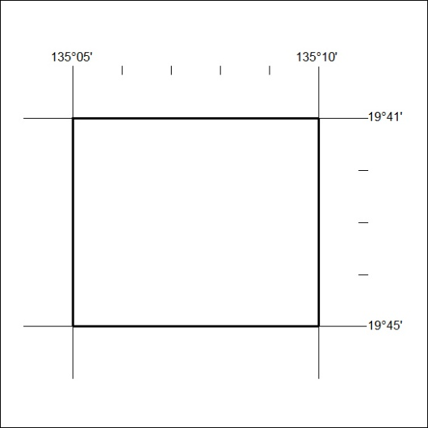
(Area now amalgamated into Exploration Licence 34498 under s102 – EL moratorium period does not apply)

386/26

Mineral Titles Act 2010
NOTICE OF LAND CEASING TO BE A MINERAL TITLE APPLICATION AREA
Title Type and Number: | Exploration Licence 34362
Area Ceased on: | 10 September 2026
Area: | 9 Blocks, 28.42 km²
Locality: | QUARTZ
Name of Applicant(s)/Holder(s): | 100% GEMPART (NT) PTY LTD* [ACN. 081 859 896]
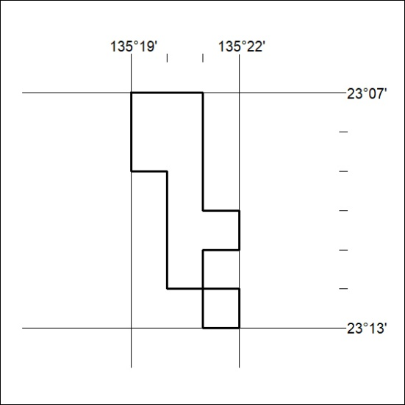

387/26

Mineral Titles Act 2010
NOTICE OF LAND CEASING TO BE A MINERAL TITLE APPLICATION AREA
Title Type and Number: | Exploration Licence 34366
Area Ceased on: | 08 September 2026
Area: | 65 Blocks, 193.86 km²
Locality: | QUARTZ
Name of Applicant(s)/Holder(s): | 100% THE AUSTRALIAN MINING SERVICE PTY LTD [ACN. 625 506 247]
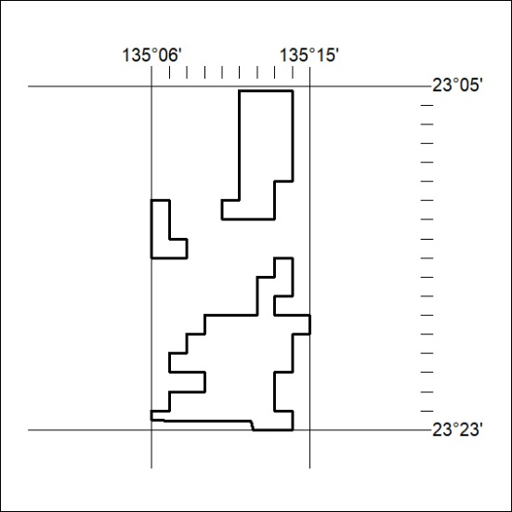

388/26

Mineral Titles Act 2010
NOTICE OF LAND CEASING TO BE A MINERAL TITLE APPLICATION AREA
Title Type and Number: | Exploration Licence 34367
Area Ceased on: | 10 September 2026
Area: | 35 Blocks, 105.99 km²
Locality: | QUARTZ
Name of Applicant(s)/Holder(s): | 100% THE AUSTRALIAN MINING SERVICE PTY LTD [ACN. 625 506 247]
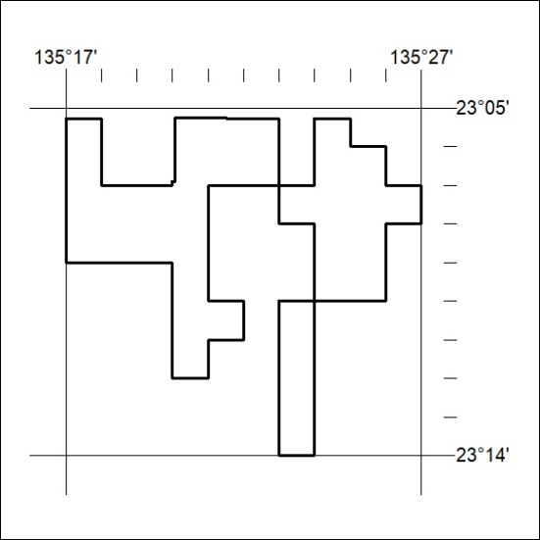

389/26

Mineral Titles Act 2010
NOTICE OF LAND CEASING TO BE A MINERAL TITLE APPLICATION AREA
Title Type and Number: | Exploration Licence 34404
Area Ceased on: | 10 September 2026
Area: | 250 Blocks, 791.19 km²
Locality: | JINKA
Name of Applicant(s)/Holder(s): | 100% KALK EXPLORATION PTY LTD [ACN. 634 749 429]
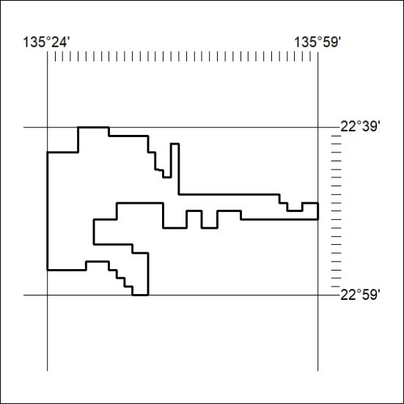

390/26

Mineral Titles Act 2010
NOTICE OF LAND CEASING TO BE A MINERAL TITLE APPLICATION AREA
Title Type and Number: | Exploration Licence 34407
Area Ceased on: | 10 September 2026
Area: | 138 Blocks, 437.06 km²
Locality: | DNEIPER
Name of Applicant(s)/Holder(s): | 100% GLYDE RIVER PTY LTD [ACN. 680 722 810]
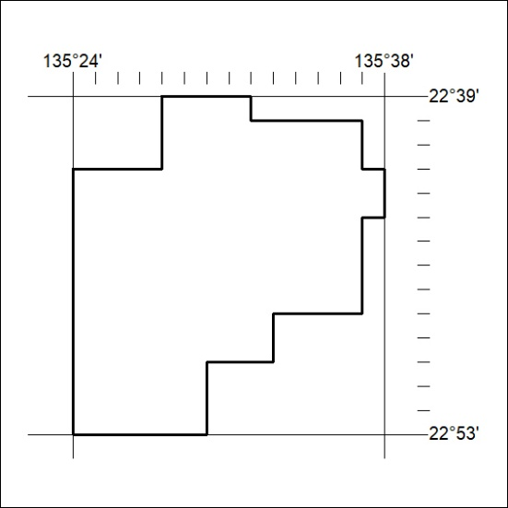

391/26

Mineral Titles Act 2010
NOTICE OF LAND CEASING TO BE A MINERAL TITLE AREA
Title Type and Number: | Extractive Mineral Exploration Licence 33693
Area Ceased on: | 11 September 2026
Area: | 2 Blocks, 1.30 km²
Locality: | BYNOE
Name of Applicant(s)/Holder(s): | 100% TERRITORY QUARTZ PTY LTD [ACN. 671 474 409]
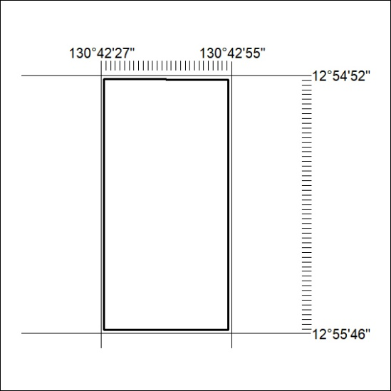

392/26

Mineral Titles Act
NOTICE OF GRANT OF A MINERAL TITLE
Title Type and Number: | Exploration Licence 34197
Granted: | 10 September 2026, for a period of 6 Years
Area: | 67 Blocks, 181.61 km²
Locality: | TEA TREE
Name of Holder/s: | 100% WA1 EXPLORATION (NT) PTY LTD [ACN. 689 129 324]
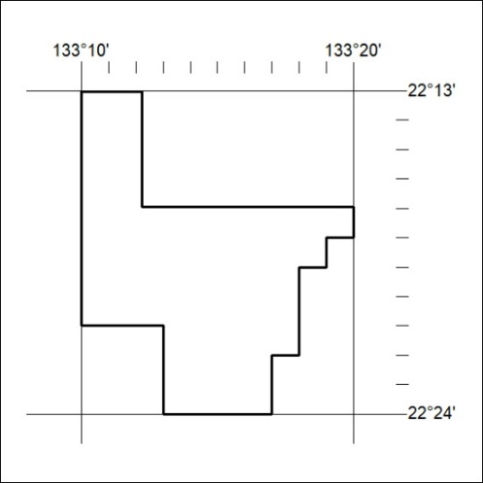
Area granted is indicated above. The titleholder is not permitted to exercise occupational rights on any land that is subject to a development title, or an application for a development title. Any land the subject of a Reserved Land gazettal under the Mineral Titles Act and all land vested in the Commonwealth of Australia is also excluded by description but not excised from the grant area.

393/26

Mineral Titles Act
NOTICE OF GRANT OF A MINERAL TITLE
Title Type and Number: | Exploration Licence 34198
Granted: | 10 September 2026, for a period of 6 Years
Area: | 149 Blocks, 436.81 km²
Locality: | TEA TREE
Name of Holder/s: | 100% WA1 EXPLORATION (NT) PTY LTD [ACN. 689 129 324]
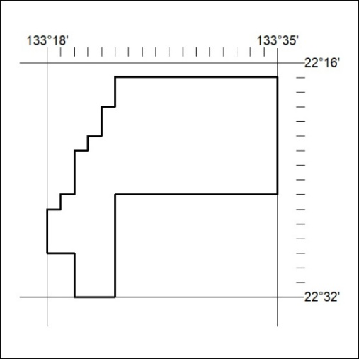
Area granted is indicated above. The titleholder is not permitted to exercise occupational rights on any land that is subject to a development title, or an application for a development title. Any land the subject of a Reserved Land gazettal under the Mineral Titles Act and all land vested in the Commonwealth of Australia is also excluded by description but not excised from the grant area.

394/26

Mineral Titles Act
NOTICE OF GRANT OF A MINERAL TITLE
Title Type and Number: | Exploration Licence 34235
Granted: | 09 September 2026, for a period of 6 Years
Area: | 7 Blocks, 14.84 km²
Locality: | BYNOE
Name of Holder/s: | 100% GECKO MINING COMPANY PTY LTD* [ACN. 169 920 745]
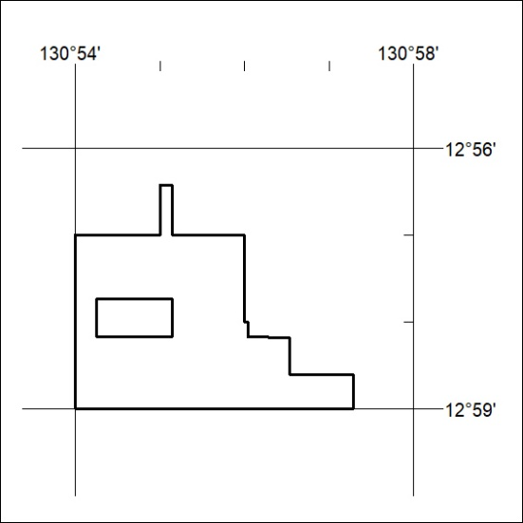
Area granted is indicated above. The titleholder is not permitted to exercise occupational rights on any land that is subject to a development title, or an application for a development title. Any land the subject of a Reserved Land gazettal under the Mineral Titles Act and all land vested in the Commonwealth of Australia is also excluded by description but not excised from the grant area.

395/26

