Mineral Titles Act
NOTICE OF GRANT OF A MINERAL TITLE
Title Type and Number: | Exploration Licence 34245
Granted: | 30 July 2026, for a period of 6 Years
Area: | 126 Blocks, 383.72 km²
Locality: | QUARTZ
Name of Holder/s: | 100% KALK EXPLORATION PTY LTD [ACN. 634 749 429]
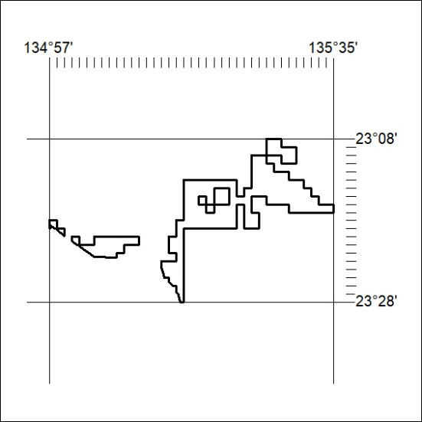
Area granted is indicated above. The titleholder is not permitted to exercise occupational rights on any land that is subject to a development title, or an application for a development title. Any land the subject of a Reserved Land gazettal under the Mineral Titles Act and all land vested in the Commonwealth of Australia is also excluded by description but not excised from the grant area.
332/26

Mineral Titles Act
NOTICE OF GRANT OF A MINERAL TITLE
Title Type and Number: | Exploration Licence 34251
Granted: | 30 July 2026, for a period of 6 Years
Area: | 250 Blocks, 789.94 km²
Locality: | BRAHMA
Name of Holder/s: | 100% KALK EXPLORATION PTY LTD [ACN. 634 749 429]
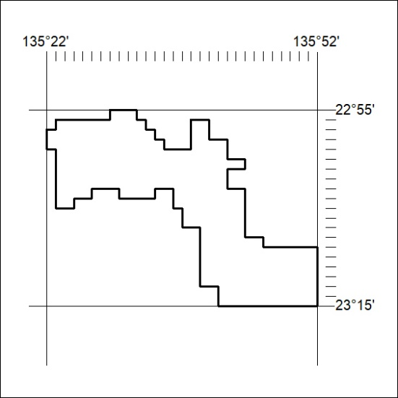
Area granted is indicated above. The titleholder is not permitted to exercise occupational rights on any land that is subject to a development title, or an application for a development title. Any land the subject of a Reserved Land gazettal under the Mineral Titles Act and all land vested in the Commonwealth of Australia is also excluded by description but not excised from the grant area.
333/26

Mineral Titles Act
NOTICE OF GRANT OF A MINERAL TITLE
Title Type and Number: | Exploration Licence 24255
Granted: | 13 October 2011, for a period of 3 Years
Area: | 2 Blocks, 4.79 km²
Locality: | SHORT RANGE
Name of Holder/s: | 100% METEORIC RESOURCES NL [ACN. 107 985 651]
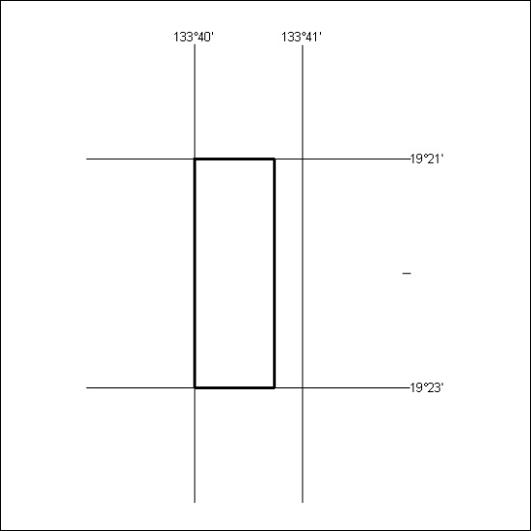
Area granted is indicated above. The titleholder is not permitted to exercise occupational rights on any land that is subject to a development title, or an application for a development title. Any land the subject of a Reserved Land gazettal under the Mineral Titles Act and all land vested in the Commonwealth of Australia is also excluded by description but not excised from the grant area.
334/26

Mineral Titles Act
NOTICE OF GRANT OF A MINERAL TITLE
Title Type and Number: | Exploration Licence 34257
Granted: | 30 July 2026, for a period of 6 Years
Area: | 38 Blocks, 119.80 km²
Locality: | QUARTZ
Name of Holder/s: | 100% KALK EXPLORATION PTY LTD [ACN. 634 749 429]
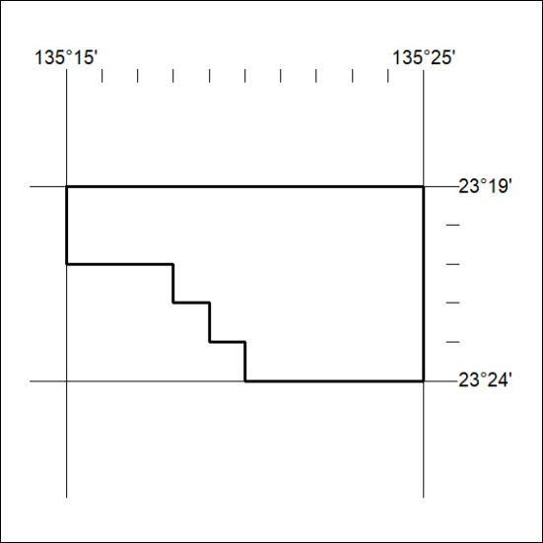
Area granted is indicated above. The titleholder is not permitted to exercise occupational rights on any land that is subject to a development title, or an application for a development title. Any land the subject of a Reserved Land gazettal under the Mineral Titles Act and all land vested in the Commonwealth of Australia is also excluded by description but not excised from the grant area.
335/26

