Mineral Titles Act 2010
NOTICE OF LAND CEASING TO BE A MINERAL TITLE AREA
Title Type and Number: | Exploration Licence 33811
Area Ceased on: | 30 July 2026
Area: | 6 Blocks, 19.12 km²
Locality: | GILES
Name of Applicant(s)/Holder(s): | 100% WA1 RESOURCES LTD [ACN. 646 878 631]
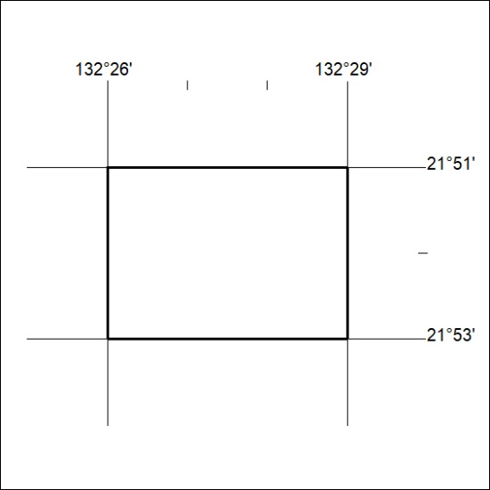

224/26

Mineral Titles Act 2010
NOTICE OF LAND CEASING TO BE A MINERAL TITLE AREA
Title Type and Number: | Exploration Licence 33813
Area Ceased on: | 30 July 2026
Area: | 25 Blocks, 79.06 km²
Locality: | AILERON
Name of Applicant(s)/Holder(s): | 100% WA1 RESOURCES LTD [ACN. 646 878 631]
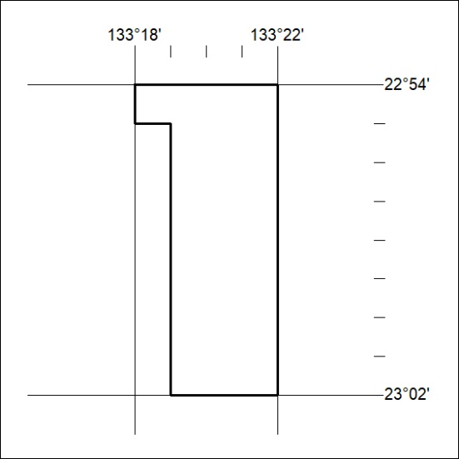

225/26

Mineral Titles Act 2010
NOTICE OF LAND CEASING TO BE A MINERAL TITLE AREA
Title Type and Number: | Exploration Licence 33825
Area Ceased on: | 30 July 2026
Area: | 9 Blocks, 28.53 km²
Locality: | AILERON
Name of Applicant(s)/Holder(s): | 100% WA1 RESOURCES LTD [ACN. 646 878 631]
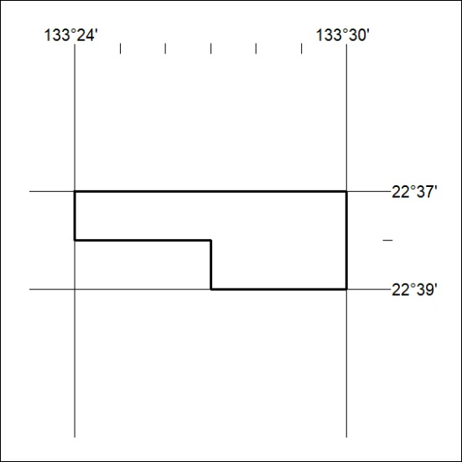

226/26

Mineral Titles Act 2010
NOTICE OF LAND CEASING TO BE A MINERAL TITLE AREA
Title Type and Number: | Exploration Licence 33846
Area Ceased on: | 30 July 2026
Area: | 27 Blocks, 86.08 km²
Locality: | CHILLA
Name of Applicant(s)/Holder(s): | 100% WA1 RESOURCES LTD [ACN. 646 878 631]
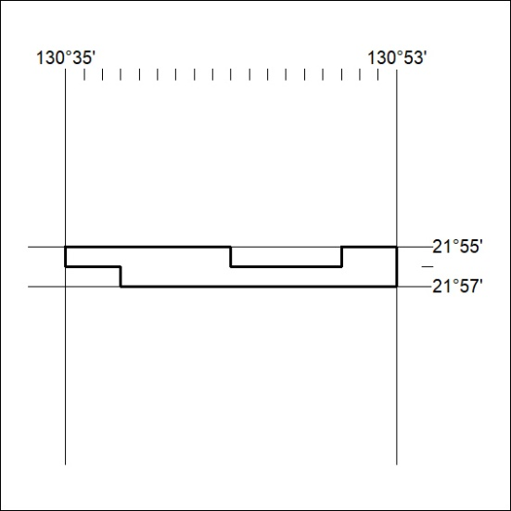

227/26

Mineral Titles Act 2010
NOTICE OF LAND CEASING TO BE A MINERAL TITLE AREA
Title Type and Number: | Exploration Licence 33847
Area Ceased on: | 30 July 2026
Area: | 7 Blocks, 22.28 km²
Locality: | DOREEN
Name of Applicant(s)/Holder(s): | 100% WA1 RESOURCES LTD [ACN. 646 878 631]
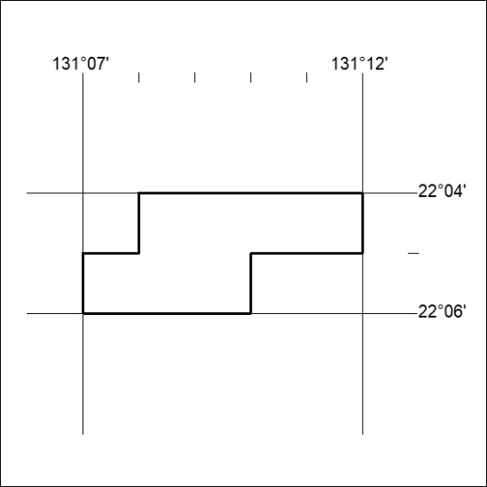

228/26

Mineral Titles Act 2010
NOTICE OF LAND CEASING TO BE A MINERAL TITLE AREA
Title Type and Number: | Exploration Licence 23875
Area Ceased on: | 09 July 2026
Area: | 22 Blocks, 70.68 km²
Locality: | SOLITAIRE
Name of Applicant(s)/Holder(s): | 100% JRE MINING PTY LTD [ACN. 601 609 161]
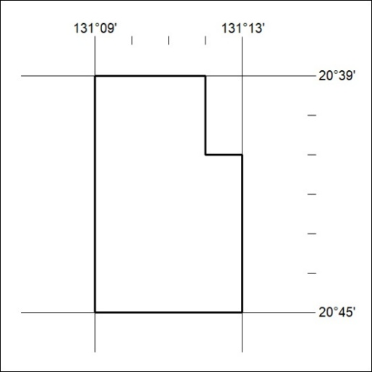
(Area now divided into Exploration Licence 34476 under s101 – EL moratorium period does not apply)

229/26

Mineral Titles Act 2010
NOTICE OF LAND CEASING TO BE A MINERAL TITLE AREA
Title Type and Number: | Exploration Licence 31402
Area Ceased on: | 09 July 2026
Area: | 34 Blocks, 109.24 km²
Locality: | GIBBESMURRAY
Name of Applicant(s)/Holder(s): | 100% JRE MINING PTY LTD [ACN. 601 609 161]
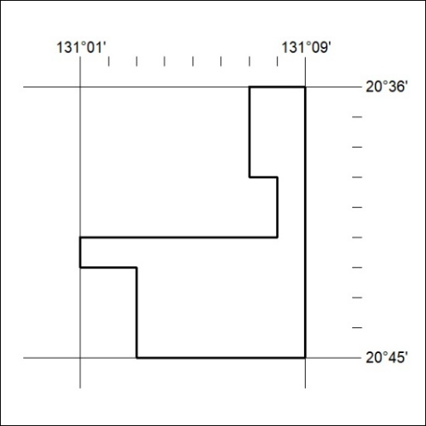
(Area now divided into Exploration Licence 34477 under s101 – EL moratorium period does not apply)

330/26

Mineral Titles Act
NOTICE OF GRANT OF A MINERAL TITLE
Title Type and Number: | Exploration Licence 34214
Granted: | 28 July 2026, for a period of 6 Years
Area: | 250 Blocks, 789.14 km²
Locality: | YALOOGARRIE
Name of Holder/s: | 100% URO CORPORATION PTY LTD [ACN. 653 927 998]
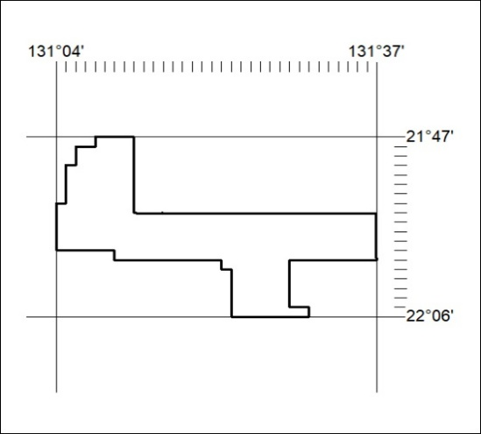
Area granted is indicated above. The titleholder is not permitted to exercise occupational rights on any land that is subject to a development title, or an application for a development title. Any land the subject of a Reserved Land gazettal under the Mineral Titles Act and all land vested in the Commonwealth of Australia is also excluded by description but not excised from the grant area.
331/26

