Mineral Titles Act 2010
NOTICE OF LAND CEASING TO BE A MINERAL TITLE AREA
Title Type and Number: | Mineral Claim (Central) 18
Area ceased on: | 31 March 2026
Area: | 4.00 Hectare
Locality: | HATCHES
Name of Applicants(s)Holder(s): | 100% SHAND Leonard John
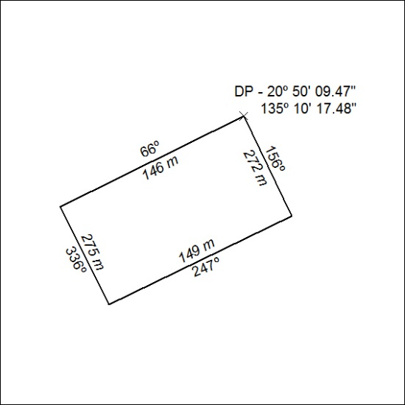

110/26

Mineral Titles Act 2010
NOTICE OF LAND CEASING TO BE A MINERAL TITLE AREA
Title Type and Number: | Mineral Claim (Central) 19
Area ceased on: | 31 March 2026
Area: | 7.00 Hectare
Locality: | HATCHES
Name of Applicants(s)Holder(s): | 100% SHAND Leonard John
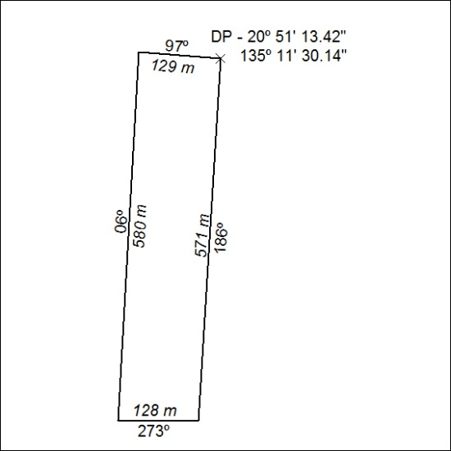

111/26

Mineral Titles Act 2010
NOTICE OF LAND CEASING TO BE A MINERAL TITLE AREA
Title Type and Number: | Mineral Claim (Central) 20
Area ceased on: | 31 March 2026
Area: | 7.00 Hectare
Locality: | HATCHES
Name of Applicants(s)Holder(s): | 100% SHAND Leonard John
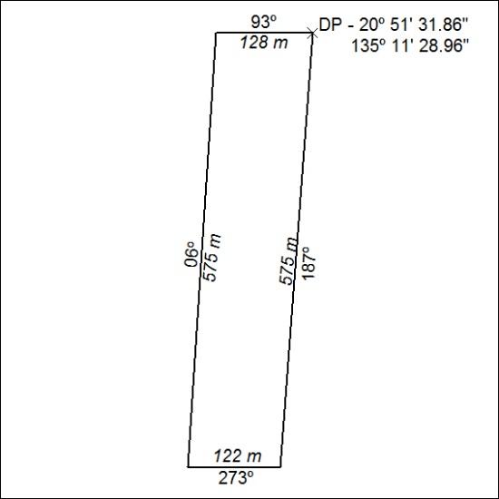

112/26

Mineral Titles Act
NOTICE OF GRANT OF A MINERAL TITLE
Title Type and Number: | Exploration Licence 34167
Granted: | 27 March 2026, for a period of 6 Years
Area: | 20 Blocks, 54.98 km²
Locality: | AILERON
Name of Holder/s: | 100% GEMPART (NT) PTY LTD* [ACN. 081 859 896]
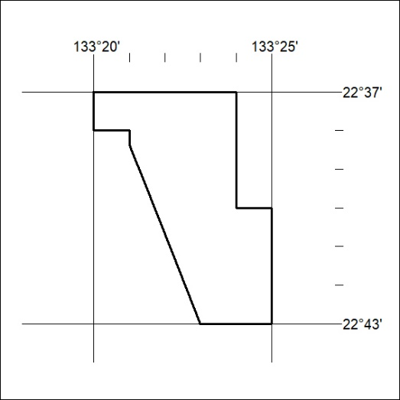
Area granted is indicated above. The titleholder is not permitted to exercise occupational rights on any land that is subject to a development title, or an application for a development title. Any land the subject of a Reserved Land gazettal under the Mineral Titles Act and all land vested in the Commonwealth of Australia is also excluded by description but not excised from the grant area.

113/26

Mineral Titles Act
NOTICE OF GRANT OF A MINERAL TITLE
Title Type and Number: | Exploration Licence 34181
Granted: | 30 March 2026, for a period of 6 Years
Area: | 3 Blocks, 0.92 km²
Locality: | BYNOE
Name of Holder/s: | 100% NT LITHIUM PTY LTD [ACN. 659 411 926]
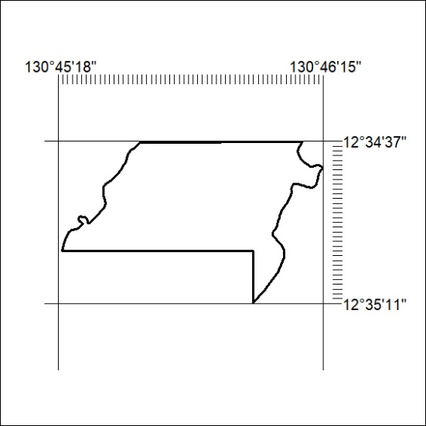
Area granted is indicated above. The titleholder is not permitted to exercise occupational rights on any land that is subject to a development title, or an application for a development title. Any land the subject of a Reserved Land gazettal under the Mineral Titles Act and all land vested in the Commonwealth of Australia is also excluded by description but not excised from the grant area.

114/26

