Mineral Titles Act 2010
NOTICE OF LAND CEASING TO BE A MINERAL TITLE AREA
Title Type and Number: | Extractive Mineral Exploration Licence 33647
Area Ceased on: | 20 March 2026
Area: | 4 Blocks, 11.41 km²
Locality: | BYNOE
Name of Applicant(s)/Holder(s): | 100% TERRITORY QUARTZ PTY LTD [ACN. 671 474 409]
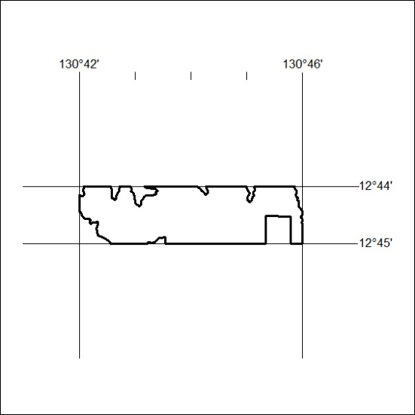

99/26

Mineral Titles Act 2010
NOTICE OF LAND CEASING TO BE A MINERAL TITLE AREA
Title Type and Number: | Exploration Licence 33942
Area Ceased on: | 23 March 2026
Area: | 42 Blocks, 133.87 km²
Locality: | BARROW
Name of Applicant(s)/Holder(s): | 100% BAUDIN RESOURCES PTY LTD [ACN. 618 455 593]
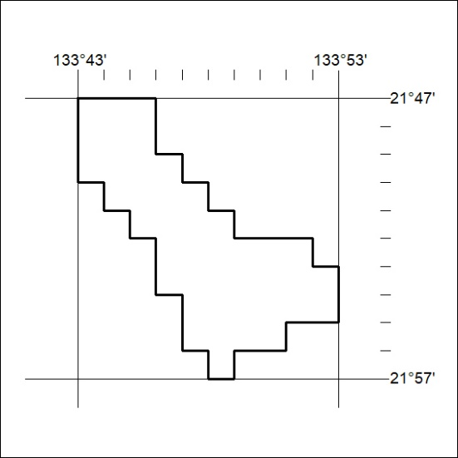

100/26

