Mineral Titles Act 2010
NOTICE OF LAND CEASING TO BE A MINERAL TITLE AREA
Title Type and Number: | Exploration Licence 32767
Area Ceased on: | 05 March 2026
Area: | 79 Blocks, 249.40 km²
Locality: | QUARTZ
Name of Applicant(s)/Holder(s): | 100% IGO NEWSEARCH PTY LTD [ACN. 142 192 701]
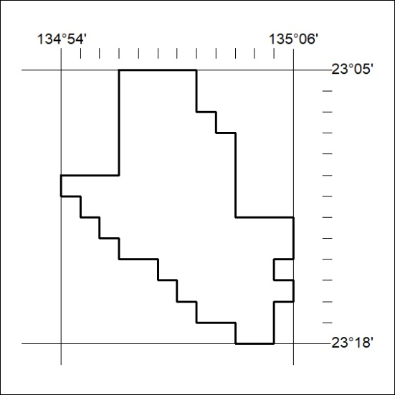

77/26

Mineral Titles Act 2010
NOTICE OF LAND CEASING TO BE A MINERAL TITLE AREA
Title Type and Number: | Exploration Licence 32771
Area Ceased on: | 05 March 2026
Area: | 154 Blocks, 486.19 km²
Locality: | BRAHMA
Name of Applicant(s)/Holder(s): | 100% IGO NEWSEARCH PTY LTD [ACN. 142 192 701]
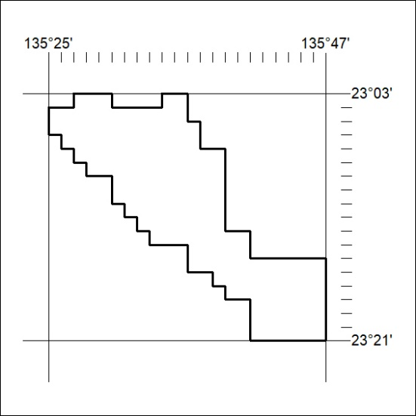

78/26

Mineral Titles Act 2010
NOTICE OF LAND CEASING TO BE A MINERAL TITLE AREA
Title Type and Number: | Exploration Licence 32777
Area Ceased on: | 05 March 2026
Area: | 208 Blocks, 654.56 km²
Locality: | DELNY
Name of Applicant(s)/Holder(s): | 100% IGO NEWSEARCH PTY LTD [ACN. 142 192 701]
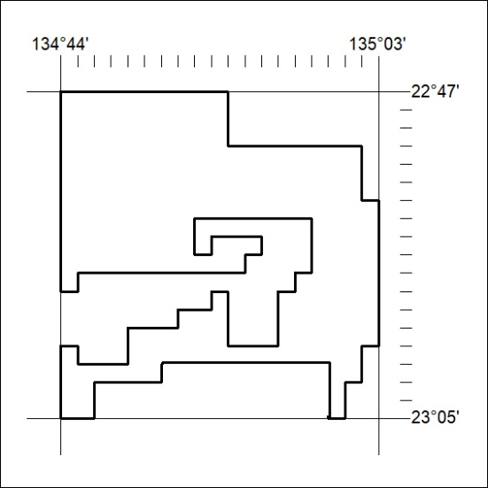

79/26

Mineral Titles Act 2010
NOTICE OF LAND CEASING TO BE A MINERAL TITLE AREA
Title Type and Number: | Exploration Licence 32780
Area Ceased on: | 05 March 2026
Area: | 161 Blocks, 475.48 km²
Locality: | BRAHMA
Name of Applicant(s)/Holder(s): | 100% IGO NEWSEARCH PTY LTD [ACN. 142 192 701]
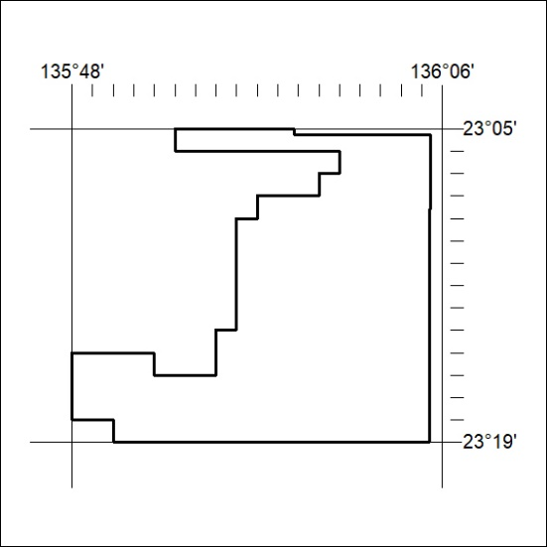

80/26

Mineral Titles Act 2010
NOTICE OF LAND CEASING TO BE A MINERAL TITLE AREA
Title Type and Number: | Exploration Licence 32781
Area Ceased on: | 05 March 2026
Area: | 200 Blocks, 591.88 km²
Locality: | BRAHMA
Name of Applicant(s)/Holder(s): | 100% IGO NEWSEARCH PTY LTD [ACN. 142 192 701]
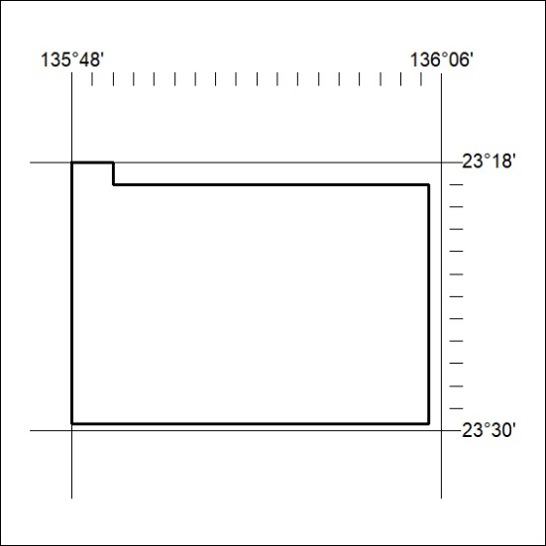

81/26

Mineral Titles Act 2010
NOTICE OF LAND CEASING TO BE A MINERAL TITLE AREA
Title Type and Number: | Exploration Licence 33694
Area Ceased on: | 05 March 2026
Area: | 142 Blocks, 447.65 km²
Locality: | DELNY
Name of Applicant(s)/Holder(s): | 100% IGO NEWSEARCH PTY LTD [ACN. 142 192 701]
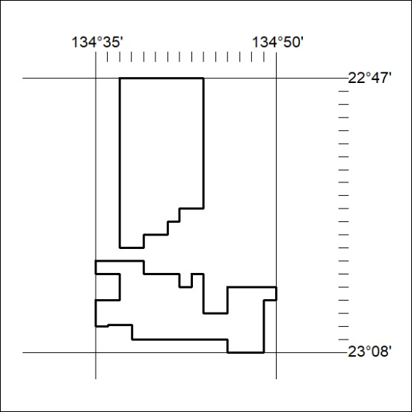

82/26

