Mineral Titles Act
NOTICE OF GRANT OF A MINERAL TITLE
Title Type and Number: | Exploration Licence 34022
Granted: | 21 May 2025, for a period of 6 Years
Area: | 8 Blocks, 25.28 km²
Locality: | QUARTZ
Name of Holder/s: | 100% AUDAX HOLDINGS PTY LTD [ACN. 678 403 864]
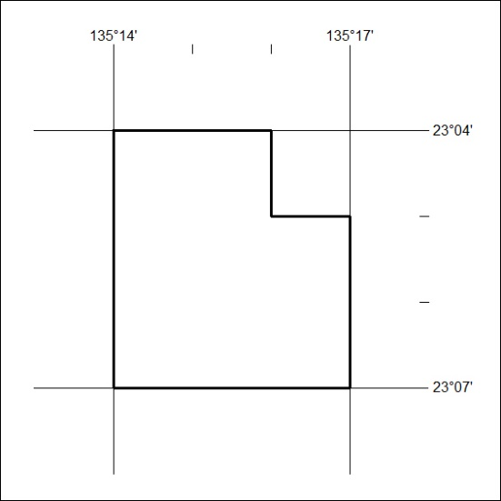
Area granted is indicated above. The titleholder is not permitted to exercise occupational rights on any land that is subject to a development title, or an application for a development title. Any land the subject of a Reserved Land gazettal under the Mineral Titles Act and all land vested in the Commonwealth of Australia is also excluded by description but not excised from the grant area.

326/25

