Mineral Titles Act
NOTICE OF GRANT OF A MINERAL TITLE
Title Type and Number: | Exploration Licence 33974
Granted: | 09 May 2025, for a period of 6 Years
Area: | 78 Blocks, 247.23 km²
Locality: | NAPPERBY
Name of Holder/s: | 100% MAC MINERALS PTY LTD [ACN. 664 335 424]
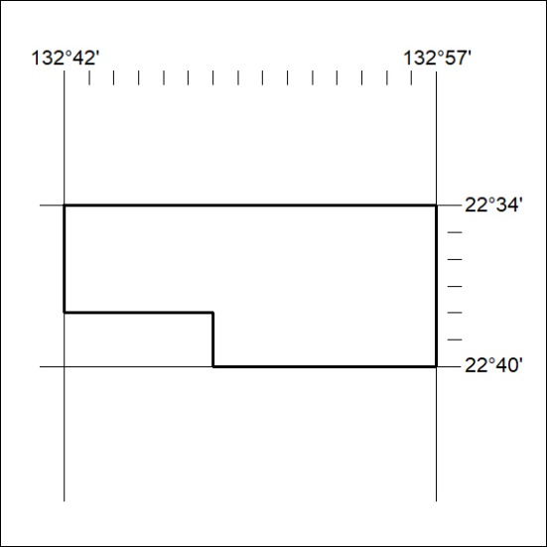
Area granted is indicated above. The titleholder is not permitted to exercise occupational rights on any land that is subject to a development title, or an application for a development title. Any land the subject of a Reserved Land gazettal under the Mineral Titles Act and all land vested in the Commonwealth of Australia is also excluded by description but not excised from the grant area.
298/25

Mineral Titles Act
NOTICE OF GRANT OF A MINERAL TITLE
Title Type and Number: | Exploration Licence 34018
Granted: | 08 May 2025, for a period of 6 Years
Area: | 52 Blocks, 171.45 km²
Locality: | VICTORIA RIVER DOWNS
Name of Holder/s: | 100% VRD EXPLORATION PTY LTD [ACN. 681 021 741]
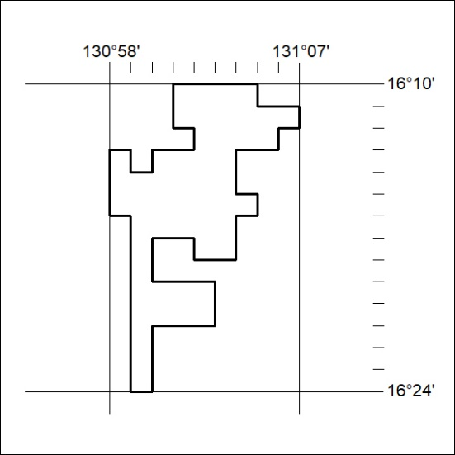
Area granted is indicated above. The titleholder is not permitted to exercise occupational rights on any land that is subject to a development title, or an application for a development title. Any land the subject of a Reserved Land gazettal under the Mineral Titles Act and all land vested in the Commonwealth of Australia is also excluded by description but not excised from the grant area.
299/25

Mineral Titles Act
NOTICE OF GRANT OF A MINERAL TITLE
Title Type and Number: | Exploration Licence 34023
Granted: | 09 May 2025, for a period of 6 Years
Area: | 5 Blocks, 15.83 km²
Locality: | JERVOIS RANGE
Name of Holder/s: | 100% GUNDERSEN Patrick Boschmans
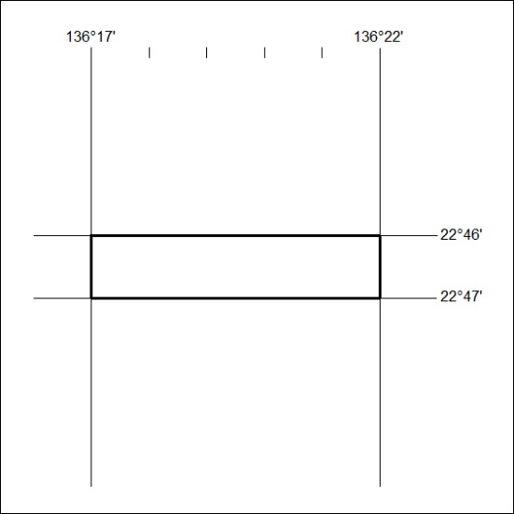
Area granted is indicated above. The titleholder is not permitted to exercise occupational rights on any land that is subject to a development title, or an application for a development title. Any land the subject of a Reserved Land gazettal under the Mineral Titles Act and all land vested in the Commonwealth of Australia is also excluded by description but not excised from the grant area.
300/25

