Mineral Titles Act 2010
NOTICE OF LAND CEASING TO BE A MINERAL TITLE APPLICATION AREA
Title Type and Number: | Extractive Mineral Permit 33483
Area ceased on: | 24 February 2025
Area: | 93.00 Hectare
Locality: | McKINLAY RIVER
Name of Applicants(s)Holder(s): | 100% TANK BIZ PTY LTD [ACN. 155 050 749]
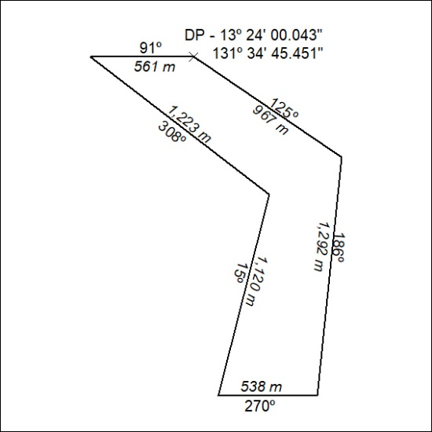

58/25

Mineral Titles Act
NOTICE OF GRANT OF A MINERAL TITLE
Title Type and Number: | Extractive Mineral Permit 33367
Granted: | 21 February 2025, for a period of 5 Years
Area: | 73.98 Hectares
Locality: | NOONAMAH
Name of Holder/s: | 100% AKJ SERVICES PTY LTD [ACN. 625 846 031]
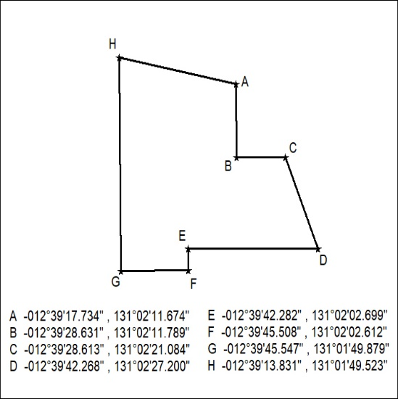

59/25

