**z**

**© Northern Territory of Australia 2025**

**Preferred Reference:** Department of Trade, Business and Asian Relations, 2023 Remote Towns Jobs Profiles, Northern Territory Government, January 2025, Darwin.

**Front cover image:** *Vitex rotundifolia* – known commonly as Beach Vitex

**Image Credits:** Robyn Wing

**Disclaimer**

The data in this publication was collected by conducting a survey of businesses located in the 28 remote town boundaries. This body of work was completed in 2023 by the former Northern Territory Department of Industry, Tourism and Trade.

The collection methodology was created in accordance with Australian Bureau of Statistics data quality framework principles. Data in this publication is only reflective of those businesses reported on as operating in the town at the time of data collection (see table at the end of publication for list of businesses reported on). To comply with privacy legislation or where appropriate, some data in this publication may have been adjusted and will not reflect the actual data reported by businesses. As a result of this, combined with certain data not being reported by some businesses, some components may not add to totals. Changes over time may also reflect business' change in propensity to report on certain data items rather than actual changes over time. Total figures have generally not been adjusted. Caution is advised when interpreting the comparisons made to the earlier 2011, 2014 and 2017 publications as the businesses identified and reported on and the corresponding jobs may differ between publications.

**Notes for each table and chart are alphabetically ordered and listed at the end of the publication.**

The Northern Territory of Australia exercised due care and skill to ensure that at the time of publication the information contained in this publication is true and correct. However, it is not intended to be relied on as professional advice or used for commercial purposes. The Territory gives no warranty or assurances as to the accuracy of the information contained in the publication and to the maximum extent permitted by law accepts no direct or indirect liability for reliance on its content.

Any use of this report for commercial purposes is not endorsed by the Department of Trade, Business and Asian Relations.

Contents

Angurugu 4

Introduction 5

Summary 6

Jobs Overview 7

Jobs filled by Aboriginality 8

Jobs by Sector: Private and Public 10

Job Status: Permanent and Temporary 17

Job Vacancies 21

Jobs by Industry 23

Jobs by Occupation 29

Jobs by Industry by Occupation 33

Jobs by Gender 35

Jobs by Age 41

Vocational Education and Training 47

Population 53

Community Development Program 55

Businesses 56

Notes 57

Abbreviations and Acronyms 58

# Angurugu

Angurugu is located on Groote Eylandt approximately 640 kilometres east-southeast of Darwin and a half hour flight south of Gove, with a population of 884 residents. 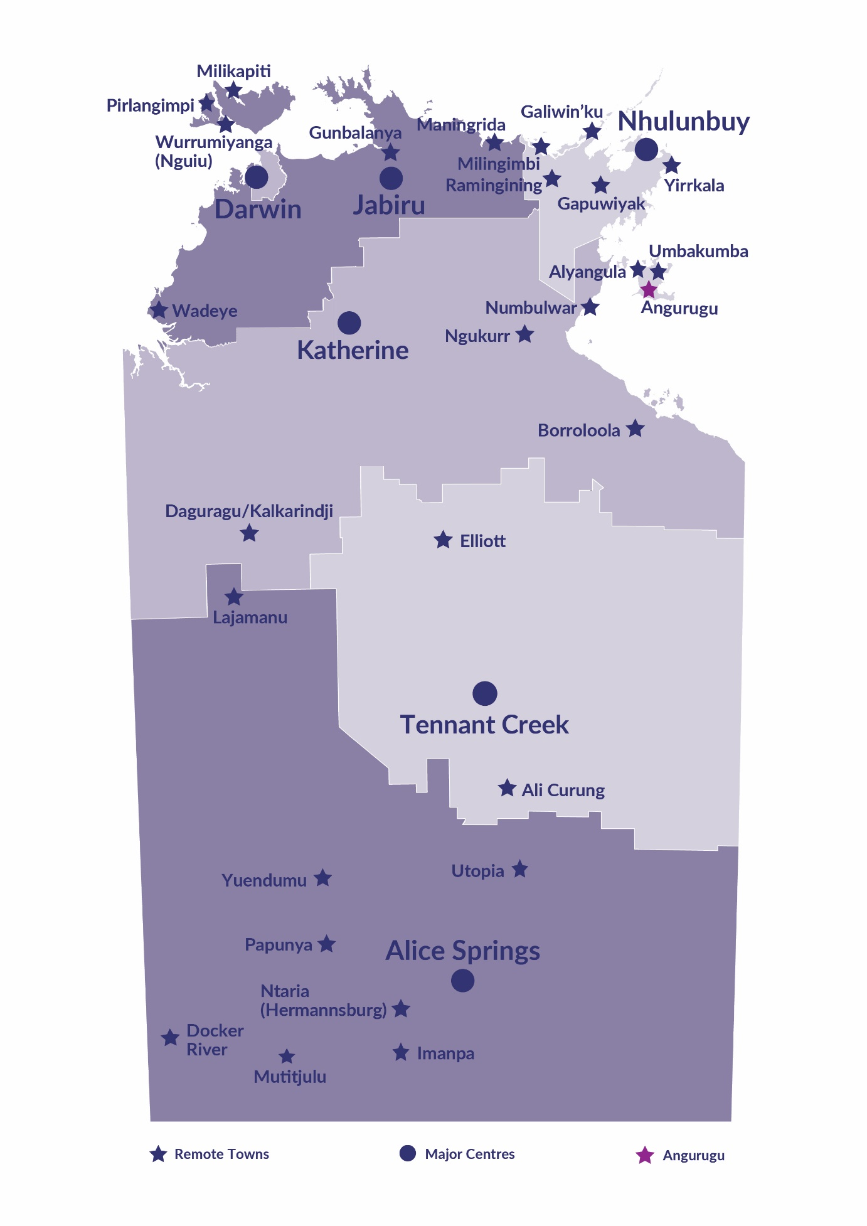*Source: Northern Territory Department of Industry, Tourism and Trade*

# Introduction

This jobs profile provides a snapshot of jobs and the characteristics of job holders in Angurugu as of September 2023. It also outlines trends from the 2011, 2014 and 2017 surveys.

This job profile is one of 28 profiles developed for remote towns in the Northern Territory. It is anticipated these, and subsequent profiles will contribute to a robust evidence base to inform decision making in and relating to these remote Territory towns.

This profile contains information collected by the Northern Territory Northern Territory Department of Industry, Tourism and Trade from businesses operating within the town and is supplemented by other administrative data sets and information.

Each profile provides up-to-date information that is intended to inform the planning and design of current and future government programs and as an evidence base to inform decision making relating to workforce development, enterprise and job opportunities.

The profile may best be understood as a point-in-time tool. The number of business surveys from which the data was drawn is significantly less than in earlier surveys, and business participation has decreased with each survey. For Angurugu, 27% fewer businesses than in 2017 are reported here.

The data collection methodology and corresponding questionnaire were created in partnership with the Australian Bureau of Statistics (ABS) and in accordance with ABS data quality framework and survey principles.

The Northern Institute at Charles Darwin University facilitated the surveys with the support of the Northern Territory Department of Industry, Tourism and Trades’ Territory Engagement and Delivery teams.

The information collected and reported on represents a significant goodwill investment by those businesses and organisations that participated. Each business is listed at the end of this publication.

# Summary

The 2023 jobs profile was developed based on responses from 11 businesses operating within the Angurugu town boundary, four less than in the 2017 survey. Of these there were:

* 5 businesses from the private sector, accounting for 110 filled jobs or 53% of total filled jobs
* 6 businesses from the public sector, accounting for 96 filled jobs or 47% of total filled jobs
* 4 businesses participated in all four surveys (completed in 2011, 2014, 2017 and 2023).

A total of 235 filled and vacant jobs in Angurugu were reported, an increase of 40 jobs from 2017.[1]

The 2023 profile highlights:

* of the 206 filled jobs:
* 118 jobs (57%) were filled by Aboriginal people, an increase of 26 jobs from 2017
* 88 jobs (43%) were filled by non-Aboriginal people, unchanged from 2017
* 30% of employed Aboriginal people are working in the private sector
* Aboriginal people accounted for 57% of job holders in the town compared to 51% in 2017
* Aboriginal females made up 37.86% of total Aboriginal filled jobs in the town compared to 32.39% in 2017
* there were 29 vacant jobs, of which:
* job vacancies as a percentage of jobs increased to 12.3% in 2023 from 7.7 % in 2017
* job vacancies equate to 1 in 8 jobs
* 21 of the vacancies were in the Clerical and Administrative and Community and Personal Service Workers areas.
* Public Administration and Safety was the largest industry employer, with an increase in 18 filled jobs compared to 2017
* the Administrative and Support Services industry had the greatest increase in filled jobs (40) compared to 2017
* training had a decrease of 21 student numbers between 2016 and 2023 with the largest decrease (12) in the Community Services, Health and Education training sector
* in 2023 there were only 3 VET students across the Community Services, Health and Education, and Business and Clerical training sectors.

The overall population in Angurugu increased by 48 people (5.7%) between 2011 and 2021 to 884 people.

In comparison, the overall Northern Territory population increased by 9.7% between 2011 and 2021.

In 2021, the working age population (15 years and over) in Angurugu was an estimated 723 people compared to 570 in 2011 an increase of 26.8%.

There were 0.3 jobs in Angurugu per working age person compared to 0.3 jobs per person across the NT.

# Jobs Overview

Table 1: Count of filled jobs and vacancies, 2011, 2014, 2017 & 2023 (a)(b)

|  |  |  |  |  |  |  |  |
| --- | --- | --- | --- | --- | --- | --- | --- |
|  | **2011** | **2014** | **2017** | **2023** | **Change 2011-2014** | **Change 2014-2017** | **Change**  **2017-2023** |
| **Total All Jobs** | **219** | **186** | **195** | **235** | **-33** | **9** | **40** |
| **Vacancies** | **19** | **32** | **15** | **29** | **13** | **-17** | **14** |
| Vacancies as % of Total All Jobs | 8.7% | 17.2% | 7.7% | 12.3% | 8.5 ppt | -9.5 ppt | 4.6 ppt |
| **Filled Jobs** | **200** | **154** | **180** | **206** | **-46** | **26** | **26** |
| Full-time | 168 | 120 | 121 | 156 | -48 | 1 | 35 |
| Part-time | 32 | 34 | 59 | 50 | 2 | 25 | -9 |

Source: Northern Territory Department of Industry, Tourism and Trade

Chart 1: Count of vacant jobs and filled jobs by full-time/part-time status, 2011, 2014, 2017 & 2023 (a)(b)

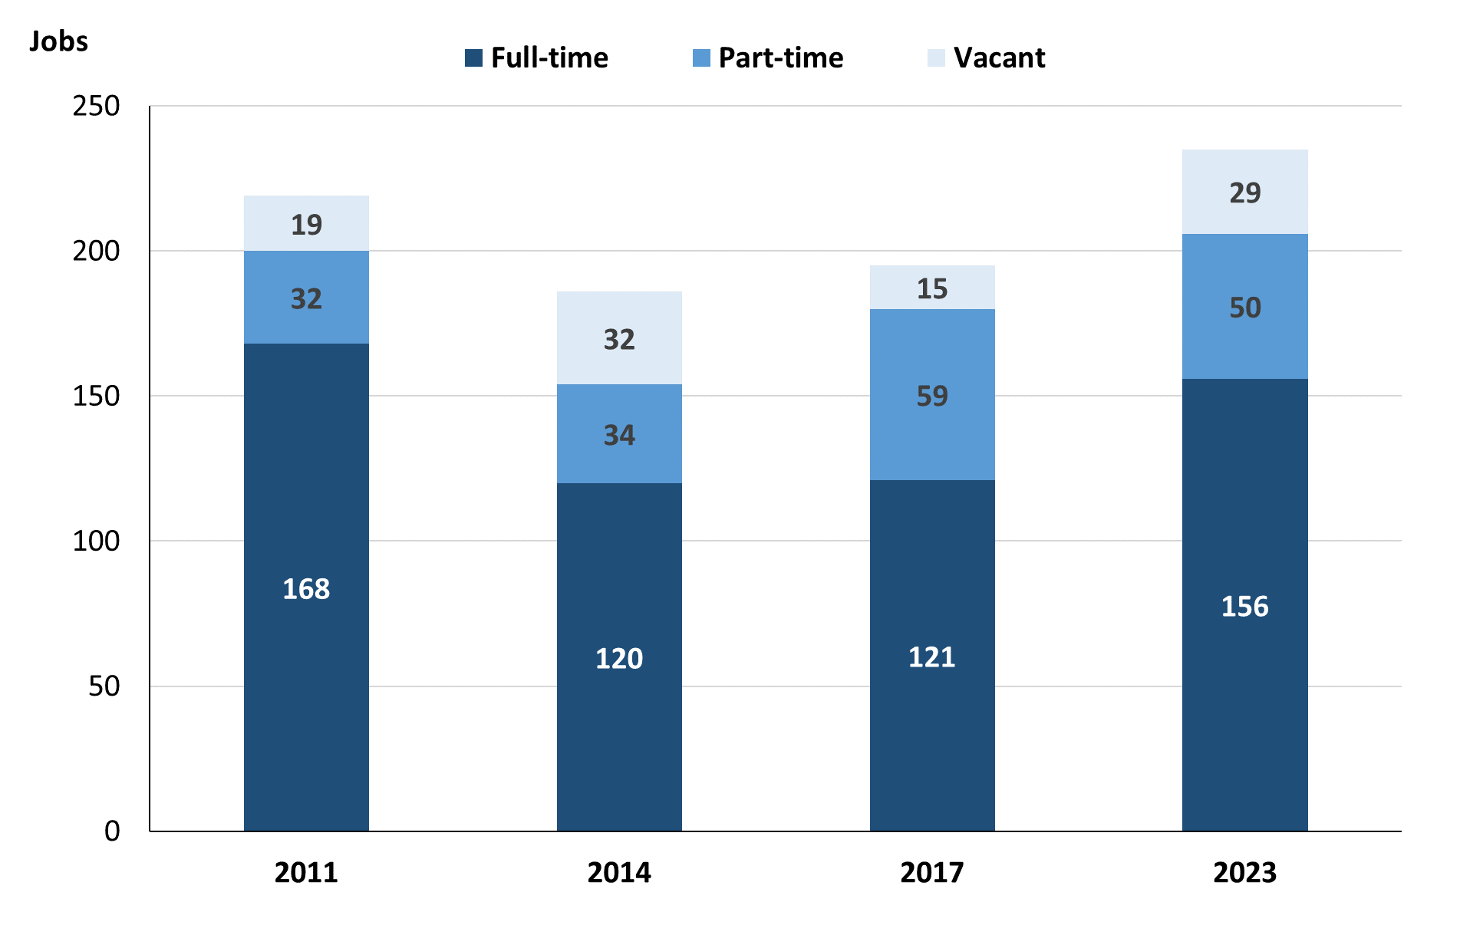

Source: Northern Territory Department of Industry, Tourism and Trade

In 2023 in Angurugu:

* a total of 206 **filled jobs**, an increase of 26 jobs from 2017 and an increase of 52 jobs from 2014
* of the 206 **filled jobs** in 2023:
* 156 were full-time jobs, an increase of 35 jobs from 2017 and an increase of 36 jobs from 2014
* 50 were part-time jobs, a decrease of 9 jobs from 2017 and an increase of 16 jobs from 2014
* there were 29 **job vacancies**, an increase of 14 vacancies from 2017 and a decrease of 3 vacancies from 2014.

# Jobs filled by Aboriginality

Chart 2: Count of filled jobs by Aboriginality, 2011, 2014, 2017 & 2023 (a)(c)

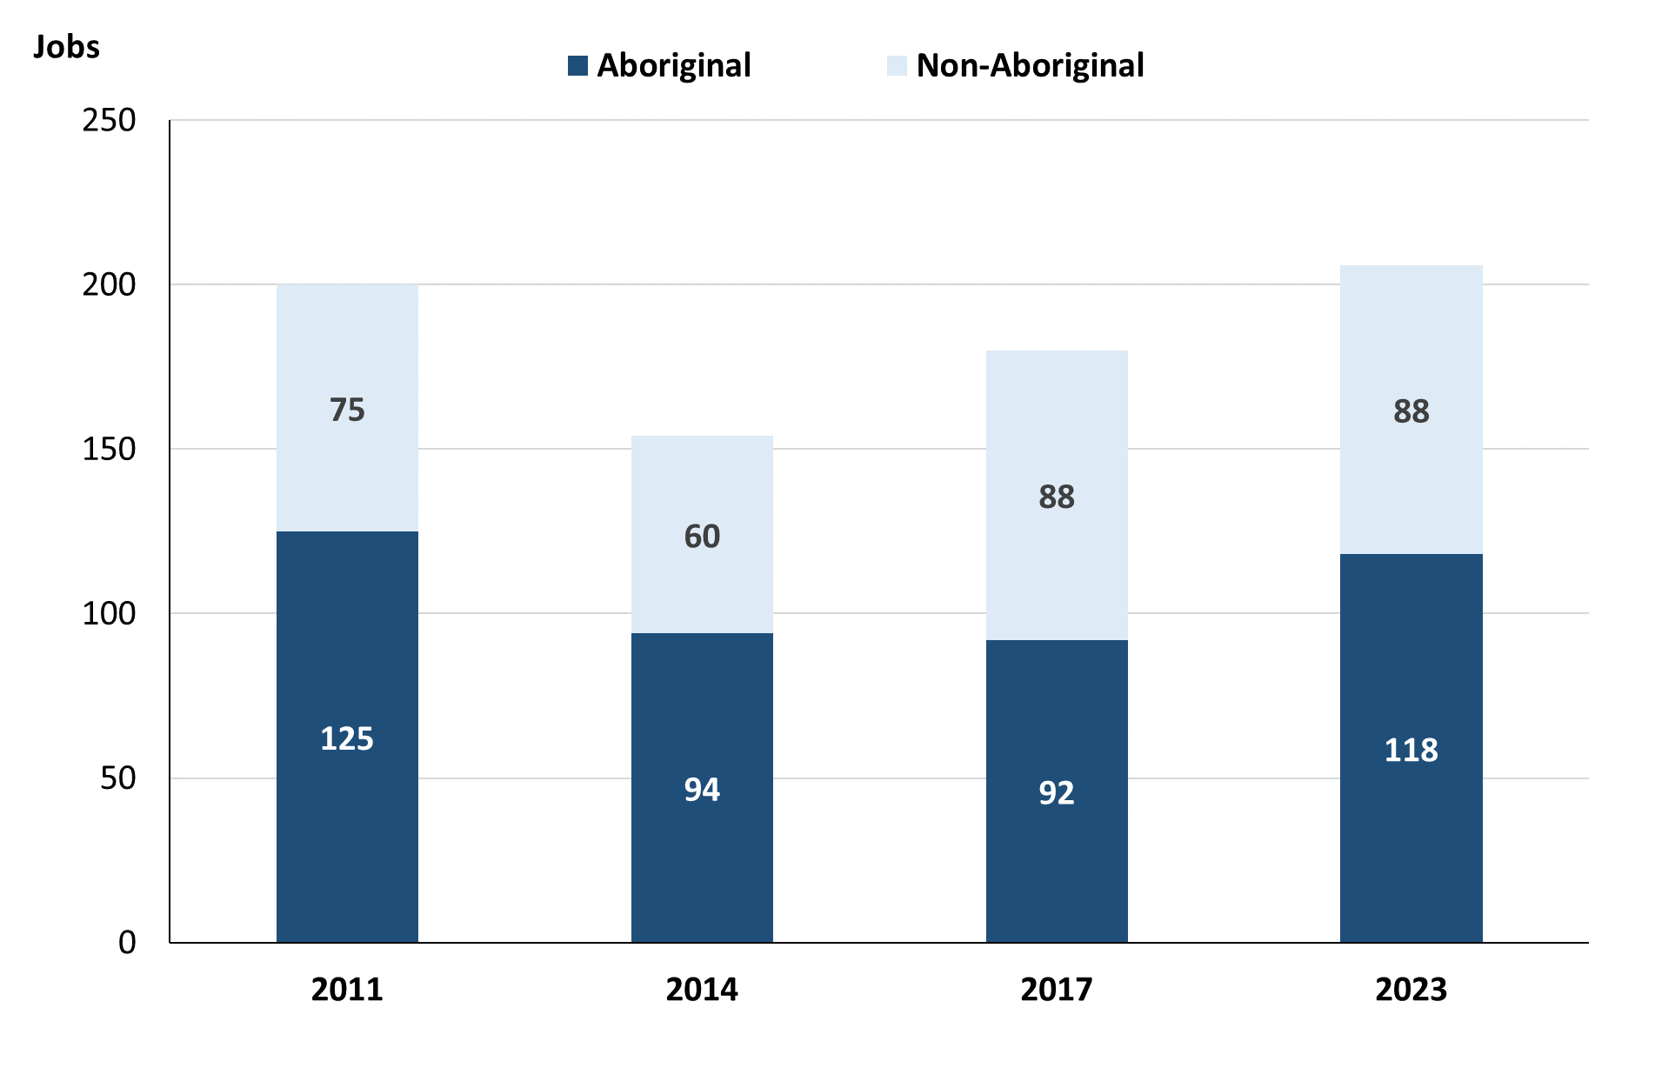

Source: Northern Territory Department of Industry, Tourism and Trade

In 2023 in Angurugu:

* of the 206 **filled jobs**:
* 118 jobs were filled by **Aboriginal** people, an increase of 26 jobs from 2017 and an increase of 24 jobs from 2014
* 88 jobs were filled by **non-Aboriginal** people, unchanged from 2017 and an increase of 28 jobs from 2014
* **Aboriginal** people accounted for 57% of job holders compared to 51% in 2017 and 61% in 2014.

**Table 2a: Count of filled jobs by full-time/part-time status, 2011, 2014, 2017 & 2023 (a)(b)(c)**

|  |  |  |  |  |  |  |  |  |  |  |  |  |
| --- | --- | --- | --- | --- | --- | --- | --- | --- | --- | --- | --- | --- |
| **Indicator** | **2011** | | | **2014** | | | **2017** | | | **2023** | | |
| **Aboriginal** | **Non-Aboriginal** | **Total** | **Aboriginal** | **Non-Aboriginal** | **Total** | **Aboriginal** | **Non-Aboriginal** | **Total** | **Aboriginal** | **Non-Aboriginal** | **Total** |
| Full-time | 102 | 66 | **168** | 64 | 56 | **120** | 44 | 77 | **121** | 80 | 76 | **156** |
| Part-time | 23 | 9 | **32** | 30 | 4 | **34** | 48 | 11 | **59** | 38 | 12 | **50** |
| **Total** | **125** | **75** | **200** | **94** | **60** | **154** | **92** | **88** | **180** | **118** | **88** | **206** |

Source: Northern Territory Department of Industry, Tourism and Trade

Table 2b: Count of filled jobs by full-time/part-time status, 2011-2014, 2014-2017 & 2017-2023 (a)(b)(c)

|  |  |  |  |  |  |  |  |  |  |
| --- | --- | --- | --- | --- | --- | --- | --- | --- | --- |
| **Indicator** | **Change 2011-2014** | | | **Change 2014-2017** | | | **Change 2017-2023** | | |
| **Aboriginal** | **Non-Aboriginal** | **Total** | **Aboriginal** | **Non-Aboriginal** | **Total** | **Aboriginal** | **Non-Aboriginal** | **Total** |
| Full-time | -38 | -10 | **-48** | -20 | 21 | **1** | 36 | -1 | **35** |
| Part-time | 7 | -5 | **2** | 18 | 7 | **25** | -10 | 1 | **-9** |
| **Total** | **-31** | **-15** | **-46** | **-2** | **28** | **26** | **26** | **0** | **26** |

Source: Northern Territory Department of Industry, Tourism and Trade

Chart 3: Count of filled jobs by full-time/part-time status, 2011, 2014, 2017 & 2023 (a)(b)(c)

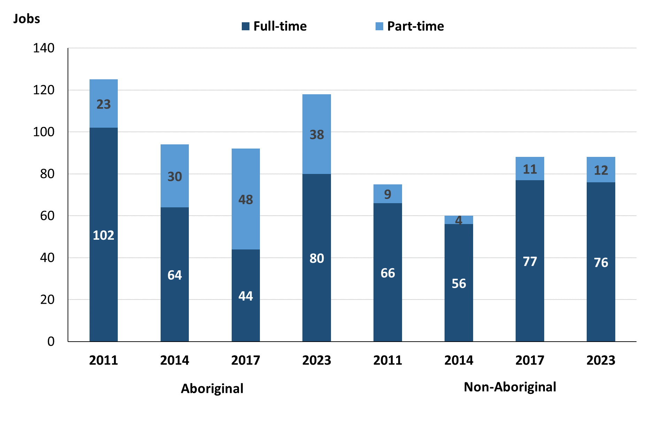

Source: Northern Territory Department of Industry, Tourism and Trade

In 2023 in Angurugu:

* of the 206 **filled jobs**:
* 80 were **full-time** jobs filled by **Aboriginal** people, an increase of 36 jobs from 2017 and an increase of 16 jobs from 2014
* 38 were **part-time** jobs filled by **Aboriginal** people, a decrease of 10 jobs from 2017 and an increase of 8 jobs from 2014
* 76 were **full-time** jobs filled by **non-Aboriginal** people, a decrease of 1 job from 2017 and an increase of 20 jobs from 2014
* 12 were **part-time** jobs filled by **non-Aboriginal** people, an increase of 1 job from 2017 and an increase of 8 jobs from 2014.

# Jobs by Sector: Private and Public

Table 3a: Count of filled jobs by business sector, 2011, 2014, 2017 & 2023 (a)(b)(c)

|  |  |  |  |  |  |  |  |  |  |  |  |  |
| --- | --- | --- | --- | --- | --- | --- | --- | --- | --- | --- | --- | --- |
| **Indicator** | **2011** | | | **2014** | | | **2017** | | | **2023** | | |
| **Aboriginal** | **Non-Aboriginal** | **Total** | **Aboriginal** | **Non-Aboriginal** | **Total** | **Aboriginal** | **Non-Aboriginal** | **Total** | **Aboriginal** | **Non-Aboriginal** | **Total** |
| **Public Sector** | 54 | 56 | **110** | 45 | 38 | **83** | 45 | 38 | **83** | 56 | 40 | **96** |
| Australian Government | 3 | 2 | **5** | 7 | 1 | **8** | 5 | 1 | **6** | 1 | 1 | **2** |
| Territory Government | 22 | 40 | **62** | 14 | 28 | **42** | 22 | 28 | **50** | 38 | 32 | **70** |
| Local Government | 29 | 14 | **43** | 24 | 9 | **33** | 18 | 9 | **27** | 17 | 7 | **24** |
| **Private Sector** | 71 | 19 | **90** | 49 | 22 | **71** | 47 | 50 | **97** | 62 | 48 | **110** |
| **Total** | **125** | **75** | **200** | **94** | **60** | **154** | **92** | **88** | **180** | **118** | **88** | **206** |

Source: Northern Territory Department of Industry, Tourism and Trade

Table 3b: Count of filled jobs by business sector, 2011-2014, 2014-2017 & 2017-2023 (a)(b)(c)

|  |  |  |  |  |  |  |  |  |  |  |  |  |
| --- | --- | --- | --- | --- | --- | --- | --- | --- | --- | --- | --- | --- |
| **Indicator** | **Change 2011-2014** | | | | **Change 2014-2017** | | | | **Change 2017-2023** | | | |
| **Aboriginal** | **Non-Aboriginal** | **Total** | **Aboriginal** | | **Non-Aboriginal** | **Total** | **Aboriginal** | | **Non-Aboriginal** | **Total** |
| **Public Sector** | -9 | -18 | **-27** | 0 | | 0 | **0** | 11 | | 2 | **13** |
| Australian Government | 4 | -1 | **3** | -2 | | 0 | **-2** | -4 | | 0 | **-4** |
| Territory Government | -8 | -12 | **-20** | 8 | | 0 | **8** | 16 | | 4 | **20** |
| Local Government | -5 | -5 | **-10** | -6 | | 0 | **-6** | -1 | | -2 | **-3** |
| **Private Sector** | -22 | 3 | **-19** | -2 | | 28 | **26** | 15 | | -2 | **13** |
| **Total** | **-31** | **-15** | **-46** | **-2** | | **28** | **26** | **26** | | **0** | **26** |

Source: Northern Territory Department of Industry, Tourism and Trade

Chart 4: Count of filled jobs by business sector, 2011, 2014, 2017 & 2023 (a)(d)

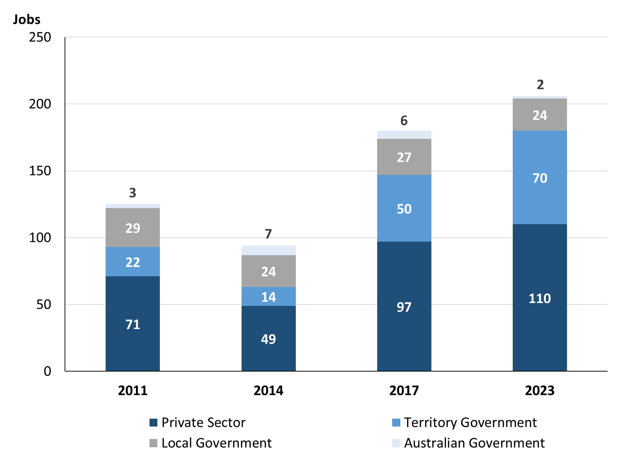

Source: Northern Territory Department of Industry, Tourism and Trade

**Chart 5: Percentage of filled jobs by business sector in 2023 (a)(d)**

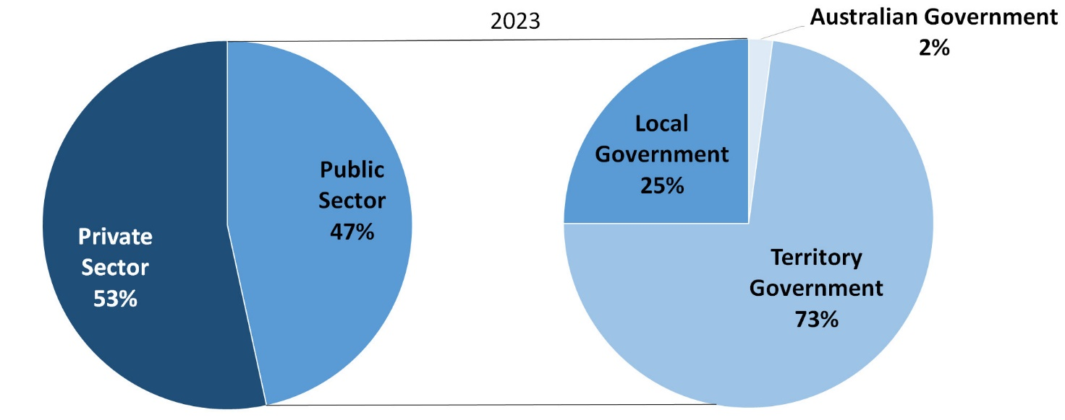

Source: Northern Territory Department of Industry, Tourism and Trade

In 2023 in Angurugu:

* there were 96 jobs in the **public sector**, an increase of 13 jobs from 2017 and an increase of 13 jobs from 2014
* of the 96 jobs in the **public sector**:
* 2 jobs were in the Australian Government, a decrease of 4 jobs from 2017 and a decrease of 6 jobs from 2014
* 70 jobs were in the Territory Government, an increase of 20 jobs from 2017 and an increase of 28 jobs from 2014
* 24 jobs were in the Local Government, a decrease of 3 jobs from 2017 and a decrease of 9 jobs from 2014
* there were 110 jobs in the **private sector**, an increase of 13 jobs from 2017 and an increase of 39 jobs from 2014.

Chart 6: Count of filled jobs by sector, 2011, 2014, 2017 & 2023 (a)(c)(d)

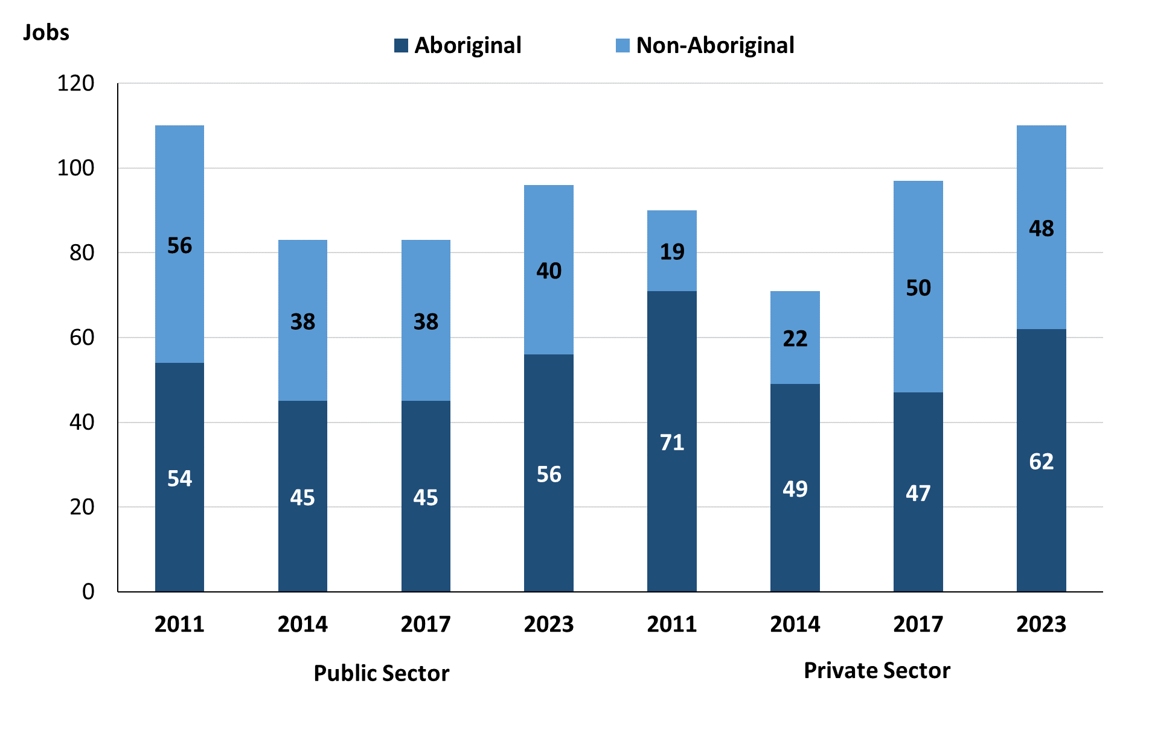

Source: Northern Territory Department of Industry, Tourism and Trade

In 2023 in Angurugu:

* of the 96 jobs in the **public sector**:
* 56 jobs were filled by **Aboriginal** people, an increase of 11 jobs from 2017 and an increase of 11 jobs from 2014
* 40 jobs were filled by **non-Aboriginal** people, an increase of 2 jobs from 2017 and an increase of 2 jobs from 2014
* of the 110 jobs in the **private sector**:
* 62 jobs were filled by **Aboriginal** people, an increase of 15 jobs from 2017 and an increase of 13 jobs from 2014
* 48 jobs were filled by **non-Aboriginal** people, a decrease of 2 jobs from 2017 and an increase of 26 jobs from 2014.

Chart 7: Count of filled jobs by sector and full-time/part-time status, 2011, 2014, 2017 & 2023 (a)(b)(d)

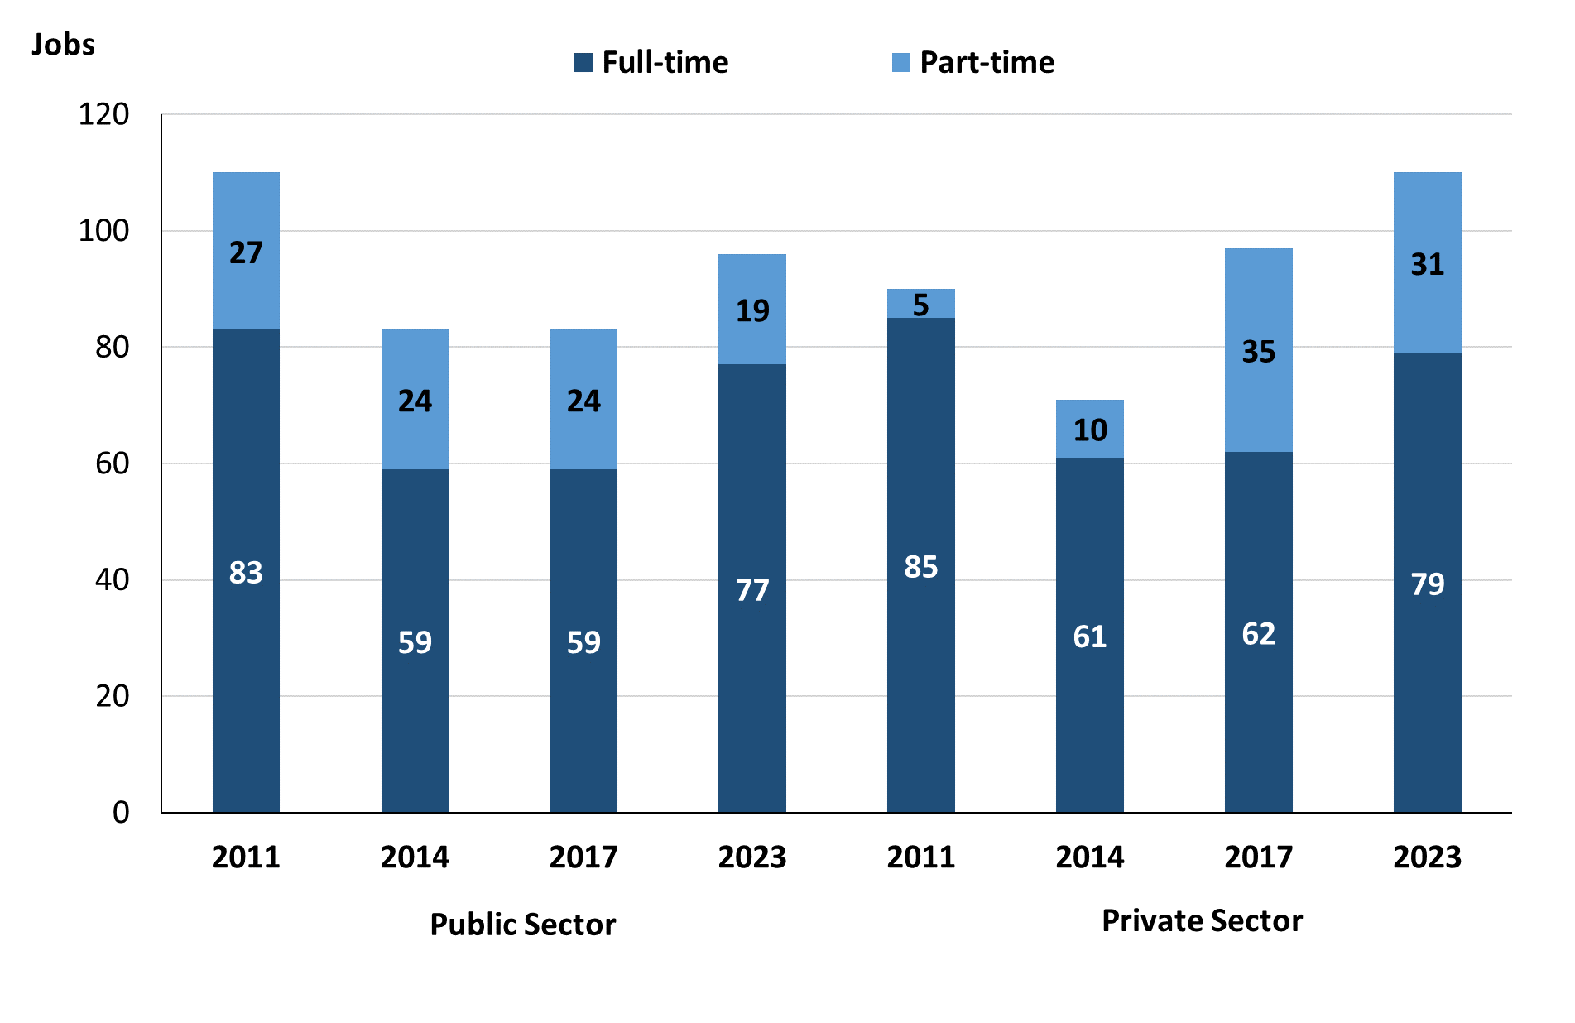

Source: Northern Territory Department of Industry, Tourism and Trade

In 2023 in Angurugu:

* of the 96 jobs in the **Public Sector**:
* 77 were **full-time** jobs, an increase of 18 jobs from 2017 and an increase of 18 jobs from 2014
* 19 were **part-time** jobs, a decrease of 5 jobs from 2017 and a decrease of 5 jobs from 2014
* of the 110 jobs in the **Private Sector**:
* 79 were **full-time** jobs, an increase of 17 jobs from 2017 and an increase of 18 jobs from 2014
* 31 were **part-time** jobs, a decrease of 4 jobs from 2017 and an increase of 21 jobs from 2014.

Table 4: Count of filled jobs by full-time/part-time status by sector, 2011, 2014, 2017 & 2023 (a)(b)(c)(d)

|  |  |  |  |  |  |  |  |  |  |
| --- | --- | --- | --- | --- | --- | --- | --- | --- | --- |
| **Indicator** | **2011** | | | | | | | | |
| **Aboriginal** | | | **Non-Aboriginal** | | | **Total** | | |
| **Full-time** | **Part-time** | **Total** | **Full-time** | **Part-time** | **Total** | **Full-time** | **Part-time** | **Total** |
| Public Sector | 35 | 19 | **54** | 48 | 8 | **56** | 83 | 27 | **110** |
| Private Sector | 67 | 4 | **71** | 18 | 1 | **19** | 85 | 5 | **90** |
| **Total** | **102** | **23** | **125** | **66** | **9** | **75** | **168** | **32** | **200** |

|  |  |  |  |  |  |  |  |  |  |  |
| --- | --- | --- | --- | --- | --- | --- | --- | --- | --- | --- |
| **Indicator** | **2014** | | | | | | | | | |
| **Aboriginal** | | | **Non-Aboriginal** | | | **Total** | | | |
| **Full-time** | **Part-time** | **Total** | **Full-time** | **Part-time** | **Total** | **Full-time** | **Part-time** | **Total** |
| Public Sector | 23 | 22 | **45** | 36 | 2 | **38** | 59 | 24 | **83** |
| Private Sector | 41 | 8 | **49** | 20 | 2 | **22** | 61 | 10 | **71** |
| **Total** | **64** | **30** | **94** | **56** | **4** | **60** | **120** | **34** | **154** |

|  |  |  |  |  |  |  |  |  |  |  |
| --- | --- | --- | --- | --- | --- | --- | --- | --- | --- | --- |
| **Indicator** | **2017** | | | | | | | | | |
| **Aboriginal** | | | **Non-Aboriginal** | | | **Total** | | | |
| **Full-time** | **Part-time** | **Total** | **Full-time** | **Part-time** | **Total** | **Full-time** | **Part-time** | **Total** |
| Public Sector | 24 | 21 | **45** | 35 | 3 | **38** | 59 | 24 | **83** |
| Private Sector | 20 | 27 | **47** | 42 | 8 | **50** | 62 | 35 | **97** |
| **Total** | **64** | **30** | **92** | **77** | **11** | **88** | **121** | **59** | **180** |

|  |  |  |  |  |  |  |  |  |  |  |
| --- | --- | --- | --- | --- | --- | --- | --- | --- | --- | --- |
| **Indicator** | **2023** | | | | | | | | | |
| **Aboriginal** | | | **Non-Aboriginal** | | | **Total** | | | |
| **Full-time** | **Part-time** | **Total** | **Full-time** | **Part-time** | **Total** | **Full-time** | **Part-time** | **Total** |
| Public Sector | 41 | 15 | **56** | 36 | 4 | **40** | 77 | 19 | **96** |
| Private Sector | 39 | 23 | **62** | 40 | 8 | **48** | 79 | 31 | **110** |
| **Total** | **80** | **38** | **118** | **76** | **12** | **88** | **156** | **50** | **206** |

*Source: Northern Territory Department of Industry, Tourism and Trade*

In 2023 in Angurugu there were:

* 56 jobs in the **public sector** filled by **Aboriginal** people, an increase of 11 jobs from 2017 and an increase of 11 jobs from 2014, of which:
* 41 were **full-time** jobs, an increase of 17 jobs from 2017 and an increase of 18 jobs from 2014
* 15 were **part-time** jobs, a decrease of 6 jobs from 2017 and a decrease of 7 jobs from 2014
* 62 jobs in the **private sector** filled by **Aboriginal** people, an increase of 15 jobs from 2017 and an increase of 13 jobs from 2014, of which:
* 39 were **full-time** jobs, an increase of 19 jobs from 2017 and a decrease of 2 jobs from 2014
* 23 were **part-time** jobs, a decrease of 4 jobs from 2017 and an increase of 15 jobs from 2014
* 40 jobs in the **Public Sector** filled by **non-Aboriginal** people, an increase of 2 jobs from 2017 and an increase of 2 jobs from 2014, of which:
* 36 were **full-time** jobs, an increase of 1 job from 2017 and unchanged from 2014
* 4 were **part-time** jobs, an increase of 1 job from 2017 and an increase of 2 jobs from 2014
* 48 jobs in the **Private Sector** filled by **non-Aboriginal** people, a decrease of 2 jobs from 2017 and an increase of 26 jobs from 2014, of which:
* 40 were **full-time** jobs, a decrease of 2 jobs from 2017 and an increase of 20 jobs from 2014
* 8 were **part-time** jobs, unchanged from 2017 and an increase of 6 jobs from 2014.

# Job Status: Permanent and Temporary

Table 5a: Count of filled jobs by employment status, 2011, 2014, 2017 & 2023 (a)(c)(e)

|  |  |  |  |  |  |  |  |  |  |  |  |  |  |
| --- | --- | --- | --- | --- | --- | --- | --- | --- | --- | --- | --- | --- | --- |
| **Indicator** | **2011** | | | **2014** | | | **2017** | | | **2023** | | | |
| **Aboriginal** | **Non-Aboriginal** | **Total** | **Aboriginal** | **Non-Aboriginal** | **Total** | **Aboriginal** | **Non-Aboriginal** | **Total** | **Aboriginal** | **Non-Aboriginal** | **Total** |
| Permanent | 45 | 29 | **74** | 45 | 40 | **85** | 49 | 39 | **88** | 89 | 70 | **159** |
| Temporary | 80 | 46 | **126** | 49 | 20 | **69** | 43 | 49 | **92** | 29 | 18 | **47** |
| **Total** | **125** | **75** | **200** | **94** | **60** | **154** | **92** | **88** | **180** | **118** | **88** | **206** |

Source: Northern Territory Department of Industry, Tourism and Trade

Table 5b: Count of filled jobs by employment status, 2011-2014, 2014-2017 & 2017-2023 (a)(c)(e)

|  |  |  |  |  |  |  |  |  |  |  |  |  |
| --- | --- | --- | --- | --- | --- | --- | --- | --- | --- | --- | --- | --- |
| **Indicator** | **Change 2011-2014** | | | | **Change 2014-2017** | | | | **Change 2017-2023** | | | |
| **Aboriginal** | **Non-Aboriginal** | **Total** | **Aboriginal** | | **Non-Aboriginal** | **Total** | **Aboriginal** | | **Non-Aboriginal** | **Total** |
| Permanent | 0 | 11 | **11** | 4 | | -1 | **3** | 40 | | 31 | **71** |
| Temporary | -31 | -26 | **-57** | -6 | | 29 | **23** | -14 | | -31 | **-45** |
| **Total** | **-31** | **-15** | **-46** | **-2** | | **28** | **26** | **26** | | **0** | **26** |

Source: Northern Territory Department of Industry, Tourism and Trade

**Chart 8: Count of filled jobs by employment status, 2011, 2014, 2017 & 2023 (a)(c)(e)**

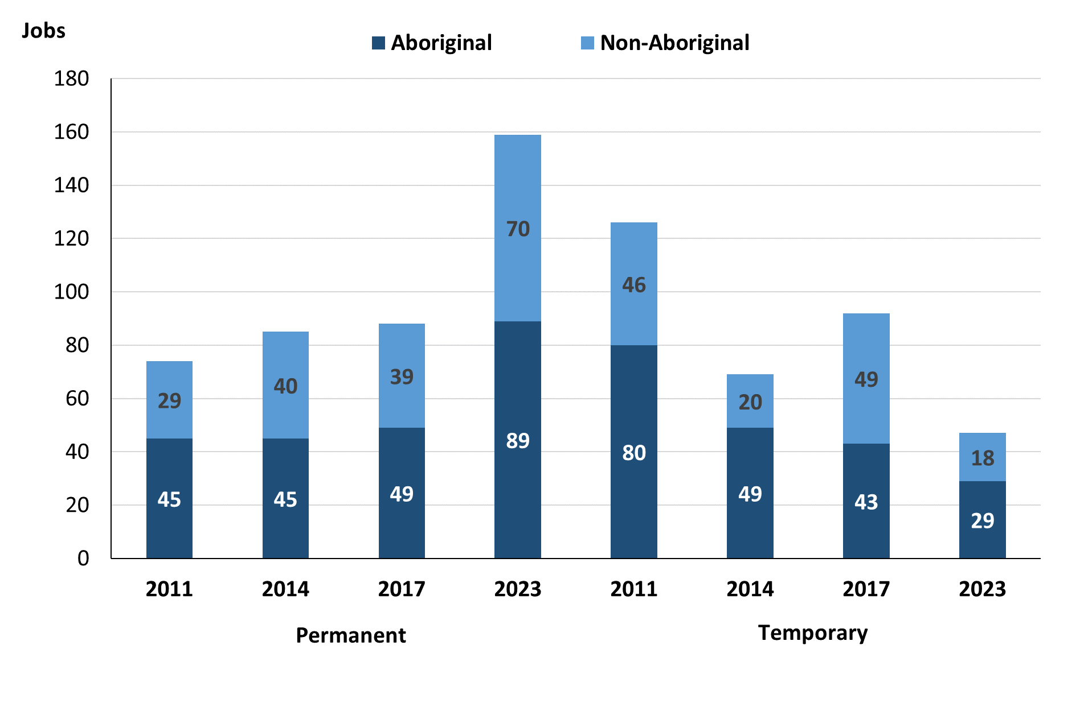

Source: Northern Territory Department of Industry, Tourism and Trade

In 2023 in Angurugu:

* there were 159 **Permanent jobs**, an increase of 71 jobs from 2017, and an increase of 74 jobs from 2014, of which:
* **Aboriginal** people filled 89 jobs, an increase of 40 jobs from 2017 and an increase of 44 jobs from 2014
* **non-Aboriginal** people filled 70 jobs, an increase of 31 jobs from 2017 and an increase of 30 jobs from 2014
* there were 47 **Temporary jobs**, a decrease of 45 jobs from 2017 and a decrease of 22 jobs from 2014, of which:
* **Aboriginal** people filled 29 jobs, a decrease of 14 jobs from 2017 and a decrease of 20 jobs from 2014
* **non-Aboriginal** people filled 18 jobs, a decrease of 31 jobs from 2017 and a decrease of 2 jobs from 2014.

Table 6: Count of filled jobs by sector and employment status, 2011, 2014, 2017 & 2023 (a)(c)(d)(e)

|  |  |  |  |  |  |  |  |  |  |  |
| --- | --- | --- | --- | --- | --- | --- | --- | --- | --- | --- |
| **Indicator** | **2011** | | | | | | | | | |
| **Aboriginal** | | | **Non-Aboriginal** | | | **Total** | | | |
| **Perm** | **Temp** | **Total** | **Perm** | **Temp** | **Total** | **Perm** | **Temp** | **Total** |
| Public Sector | 40 | 14 | **54** | 23 | 33 | **56** | 63 | 47 | **110** |
| Private Sector | 5 | 66 | **71** | 6 | 13 | **19** | 11 | 79 | **90** |
| **Total** | **45** | **80** | **125** | **29** | **46** | **75** | **74** | **126** | **200** |

|  |  |  |  |  |  |  |  |  |  |
| --- | --- | --- | --- | --- | --- | --- | --- | --- | --- |
| **Indicator** | **2014** | | | | | | | | |
| **Aboriginal** | | | **Non-Aboriginal** | | | **Total** | | |
| **Perm** | **Temp** | **Total** | **Perm** | **Temp** | **Total** | **Perm** | **Temp** | **Total** |
| Public Sector | 28 | 17 | **45** | 31 | 7 | **38** | 59 | 24 | **83** |
| Private Sector | 17 | 32 | **49** | 9 | 13 | **22** | 26 | 45 | **71** |
| **Total** | **45** | **49** | **94** | **40** | **20** | **60** | **85** | **69** | **154** |

|  |  |  |  |  |  |  |  |  |  |
| --- | --- | --- | --- | --- | --- | --- | --- | --- | --- |
| **Indicator** | **2017** | | | | | | | | |
| **Aboriginal** | | | **Non-Aboriginal** | | | **Total** | | |
| **Perm** | **Temp** | **Total** | **Perm** | **Temp** | **Total** | **Perm** | **Temp** | **Total** |
| Public Sector | 26 | 19 | **45** | 11 | 27 | **38** | 37 | 46 | **83** |
| Private Sector | 23 | 24 | **47** | 28 | 22 | **50** | 51 | 46 | **97** |
| **Total** | **49** | **43** | **92** | **39** | **49** | **88** | **88** | **92** | **180** |

|  |  |  |  |  |  |  |  |  |  |
| --- | --- | --- | --- | --- | --- | --- | --- | --- | --- |
| **Indicator** | **2023** | | | | | | | | |
| **Aboriginal** | | | **Non-Aboriginal** | | | **Total** | | |
| **Perm** | **Temp** | **Total** | **Perm** | **Temp** | **Total** | **Perm** | **Temp** | **Total** |
| Public Sector | 27 | 29 | **56** | 23 | 17 | **40** | 50 | 46 | **96** |
| Private Sector | 62 | 0 | **62** | 47 | 1 | **48** | 109 | 1 | **110** |
| **Total** | **89** | **29** | **118** | **70** | **18** | **88** | **159** | **47** | **206** |

Source: Northern Territory Department of Industry, Tourism and Trade

In 2023 in Angurugu there were:

* 96 jobs in the **public sector**, an increase of 13 jobs from 2017 and an increase of 13 jobs from 2014, of which:
* 50 jobs were **permanent**, an increase of 13 jobs from 2017 and a decrease of 9 jobs from 2014, of which:
* **Aboriginal** people filled 27 jobs, an increase of 1 job from 2017 and a decrease of 1 job from 2014
* **non-Aboriginal** people filled 23 jobs, an increase of 12 jobs from 2017 and a decrease of 8 jobs from 2014
* 46 jobs were **temporary**, unchanged from 2017 and an increase of 22 jobs from 2014, of which:
* **Aboriginal** people filled 29 jobs, an increase of 10 jobs from 2017 and an increase of 12 jobs from 2014
* **non-Aboriginal** people filled 17 jobs, a decrease of 10 jobs from 2017 and an increase of 10 jobs from 2014
* 110 jobs in the **private sector**, an increase of 13 jobs from 2017 and an increase of 39 jobs from 2014, of which:
* 109 jobs were **permanent**, an increase of 58 jobs from 2017 and an increase of 83 jobs from 2014, of which:
* **Aboriginal** people filled 62 jobs, an increase of 39 jobs from 2017 and an increase of 45 jobs from 2014
* **non-Aboriginal** people filled 47 jobs, an increase of 19 jobs from 2017 and an increase of 38 jobs from 2014
* 1 job was **temporary**, a decrease of 45 jobs from 2017 and a decrease of 44 jobs from 2014, of which:
* **Aboriginal** people held no jobs, a decrease of 24 jobs from 2017 and a decrease of 32 jobs from 2014
* a **non-Aboriginal** person held 1 job, a decrease of 21 jobs from 2017 and a decrease of 12 jobs from 2014.

# Job Vacancies

Table 7: Job vacancies, 2011, 2014, 2017 & 2023

|  |  |  |  |  |  |  |  |
| --- | --- | --- | --- | --- | --- | --- | --- |
| **Indicator** | **2011** | **2014** | **2017** | **2023** | **Change 2011-2014** | **Change 2014-2017** | **Change 2017-2023** |
| **Job vacancies** | **19** | **32** | **15** | **29** | **13** | **-17** | **14** |

Source: Northern Territory Department of Industry, Tourism and Trade

Table 8a: Job vacancies by occupation, 2011, 2014, 2017 & 2023 (f)(g)

|  |  |  |  |  |
| --- | --- | --- | --- | --- |
| **Occupation (ANZSCO major group)** | **2011** | **2014** | **2017** | **2023** |
| Clerical and Administrative Workers | 0 | 3 | 4 | 8 |
| Community and Personal Service Workers | 11 | 8 | 2 | 13 |
| Labourers | 3 | 0 | 1 | 1 |
| Machinery Operators and Drivers | 0 | 0 | 1 | 0 |
| Managers | 1 | 3 | 2 | 0 |
| Professionals | 4 | 13 | 4 | 5 |
| Sales Workers | 0 | 5 | 1 | 0 |
| Technicians and Trades Workers | 0 | 0 | 0 | 2 |
| **Total** | **19** | **32** | **15** | **29** |

Source: Northern Territory Department of Industry, Tourism and Trade

Table 8b: Job vacancies by occupation, 2011-2014, 2014-2017 & 2017-2023 (f)(g)

|  |  |  |  |
| --- | --- | --- | --- |
| **Occupation (ANZSCO major group)** | **Change 2011-2014** | **Change 2014-2017** | **Change 2017-2023** |
| Clerical and Administrative Workers | 3 | 1 | 4 |
| Community and Personal Service Workers | -3 | -6 | 11 |
| Labourers | -3 | 1 | 0 |
| Machinery Operators and Drivers | 0 | 1 | -1 |
| Managers | 2 | -1 | -2 |
| Professionals | 9 | -9 | 1 |
| Sales Workers | 5 | -4 | -1 |
| Technicians and Trades Workers | 0 | 0 | 2 |
| **Total** | **13** | **-17** | **14** |

Source: Northern Territory Department of Industry, Tourism and Trade

Table 9: Job vacancies by job title, 2023 profile (f)

|  |  |
| --- | --- |
| **Job Vacancy** | **No.** |
| Assistant Principal | 1 |
| Classroom Teacher | 3 |
| Community Worker | 2 |
| Engineering, ICT and Science Technician | 2 |
| General Clerk | 4 |
| Handyperson | 1 |
| Health and Welfare Support Worker | 6 |
| Interpreter | 1 |
| Liaison Officer | 5 |
| Program or Project Administrator | 4 |
| **Total** | **29** |

Source: Northern Territory Department of Industry, Tourism and Trade

In 2023 in Angurugu:

* there were 29 **vacancies** reported, an increase of 14 vacancies from 2017 and a decrease of 3 vacancies from 2014
* Of the 29 reported **vacancies**, the largest requirements were for:
* Community and Personal Service Workers had 13 vacancies, the majority of which were in the following jobs:
* Health and Welfare Support Worker
* Liaison Officer
* Clerical and Administrative Workers had 8 vacancies in the following jobs:
* General Clerk
* Program or Project Administrator
* Professionals had 5 vacancies in the following jobs:
* Assistant Principal
* Classroom Teacher
* Interpreter.

# Jobs by Industry

Table 10: Count of filled jobs by industry of business, 2011, 2014, 2017, 2023 and change in count of filled jobs by industry 2011-2014, 2014-2017 & 2017-2023 (a)(h)

|  |  |  |  |  |  |  |  |  |  |  |  |
| --- | --- | --- | --- | --- | --- | --- | --- | --- | --- | --- | --- |
| **Industry (ANZSIC Division)** | **2011** | | **2014** | | **2017** | | **2023** | | **Change 2011-2014** | **Change 2014-2017** | **Change 2017-2023** |
| **Total** | **% of Total** | **Total** | **% of Total** | **Total** | **% of Total** | **Total** | **% of Total** | **Total** | **Total** | **Total** |
| Administrative and Support Services | 0 | 0.0% | 0 | 0.0% | 8 | 4.4% | 48 | 23.3% | 0 | 8 | 40 |
| Agriculture, Forestry and Fishing | 0 | 0.0% | 31 | 20.1% | 0 | 0.0% | 0 | 0.0% | 31 | -31 | 0 |
| Arts and Recreation Services | 2 | 1.0% | 15 | 9.7% | 0 | 0.0% | 25 | 12.1% | 13 | -15 | 25 |
| Construction | 80 | 40.0% | 0 | 0.0% | 39 | 21.7% | 0 | 0.0% | -80 | 39 | -39 |
| Education and Training | 53 | 26.5% | 33 | 21.4% | 45 | 25.0% | 46 | 22.3% | -20 | 12 | 1 |
| Health Care and Social Assistance | 12 | 6.0% | 18 | 11.7% | 21 | 11.7% | 21 | 10.2% | 6 | 3 | 0 |
| Public Administration and Safety | 48 | 24.0% | 41 | 26.6% | 38 | 21.1% | 56 | 27.2% | -7 | -3 | 18 |
| Retail Trade | 3 | 1.5% | 15 | 9.7% | 28 | 15.6% | 10 | 4.9% | 12 | 13 | -18 |
| **Total** | **200** | **100.0%** | **154** | **100.0%** | **180** | **100.0%** | **206** | **100.0%** | **-46** | **26** | **26** |

Source: Northern Territory Department of Industry, Tourism and Trade

In 2023 in Angurugu:

* Public Administration and Safety was the **largest industry employer**, with 56 filled jobs or 27.2% of filled jobs, an increase of 18 jobs from 2017 and an increase of 15 jobs from 2014
* **other significant** industry employers were:
* Administrative and Support Services with 48 jobs (or 23.3% of filled jobs), an increase of 40 jobs from 2017 and an increase of 48 jobs from 2014
* Education and Training with 46 jobs (or 22.3% of filled jobs), an increase of 1 job from 2017 and an increase of 13 jobs from 2014
* Arts and Recreation Services with 25 jobs (or 12.1% of filled jobs), an increase of 25 jobs from 2017 and an increase of 10 jobs from 2014.

Table 11a: Count of filled jobs by industry of business, 2011, 2014, 2017 & 2023 (a)(c)(h)

|  |  |  |  |  |  |  |  |  |  |  |  |  |  |
| --- | --- | --- | --- | --- | --- | --- | --- | --- | --- | --- | --- | --- | --- |
| **Industry (ANZSIC division)** | **2011** | | | **2014** | | | **2017** | | | | **2023** | | |
| **Aboriginal** | **Non-Aboriginal** | **Total** | **Aboriginal** | **Non-Aboriginal** | **Total** | **Aboriginal** | **Non-Aboriginal** | **Total** | **Aboriginal** | | **Non-Aboriginal** | **Total** |
| Administrative and Support Services | 0 | 0 | **0** | 0 | 0 | **0** | 3 | 5 | **8** | 24 | | 24 | **48** |
| Agriculture, Forestry and Fishing | 0 | 0 | **0** | 30 | 1 | **31** | 0 | 0 | **0** | 0 | | 0 | **0** |
| Arts and Recreation Services | 0 | 2 | **2** | 6 | 9 | **15** | 0 | 0 | **0** | 16 | | 9 | **25** |
| Construction | 65 | 15 | **80** | 0 | 0 | **0** | 12 | 27 | **39** | 0 | | 0 | **0** |
| Education and Training | 21 | 32 | **53** | 11 | 22 | **33** | 25 | 20 | **45** | 30 | | 16 | **46** |
| Electricity, Gas, Water and Waste Services | 0 | 1 | **1** | 0 | 1 | **1** | 0 | 1 | **1** | 0 | | 0 | **0** |
| Health Care and Social Assistance | 4 | 8 | **12** | 8 | 10 | **18** | 10 | 11 | **21** | 8 | | 13 | **21** |
| Public Administration and Safety | 32 | 16 | **48** | 31 | 10 | **41** | 27 | 11 | **38** | 33 | | 23 | **56** |
| Retail Trade | 2 | 1 | **3** | 8 | 7 | **15** | 15 | 13 | **28** | 7 | | 3 | **10** |
| **Total** | **125** | **75** | **200** | **94** | **60** | **154** | **92** | **88** | **180** | **118** | | **88** | **206** |

Source: Northern Territory Department of Industry, Tourism and Trade

Table 11b: Count of filled jobs by industry of business, 2011-2014, 2014-2017 & 2017-2023 (a)(c)(h)

|  |  |  |  |  |  |  |  |  |  |  |  |
| --- | --- | --- | --- | --- | --- | --- | --- | --- | --- | --- | --- |
| **Industry (ANZSIC division)** | **Change 2011-2014** | | | | **Change  2014-2017** | | | | **Change  2017-2023** | | |
| **Aboriginal** | **Non-Aboriginal** | **Total** | **Aboriginal** | | **Non-Aboriginal** | **Total** | **Aboriginal** | | **Non-Aboriginal** | **Total** |
| Administrative and Support Services | 0 | 0 | **0** | 3 | | 5 | **8** | 21 | | 19 | **40** |
| Agriculture, Forestry and Fishing | 30 | 1 | **31** | -30 | | -1 | **-31** | 0 | | 0 | **0** |
| Arts and Recreation Services | 6 | 7 | **13** | -6 | | -9 | **-15** | 16 | | 9 | **25** |
| Construction | -65 | -15 | **-80** | 12 | | 27 | **39** | -12 | | -27 | **-39** |
| Education and Training | -10 | -10 | **-20** | 14 | | -2 | **12** | 5 | | -4 | **1** |
| Electricity, Gas, Water and Waste Services | 0 | 0 | **0** | 0 | | 0 | **0** | 0 | | -1 | **-1** |
| Health Care and Social Assistance | 4 | 2 | **6** | 2 | | 1 | **3** | -2 | | 2 | **0** |
| Public Administration and Safety | -1 | -6 | **-7** | -4 | | 1 | **-3** | 6 | | 12 | **18** |
| Retail Trade | 6 | 6 | **12** | 7 | | 6 | **13** | -8 | | -10 | **-18** |
| **Total** | **-31** | **-15** | **-46** | **-2** | | **28** | **26** | **26** | | **0** | **26** |

Source: Northern Territory Department of Industry, Tourism and Trade

Chart 9: Count of filled jobs by top 5 industries, 2023 (a)(c)(h)

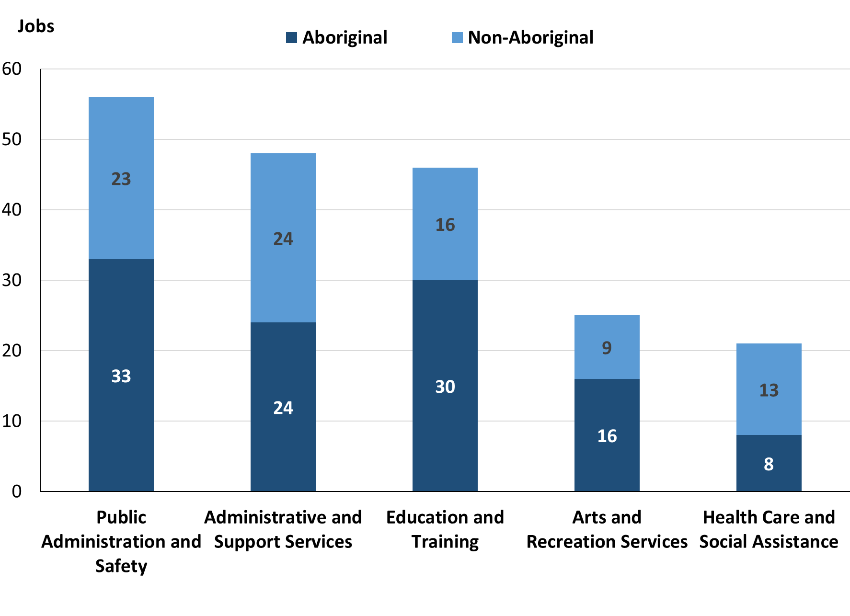

Source: Northern Territory Department of Industry, Tourism and Trade

In 2023 in Angurugu of the:

* 118 jobs filled by **Aboriginal** people, there were:
* Public Administration and Safety had 33 jobs, an increase of 6 jobs from 2017 and an increase of 2 jobs from 2014
* Education and Training had 30 jobs, an increase of 5 jobs from 2017 and an increase of 19 jobs from 2014
* Administrative and Support Services had 24 jobs, an increase of 21 jobs from 2017 and an increase of 24 jobs from 2014
* 88 jobs filled by **non-Aboriginal** people, there were:
* Administrative and Support Services had 24 jobs, an increase of 19 jobs from 2017 and an increase of 24 jobs from 2014
* Public Administration and Safety had 23 jobs, an increase of 12 jobs from 2017 and an increase of 13 jobs from 2014
* Education and Training had 16 jobs, a decrease of 4 jobs from 2017 and a decrease of 6 jobs from 2014.

Table 12: Count of filled jobs by industry and employment status, 2011 (a)(c)(e)(h)

|  |  |  |  |  |  |  |  |  |  |
| --- | --- | --- | --- | --- | --- | --- | --- | --- | --- |
| **Industry (ANZSIC division)** | **2011** | | | | | | | | |
| **Aboriginal** | | | **Non-Aboriginal** | | | **Total** | | |
| **Perm** | **Temp** | **Total** | **Perm** | **Temp** | **Total** | **Perm** | **Temp** | **Total** |
| Arts and Recreation Services | 0 | 0 | **0** | 2 | 0 | **2** | 2 | 0 | **2** |
| Construction | 1 | 64 | **65** | 2 | 13 | **15** | 3 | 77 | **80** |
| Education and Training | 14 | 7 | **21** | 13 | 19 | **32** | 27 | 26 | **53** |
| Electricity, Gas, Water and Waste Services | 0 | 0 | **0** | 1 | 0 | **1** | 1 | 0 | **1** |
| Health Care and Social Assistance | 2 | 2 | **4** | 0 | 8 | **8** | 2 | 10 | **12** |
| Public Administration and Safety | 27 | 5 | **32** | 10 | 6 | **16** | 37 | 11 | **48** |
| Retail Trade | 0 | 2 | **2** | 1 | 0 | **1** | 1 | 2 | **3** |
| **Total** | **45** | **80** | **125** | **29** | **46** | **75** | **74** | **126** | **200** |

Source: Northern Territory Department of Industry, Tourism and Trade

Table 13: Count of filled jobs by industry and employment status, 2014 (a)(c)(e)(h)

|  |  |  |  |  |  |  |  |  |  |
| --- | --- | --- | --- | --- | --- | --- | --- | --- | --- |
| **Industry (ANZSIC division)** | **2014** | | | | | | | | |
| **Aboriginal** | | | **Non-Aboriginal** | | | **Total** | | |
| **Perm** | **Temp** | **Total** | **Perm** | **Temp** | **Total** | **Perm** | **Temp** | **Total** |
| Agriculture, Forestry and Fishing | 6 | 24 | **30** | 1 | 0 | **1** | 7 | 24 | **31** |
| Arts and Recreation Services | 3 | 3 | **6** | 3 | 6 | **9** | 6 | 9 | **15** |
| Education and Training | 4 | 7 | **11** | 14 | 8 | **22** | 18 | 15 | **33** |
| Electricity, Gas, Water and Waste Services | 0 | 0 | **0** | 0 | 1 | **1** | 0 | 1 | **1** |
| Health Care and Social Assistance | 8 | 0 | **8** | 9 | 1 | **10** | 17 | 1 | **18** |
| Public Administration and Safety | 16 | 15 | **31** | 8 | 2 | **10** | 24 | 17 | **41** |
| Retail Trade | 8 | 0 | **8** | 5 | 2 | **7** | 13 | 2 | **15** |
| **Total** | **45** | **49** | **94** | **40** | **20** | **60** | **85** | **69** | **154** |

Source: Northern Territory Department of Industry, Tourism and Trade

Table 14: Count of filled jobs by industry and employment status, 2017 (a)(c)(e)(h)

|  |  |  |  |  |  |  |  |  |  |  |
| --- | --- | --- | --- | --- | --- | --- | --- | --- | --- | --- |
| **Industry (ANZSIC division)** | **2017** | | | | | | | | | |
| **Aboriginal** | | | **Non-Aboriginal** | | | **Total** | | | |
| **Perm** | **Temp** | **Total** | **Perm** | **Temp** | **Total** | **Perm** | **Temp** | **Total** |
| Administrative and Support Services | 0 | 3 | **3** | 0 | 5 | **5** | 0 | 8 | **8** |
| Construction | 7 | 5 | **12** | 15 | 12 | **27** | 22 | 17 | **39** |
| Education and Training | 7 | 18 | **25** | 8 | 12 | **20** | 15 | 30 | **45** |
| Electricity, Gas, Water and Waste Services | 0 | 0 | **0** | 1 | 0 | **1** | 1 | 0 | **1** |
| Health Care and Social Assistance | 3 | 7 | **10** | 1 | 10 | **11** | 4 | 17 | **21** |
| Public Administration and Safety | 17 | 10 | **27** | 2 | 9 | **11** | 19 | 19 | **38** |
| Retail Trade | 15 | 0 | **15** | 12 | 1 | **13** | 27 | 1 | **28** |
| **Total** | **49** | **43** | **92** | **39** | **49** | **88** | **88** | **92** | **180** |

Source: Northern Territory Department of Industry, Tourism and Trade

Table 15: Count of filled jobs by industry and employment status, 2023 (a)(c)(e)(h)

|  |  |  |  |  |  |  |  |  |  |  |
| --- | --- | --- | --- | --- | --- | --- | --- | --- | --- | --- |
| **Industry (ANZSIC division)** | **2023** | | | | | | | | | |
| **Aboriginal** | | | **Non-Aboriginal** | | | **Total** | | | |
| **Perm** | **Temp** | **Total** | **Perm** | **Temp** | **Total** | **Perm** | **Temp** | **Total** |
| Administrative and Support Services | 24 | 0 | **24** | 24 | 0 | **24** | 48 | 0 | **48** |
| Arts and recreation services | 16 | 0 | **16** | 9 | 0 | **9** | 25 | 0 | **25** |
| Education and Training | 5 | 25 | **30** | 7 | 9 | **16** | 12 | 34 | **46** |
| Electricity, Gas, Water and Waste Services | 0 | 0 | **0** | 0 | 0 | **0** | 0 | 0 | **0** |
| Health Care and Social Assistance | 5 | 3 | **8** | 7 | 6 | **13** | 12 | 9 | **21** |
| Public Administration and Safety | 32 | 1 | **33** | 20 | 3 | **23** | 52 | 4 | **56** |
| Retail Trade | 7 | 0 | **7** | 3 | 0 | **3** | 10 | 0 | **10** |
| **Total** | **89** | **29** | **118** | **70** | **18** | **88** | **159** | **47** | **206** |

Source: Northern Territory Department of Industry, Tourism and Trade

In 2023 in Angurugu:

* of the 159 **Permanent jobs**, there were:
* Public Administration and Safety had 52 jobs, an increase of 33 jobs from 2017 and an increase of 28 jobs from 2014, including:
* **Aboriginal** people filled 32 jobs, an increase of 15 jobs from 2017 and an increase of 16 jobs from 2014
* **non-Aboriginal** people filled 20 jobs, an increase of 18 jobs from 2017 and an increase of 12 jobs from 2014
* Administrative and Support Services had 48 jobs, an increase of 48 jobs from 2017 and an increase of 48 jobs from 2014, including:
* **Aboriginal** people filled 24 jobs, an increase of 24 jobs from 2017 and an increase of 24 jobs from 2014
* **non-Aboriginal** people filled 24 jobs, an increase of 24 jobs from 2017 and an increase of 24 jobs from 2014
* Arts and recreation services had 25 jobs, an increase of 25 jobs from 2017 and an increase of 19 jobs from 2014, including:
* **Aboriginal** people filled 16 jobs, an increase of 16 jobs from 2017 and an increase of 13 jobs from 2014
* **non-Aboriginal** people filled 9 jobs, an increase of 9 jobs from 2017 and an increase of 6 jobs from 2014
* of the 47 **Temporary jobs**, there were:
* Education and Training had 34 jobs, an increase of 4 jobs from 2017 and an increase of 19 jobs from 2014, including:
* **Aboriginal** people filled 25 jobs, an increase of 7 jobs from 2017 and an increase of 18 jobs from 2014
* **non-Aboriginal** people filled 9 jobs, a decrease of 3 jobs from 2017 and an increase of 1 job from 2014
* Health Care and Social Assistance had 9 jobs, a decrease of 8 jobs from 2017 and an increase of 8 jobs from 2014, including:
* **Aboriginal** people filled 3 jobs, a decrease of 4 jobs from 2017 and an increase of 3 jobs from 2014
* **non-Aboriginal** people filled 6 jobs, a decrease of 4 jobs from 2017 and an increase of 5 jobs from 2014
* Public Administration and Safety had 4 jobs, a decrease of 15 jobs from 2017 and a decrease of 13 jobs from 2014, including
* an **Aboriginal** person filled 1 job, a decrease of 9 jobs from 2017 and a decrease of 14 jobs from 2014
* **non-Aboriginal** people filled 3 jobs, a decrease of 6 jobs from 2017 and an increase of 1 job from 2014.

# Jobs by Occupation

Table 16a: Count of filled jobs by occupation, 2011, 2014, 2017 & 2023 (a)(f)(g)

|  |  |  |  |  |  |  |  |  |  |
| --- | --- | --- | --- | --- | --- | --- | --- | --- | --- |
| **Occupation (ANZSCO major group)** | **2011** | | **2014** | | **2017** | | **2023** | | |
| **Total** | **% of Total** | **Total** | **% of Total** | **Total** | **% of Total** | **Total** | **% of Total** |
| Clerical and Administrative Workers | 21 | 10.5% | 19 | 12.3% | 27 | 15.0% | 32 | 15.5% |
| Community and Personal Service Workers | 53 | 26.5% | 40 | 26.0% | 40 | 22.2% | 54 | 26.2% |
| Labourers | 19 | 9.5% | 16 | 10.4% | 29 | 16.1% | 22 | 10.7% |
| Machinery Operators and Drivers | 0 | 0.0% | 3 | 1.9% | 6 | 3.3% | 0 | 0.0% |
| Managers | 16 | 8.0% | 8 | 5.2% | 19 | 10.6% | 12 | 5.8% |
| Professionals | 34 | 17.0% | 36 | 23.4% | 36 | 20.0% | 63 | 30.6% |
| Sales Workers | 1 | 0.5% | 5 | 3.2% | 8 | 4.4% | 8 | 3.9% |
| Technicians and Trades Workers | 55 | 27.5% | 27 | 17.5% | 15 | 8.3% | 15 | 7.3% |
| Other Occupations | 1 | 0.5% | 0 | 0.0% | 0 | 0.0% | 0 | 0.0% |
| **Total** | **200** | **100.0%** | **154** | **100.0%** | **180** | **100.0%** | **206** | **100.0%** |

Source: Northern Territory Department of Industry, Tourism and Trade

Table 16b: Count of filled jobs by occupation, 2011-2014, 2014-2017 & 2017-2023 (a)(f)(g)

|  |  |  |  |
| --- | --- | --- | --- |
| **Occupation (ANZSCO major group)** | **Change 2011-2014** | **Change 2014-2017** | **Change 2017-2023** |
| **Total** | **Total** | **Total** |
| Clerical and Administrative Workers | -2 | 8 | 5 |
| Community and Personal Service Workers | -13 | 0 | 14 |
| Labourers | -3 | 13 | -7 |
| Machinery Operators and Drivers | 3 | 3 | -6 |
| Managers | -8 | 11 | -7 |
| Professionals | 2 | 0 | 27 |
| Sales Workers | 4 | 3 | 0 |
| Technicians and Trades Workers | -28 | -12 | 0 |
| Other Occupations | -1 | 0 | 0 |
| **Total** | **-46** | **26** | **26** |

Source: Northern Territory Department of Industry, Tourism and Trade

Chart 10: Percentage and count of top 6 filled jobs by occupation, 2011, 2014, 2017 & 2023 (a)(f)(g)

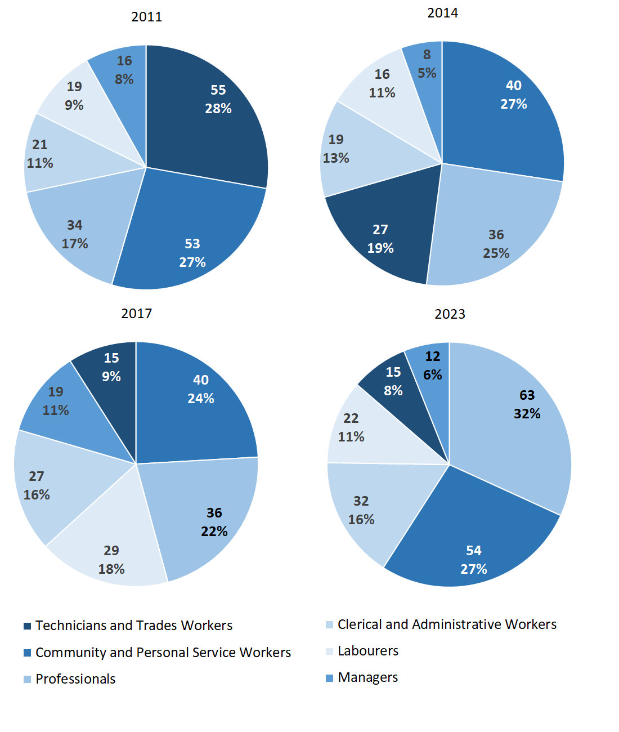

Source: Northern Territory Department of Industry, Tourism and Trade

In 2023 in Angurugu:

* Professionals was the **largest occupation classification** in terms of filled jobs, accounting for 63 jobs (30.6% of total filled jobs), an increase of 27 jobs from 2017 and from 2014
* **other significant** occupation classifications were:
* Community and Personal Service Workers accounting for 54 jobs or 26.2% of total jobs an increase of 14 jobs from 2017 and an increase of 14 jobs from 2014
* Clerical and Administrative Workers accounting for 32 jobs or 15.5% of total jobs an increase of 5 jobs from 2017 and an increase of 13 jobs from 2014
* Labourers accounting for 22 jobs or 10.7% of total jobs a decrease of 7 jobs from 2017 and an increase of 6 jobs from 2014.

**Table 17a: Count of filled jobs by ANZSCO occupation, 2011, 2014, 2017 & 2023 (a)(c)(f)(g)**

|  |  |  |  |  |  |  |  |  |  |  |  |  |  |
| --- | --- | --- | --- | --- | --- | --- | --- | --- | --- | --- | --- | --- | --- |
| **Occupation (ANZSCO major group)** | **2011** | | | **2014** | | | **2017** | | | **2023** | | | |
| **Aboriginal** | **Non-Aboriginal** | **Total** | **Aboriginal** | **Non-Aboriginal** | **Total** | **Aboriginal** | **Non-Aboriginal** | **Total** | **Aboriginal** | **Non-Aboriginal** | **Total** |
| Clerical and Administrative Workers | 9 | 12 | **21** | 7 | 12 | **19** | 12 | 15 | **27** | 19 | 13 | **32** |
| Community and Personal Service Workers | 38 | 15 | **53** | 28 | 12 | **40** | 33 | 7 | **40** | 44 | 10 | **54** |
| Labourers | 17 | 2 | **19** | 10 | 6 | **16** | 19 | 10 | **29** | 13 | 9 | **22** |
| Machinery Operators and Drivers | 0 | 0 | **0** | 2 | 1 | **3** | 3 | 3 | **6** | 0 | 0 | **0** |
| Managers | 5 | 11 | **16** | 2 | 6 | **8** | 1 | 18 | **19** | 2 | 10 | **12** |
| Professionals | 8 | 26 | **34** | 13 | 23 | **36** | 17 | 19 | **36** | 20 | 43 | **63** |
| Sales Workers | 1 | 0 | **1** | 5 | 0 | **5** | 6 | 2 | **8** | 7 | 1 | **8** |
| Technicians and Trades Workers | 47 | 8 | **55** | 27 | 0 | **27** | 1 | 14 | **15** | 13 | 2 | **15** |
| Other Occupations | 0 | 1 | **1** | 0 | 0 | **0** | 0 | 0 | **0** | 0 | 0 | **0** |
| **Total** | **125** | **75** | **200** | **94** | **60** | **154** | **92** | **88** | **180** | **118** | **88** | **206** |

Source: Northern Territory Department of Industry, Tourism and Trade

**Table 17b: Count of filled jobs by ANZSCO occupation, 2011-2014, 2014-2017 & 2017-2023 (a)(c)(f)(g)**

|  |  |  |  |  |  |  |  |  |  |
| --- | --- | --- | --- | --- | --- | --- | --- | --- | --- |
| **Occupation (ANZSCO major group)** | **Change 2011-2014** | | | **Change 2014-2017** | | | **Change 2017-2023** | | |
| **Aboriginal** | **Non-Aboriginal** | **Total** | **Aboriginal** | **Non-Aboriginal** | **Total** | **Aboriginal** | **Non-Aboriginal** | **Total** |
| Clerical and Administrative Workers | -2 | 0 | **-2** | 5 | 3 | **8** | 7 | -2 | **5** |
| Community and Personal Service Workers | -10 | -3 | **-13** | 5 | -5 | **0** | 11 | 3 | **14** |
| Labourers | -7 | 4 | **-3** | 9 | 4 | **13** | -6 | -1 | **-7** |
| Machinery Operators and Drivers | 2 | 1 | **3** | 1 | 2 | **3** | -3 | -3 | **-6** |
| Managers | -3 | -5 | **-8** | -1 | 12 | **11** | 1 | -8 | **-7** |
| Professionals | 5 | -3 | **2** | 4 | -4 | **0** | 3 | 24 | **27** |
| Sales Workers | 4 | 0 | **4** | 1 | 2 | **3** | 1 | -1 | **0** |
| Technicians and Trades Workers | -20 | -8 | **-28** | -26 | 14 | **-12** | 12 | -12 | **0** |
| Other Occupations | 0 | -1 | **-1** | 0 | 0 | **0** | 0 | 0 | **0** |
| **Total** | **-31** | **-15** | **-46** | **-2** | **28** | **26** | **26** | **0** | **26** |

Source: Northern Territory Department of Industry, Tourism and Trade

In 2023 in Angurugu of the:

* 118 **jobs filled by** **Aboriginal** people, there were:
* Community and Personal Service Workers had 44 jobs filled, an increase of 11 jobs from 2017 and an increase of 16 jobs from 2014
* Professionals had 2 jobs filled, an increase of 3 jobs from 2017 and an increase of 7 jobs from 2014
* Clerical and Administrative Workers had 19 jobs filled, an increase of 7 jobs from 2017 and an increase of 12 jobs from 2014
* 88 **jobs filled by non-Aboriginal** people, there were:
* Professionals had 43 jobs filled, an increase of 24 jobs from 2017 and an increase of 20 jobs from 2014
* Clerical and Administrative Workers had 13 jobs filled, a decrease of 2 jobs from 2017 and an increase of 1 job from 2014
* Managers had 10 jobs filled, a decrease of 8 jobs from 2017 and an increase of 4 jobs from 2014.

# Jobs by Industry by Occupation

Table 18: Count of filled jobs by industry by occupation, 2011 (a)(f)(g)(h)

|  |  |  |  |  |  |  |  |  |  |  |  |
| --- | --- | --- | --- | --- | --- | --- | --- | --- | --- | --- | --- |
| **2011** | | | | | | | | | | | |
| **Industry (ANZSIC Division)** |  | **Occupation (ANZSCO major group)** | | | | | | | | | |
| **Clerical and Administrative Workers** | **Community and Personal Service Workers** | **Labourers** | **Machinery Operators and Drivers** | **Managers** | **Professionals** | **Sales Workers** | **Technicians and Trades Workers** | **Other occupations** | **Total** |
| Arts and Recreation Services | 0 | 0 | 0 | 0 | 2 | 0 | 0 | 0 | 0 | **2** |
| Construction | 10 | 0 | 10 | 0 | 10 | 0 | 0 | 50 | 0 | **80** |
| Education and Training | 4 | 25 | 1 | 0 | 1 | 22 | 0 | 0 | 0 | **53** |
| Electricity, Gas, Water and Waste Services | 0 | 0 | 0 | 0 | 0 | 0 | 0 | 1 | 0 | **1** |
| Health Care and Social Assistance | 0 | 3 | 1 | 0 | 0 | 7 | 0 | 0 | 1 | **12** |
| Public Administration and Safety | 6 | 24 | 7 | 0 | 3 | 5 | 1 | 2 | 0 | **48** |
| Retail Trade | 0 | 1 | 0 | 0 | 0 | 0 | 0 | 2 | 0 | **3** |
| **Total** | **21** | **53** | **19** | **0** | **16** | **34** | **1** | **55** | **1** | **200** |

Source: Northern Territory Department of Industry, Tourism and Trade

Table 19: Count of filled jobs by industry by occupation, 2014 (a)(f)(g)(h)

|  |  |  |  |  |  |  |  |  |  |  |  |
| --- | --- | --- | --- | --- | --- | --- | --- | --- | --- | --- | --- |
| **2014** | | | | | | | | | | | |
| **Industry (ANZSIC Division)** |  | **Occupation (ANZSCO major group)** | | | | | | | | | |
| **Clerical and Administrative Workers** | **Community and Personal Service Workers** | **Labourers** | **Machinery Operators and Drivers** | **Managers** | **Professionals** | **Sales Workers** | **Technicians and Trades Workers** | **Other occupations** | **Total** |
| Agriculture, Forestry and Fishing | 2 | 0 | 2 | 0 | 0 | 0 | 0 | 27 | 0 | **31** |
| Arts and Recreation Services | 4 | 1 | 0 | 0 | 4 | 6 | 0 | 0 | 0 | **15** |
| Education and Training | 3 | 13 | 1 | 0 | 0 | 16 | 0 | 0 | 0 | **33** |
| Electricity, Gas, Water and Waste Services | 0 | 0 | 1 | 0 | 0 | 0 | 0 | 0 | 0 | **1** |
| Health Care and Social Assistance | 2 | 6 | 2 | 0 | 1 | 7 | 0 | 0 | 0 | **18** |
| Public Administration and Safety | 8 | 20 | 5 | 0 | 1 | 7 | 0 | 0 | 0 | **41** |
| Retail Trade | 0 | 0 | 5 | 3 | 2 | 0 | 5 | 0 | 0 | **15** |
| **Total** | **19** | **40** | **16** | **3** | **8** | **36** | **5** | **27** | **0** | **154** |

Source: Northern Territory Department of Industry, Tourism and Trade

Table 20: Count of filled jobs by occupation and by industry, 2017 (a)(f)(g)(h)

|  |  |  |  |  |  |  |  |  |  |  |
| --- | --- | --- | --- | --- | --- | --- | --- | --- | --- | --- |
| **2017** | | | | | | | | | | |
| **Industry (ANZSIC Division)** |  | **Occupation (ANZSCO major group)** | | | | | | | | |
| **Clerical and Administrative Workers** | **Community and Personal Service Workers** | **Labourers** | **Machinery Operators and Drivers** | **Managers** | **Professionals** | **Sales Workers** | **Technicians and Trades Workers** | **Other occupations** | **Total** |
| Administrative and Support Services | 1 | 0 | 1 | 1 | 4 | 1 | 0 | 0 | 0 | **8** |
| Construction | 4 | 4 | 11 | 2 | 3 | 2 | 0 | 13 | 0 | **39** |
| Education and Training | 6 | 16 | 1 | 0 | 5 | 17 | 0 | 0 | 0 | **45** |
| Electricity, Gas, Water and Waste Services | 0 | 0 | 0 | 0 | 0 | 0 | 0 | 1 | 0 | **1** |
| Health Care and Social Assistance | 4 | 6 | 4 | 0 | 1 | 6 | 0 | 0 | 0 | **21** |
| Public Administration and Safety | 10 | 14 | 1 | 0 | 2 | 10 | 0 | 1 | 0 | **38** |
| Retail Trade | 2 | 0 | 11 | 3 | 4 | 0 | 8 | 0 | 0 | **28** |
| **Total** | **27** | **40** | **29** | **6** | **19** | **36** | **8** | **15** | **0** | **180** |

Source: Northern Territory Department of Industry, Tourism and Trade

Table 21: Count of filled jobs by occupation and by industry, 2023 (a)(f)(g)(h)

|  |  |  |  |  |  |  |  |  |  |  |
| --- | --- | --- | --- | --- | --- | --- | --- | --- | --- | --- |
| **2023** | | | | | | | | | | |
| **Industry (ANZSIC Division)** |  | **Occupation (ANZSCO major group)** | | | | | | | | |
| **Clerical and Administrative Workers** | **Community and Personal Service Workers** | **Labourers** | **Machinery Operators and Drivers** | **Managers** | **Professionals** | **Sales Workers** | **Technicians and Trades Workers** | **Other occupations** | **Total** |
| Administrative and Support Services | 2 | 18 | 11 | 0 | 0 | 11 | 0 | 6 | 0 | **48** |
| Arts and Recreation Services | 11 | 8 | 0 | 0 | 1 | 5 | 0 | 0 | 0 | **25** |
| Education and Training | 9 | 3 | 11 | 0 | 0 | 23 | 0 | 0 | 0 | **46** |
| Health Care and Social Assistance | 3 | 6 | 0 | 0 | 0 | 12 | 0 | 0 | 0 | **21** |
| Public Administration and Safety | 7 | 19 | 0 | 0 | 9 | 12 | 0 | 9 | 0 | **56** |
| Retail Trade | 0 | 0 | 0 | 0 | 2 | 0 | 8 | 0 | 0 | **10** |
| **Total** | **32** | **54** | **22** | **0** | **12** | **63** | **8** | **15** | **0** | **206** |

Source: Northern Territory Department of Industry, Tourism and Trade

In 2023 in Angurugu:

* Professionals held the majority of 63 jobs (the largest occupation group)
  + Education and Training had a total of 23 jobs,
  + Health Care and Social Assistance had a total 12 jobs,
  + Public Administration and Safety had a total of 12 jobs
  + Administrative and Support Services industries had a total of 11 jobs.
* Community and Personal Service Workers had the majority of jobs (the 2nd largest occupation group) were shared across the
  + Public Administration and Safety with 19 jobs
  + Administrative and Support Services industries with 18 jobs.
* in Public Administration and Safety (the largest industry), there were 19 filled jobs for Community and Personal Service Workers, an increase of 5 jobs from 2017
* in Administrative and Support Services (the second largest industry), there were 18 filled jobs for Community and Personal Service Workers, an increase of 18 jobs from 2017
* Arts and Recreation Services industry showed an increase of 25 filled jobs between 2023 and 2017
* Construction industry showed a decrease of 39 filled jobs between 2023 and 2017.

# Jobs by Gender

Table 22a: Count of filled jobs by gender[2], 2011, 2014, 2017 & 2023 (a)(c)(i)

|  |  |  |  |  |  |  |  |  |  |  |  |  |
| --- | --- | --- | --- | --- | --- | --- | --- | --- | --- | --- | --- | --- |
| **Indicator** | **2011** | | | **2014** | | | **2017** | | | **2023** | | |
| **Aboriginal** | **Non-Aboriginal** | **Total** | **Aboriginal** | **Non-Aboriginal** | **Total** | **Aboriginal** | **Non-Aboriginal** | **Total** | **Aboriginal** | **Non-Aboriginal** | **Total** |
| Male | 74 | 27 | **101** | 42 | 19 | **61** | 31 | 48 | **79** | 40 | 23 | **63** |
| Female | 51 | 48 | **99** | 52 | 41 | **93** | 57 | 40 | **97** | 78 | 65 | **143** |
| **Total** | **125** | **75** | **200** | **94** | **60** | **154** | **88** | **88** | **176** | **118** | **88** | **206** |

Source: Northern Territory Department of Industry, Tourism and Trade

Table 22b: Count of filled jobs by gender[3], 2011-2014, 2014-2017 & 2017-2023 (a)(c)(i)

|  |  |  |  |  |  |  |  |  |  |  |
| --- | --- | --- | --- | --- | --- | --- | --- | --- | --- | --- |
| **Indicator** | **2011-2014**  **Change** | | | **2014-2017 Change** | | | **2017-2023 Change** | | | |
| **Aboriginal** | **Non-Aboriginal** | **Total** | **Aboriginal** | **Non-Aboriginal** | **Total** | **Aboriginal** | **Non-Aboriginal** | **Total** |
| Male | -32 | -8 | **-40** | -11 | 29 | **18** | 9 | -25 | **-16** |
| Female | 1 | -7 | **-6** | 5 | -1 | **4** | 21 | 25 | **46** |
| **Total** | **-31** | **-15** | **-46** | **-6** | **28** | **22** | **30** | **0** | **30** |

Source: Northern Territory Department of Industry, Tourism and Trade

**Chart 11: Count of filled jobs by gender, 2011, 2014, 2017 & 2023 (a)(c)(i)**

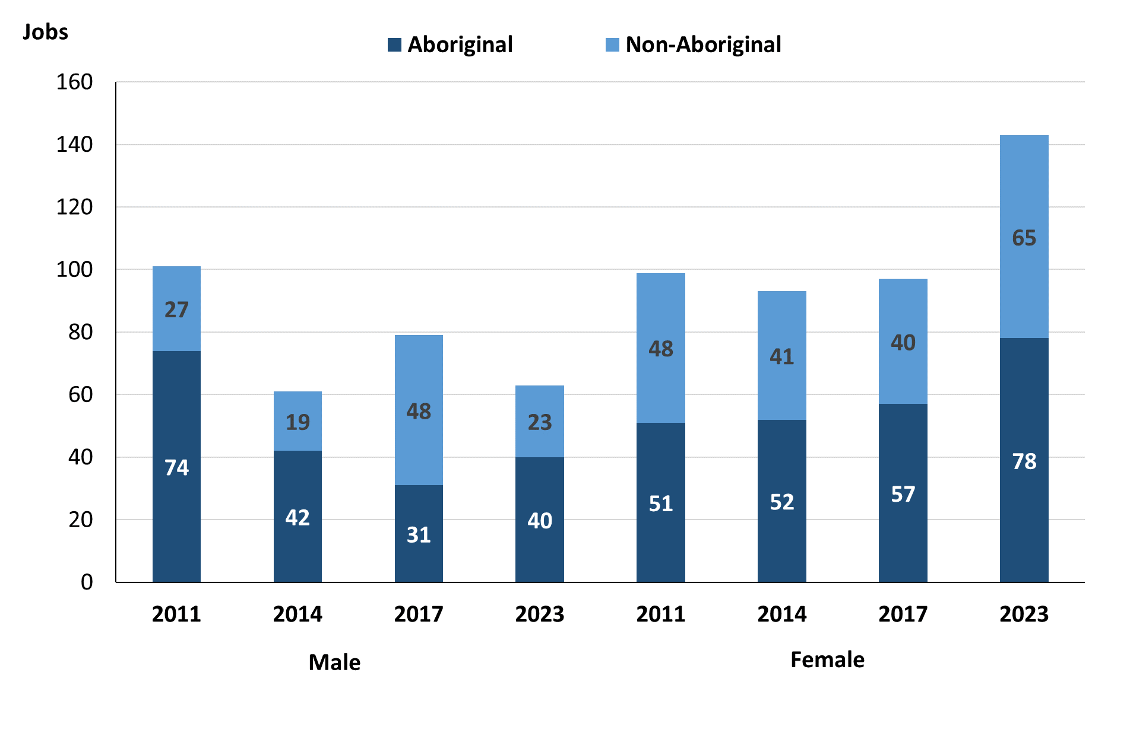

Source: Northern Territory Department of Industry, Tourism and Trade

In 2023 in Angurugu:

* there were 63 **jobs filled by males**, a decrease of 16 jobs from 2017 and an increase of 2 jobs from 2014
* of the 63 jobs **filled by males**:
* **Aboriginal** workers filled 40 jobs, an increase of 9 jobs from 2017 and a decrease of 2 jobs from 2014
* **non-Aboriginal** workers filled 23 jobs, a decrease of 25 jobs from 2017 and an increase of 4 jobs from 2014
* there were 143 **jobs filled by females**, an increase of 46 jobs from 2017 and an increase of 50 jobs from 2014
* of the 143 jobs **filled by females**:
* **Aboriginal** females filled 78 jobs, an increase of 21 jobs from 2017 and an increase of 26 jobs from 2014
* **non-Aboriginal** females filled 65 jobs, an increase of 25 jobs from 2017 and an increase of 24 jobs from 2014.

**Table 23: Count of filled jobs by gender, by full-time/part-time status, by job permanency and by sector 2011 (a)(b)(c)(d)(e)(i)**

|  |  |  |  |  |  |  |  |  |  |
| --- | --- | --- | --- | --- | --- | --- | --- | --- | --- |
| **2011** | | | | | | | | | |
| **Indicator** | **Male** | | | **Female** | | | **Total** | | |
| **Aboriginal** | **Non-Aboriginal** | **Total** | **Aboriginal** | **Non-Aboriginal** | **Total** | **Aboriginal** | **Non-Aboriginal** | **Total** |
| Full-time | 70 | 27 | **97** | 32 | 39 | **71** | 102 | 66 | **168** |
| Part-time | 4 | 0 | **4** | 19 | 9 | **28** | 23 | 9 | **32** |
| **Total** | **74** | **27** | **101** | **51** | **48** | **99** | **125** | **75** | **200** |
| Permanent | 15 | 9 | **24** | 30 | 20 | **50** | 45 | 29 | **74** |
| Temporary | 59 | 18 | **77** | 21 | 28 | **49** | 80 | 46 | **126** |
| **Total** | **74** | **27** | **101** | **51** | **48** | **99** | **125** | **75** | **200** |
| Public Sector | 17 | 11 | **28** | 37 | 45 | **82** | 54 | 56 | **110** |
| Private Sector | 57 | 16 | **73** | 14 | 3 | **17** | 71 | 19 | **90** |
| **Total** | **74** | **27** | **101** | **51** | **48** | **99** | **125** | **75** | **200** |

Source: Northern Territory Department of Industry, Tourism and Trade

Table 24: Count of filled jobs by gender, by full-time/part-time status, by job permanency and by sector 2014 (a)(b)(c)(d)(e)(i)

|  |  |  |  |  |  |  |  |  |  |
| --- | --- | --- | --- | --- | --- | --- | --- | --- | --- |
| **2014** | | | | | | | | | |
| **Indicator** | **Male** | | | **Female** | | | **Total** | | |
| **Aboriginal** | **Non-Aboriginal** | **Total** | **Aboriginal** | **Non-Aboriginal** | **Total** | **Aboriginal** | **Non-Aboriginal** | **Total** |
| Full-time | 37 | 19 | **56** | 27 | 37 | **64** | 64 | 56 | **120** |
| Part-time | 5 | 0 | **5** | 25 | 4 | **29** | 30 | 4 | **34** |
| **Total** | **42** | **19** | **61** | **52** | **41** | **93** | **94** | **60** | **154** |
| Permanent | 19 | 11 | **30** | 26 | 29 | **55** | 45 | 40 | **85** |
| Temporary | 23 | 8 | **31** | 26 | 12 | **38** | 49 | 20 | **69** |
| **Total** | **42** | **19** | **61** | **52** | **41** | **93** | **94** | **60** | **154** |
| Public Sector | 19 | 11 | **30** | 26 | 27 | **53** | 45 | 38 | **83** |
| Private Sector | 23 | 8 | **31** | 26 | 14 | **40** | 49 | 22 | **71** |
| **Total** | **42** | **19** | **61** | **52** | **41** | **93** | **94** | **60** | **154** |

Source: Northern Territory Department of Industry, Tourism and Trade

Table 25: Count of filled jobs by gender[4], by full-time/part-time status, by job permanency and by sector 2017 (a)(b)(c)(d)(e)(i)

|  |  |  |  |  |  |  |  |  |  |
| --- | --- | --- | --- | --- | --- | --- | --- | --- | --- |
| **2017** | | | | | | | | | |
| **Indicator** | **Male** | | | **Female** | | | **Total** | | |
| **Aboriginal** | **Non-Aboriginal** | **Total** | **Aboriginal** | **Non-Aboriginal** | **Total** | **Aboriginal** | **Non-Aboriginal** | **Total** |
| Full-time | 17 | 45 | **62** | 24 | 32 | **56** | 44 | 77 | **121** |
| Part-time | 14 | 3 | **17** | 33 | 8 | **41** | 48 | 11 | **59** |
| **Total** | **31** | **48** | **79** | **57** | **40** | **97** | **92** | **88** | **180** |
| Permanent | 13 | 26 | **39** | 32 | 13 | **45** | 49 | 39 | **88** |
| Temporary | 18 | 22 | **40** | 25 | 27 | **52** | 43 | 49 | **92** |
| **Total** | **31** | **48** | **79** | **57** | **40** | **97** | **92** | **88** | **180** |
| Public Sector | 10 | 14 | **24** | 31 | 24 | **55** | 45 | 38 | **83** |
| Private Sector | 21 | 34 | **55** | 26 | 16 | **42** | 47 | 50 | **97** |
| **Total** | **31** | **48** | **79** | **57** | **40** | **97** | **92** | **88** | **180** |

Source: Northern Territory Department of Industry, Tourism and Trade

Table 26: Count of filled jobs by gender[5], by full-time/part-time status, by job permanency and by sector 2023 (a)(b)(c)(d)(e)(i)

|  |  |  |  |  |  |  |  |  |  |  |
| --- | --- | --- | --- | --- | --- | --- | --- | --- | --- | --- |
| **2023** | | | | | | | | | | |
| **Indicator** | **Male** | | | **Female** | | | **Total** | | | |
| **Aboriginal** | **Non-Aboriginal** | **Total** | **Aboriginal** | **Non-Aboriginal** | **Total** | **Aboriginal** | **Non-Aboriginal** | **Total** |
| Full-time | 31 | 23 | **54** | 49 | 53 | **102** | 80 | 76 | **156** |
| Part-time | 9 | 0 | **9** | 29 | 12 | **41** | 38 | 12 | **50** |
| **Total** | **40** | **23** | **63** | **78** | **65** | **143** | **118** | **88** | **206** |
| Permanent | 38 | 18 | **56** | 51 | 52 | **103** | 89 | 70 | **159** |
| Temporary | 2 | 5 | **7** | 27 | 13 | **40** | 29 | 18 | **47** |
| **Total** | **40** | **23** | **63** | **78** | **65** | **143** | **118** | **88** | **206** |
| Public Sector | 28 | 10 | **38** | 34 | 38 | **72** | 62 | 48 | **110** |
| Private Sector | 12 | 13 | **25** | 44 | 27 | **71** | 56 | 40 | **96** |
| **Total** | **40** | **23** | **63** | **78** | **65** | **143** | **118** | **88** | **206** |

Source: Northern Territory Department of Industry, Tourism and Trade

In 2023 in Angurugu:

* of the 63 **jobs filled by males**, there were:
* 40 jobs filled by **Aboriginal males**, an increase of 9 jobs from 2017 and a decrease of 2 jobs from 2014, including:
* 31 full-time jobs, an increase of 14 jobs from 2017 and a decrease of 6 jobs from 2014
* 9 part-time jobs, a decrease of 5 jobs from 2017 and an increase of 4 jobs from 2014
* 38 permanent jobs, an increase of 25 jobs from 2017 and an increase of 19 jobs from 2014
* 2 temporary jobs, a decrease of 16 jobs from 2017 and a decrease of 21 jobs from 2014
* 28 public sector jobs, an increase of 18 jobs from 2017 and an increase of 9 jobs from 2014
* 12 private sector jobs, a decrease of 9 jobs from 2017 and a decrease of 11 jobs from 2014
* 23 jobs filled by **non-Aboriginal males**, a decrease of 25 jobs from 2017 and an increase of 4 jobs from 2014, including:
* 23 full-time jobs, a decrease of 22 jobs from 2017 and an increase of 4 jobs from 2014
* 0 part-time jobs, a decrease of 3 jobs from 2017and unchanged from 2014
* 18 permanent jobs, a decrease of 8 jobs from 2017 and an increase of 7 jobs from 2014
* 5 temporary jobs, a decrease of 17 jobs from 2017 and a decrease of 3 jobs from 2014
* 10 public sector jobs, a decrease of 4 jobs from 2017 and a decrease of 1 job from 2014
* 13 private sector jobs, a decrease of 21 jobs from 2017 and an increase of 5 jobs from 2014
* of the 143 **jobs filled by females**, there were:
* 78 jobs filled by **Aboriginal females**, an increase of 21 jobs from 2017 and an increase of 26 jobs from 2014, including:
* 49 full-time jobs, an increase of 25 jobs from 2017 and an increase of 22 jobs from 2014
* 29 part-time jobs, a decrease of 4 jobs from 2017 and an increase of 4 jobs from 2014
* 51 permanent jobs, an increase of 19 jobs from 2017 and an increase of 25 jobs from 2014
* 27 temporary jobs, an increase of 2 jobs from 2017 and an increase of 1 from 2014
* 34 public sector jobs, an increase of 3 jobs from 2017 and an increase of 8 jobs from 2014
* 44 private sector jobs, an increase of 18 jobs from 2017 and an increase of 18 jobs from 2014
* 65 jobs filled by **non-Aboriginal females**, an increase of 25 jobs from 2017 and an increase of 24 jobs from 2014, including:
* 53 full-time jobs, an increase of 21 jobs from 2017 and an increase of 16 jobs from 2014
* 12 part-time jobs, an increase of 4 jobs from 2017 and an increase of 8 job from 2014
* 52 permanent jobs, an increase of 39 jobs from 2017 and an increase of 23 jobs from 2014
* 13 temporary jobs, a decrease of 14 jobs from 2017 and an increase of 1 job from 2014
* 38 public sector jobs, an increase of 14 jobs from 2017 and an increase of 11 jobs from 2014
* 27 private sector jobs, an increase of 11 jobs from 2017 and an increase of 13 jobs from 2014.

# Jobs by Age

Table 27a: Count of filled jobs by age, 2011, 2014, 2017 & 2023 (a)(c)(j)

|  |  |  |  |  |  |  |  |  |  |  |  |  |
| --- | --- | --- | --- | --- | --- | --- | --- | --- | --- | --- | --- | --- |
| **Indicator** | **2011** | | | **2014** | | | **2017** | | | **2023** | | |
| **Aboriginal** | **Non-Aboriginal** | **Total** | **Aboriginal** | **Non-Aboriginal** | **Total** | **Aboriginal** | **Non-Aboriginal** | **Total** | **Aboriginal** | **Non-Aboriginal** | **Total** |
| 15-24 years | 2 | 1 | **3** | 1 | 1 | **2** | 4 | 5 | **9** | 20 | 4 | **24** |
| 25-44 years | 62 | 31 | **93** | 71 | 37 | **108** | 54 | 40 | **94** | 52 | 41 | **93** |
| 45+ years | 61 | 43 | **104** | 22 | 22 | **44** | 30 | 43 | **73** | 36 | 32 | **68** |
| **Total** | **125** | **75** | **200** | **94** | **60** | **154** | **92** | **88** | **180** | **118** | **88** | **206** |

Source: Northern Territory Department of Industry, Tourism and Trade

Table 27b: Count of filled jobs by age, 2011-2014, 2014-2017 & 2017-2023 (a)(c)(j)

|  |  |  |  |  |  |  |  |  |  |
| --- | --- | --- | --- | --- | --- | --- | --- | --- | --- |
| **Indicator** | **Change 2011-2014** | | | **Change 2014-2017** | | | **Change 2017-2023** | | |
| **Aboriginal** | **Non-Aboriginal** | **Total** | **Aboriginal** | **Non-Aboriginal** | **Total** | **Aboriginal** | **Non-Aboriginal** | **Total** |
| 15-24 years | -1 | 0 | **-1** | 3 | 4 | **7** | 16 | -1 | **15** |
| 25-44 years | 9 | 6 | **15** | -17 | 3 | **-14** | -2 | 1 | **-1** |
| 45+ years | -39 | -21 | **-60** | 8 | 21 | **29** | 6 | -11 | **-5** |
| **Total** | **-31** | **-15** | **-46** | **-2** | **28** | **26** | **30** | **0** | **30** |

Source: Northern Territory Department of Industry, Tourism and Trade

Chart 12: Count of filled jobs by age, 2011, 2014, 2017 & 2023 (a)(c)(j)

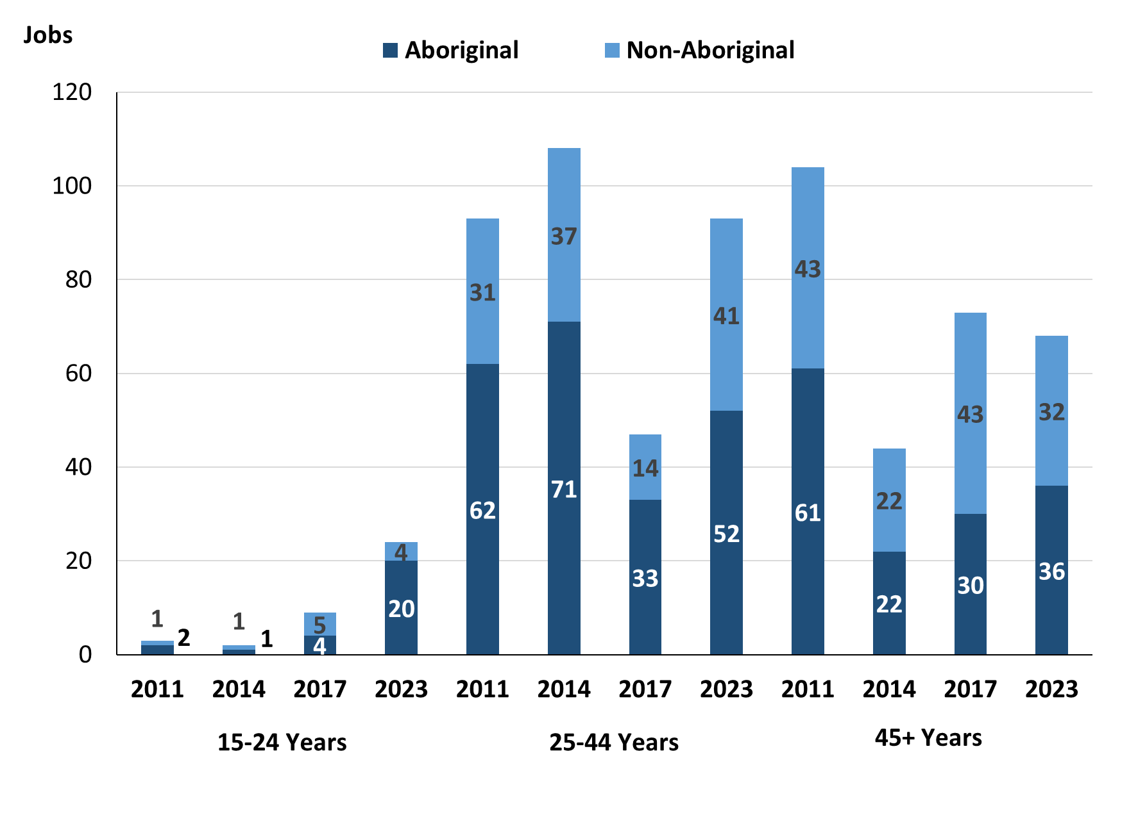

Source: Northern Territory Department of Industry, Tourism and Trade

In 2023 in Angurugu there were:

* 24 **jobs filled** by people aged **15-24 years**, an increase of 15 jobs from 2017 and an increase of 22 jobs from 2014. Of these:
* **Aboriginal** people filled 20 jobs, an increase of 16 jobs from 2017 and an increase of 19 jobs from 2014
* **non-Aboriginal** people filled 4 jobs, a decrease of 1 job from 2017 and an increase of 3 jobs from 2014
* 93 **jobs filled** by people aged **25-44 years**, a decrease of 1 job from 2017 and a decrease of 15 jobs from 2014. Of these:
* **Aboriginal** people filled 52 jobs, a decrease of 2 jobs from 2017 and a decrease of 19 jobs from 2014
* **non-Aboriginal** people filled 41 jobs, an increase of 1 job from 2017 and an increase of 4 jobs from 2014
* 68 **jobs filled** by people aged **45+ years**, a decrease of 5 jobs from 2017 and an increase of 24 jobs from 2014. Of these:
* **Aboriginal** people filled 36 jobs, an increase of 6 jobs from 2017 and an increase of 14 jobs from 2014
* **non-Aboriginal** people filled 32 jobs, a decrease of 11 jobs from 2017 and an increase of 10 jobs from 2014.

Table 28: Count of filled jobs by age, by full-time/part-time status, by job permanency and by sector June-July 2011 (a)(b)(c)(d)(e)(i)

|  |  |  |  |  |  |  |  |  |  |  |  |  |  |
| --- | --- | --- | --- | --- | --- | --- | --- | --- | --- | --- | --- | --- | --- |
| **2011** | | | | | | | | | | | | | |
| **Indicator** | **15-24 years** | | | **25-44 years** | | | **45+ years** | | | **Total** | | | |
| **Aboriginal** | **Non-Aboriginal** | **Total** | **Aboriginal** | **Non-Aboriginal** | **Total** | **Aboriginal** | **Non-Aboriginal** | **Total** | **Aboriginal** | **Non-Aboriginal** | **Total** |
| Full-time | 0 | 0 | **0** | 52 | 27 | **79** | 50 | 39 | **89** | 102 | 66 | **168** |
| Part-time | 2 | 1 | **3** | 10 | 4 | **14** | 11 | 4 | **15** | 23 | 9 | **32** |
| **Total** | **2** | **1** | **3** | **62** | **31** | **93** | **61** | **43** | **104** | **125** | **75** | **200** |
| Permanent | 1 | 0 | **1** | 25 | 10 | **35** | 19 | 19 | **38** | 45 | 29 | **74** |
| Temporary | 1 | 1 | **2** | 37 | 21 | **58** | 42 | 24 | **66** | 80 | 46 | **126** |
| **Total** | **2** | **1** | **3** | **62** | **31** | **93** | **61** | **43** | **104** | **125** | **75** | **200** |
| Public Sector | 2 | 1 | **3** | 32 | 31 | **63** | 20 | 24 | **44** | 54 | 56 | **110** |
| Private Sector | 0 | 0 | **0** | 30 | 0 | **30** | 41 | 19 | **60** | 71 | 19 | **90** |
| **Total** | **2** | **1** | **3** | **62** | **31** | **93** | **61** | **43** | **104** | **125** | **75** | **200** |

Source: Northern Territory Department of Industry, Tourism and Trade

Table 29: Count of filled jobs by age, by full-time/part-time status, by job permanency and by sector June-July 2014 (a)(b)(c)(d)(e)(i)

|  |  |  |  |  |  |  |  |  |  |  |  |  |  |
| --- | --- | --- | --- | --- | --- | --- | --- | --- | --- | --- | --- | --- | --- |
| **2014** | | | | | | | | | | | | | |
| **Indicator** | **15-24 years** | | | **25-44 years** | | | **45+ years** | | | **Total** | | | |
| **Aboriginal** | **Non-Aboriginal** | **Total** | **Aboriginal** | **Non-Aboriginal** | **Total** | **Aboriginal** | **Non-Aboriginal** | **Total** | **Aboriginal** | **Non-Aboriginal** | **Total** |
| Full-time | 1 | 1 | **2** | 48 | 34 | **82** | 15 | 21 | **36** | 64 | 56 | **120** |
| Part-time | 0 | 0 | **0** | 23 | 3 | **26** | 7 | 1 | **8** | 30 | 4 | **34** |
| **Total** | **1** | **1** | **2** | **71** | **37** | **108** | **22** | **22** | **44** | **94** | **60** | **154** |
| Permanent | 1 | 1 | **2** | 30 | 22 | **52** | 14 | 17 | **31** | 45 | 40 | **85** |
| Temporary | 0 | 0 | **0** | 41 | 15 | **56** | 8 | 5 | **13** | 49 | 20 | **69** |
| **Total** | **1** | **1** | **2** | **71** | **37** | **108** | **22** | **22** | **44** | **94** | **60** | **154** |
| Public Sector | 0 | 0 | **0** | 29 | 17 | **46** | 16 | 21 | **37** | 45 | 38 | **83** |
| Private Sector | 1 | 1 | **2** | 42 | 20 | **62** | 6 | 1 | **7** | 49 | 22 | **71** |
| **Total** | **1** | **1** | **2** | **71** | **37** | **108** | **22** | **22** | **44** | **94** | **60** | **154** |

Source: Northern Territory Department of Industry, Tourism and Trade

Table 30: Count of filled jobs by age, by full-time/part-time status, by job permanency and by sector June-July 2017 (a)(b)(c)(d)(e)(i)

|  |  |  |  |  |  |  |  |  |  |  |  |  |  |
| --- | --- | --- | --- | --- | --- | --- | --- | --- | --- | --- | --- | --- | --- |
| **2017** | | | | | | | | | | | | | |
| **Indicator** | **15-24 years** | | | **25-44 years** | | | **45+ years** | | | **Total** | | | |
| **Aboriginal** | **Non-Aboriginal** | **Total** | **Aboriginal** | **Non-Aboriginal** | **Total** | **Aboriginal** | **Non-Aboriginal** | **Total** | **Aboriginal** | **Non-Aboriginal** | **Total** |
| Full-time | 3 | 5 | **8** | 26 | 34 | **60** | 12 | 38 | **50** | 44 | 77 | **121** |
| Part-time | 1 | 0 | **1** | 28 | 6 | **34** | 18 | 5 | **23** | 48 | 11 | **59** |
| **Total** | **4** | **5** | **9** | **54** | **40** | **94** | **30** | **43** | **73** | **92** | **88** | **180** |
| Permanent | 0 | 3 | **3** | 30 | 20 | **50** | 15 | 16 | **31** | 49 | 39 | **88** |
| Temporary | 4 | 2 | **6** | 24 | 20 | **44** | 15 | 27 | **42** | 43 | 49 | **92** |
| **Total** | **4** | **5** | **9** | **54** | **40** | **94** | **30** | **43** | **73** | **92** | **88** | **180** |
| Public Sector | 1 | 1 | **2** | 21 | 12 | **33** | 19 | 25 | **44** | 45 | 38 | **83** |
| Private Sector | 3 | 4 | **7** | 33 | 28 | **61** | 11 | 18 | **29** | 47 | 50 | **97** |
| **Total** | **4** | **5** | **9** | **54** | **40** | **94** | **30** | **43** | **73** | **92** | **88** | **180** |

Source: Northern Territory Department of Industry, Tourism and Trade

Table 31: Count of filled jobs by age, by full-time/part-time status, by job permanency and by sector September 2023 (a)(b)(c)(d)(e)(i)

| **2023** | | | | | | | | | | | | |
| --- | --- | --- | --- | --- | --- | --- | --- | --- | --- | --- | --- | --- |
| **Indicator** | **15-24 years** | | | **25-44 years** | | | **45+ years** | | | **Total** | | |
| **Aboriginal** | **Non-Aboriginal** | **Total** | **Aboriginal** | **Non-Aboriginal** | **Total** | **Aboriginal** | **Non-Aboriginal** | **Total** | **Aboriginal** | **Non-Aboriginal** | **Total** |
| Full-time | 12 | 4 | **16** | 39 | 34 | **73** | 19 | 27 | **46** | 80 | 76 | **156** |
| Part-time | 8 | 0 | **8** | 13 | 7 | **20** | 17 | 5 | **22** | 38 | 12 | **50** |
| Total | **20** | **4** | **24** | **52** | **41** | **93** | **36** | **32** | **68** | **118** | **88** | **206** |
| Permanent | 13 | 3 | **16** | 40 | 35 | **75** | 26 | 21 | **47** | 89 | 70 | **159** |
| Temporary | 7 | 1 | **8** | 12 | 6 | **18** | 10 | 11 | **21** | 29 | 18 | **47** |
| Total | **20** | **4** | **24** | **52** | **41** | **93** | **36** | **32** | **68** | **118** | **88** | **206** |
| Public Sector | 10 | 3 | **13** | 28 | 24 | **52** | 14 | 10 | **24** | 62 | 48 | **110** |
| Private Sector | 10 | 1 | **11** | 24 | 17 | **41** | 22 | 22 | **44** | 56 | 40 | **96** |
| Total | **20** | **4** | **24** | **52** | **41** | **93** | **36** | **32** | **68** | **118** | **88** | **206** |

Source: Northern Territory Department of Industry, Tourism and Trade

In 2023 in Angurugu:

* of the 24 **jobs** **filled** by people aged **15-24 years**, there were:
* 20 jobs filled by **Aboriginal** people, of which:
* 12 were full-time jobs, an increase of 9 jobs from 2017 and an increase of 11 jobs from 2014
* 8 were part-time jobs, an increase of 7 jobs from 2017 and an increase of 8 jobs from 2014
* 13 were permanent jobs, an increase of 13 jobs from 2017 and an increase of 12 jobs from 2014
* 7 were temporary jobs, an increase of 3 jobs from 2017 and an increase of 7 jobs from 2014
* 10 were public sector jobs, an increase of 9 jobs from 2017 and an increase of 10 jobs from 2014
* 10 were private sector jobs, an increase of 7 jobs from 2017 and an increase of 9 jobs from 2014
* 4 jobs filled by **non-Aboriginal** people, of which:
* 4 were full-time jobs, a decrease of 1 job from 2017 and an increase of 3 jobs from 2014
* none were part-time jobs, unchanged from 2017 and unchanged from 2014
* 3 were permanent jobs, unchanged from 2017 and an increase of 2 jobs from 2014
* 1 was a temporary job, a decrease of 1 job from 2017 and an increase of 1 job from 2014
* 3 were public sector jobs, an increase of 2 jobs from 2017 and an increase of 3 jobs from 2014
* 1 was a private sector job, a decrease of 3 jobs from 2017 and unchanged from 2014
* of the 93 **jobs** **filled** by people aged **25-44** years, there were:
* 52 jobs filled by **Aboriginal** people, of which:
* 39 were full-time jobs, an increase of 13 jobs from 2017 and a decrease of 9 jobs from 2014
* 13 were part-time jobs, a decrease of 15 jobs from 2017 and a decrease of 10 jobs from 2014
* 40 were permanent jobs, an increase of 10 jobs from 2017 and an increase of 10 jobs from 2014
* 12 were temporary jobs, a decrease of 12 jobs from 2017 and a decrease of 29 jobs from 2014
* 28 were public sector jobs, an increase of 7 jobs from 2017 and a decrease of 1 job from 2014
* 24 were private sector jobs, a decrease of 9 jobs from 2017 and a decrease of 18 jobs from 2014
* 41 jobs filled by **non-Aboriginal** people, of which:
* 34 were full-time jobs, unchanged from 2017 and unchanged from 2014
* 7 were part-time jobs, an increase of 1 job from 2017 and an increase of 4 jobs from 2014
* 35 were permanent jobs, an increase of 15 jobs from 2017 and an increase of 13 jobs from 2014
* 6 were temporary jobs, a decrease of 14 jobs from 2017 and a decrease of 9 jobs from 2014
* 24 were public sector jobs, an increase of 12 jobs from 2017 and an increase of 7 jobs from 2014
* 17 were private sector jobs, a decrease of 11 jobs from 2017 and a decrease of 3 jobs from 2014
* of the 68 **jobs** **filled** by people aged **45+ years**, there were:
* 36 jobs filled by **Aboriginal** people, of which:
* 19 were full-time jobs, an increase of 7 jobs from 2017 and an increase of 4 jobs from 2014
* 17 were part-time jobs, a decrease of 1 job from 2017 and an increase of 10 jobs from 2014
* 26 were permanent jobs, an increase of 11 jobs from 2017 and an increase of 12 jobs from 2014
* 10 were temporary jobs, a decrease of 5 jobs from 2017 and an increase of 2 jobs from 2014
* 14 were public sector jobs, a decrease of 5 jobs from 2017 and a decrease of 2 jobs from 2014
* 22 were private sector jobs, an increase of 11 jobs from 2017 and an increase of 16 jobs from 2014
* 32 jobs filled by **non-Aboriginal** people, of which:
* 27 were full-time jobs, a decrease of 11 jobs from 2017 and an increase of 6 jobs from 2014
* 5 were part-time jobs, unchanged from 2017 and an increase of 4 jobs from 2014
* 21 were permanent jobs, an increase of 5 jobs from 2017 and an increase of 4 jobs from 2014
* 11 were temporary jobs, a decrease of 16 jobs from 2017 and an increase of 6 jobs from 2014
* 10 were public sector jobs, a decrease of 15 jobs from 2017 and a decrease of 11 jobs from 2014
* 22 were private sector jobs, an increase of 4 jobs from 2017 and an increase of 21 jobs from 2014.

# Vocational Education and Training

Note: *Since previous publications, the 2010 data have fallen in line with the new standardised reporting practices with an emphasis of all training activity undertaken in the remote town regardless of funding stream. As such, figures for 2010 VET data in this publication may differ from previous publications.*

*The impact of the Remote Jobs and Communities Program (RJCP) being established in 2013 has played a significant role in the downturn of accredited training in many remote towns across the Territory.*

Table 32a: Northern Territory Vocational Education and Training (VET) students, 2010, 2013, 2016 and 2023 (k)

|  |  |  |  |  |  |  |  |  |
| --- | --- | --- | --- | --- | --- | --- | --- | --- |
| **VET Funding Group** | **2010** | | **2013** | | **2016** | | **2023** | |
| **No.** | **% of Total** | **No.** | **% of Total** | **No.** | **% of Total** | **No.** | **% of Total** |
| Automotive | 0 | 0% | 6 | 5% | 0 | 0% | 0 | 0% |
| Building and Construction | 23 | 18% | 16 | 12% | 1 | 4% | 0 | 0% |
| Business and Clerical | 2 | 2% | 1 | 1% | 0 | 0% | 1 | 33% |
| Community Services, Health and Education | 67 | 52% | 46 | 35% | 14 | 58% | 2 | 67% |
| Engineering and Mining | 11 | 9% | 4 | 3% | 1 | 4% | 0 | 0% |
| Finance, Banking and Insurance | 0 | 0% | 2 | 2% | 0 | 0% | 0 | 0% |
| Primary Industry | 9 | 7% | 50 | 38% | 0 | 0% | 0 | 0% |
| Sales and Personal Services | 0 | 0% | 8 | 6% | 8 | 33% | 0 | 0% |
| Utilities | 17 | 13% | 0 | 0% | 0 | 0% | 0 | 0% |
| **Total** | **129** | **100%** | **133** | **100%** | **24** | **100%** | **3** | **100%** |

Source: Northern Territory Department of Industry, Tourism and Trade

**Table 32b: Northern Territory Vocational Education and Training (VET) students, 2010-2013, 2013-2016 and 2016-2023 (k)**

|  |  |  |  |  |
| --- | --- | --- | --- | --- |
| **VET Funding Group** | **Change** | | | |
| **2010-2013** | **2013-2016** | **2016-2023** |
| Automotive | 6 | - 6 | 0 |
| Building and Construction | - 7 | - 15 | -1 |
| Business and Clerical | - 1 | - 1 | 1 |
| Community Services, Health and Education | - 21 | - 32 | -12 |
| Engineering and Mining | - 7 | - 3 | -1 |
| Finance, Banking and Insurance | 2 | - 2 | 0 |
| Primary Industry | 41 | - 50 | 0 |
| Sales and Personal Services | 8 | 0 | -8 |
| Utilities | - 17 | 0 | 0 |
| **Total** | **4** | **- 109** | **-21** |

Source: Northern Territory Department of Industry, Tourism and Trade

In 2023 in Angurugu:

* there were 3 **VET students**, a decrease of 21 students from 2016 and a decrease of 130 students from 2013
* VET activity with the most students were Community Services, Health and Education with 2 students
* Business and Clerical had 1 student
* Business and Clerical reported the largest increase with 1 student compared to 2016
* Community Services, Health and Education reported the largest decrease with 12 less students over the same period.

Table 33a: Northern Territory Vocational Education and Training (VET) unit enrolments, 2010, 2013, 2016 and 2023 (l)

|  |  |  |  |  |  |  |  |  |
| --- | --- | --- | --- | --- | --- | --- | --- | --- |
| **VET Funding Group** | **2010** | | **2013** | | **2016** | | **2023** | |
| **No.** | **% of Total** | **No.** | **% of Total** | **No.** | **% of Total** | **No.** | **% of Total** |
| Automotive | 0 | 0% | 26 | 5% | 0 | 0% | 0 | 0% |
| Building and Construction | 69 | 26% | 74 | 15% | 6 | 6% | 0 | 0% |
| Business and Clerical | 2 | 1% | 7 | 1% | 0 | 0% | 7 | 47% |
| Community Services, Health and Education | 132 | 49% | 119 | 24% | 24 | 22% | 8 | 53% |
| Engineering and Mining | 40 | 15% | 37 | 7% | 1 | 1% | 0 | 0% |
| Finance, Banking and Insurance | 0 | 0% | 11 | 2% | 0 | 0% | 0 | 0% |
| Primary Industry | 10 | 4% | 187 | 37% | 0 | 0% | 0 | 0% |
| Sales and Personal Services | 0 | 0% | 39 | 8% | 76 | 71% | 0 | 0% |
| Utilities | 17 | 6% | 0 | 0% | 0 | 0% | 0 | 0% |
| **Total** | **270** | **100%** | **500** | **100%** | **107** | **100%** | **15** | **100%** |

Source: Northern Territory Department of Industry, Tourism and Trade

Table 33b: Northern Territory Vocational Education and Training (VET) unit enrolments, 2010-2013, 2013-2016 and 2016-2023 (l)

|  |  |  |  |
| --- | --- | --- | --- |
| **VET Funding Group** | **Change** | | |
| **2010-2013** | **2013-2016** | **2016-2023** |
| Automotive | 26 | - 26 | 0 |
| Building and Construction | 5 | - 68 | -6 |
| Business and Clerical | 5 | - 7 | 7 |
| Community Services, Health and Education | - 13 | - 95 | -16 |
| Engineering and Mining | - 3 | - 36 | -1 |
| Finance, Banking and Insurance | 11 | - 11 | 0 |
| Primary Industry | 177 | - 187 | 0 |
| Sales and Personal Services | 39 | 37 | -76 |
| Utilities | - 17 | 0 | 0 |
| **Total** | **230** | **- 393** | **-92** |

Source: Northern Territory Department of Industry, Tourism and Trade

In 2023 in Angurugu:

* there were 15 **VET unit enrolments**, a decrease of 92-student enrolments from 2016 and a decrease of 485-unit enrolments from 2013
* VET activity with the most student enrolments were Community Services, Health and Education with 8-unit enrolments
* Business and Clerical had 7-unit enrolments
* Business and Clerical reported the largest increase in student enrolments with 7-unit enrolments compared to 2016
* Sales and Personal Service reported the largest decrease in enrolments with 76 less unit enrolments over the same period.

Table 34a: Northern Territory Vocational Education and Training (VET) nominal hours, 2010, 2013, 2016 and 2023 (m)

|  |  |  |  |  |  |  |  |  |
| --- | --- | --- | --- | --- | --- | --- | --- | --- |
| **VET Funding Group** | **2010** | | **2013** | | **2016** | | **2023** | |
| **No.** | **% of Total** | **No.** | **% of Total** | **No.** | **% of Total** | **No.** | **% of Total** |
| Automotive | 0 | 0% | 425 | 3% | 0 | 0% | 0 | 0% |
| Building and Construction | 1421 | 20% | 2676 | 17% | 0 | 0% | 0 | 0% |
| Business and Clerical | 60 | 1% | 290 | 2% | 0 | 0% | 250 | 33% |
| Community Services, Health and Education | 4339 | 60% | 4163 | 26% | 0 | 0% | 510 | 67% |
| Engineering and Mining | 930 | 13% | 2002 | 13% | 0 | 0% | 0 | 0% |
| Finance, Banking and Insurance | 0 | 0% | 490 | 3% | 0 | 0% | 0 | 0% |
| Primary Industry | 200 | 3% | 4820 | 30% | 0 | 0% | 0 | 0% |
| Sales and Personal Services | 0 | 0% | 1135 | 7% | 1465 | 100% | 0 | 0% |
| Utilities | 255 | 4% | 0 | 0% | 0 | 0% | 0 | 0% |
| **Total** | **7205** | **100%** | **16 001** | **100%** | **1465** | **100%** | **760** | **100%** |

Source: Northern Territory Department of Industry, Tourism and Trade

Table 34b: Northern Territory Vocational Education and Training (VET) nominal hours, 2010-2013, 2013-2016 and 2016-2023 (m)

|  |  |  |  |
| --- | --- | --- | --- |
| **VET Funding Group** | **Change** | | |
| **2010-2013** | **2013-2016** | **2016-2023** |
| Automotive | 425 | - 425 | 0 |
| Building and Construction | 1255 | -2676 | 0 |
| Business and Clerical | 230 | - 290 | 250 |
| Community Services, Health and Education | - 176 | -4163 | 510 |
| Engineering and Mining | 1072 | -2002 | 0 |
| Finance, Banking and Insurance | 490 | - 490 | 0 |
| Primary Industry | 4620 | -4820 | 0 |
| Sales and Personal Services | 1135 | 330 | -1465 |
| Utilities | - 255 | 0 | 0 |
| **Total** | **8796** | **-14 536** | **-705** |

Source: Northern Territory Department of Industry, Tourism and Trade

In 2023 in Angurugu:

* there were 760 **VET nominal hours** delivered, a decrease of 705 nominal hours delivered from 2016 and a decrease of 15241 nominal hours delivered from 2013
* VET activity with the most nominal hours delivered were Community Services, Health and Education with 510 nominal hours
* Business and Clerical had 250 nominal hours delivered
* Community Services, Health and Education reported the largest increase in nominal hours with 510 delivered compared to 2016
* Sales and Personal Services reported the largest decrease in nominal hours delivered with 1,465 less hours delivered over the same period.

Caveat: *Nominal hours are based on the hours funded through Northern Territory Government contracts and fee for service. Students and units include delivery that may have been funded in a previous year. Because of these factors, a direct match cannot be made between hours and student/units.*

**Table 35a: Northern Territory Vocational Education and Training (VET) unit completions, 2010, 2013, 2016 and 2023 (n)**

|  |  |  |  |  |  |  |  |  |
| --- | --- | --- | --- | --- | --- | --- | --- | --- |
| **VET Funding Group** | **2010** | | **2013** | | **2016** | | **2023** | |
| **No.** | **% of Total** | **No.** | **% of Total** | **No.** | **% of Total** | **No.** | **% of Total** |
| Automotive | 0 | 0% | 17 | 8% | 0 | 0% | 0 | 0% |
| Building and Construction | 29 | 18% | 18 | 8% | 0 | 0% | 0 | 0% |
| Business and Clerical | 2 | 1% | 7 | 3% | 0 | 0% | 7 | 100% |
| Community Services, Health and Education | 104 | 64% | 48 | 21% | 11 | 22% | 0 | 0% |
| Engineering and Mining | 2 | 1% | 6 | 3% | 0 | 0% | 0 | 0% |
| Finance, Banking and Insurance | 0 | 0% | 6 | 3% | 0 | 0% | 0 | 0% |
| Primary Industry | 10 | 6% | 113 | 50% | 0 | 0% | 0 | 0% |
| Sales and Personal Services | 0 | 0% | 10 | 4% | 40 | 78% | 0 | 0% |
| Utilities | 16 | 10% | 0 | 0% | 0 | 0% | 0 | 0% |
| **Total** | **163** | **100%** | **225** | **100%** | **51** | **100%** | **7** | **100%** |

Source: Northern Territory Department of Industry, Tourism and Trade

**Table 35b: Northern Territory Vocational Education and Training (VET) unit completions, 2010-2013, 2013-2016 and 2016-2023 (n)**

|  |  |  |  |
| --- | --- | --- | --- |
| **VET Funding Group** | **Change** | | |
| **2010-2013** | **2013-2016** | **2016-2023** |
| Automotive | 17 | - 17 | 0 |
| Building and Construction | - 11 | - 18 | 0 |
| Business and Clerical | 5 | - 7 | 7 |
| Community Services, Health and Education | - 56 | - 37 | -11 |
| Engineering and Mining | 4 | - 6 | 0 |
| Finance, Banking and Insurance | 6 | - 6 | 0 |
| Primary Industry | 103 | - 113 | 0 |
| Sales and Personal Services | 10 | 30 | -40 |
| Utilities | - 16 | 0 | 0 |
| **Total** | **62** | **- 174** | -44 |

Source: Northern Territory Department of Industry, Tourism and Trade

In 2023 in Angurugu:

* there were 7 **VET unit completions**, a decrease of 44-unit completions from 2016 and a decrease of 218-unit completions from 2013
* VET activity with the most student completions were Business and Clerical with 7-unit completions
* Business and Clerical reported the largest increase in student completions with 7-unit completions compared to 2016
* Sales and Personal Service reported the largest decrease in unit completions with 40 less completions over the same period.

# Population

**Table 36: Population distribution by gender and age (p)(r)**

|  |  |  |  |  |  |  |  |  |  |
| --- | --- | --- | --- | --- | --- | --- | --- | --- | --- |
| **Indicator** | **2011** | | | **2021** | | | **Change (2011-2021)** | | |
| **Male** | **Female** | **Total** | **Male** | **Female** | **Total** | **Male** | **Female** | **Total** |
| **0-4 years** | 27 | 36 | **63** | 27 | 35 | **62** | 0 | -1 | **-1** |
| **5-14 years** | 112 | 87 | **199** | 54 | 60 | **114** | -58 | -27 | **-85** |
| **15-24 years** | 92 | 73 | **165** | 126 | 113 | **239** | 34 | 40 | **74** |
| **25-44 years** | 119 | 153 | **272** | 136 | 159 | **295** | 17 | 6 | **23** |
| **45-64 years** | 51 | 58 | **109** | 72 | 89 | **161** | 21 | 31 | **52** |
| **65+ years** | 11 | 13 | **24** | 14 | 14 | **28** | 3 | 1 | **4** |
| **Total** | **415** | **421** | **836** | **427** | **457** | **884** | **12** | **36** | **48** |

*Source: Australian Bureau of Statistics*

In 2021 in Angurugu:

* there were an estimated 884 people, of which:
* 427 (48.3%) were male
* 457 (51.7%) were female
* between 2011 and 2021, the **overall population** in Angurugu increased by 48 people from 2011, or an average of 0.6% per year compared to -0.5% across the 28 remote towns and 1.0% Territory wide
* the **male population** increased by 12 people from 2011
* the **female population** increased by 36 people from 2011
* in 2021, the **working age population** (15 years and over) in Angurugu was an estimated 723 people (81.8% of the total population) compared with 570 people (68.2% of the total population) in 2011. Of these:
* 239 (27.0%) were between 15 and 24 years of age
* 295 (33.4%) were between 25 and 44 years of age
* 161 (18.2%) were between 45 and 64 years of age
* 28 (3.2%) were over 65 years of age
* of the 723 people of **working age:**
* 348 (48.1%) were male
* 375 (51.9%) were female.

There were 0.3 jobs in Angurugu per working age person compared to 0.3 jobs per working age person across the NT.

**Chart 13: Population comparison (p)(q)** 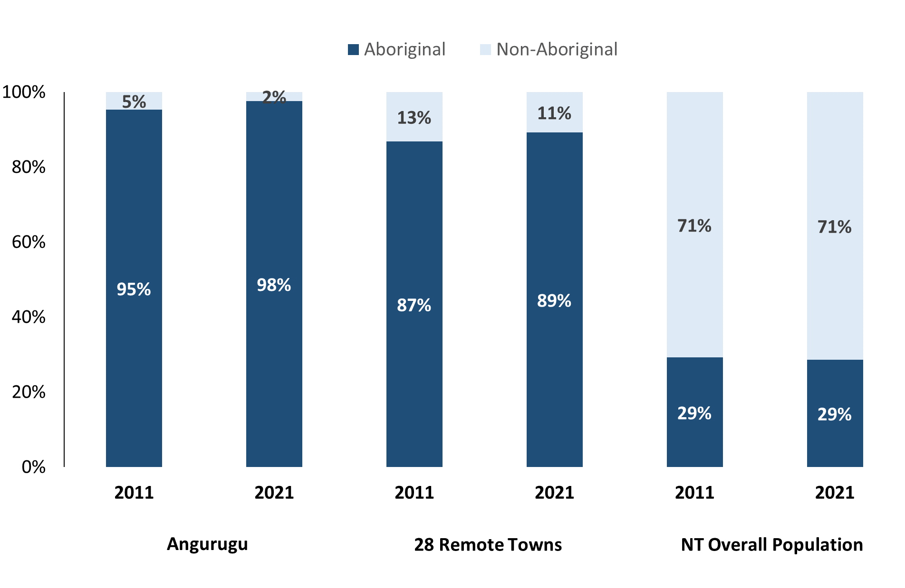

*Source: Australian Bureau of Statistics*

In 2021 in Angurugu:

* 98% of the population in Angurugu were **Aboriginal**, compared to 95% in 2011
* 89% of the population across all 28 remote towns were **Aboriginal**
* 29% of the NT population were **Aboriginal**.

**Table 37: Unemployment and Aboriginal participation rates (q)**

|  |  |  |  |  |  |  |
| --- | --- | --- | --- | --- | --- | --- |
|  | **Angurugu** | | | **Northern Territory** | | |
| **Aboriginal** | **Non-Aboriginal** | **Total** | **Aboriginal** | **Non-Aboriginal** | **Total** |
| **Unemployment rate** | 41.6% | 0.0% | 38.7% | 20.8% | 3.2% | 5.6% |
| **Participation rate** | 29.2% | 88.2% | 42.2% | 35.4% | 78.3% | 64.9% |

*Source: Australian Bureau of Statistics*

In 2021 in Angurugu the:

* **total unemployment rate** was 38.7% compared to 5.6% for the total Northern Territory
* **Aboriginal** **unemployment rate** was 41.6% compared to 20.8% for the total Northern Territory
* **non-Aboriginal** **unemployment rate** was 0.0% compared to 3.2% for the total Northern Territory
* **total participation rate** was 42.2% compared to 64.9% for the total Northern Territory
* **Aboriginal** **participation rate** was 29.2% compared to 35.4% for the total Northern Territory
* **non-Aboriginal** **participation rate** was 88.2% compared to 78.3% for the total Northern Territory.

# Community Development Program

**Table 38: Community Development Program Aboriginal Job Seekers, 31 December 2023 (o)**

|  |  |  |
| --- | --- | --- |
| **Indicator** | **Aboriginal** | |
| **No.** | **%** |
| **Total Aboriginal Job Seekers** | 355 | N/A |
| **Age (years)** | | |
| 15-24 | 119 | 34% |
| 25-44 | 161 | 45% |
| 45+ | 75 | 21% |
| **Total** | 355 | 100% |
| **Gender** | | |
| Male | 159 | 45% |
| Female | 196 | 55% |
| **Total** | 355 | 100% |
| **Employment Outcome - 1 January 2023 to 31 December 2023** | | |
| 13 Weeks | 39 | 62% |
| 26 Weeks | 24 | 38% |

*Source: Department of Prime Minister and Cabinet*

**Chart 14: Community Development Program Aboriginal Job Seekers by Gender and Age Group, 31 December 2023 (o)**

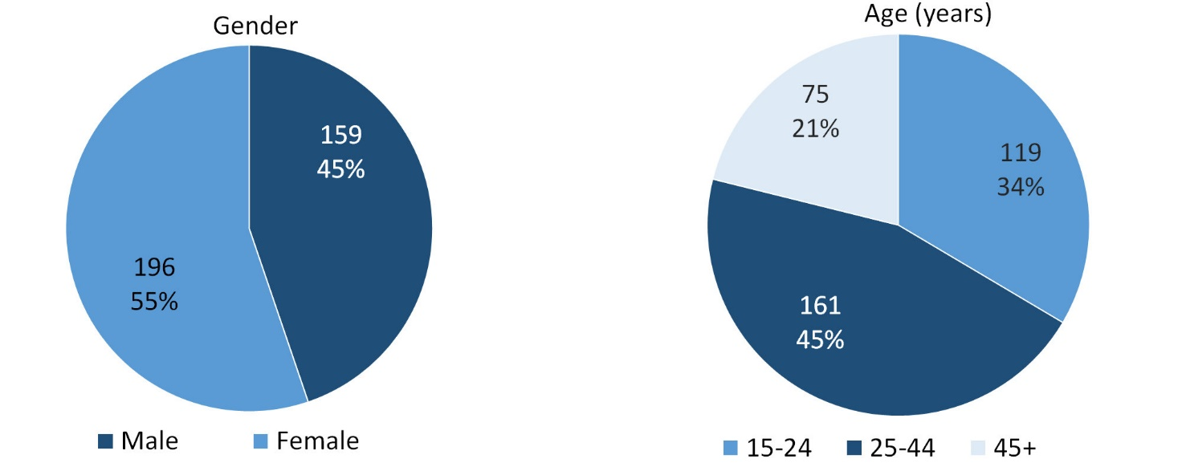

*Source: Department of Prime Minister and Cabinet*

As of 31 December 2023, in Angurugu, there were 355 CDP **Aboriginal** job seekers, of these:

* 159 (45%) were male and 196 (55%) were female
* 119 (34%) were aged 15-24 years, 161 (45%) were aged 25-44 years, and 75 (21%) were aged 45+ years
* between 1 January 2023 to 31 December 2023, 39 job seekers had reached the 13-week reporting milestone and 24 job seekers had reached the 26 week reporting milestone.

# Businesses

**Table 39: Businesses by sector (d)(s)**

|  |  |  |  |  |
| --- | --- | --- | --- | --- |
| **Business Name** | **Reported on in 2011** | **Reported on in 2014** | **Reported on in 2017** | **Reported on in 2023** |
| **PUBLIC SECTOR** | | | | |
| **Department of Chief Minister and Cabinet** | No | No | No | **Yes** |
| **Department of Education** | Yes | Yes | Yes | **Yes** |
| **Department of Health** | Yes | Yes | Yes | **Yes** |
| Department of Human Services trading as Centrelink | Yes | Yes | Yes | No |
| Department of the Prime Minister and Cabinet | Yes | Yes | Yes | No |
| **East Arnhem Regional Council** | Yes | Yes | Yes | **Yes** |
| **National Indigenous Australian Agency** | No | No | No | **Yes** |
| **Territory Families** | No | No | Yes | **Yes** |
| PRIVATE SECTOR | | | | |
| AA Electrical Pty Ltd | Yes | No | No | No |
| **Anindilyakwa Housing Aboriginal Corporation** | No | No | No | **Yes** |
| **Anindilyakwa Services Aboriginal Corporation (ASAC)** | No | Yes | Yes | **Yes** |
| GEBIE Civil and Construction Pty Ltd | Yes | No | Yes | No |
| **GEBIE Community Development Pty Ltd** | No | No | No | **Yes** |
| Groote Eylandt & Milyakburra Youth Development Unit | No | Yes | Yes | No |
| Groote Eylandt Aboriginal Trust | No | Yes | Yes | No |
| Groote Eylandt Bush Shop (NT) Pty Ltd | No | Yes | Yes | No |
| Groote Eylandt Linguistics | Yes | No | No | No |
| Kag, Kun Huy trading as Angurugu Chinese Takeaway | No | Yes | Yes | No |
| **MJD Foundation** | No | No | Yes | **Yes** |
| The Trustee for AA Essential Services Trust | No | Yes | Yes | No |
| **Warningakalinga Aboriginal Corporation trading as Yimiljumanja Store** | Yes | Yes | Yes | **Yes** |

*Source: Northern Territory Department of Industry, Tourism and Trade*

*Note: Business names captured across the four survey periods have been identified by the current 2023 Business ABN name listed as of 2023.*

In 2023 in Angurugu there were:

* 11 businesses reported on, of which:
* 6 businesses were from the Public Sector (55%)
* 5 businesses were from the Private Sector (45%)
* 4 businesses operating that were not operation in 2017.

# Notes

1. These counts represent numbers of filled jobs and not the number of people. As such the totals represent the total number of filled jobs, not the total number of employees. This count is not directly comparable to the total number of employed people as a person may have several jobs or one job may be shared by more than one person.
2. Full-time is defined as a job usually requiring 35 hours or more per week or that required 35 hours or more work during the reference week. Part-time is defined as a job usually requiring less than 35 hours per week or that required less than 35 hours work during the reference week. The reference week refers to the period that respondents were asked to provide information about. In most instances it would be the week prior to the week the questionnaire was completed. Questionnaires were predominantly conducted in June and July.
3. Care needs to be taken when analysing the counts of filled jobs by Aboriginal people. Aboriginality was reported by the business representative completing the questionnaire.
4. Sector was classified using the Standard Economic Sector of Classifications of Australia (SESCA), 2008.
5. Job permanency is classified according to what the business believes the level of job permanency is based on guidelines provided by data collectors. Those guidelines state a permanent job has paid annual and/or sick leave entitlements while a temporary job includes casual and fixed-term contract jobs.
6. Classified according to the Australian and New Zealand Standard Classification of Occupations (ANZSCO), 2006, major occupation level.
7. Other occupations include jobs where occupation was not stated, not known or inadequately described.
8. Classified using the Australian and New Zealand Standard Industrial Classification (ANZSIC), 2006, division level.
9. Care needs to be taken when analysing the counts of filled jobs by the gender of people in the jobs. The gender of the person employed in a job is reported by the business representative completing the questionnaire.
10. Care needs to be taken when analysing the counts of filled jobs by the age of people in the jobs. The age of the person employed in a job is reported by the business representative completing the questionnaire.
11. Students represent the number of individual clients that enrolled in a Vocational Education and Training unit during the calendar year.
12. Unit enrolments represent the count of individual units that students enrolled in during the calendar year.
13. Nominal hours delivered is the sum of the nominal hours of the units commenced during the calendar year regardless of when the course enrolment commenced.
14. Unit completions are the count of all successfully completed units reported in the calendar year regardless of the year of commencement of the units.
15. The Community Development Program (CDP) supports job seekers in remote Australia to build skills, address barriers and contribute to their communities through a range of flexible activities. Under the CDP, job seekers with activity requirements are expected to do up to 25 hours per week of work-like activities that benefit their community. It should be noted that some CDP participants may be reported on within the profile if they are attached to a filled position with an employer captured in the survey. Due to confidentiality issues, data below 20 people is not published.
16. Population estimates for both 2011 and 2021 are taken from the estimated resident population (ERP) data produced by the Australian Bureau of Statistics (ABS) and based on Australian Statistical Geography Standard (ASGS) Statistical Area Level 1 (SA1) regions. ERP are official estimates of the Australian population, which link people to a place of usual residence with Australia. All ERP data sources, including the Census of Population and Housing (Census), are subject to error (including inaccuracies in collection, recording and processing data) and should be used with caution.
17. Indigenous population proportions, unemployment and workforce participation rates are based on ABS Census counts at ASGS Indigenous Locations (ILOCs) for each remote town.
18. Working-age population includes all residents aged 15 years and over (commonly referred to as the civilian population) and consists of people that are employed, unemployed or not in the labour force.
19. A ‘business’ has been defined as any organisation that has undertaken productive activities in the last year, including companies, non-profit organisations, government departments and enterprises operating within the designated remote geography (town), and has one or more employees in paid employment and an Australian Business Number (ABN).

# Abbreviations and Acronyms

ABN Australian Business Number

ABS Australian Bureau of Statistics

ANZSCO Australian and New Zealand Standard Classification of Occupations

ANZSIC Australian and New Zealand Standard Industrial Classification

ASGS Australian Statistical Geography Standard

CDP Community Development Program

ERP Estimated Resident Population

ILOC Indigenous Locations

nec Not Elsewhere Classified

No. Number

Perm Permanent

ppt Percentage point

RJCP Remote Jobs and Communities Program

Temp Temporary

SA1 Statistical Area Level 1

VET Vocational Education and Training

1. The number of filled jobs does not represent the number of people as a person may have several jobs or one job may be shared by more than one person.
2. 4 Aboriginal filled jobs gender status not identified in 2017
3. 4 Aboriginal filled jobs gender status not identified in 2017
4. 4 Aboriginal filled jobs gender status not identified in 2017
5. 4 Aboriginal filled jobs gender status not identified in 2017