Mineral Titles Act 2010
NOTICE OF LAND CEASING TO BE A MINERAL TITLE AREA
Title Type and Number: | Exploration Licence 32156
Area Ceased on: | 31 January 2025
Area: | 99 Blocks, 323.70 km²
Locality: | ELLIOTT
Name of Applicant(s)/Holder(s): | 100% BAUDIN RESOURCES PTY LTD [ACN. 618 455 593]
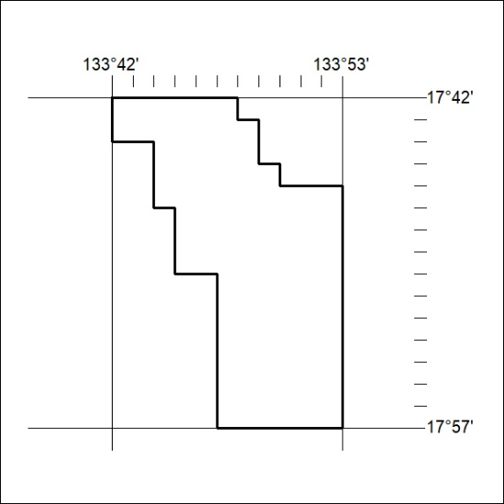

42/25

Mineral Titles Act 2010
NOTICE OF LAND CEASING TO BE A MINERAL TITLE AREA
Title Type and Number: | Exploration Licence 32157
Area Ceased on: | 31 January 2025
Area: | 69 Blocks, 217.87 km²
Locality: | ELLIOTT
Name of Applicant(s)/Holder(s): | 100% BAUDIN RESOURCES PTY LTD [ACN. 618 455 593]
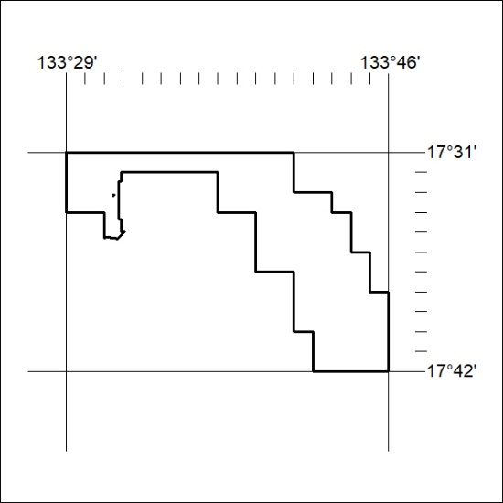

43/25

Mineral Titles Act 2010
NOTICE OF LAND CEASING TO BE A MINERAL TITLE AREA
Title Type and Number: | Exploration Licence 32158
Area Ceased on: | 31 January 2025
Area: | 132 Blocks, 425.06 km²
Locality: | HELEN
Name of Applicant(s)/Holder(s): | 100% BAUDIN RESOURCES PTY LTD [ACN. 618 455 593]
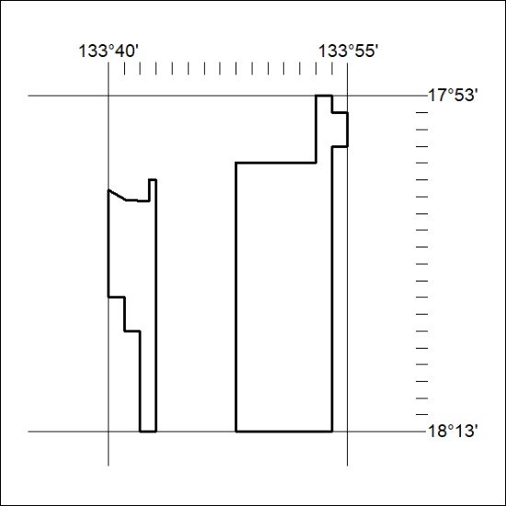

44/25

Mineral Titles Act 2010
NOTICE OF LAND CEASING TO BE A MINERAL TITLE AREA
Title Type and Number: | Exploration Licence 32329
Area Ceased on: | 31 January 2025
Area: | 20 Blocks, 65.24 km²
Locality: | HELEN
Name of Applicant(s)/Holder(s): | 100% BAUDIN RESOURCES PTY LTD [ACN. 618 455 593]
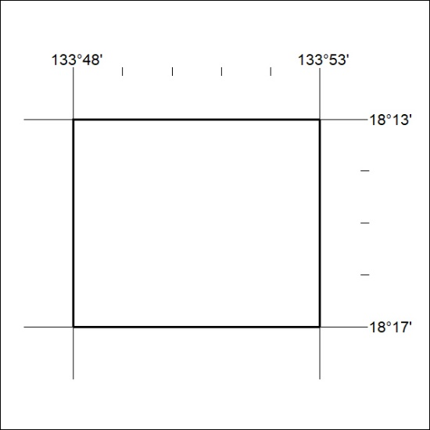

45/25

