Mineral Titles Act 2010
NOTICE OF LAND CEASING TO BE A MINERAL TITLE APPLICATION AREA
Title Type and Number: | Exploration Licence 33618
Area Ceased on: | 22 January 2025
Area: | 253 Blocks, 758.58 km²
Locality: | STYLES
Name of Applicant(s)/Holder(s): | 100% IGO NEWSEARCH PTY LTD [ACN. 142 192 701]
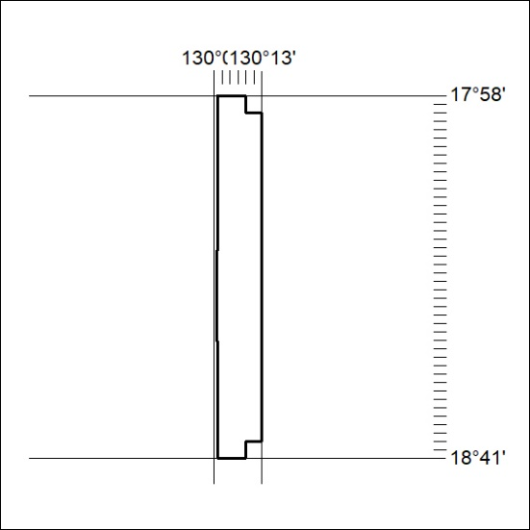

40/25

